Lesson 1002 – External Forces

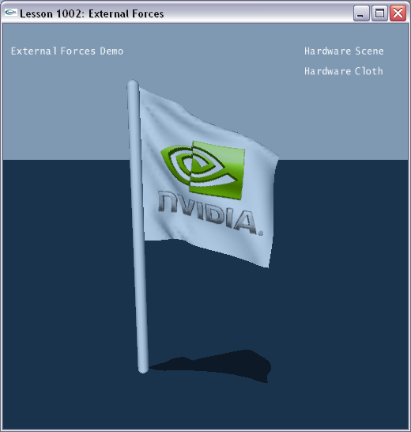

Introduction
In this lesson, we build a cloth flag. We will provide wind acceleration to the flag to simulate it blowing in the wind.

Flag
The scene gets constructed in SetupFlagScene().

void InitNx()
{
…
SetupFlagScene();
…
}
…
void SetupFlagScene()
{
sprintf(gTitleString, "External Forces Demo");

// Create the objects in the scene
groundPlane = CreateGroundPlane();
// Create a pole
NxActor* capsule = CreateCapsule(NxVec3(0.0,-0.2,0.0), 10, 0.2, 0);

// Create cloth
NxClothDesc clothDesc;
clothDesc.globalPose.t = NxVec3(0,10,0);
clothDesc.globalPose.M.rotX(-NxHalfPiF32);
clothDesc.thickness = 0.2;
clothDesc.bendingStiffness = 0.5;
clothDesc.flags |= NX_CLF_BENDING;
clothDesc.flags |= NX_CLF_COLLISION_TWOWAY | NX_CLF_VISUALIZATION;
clothDesc.windAcceleration = NxVec3(-20, 12, -1); // Set wind

if (gHardwareCloth)
clothDesc.flags |= NX_CLF_HARDWARE;

MyCloth* regularCloth = new MyCloth(gScene, clothDesc, 5, 5, 0.15, "nvidia.bmp");

if (!regularCloth->getNxCloth())
{
printf("Error: Cloth creation failed.\n");
delete regularCloth;
}
else
{
gCloths.push_back(regularCloth);
// Attach the flag to the pole
regularCloth->getNxCloth()->attachToShape(*capsule->getShapes(), NX_CLOTH_ATTACHMENT_TWOWAY);
}
}

We build the ground and a pole, called capsule that the flag will fly from. The cloth for the flag has the NX_CLOTH_ATTACHMENT_TWOWAY bit set so that the flag will be attached to any scene objects it intersects at startup.

void SetupFlagScene()
{
sprintf(gTitleString, "External Forces Demo");

// Create the objects in the scene
groundPlane = CreateGroundPlane();
// Create a pole
NxActor* capsule = CreateCapsule(NxVec3(0.0,-0.2,0.0), 10, 0.2, 0);
…
}

The cloth is created with the following codes.

void SetupFlagScene()
{
…
// Create cloth
NxClothDesc clothDesc;
clothDesc.globalPose.t = NxVec3(0,10,0);
clothDesc.globalPose.M.rotX(-NxHalfPiF32);
clothDesc.thickness = 0.2;
clothDesc.bendingStiffness = 0.5;
clothDesc.flags |= NX_CLF_BENDING;
clothDesc.flags |= NX_CLF_COLLISION_TWOWAY | NX_CLF_VISUALIZATION;
clothDesc.windAcceleration = NxVec3(-20, 12, -1); // Set wind

if (gHardwareCloth)
clothDesc.flags |= NX_CLF_HARDWARE;

MyCloth* regularCloth = new MyCloth(gScene, clothDesc, 5, 5, 0.15, "nvidia.bmp");
…
}

We fill out our cloth descriptor with parameters for the cloth.

First we set the global position of the cloth.

clothDesc.globalPose.t = NxVec3(0,10,0);

Next, we set the thickness of the cloth.

clothDesc.thickness = 0.2;

We set the bending stiffness of the cloth.

clothDesc.bendingStiffness = 0.5;

The range for this is 0 to 1 and only has an effect if NX_CLF_BENDING is set. This parameter defines how difficult it is to bend the cloth.

We set the bending flag so cloth bending is allowed.

clothDesc.flags |= NX_CLF_BENDING;

We set two-way collision so rigid body objects will push the cloth and the cloth will push back on them as well.

clothDesc.flags |= NX_CLF_COLLISION_TWOWAY;
We want to run the cloth in hardware if there’s hardware available, so we set the hardware flag on the cloth.

if (gHardwareCloth)
clothDesc.flags |= NX_CLF_HARDWARE;

Finally, we pass the cloth descriptor into our MyCloth object constructor to build the cloth.

MyCloth* regularCloth = new MyCloth(gScene, clothDesc, 5, 5, 0.15, "nvidia.bmp");

Applying Forces to the Cloth
We apply wind forces to the cloth.

void SetupFlagScene()
{
…
clothDesc.windAcceleration = NxVec3(-20, 12, -1); // Set wind
…
}
The property we use is NxClothDesc::windAcceleration. Basically, the wind acceleration is only applied in the normal direction of each vertex. This makes it easy to simulate a wind effect.

Conclusion
You have created a cloth flag and have applied a wind force to it to make it appear to fly in the wind.

Related Classes, Functions, and Parameters
NxClothDesc
windAcceleration

