Lesson 1006 – Tearing

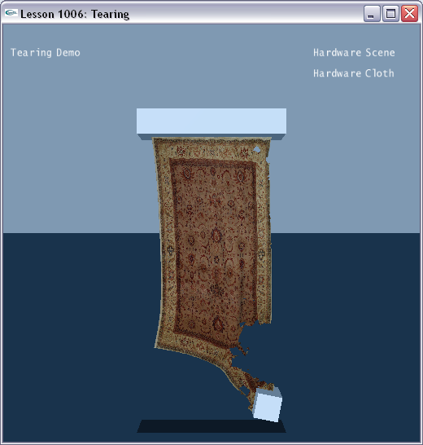

Introduction
Cloth can be made to have a limited resistance to stretching and thus to get torn in pieces under a large enough force. In this lesson, we will create a tearable cloth piece.

Creating Objects to Tear the Cloth
The scene gets constructed in SetupTearingScene().

void InitNx()
{
…
SetupTearingScene();
…
}
…
void SetupTearingScene()
{
sprintf(gTitleString, "Tearing Demo");

// Create the objects in the scene
groundPlane = CreateGroundPlane();
NxActor* bar = CreateBox(NxVec3(0,12,0), NxVec3(3,0.5,0.5), 0);
NxActor* box = CreateBox(NxVec3(-2.3,4.0,0), NxVec3(0.5,0.5,0.5), 10);

// Cloth
NxClothDesc clothDesc;
clothDesc.globalPose.t = NxVec3(2.5,12,0);
clothDesc.globalPose.M.rotX(-NxHalfPiF32);
clothDesc.thickness = 0.1;
clothDesc.tearFactor = 2;
clothDesc.flags |= NX_CLF_BENDING;
clothDesc.flags |= NX_CLF_COLLISION_TWOWAY;
clothDesc.flags |= NX_CLF_TEARABLE | NX_CLF_VISUALIZATION;
// Tearable cloth

if (gHardwareCloth)
clothDesc.flags |= NX_CLF_HARDWARE;

MyCloth* regularCloth = new MyCloth(gScene, clothDesc, 5, 8, 0.1, "rug512.bmp", gTearLines);
gCloths.push_back(regularCloth);

regularCloth->getNxCloth()->attachToShape(*bar->getShapes(), 0);
regularCloth->getNxCloth()->attachToShape(*box->getShapes(), NX_CLOTH_ATTACHMENT_TWOWAY);
}

We build a bar to hang our cloth from and a dynamic box which will be attached to the cloth on the right side.

void SetupTearingScene()
{
…
// Create the objects in the scene
groundPlane = CreateGroundPlane();
NxActor* bar = CreateBox(NxVec3(0,12,0), NxVec3(3,0.5,0.5), 0);
NxActor* box = CreateBox(NxVec3(-2.3,4.0,0), NxVec3(0.5,0.5,0.5), 10);
…
}

Creating the Tearable Cloth
We then create our cloth.

void SetupTearingScene()
{
…
// Cloth
NxClothDesc clothDesc;
clothDesc.globalPose.t = NxVec3(2.5,12,0);
clothDesc.globalPose.M.rotX(-NxHalfPiF32);
clothDesc.thickness = 0.1;
clothDesc.tearFactor = 2;
clothDesc.flags |= NX_CLF_BENDING;
clothDesc.flags |= NX_CLF_COLLISION_TWOWAY;
clothDesc.flags |= NX_CLF_TEARABLE | NX_CLF_VISUALIZATION;
// Tearable cloth

if (gHardwareCloth)
clothDesc.flags |= NX_CLF_HARDWARE;

MyCloth* regularCloth = new MyCloth(gScene, clothDesc, 5, 8, 0.1, "rug512.bmp", gTearLines);
gCloths.push_back(regularCloth);

regularCloth->getNxCloth()->attachToShape(*bar->getShapes(), 0);
regularCloth->getNxCloth()->attachToShape(*box->getShapes(), NX_CLOTH_ATTACHMENT_TWOWAY);
}

We mark our cloth as tearable using the following flag.

clothDesc.flags |= NX_CLF_TEARABLE;

We attach our cloth to the actors.

MyCloth* regularCloth = new MyCloth(gScene, clothDesc, 5, 8, 0.1, "rug512.bmp", gTearLines);
gCloths.push_back(regularCloth);

regularCloth->getNxCloth()->attachToShape(*bar->getShapes(), 0);
regularCloth->getNxCloth()->attachToShape(*box->getShapes(), NX_CLOTH_ATTACHMENT_TWOWAY);

The attachment is done using NxCloth::attachToShape(). This will attach the cloth to a particular shape passed in.

Run the demo. The dynamic box attached to the cloth will fall, tearing the cloth as it falls.

The key parameter in this scene is the “tearFactor” on the cloth descriptor.

void SetupTearingScene()
{
…
NxClothDesc clothDesc;
…
clothDesc.tearFactor = 2;
…
clothDesc.flags |= NX_CLF_TEARABLE | NX_CLF_VISUALIZATION;
…
}

The lower you set the “tearFactor” value, the more easily the cloth gets torn. The higher you set the “tearFactor” value, the more resistant the cloth gets torn.

Conclusion
You have learned how to create cloth that tears, attach the cloth to specified shapes, and raise and lower the ease with which the cloth tears.

Related Classes, Functions, and Parameters
NxCloth
attachToShape()

NxClothDesc
tearFactor
flags

NxClothFlag
NX_CLF_TEARABLE

