Lesson 1007 – Pressure

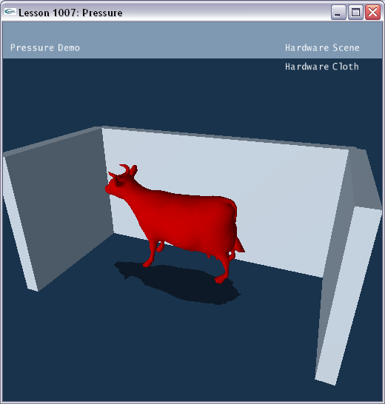

Introduction
Cloth that forms an enclosed volume can be pressurized. In this way, you can create balloon objects that you can inflate or deflate with variable pressure.

Creating the Object to Pressurize
The scene gets constructed in SetupPressureScene().

void InitNx()
{
…
SetupPressureScene();
…
}
…
void SetupPressureScene()
{
sprintf(gTitleString, "Pressure Demo");

// Create walls
groundPlane = CreateGroundPlane();
NxActor* box1 = CreateBox(NxVec3(0,0,5), NxVec3(10,5,0.5), 0);
NxActor* box2 = CreateBox(NxVec3(-10,0,0), NxVec3(0.5,5,5), 0);
NxActor* box3 = CreateBox(NxVec3( 10,0,0), NxVec3(0.5,5,5), 0);

// Create spheres
NxReal r = 1;
NxReal d = 1;
CreateSphere(NxVec3(0,20,0), r, d);
CreateSphere(NxVec3(-3,35, 0), r, d);
CreateSphere(NxVec3(3,50, 0), r, d);
CreateSphere(NxVec3(0,40, 0), r, d);
CreateSphere(NxVec3(-3,55, 0), r, d);
CreateSphere(NxVec3(3,60, 0), r, d);
CreateSphere(NxVec3(0,60, 0), r, d);
CreateSphere(NxVec3(-3,75, 0), r, d);
CreateSphere(NxVec3(3,80, 0), r, d);

// Create pressure cloth
NxClothDesc clothDesc;
clothDesc.globalPose.t = NxVec3(0.3,6,0);
clothDesc.thickness = 0.1;
clothDesc.pressure = 1.5;
clothDesc.flags |= NX_CLF_PRESSURE;
clothDesc.flags |= NX_CLF_BENDING;
clothDesc.flags |= NX_CLF_COLLISION_TWOWAY | NX_CLF_VISUALIZATION;

if (gHardwareCloth)
clothDesc.flags |= NX_CLF_HARDWARE;

MyCloth* objCloth = new MyCloth(gScene, clothDesc, "cow.obj", 1);
gCloths.push_back(objCloth);
}

First, we build the ground and three static boxes to create a small enclosure where we’ll place our balloon cloth object.

void SetupPressureScene()
{
…
// Create walls
groundPlane = CreateGroundPlane();
NxActor* box1 = CreateBox(NxVec3(0,0,5), NxVec3(10,5,0.5), 0);
NxActor* box2 = CreateBox(NxVec3(-10,0,0), NxVec3(0.5,5,5), 0);
NxActor* box3 = CreateBox(NxVec3( 10,0,0), NxVec3(0.5,5,5), 0);
…
}

Next, we create 9 spheres that we will drop on the balloon cloth object.

void SetupPressureScene()
{
…
// Create spheres
NxReal r = 1;
NxReal d = 1;
CreateSphere(NxVec3(0,20,0), r, d);
CreateSphere(NxVec3(-3,35, 0), r, d);
CreateSphere(NxVec3(3,50, 0), r, d);
CreateSphere(NxVec3(0,40, 0), r, d);
CreateSphere(NxVec3(-3,55, 0), r, d);
CreateSphere(NxVec3(3,60, 0), r, d);
CreateSphere(NxVec3(0,60, 0), r, d);
CreateSphere(NxVec3(-3,75, 0), r, d);
CreateSphere(NxVec3(3,80, 0), r, d);
…
}

Creating the Pressurized Cloth Object
We then create our pressurized balloon cloth object.

void SetupPressureScene()
{
…
// Create pressure cloth
NxClothDesc clothDesc;
clothDesc.globalPose.t = NxVec3(0.3,6,0);
clothDesc.thickness = 0.1;
clothDesc.pressure = 1.5;
clothDesc.flags |= NX_CLF_PRESSURE;
clothDesc.flags |= NX_CLF_BENDING;
clothDesc.flags |= NX_CLF_COLLISION_TWOWAY | NX_CLF_VISUALIZATION;

if (gHardwareCloth)
clothDesc.flags |= NX_CLF_HARDWARE;

MyCloth* objCloth = new MyCloth(gScene, clothDesc, "cow.obj", 1);
gCloths.push_back(objCloth);
}

We mark our cloth as pressurizable using the following flag.

clothDesc.flags |= NX_CLF_PRESSURE;

The pressure setting for the cloth object is here.

clothDesc.pressure = 1.5;

The higher you set the “pressure” value, the more the cow will inflate. The lower you set the “pressure” value, the more the cow will deflate.

Finally, we build our cloth object from our cloth descriptor.

MyCloth* objCloth = new MyCloth(gScene, clothDesc, "cow.obj", 1);

We use a WaveFront cow-shaped object to make our balloon cloth object.

Conclusion
You have learned how to create cloth enclosures that can be pressurized, i.e., cloth balloons.

Related Classes, Functions, and Parameters
NxClothDesc
pressure
flags

NxClothFlag
NX_CLF_ PRESSURE

