Lesson 1008 – Self Collision

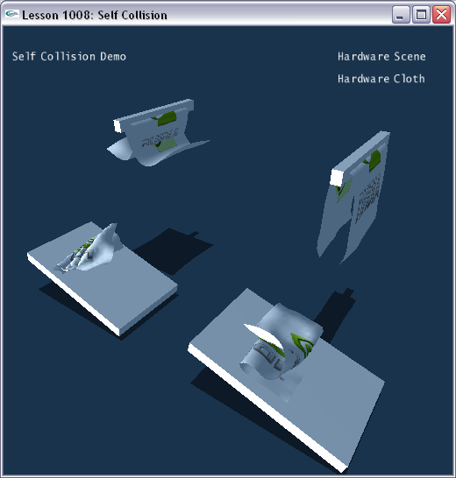

Introduction
Cloth can be enabled with self collision to prevent interpenetration. In this lesson, we create four pieces of cloth, two of them are self collision disabled and two of them are self collision enabled.

Creating Rigid Bodies and Cloth
The scene gets constructed in SetupSelfCollisionScene().

void InitNx()
{
…
SetupSelfCollisionScene();
…
}
…
void SetupSelfCollisionScene()
{
sprintf(gTitleString, "Self Collision Demo");

// Create the objects in the scene
groundPlane = CreateGroundPlane();
NxActor* box1 = CreateBox(NxVec3(4,0.8,-4.8), NxVec3(2.5,0.2,1.5), 0);
NxActor* box2 = CreateBox(NxVec3(-4,0.8,-4.8), NxVec3(2.5,0.2,1.5), 0);

// Rotate the two boxes
NxMat33 Mz;
Mz.rotZ(15.0f/180.0f*PI);
box1->setGlobalOrientation(Mz);
box2->setGlobalOrientation(Mz);

// No self collision cloth 1
NxClothDesc clothDesc;
clothDesc.globalPose.t = NxVec3(5,10,-3.5);
clothDesc.globalPose.M.rotZ(90.0f/180.0f*PI);
clothDesc.thickness = 0.18;
clothDesc.flags |= NX_CLF_BENDING | NX_CLF_BENDING_ORTHO;
clothDesc.flags |= NX_CLF_VISUALIZATION;

if (gHardwareCloth)
clothDesc.flags |= NX_CLF_HARDWARE;

MyCloth *dropCloth1 = new MyCloth(gScene, clothDesc, 5, 2.5, 0.15, "nvidia.bmp");
gCloths.push_back(dropCloth1);

// Self collision cloth 1
clothDesc.flags |= NX_CLF_SELFCOLLISION;
clothDesc.globalPose.t = NxVec3(-3,10,-3.5);
MyCloth *dropCloth2 = new MyCloth(gScene, clothDesc, 5, 2.5, 0.15, "nvidia.bmp");
gCloths.push_back(dropCloth2);

NxActor* stick1 = CreateBox(NxVec3(4,6,-1), NxVec3(0.15,0.2,2), 0);
NxActor* stick2 = CreateBox(NxVec3(-4,6,-1), NxVec3(0.15,0.2,2), 0);

// No self collision cloth 2
clothDesc.globalPose.t = NxVec3(7,6.2,-2.5);
clothDesc.globalPose.M.rotY(90.0f/180.0f*PI);
clothDesc.flags &= ~NX_CLF_SELFCOLLISION;
MyCloth* curtainCloth1 = new MyCloth(gScene, clothDesc, 3, 6, 0.15, "nvidia.bmp");
curtainCloth1->getNxCloth()->attachToCollidingShapes(0);
gCloths.push_back(curtainCloth1);

// Self collision cloth 2
clothDesc.globalPose.t = NxVec3(-1,6.2,-2.5);
clothDesc.flags |= NX_CLF_SELFCOLLISION;
MyCloth* curtainCloth2 = new MyCloth(gScene, clothDesc, 3, 6, 0.15, "nvidia.bmp");
curtainCloth2->getNxCloth()->attachToCollidingShapes(0);
gCloths.push_back(curtainCloth2);
}

We build two slopes that the cloth will fall on and two bars to hang the cloth from.

void SetupSelfCollisionScene()
{
…
NxActor* box1 = CreateBox(NxVec3(4,0.8,-4.8), NxVec3(2.5,0.2,1.5), 0);
NxActor* box2 = CreateBox(NxVec3(-4,0.8,-4.8), NxVec3(2.5,0.2,1.5), 0);

// Rotate the two boxes
NxMat33 Mz;
Mz.rotZ(15.0f/180.0f*PI);
box1->setGlobalOrientation(Mz);
box2->setGlobalOrientation(Mz);
…
NxActor* stick1 = CreateBox(NxVec3(4,6,-1), NxVec3(0.15,0.2,2), 0);
NxActor* stick2 = CreateBox(NxVec3(-4,6,-1), NxVec3(0.15,0.2,2), 0);
…
}

We build four cloth pieces. Two of them are self collision enabled and two are self collision disabled.

void SetupSelfCollisionScene()
{
…
// No self collision cloth 1
NxClothDesc clothDesc;
clothDesc.globalPose.t = NxVec3(5,10,-3.5);
clothDesc.globalPose.M.rotZ(90.0f/180.0f*PI);
clothDesc.thickness = 0.18;
clothDesc.flags |= NX_CLF_BENDING | NX_CLF_BENDING_ORTHO;
clothDesc.flags |= NX_CLF_VISUALIZATION;

if (gHardwareCloth)
clothDesc.flags |= NX_CLF_HARDWARE;

MyCloth *dropCloth1 = new MyCloth(gScene, clothDesc, 5, 2.5, 0.15, "nvidia.bmp");
gCloths.push_back(dropCloth1);

// Self collision cloth 1
clothDesc.flags |= NX_CLF_SELFCOLLISION;
clothDesc.globalPose.t = NxVec3(-3,10,-3.5);
MyCloth *dropCloth2 = new MyCloth(gScene, clothDesc, 5, 2.5, 0.15, "nvidia.bmp");
gCloths.push_back(dropCloth2);
…
// No self collision cloth 2
clothDesc.globalPose.t = NxVec3(7,6.2,-2.5);
clothDesc.globalPose.M.rotY(90.0f/180.0f*PI);
clothDesc.flags &= ~NX_CLF_SELFCOLLISION;
MyCloth* curtainCloth1 = new MyCloth(gScene, clothDesc, 3, 6, 0.15, "nvidia.bmp");
curtainCloth1->getNxCloth()->attachToCollidingShapes(0);
gCloths.push_back(curtainCloth1);

// Self collision cloth 2
clothDesc.globalPose.t = NxVec3(-1,6.2,-2.5);
clothDesc.flags |= NX_CLF_SELFCOLLISION;
MyCloth* curtainCloth2 = new MyCloth(gScene, clothDesc, 3, 6, 0.15, "nvidia.bmp");
curtainCloth2->getNxCloth()->attachToCollidingShapes(0);
gCloths.push_back(curtainCloth2);
}

We use the following flag to enable self collision.

clothDesc.flags |= NX_CLF_SELFCOLLISION;

Running the demo, the two cloth pieces on the left have no self collision. Since there isn’t collision detection between the vertexes, penetration is easy to occur within the cloth. The two cloth pieces on the right are self collision enabled. Since the collision between the vertexes is always detected, penetration can be prevented effectively.

Conclusion
You have learned how to create cloth with self collision and observe the behavior of NX_CLF_SELFCOLLISION flag.

Related Classes, Functions, and Parameters
NxClothDesc
flags

NxClothFlag
NX_CLF_SELFCOLLISION

