Lesson 1010 – Metal

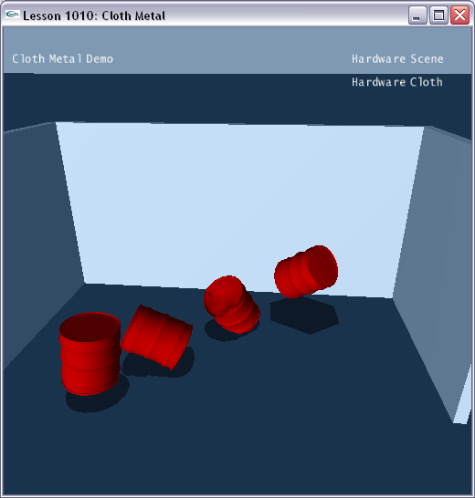

Introduction
Metal cloth can be used to simulate plastic deformation. For example dents in barrels, car bodywork or metal doors can be displayed when there is a large impact on the surface. In this lesson, we will create four metal cloth objects with different core actors.

Creating Objects
The scene gets constructed in SetupMetalScene().

void InitNx()
{
…
SetupMetalScene();
…
}
…
void SetupMetalScene()
{
sprintf(gTitleString, "Cloth Metal Demo");

// Create the objects in the scene
groundPlane = CreateGroundPlane();
NxActor *box1 = CreateBox(NxVec3(0,0,10), NxVec3(20,10,0.5), 0);
NxActor *box2 = CreateBox(NxVec3(-20,0,0), NxVec3(0.5,10,10), 0);
NxActor *box3 = CreateBox(NxVec3( 20,0,0), NxVec3(0.5,10,10), 0);

NxClothDesc clothDesc;

if (gHardwareCloth)
clothDesc.flags |= NX_CLF_HARDWARE;

// Create metal cloth with different core actors
CreateMetalCloth(NxVec3(0.0f, 3.0f, 0.5f), 0, clothDesc, "barrel.obj");
CreateMetalCloth(NxVec3(0.5f, 20.0f, 0.0f), 1, clothDesc, "barrel.obj");
CreateMetalCloth(NxVec3(0.0f, 40.0f, 0.5f), 2, clothDesc, "barrel.obj");
CreateMetalCloth(NxVec3(0.5f, 60.0f, 0.0f), 3, clothDesc, "barrel.obj");
}

We build the ground and three static boxes to create a small enclosure where we’ll place our metal cloth objects.

void SetupMetalScene()
{
…
// Create the objects in the scene
groundPlane = CreateGroundPlane();
NxActor *box1 = CreateBox(NxVec3(0,0,10), NxVec3(20,10,0.5), 0);
NxActor *box2 = CreateBox(NxVec3(-20,0,0), NxVec3(0.5,10,10), 0);
NxActor *box3 = CreateBox(NxVec3( 20,0,0), NxVec3(0.5,10,10), 0);
…
}

The metal cloth objects are created in CreateMetalCloth() function.

void CreateMetalCloth(const NxVec3 &position, int mode, NxClothDesc &clothDesc, char *meshName)
{
// Global metal data
NxReal impulseThreshold = 50.0f;
NxReal penetrationDepth = 0.5f;
NxReal maxDeformationDistance = 0.5f;

NxBodyDesc coreBodyDesc;
coreBodyDesc.linearDamping = 0.2f;
coreBodyDesc.angularDamping = 0.2f;

NxActorDesc coreActorDesc;
coreActorDesc.density = 0.1f;
coreActorDesc.body = &coreBodyDesc;

// Create the shape, no need for size info because it is automatically generated by // the cloth
if (mode == 0) { // Sphere as core
coreActorDesc.shapes.pushBack(new NxSphereShapeDesc());
}
else if (mode == 1) { // Capsule as core
coreActorDesc.shapes.pushBack(new NxCapsuleShapeDesc());
}
else if (mode == 2) { // Box as core
coreActorDesc.shapes.pushBack(new NxBoxShapeDesc());
}
else if (mode == 3) { // Compound of spheres as core
const NxU32 numSpheres = 10;
for (NxU32 i = 0; i < numSpheres; i++)
coreActorDesc.shapes.pushBack(new NxSphereShapeDesc());
}
else return;

NxActor *coreActor = gScene->createActor(coreActorDesc);
gMetalCores.push_back(coreActor);

// Clean up allocations
for (NxU32 i = 0; i < coreActorDesc.shapes.size(); i++)
delete coreActorDesc.shapes[i];

clothDesc.globalPose.t = position;

MyCloth *objCloth = new MyCloth(gScene, clothDesc, meshName, 1.0f);
if (!objCloth->getNxCloth())
{
printf("Error: Unable to create the cloth for the current scene.\n");
delete objCloth;
} else
{
gCloths.push_back(objCloth);
objCloth->getNxCloth()->attachToCore(coreActor, impulseThreshold, penetrationDepth, maxDeformationDistance);
}
}

To build a metal cloth object, we need to create a core actor first. Here we create four different core types.

void CreateMetalCloth(const NxVec3 &position, int mode, NxClothDesc &clothDesc, char *meshName)
{
…
NxActorDesc coreActorDesc;
coreActorDesc.density = 0.1f;
coreActorDesc.body = &coreBodyDesc;

// Create the shape, no need for size info because it is automatically generated by // the cloth
if (mode == 0) { // Sphere as core
coreActorDesc.shapes.pushBack(new NxSphereShapeDesc());
}
else if (mode == 1) { // Capsule as core
coreActorDesc.shapes.pushBack(new NxCapsuleShapeDesc());
}
else if (mode == 2) { // Box as core
coreActorDesc.shapes.pushBack(new NxBoxShapeDesc());
}
else if (mode == 3) { // Compound of spheres as core
const NxU32 numSpheres = 10;
for (NxU32 i = 0; i < numSpheres; i++)
coreActorDesc.shapes.pushBack(new NxSphereShapeDesc());
}
else return;

NxActor *coreActor = gScene->createActor(coreActorDesc);
…
}

The cloth needs to be attached to the core actor to enable the metal feature. We use NxCloth::attachToCore() function to attach the cloth to actors.

void CreateMetalCloth(const NxVec3 &position, int mode, NxClothDesc &clothDesc, char *meshName)
{
…
// Global metal data
NxReal impulseThreshold = 50.0f;
NxReal penetrationDepth = 0.5f;
NxReal maxDeformationDistance = 0.5f;

MyCloth *objCloth = new MyCloth(gScene, clothDesc, meshName, 1.0f);
if (!objCloth->getNxCloth())
{
printf("Error: Unable to create the cloth for the current scene.\n");
delete objCloth;
} else
{
gCloths.push_back(objCloth);
objCloth->getNxCloth()->attachToCore(coreActor, impulseThreshold, penetrationDepth, maxDeformationDistance);
}
…
}

The following parameters are needed when calling NxCloth::attachToCore().

- actor: The actor to attach to the cloth. Currently only sphere shapes, box shapes, capsule shapes and compounds of spheres are supported.

- impulseThreshold: Threshold for when deformation is allowed.

- penetrationDepth: Can be used to increase the amount of deformation due to impacts.

- maxDeformationDistance: Maximum deviation of cloth particles from initial position.

Conclusion
You have learned how to create metal cloth with different core actors.

Related Classes, Functions, and Parameters
NxCloth
attachToCore ()

