Lesson 1103 – BunnyScene

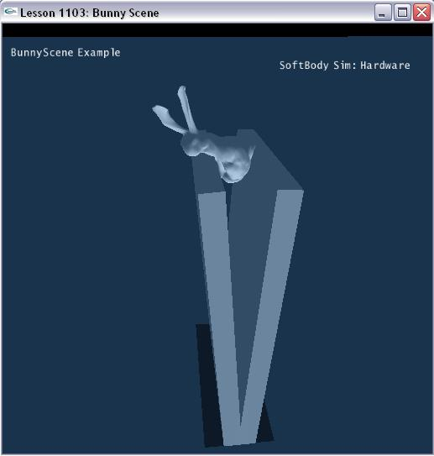

Introduction
This lesson will introduce how to make soft objects to softer by adjust soft body’s properties’ value.

Create bunny scene
General steps in creating soft body are same as Lesson1101.

The scene creates soft body in SetupBunnyScene ().

void SetupBunnyScene()
{
sprintf(gTitleString, "BunnyScene Example");

NxSoftBodyDesc softBodyDesc;
softBodyDesc.globalPose.t = NxVec3(0,35,-1);
softBodyDesc.particleRadius = 0.2f;
softBodyDesc.volumeStiffness = 1.0f;
softBodyDesc.stretchingStiffness = 0.07f;
softBodyDesc.friction = 1.0f;

if (gHardwareSoftBodySimulation)
softBodyDesc.flags |= NX_SBF_HARDWARE;

gScene->setGravity(NxVec3(0.0f, -10.0f, 0.0f));

char *fileName = "bunnyNormalized";

char tetFileName[256], objFileName[256], s[256];
sprintf(tetFileName, "%s.tet", fileName);
sprintf(objFileName, "%s.obj", fileName);

// The obj mesh is for mesh surface rendering, not physX mesh.

ObjMesh *objMesh = new ObjMesh();
objMesh->loadFromObjFile(FindMediaFile(objFileName, s));

MySoftBody *softBody = new MySoftBody(gScene, softBodyDesc, FindMediaFile(tetFileName,s), objMesh);
if (!softBody->getNxSoftBody())
{
printf("Error: Unable to create the SoftBody for the current scene.\n");
delete softBody;
} else
{
gSoftBodies.push_back(softBody);
gObjMeshes.push_back(objMesh);
}

NxMat33 rot;
NxActor *plate0 = CreateBox(NxVec3(-2.5,10,0), NxVec3(20.0f, 1.0f, 10.0f), 0.0f);
rot.rotZ(-1.5f);
plate0->setGlobalOrientation(rot);
NxActor *plate1 = CreateBox(NxVec3(2.5,10,0), NxVec3(20.0f, 1.0f, 10.0f), 0.0f);
rot.rotZ(1.5f);
plate1->setGlobalOrientation(rot);

// set camera position and direction
gCameraPos.set(-5.0f, 40.0f, 35.0f);
gCameraForward.set(0.2,-1.1,-2);
gCameraForward.normalize();
}

We fill out soft body descriptor with parameters for the soft body.

First we set the global position of the soft body.

softBodyDesc.globalPose.t = NxVec3(0,35,-1);

Next, we set the particle radius of the soft body.

softBodyDesc.particleRadius = 0.2f;

We set the volumeStiffness of the soft cube.

softBodyDesc.volumeStiffness = 1.0;

The range for volumeStiffness is 0 to 1 and only has effect if NX_SBF_VOLUME_CONSERVATION is set. This parameter defines how strongly the soft body counteracts deviations from the rest volume.

We set the stretching stiffness of the soft body.

softBodyDesc.stretchingStiffness = 0.07f;

Stretching stiffness defines how difficult it is to stretch the soft body. Here we take low value, so bunny is very easy to be stretched.

Next we set the friction of the soft body.

softBodyDesc.friction = 1.0f;

This defines the damping of the velocities of soft body particles that are in contact.

The soft body flag is default as NX_SBF_GRAVITY | NX_SBF_VOLUME_CONSERVATION.

Finally, we pass the soft body descriptor into our MySoftBody object constructor to build the soft body. We also push our soft body on the application’s stack of soft bodies.

MySoftBody *softBody = new MySoftBody(gScene, softBodyDesc,SOFTBODY_BOX,3,3,3,1);

gSoftBodies.push_back(softBody);

Ok, now the soft body has already been created in PhysX.

Conclusion
We can change the behavior of soft body by adjusting the volume stiffness and stretch stiffness value.

Related Classes, Functions, and Parameters
NxMeshData

NxSoftBodyMesh

NxSoftBodyDesc

NxReal volumeStiffness;
NxReal stretchingStiffness;

