Lesson 1104 – Self-Collision

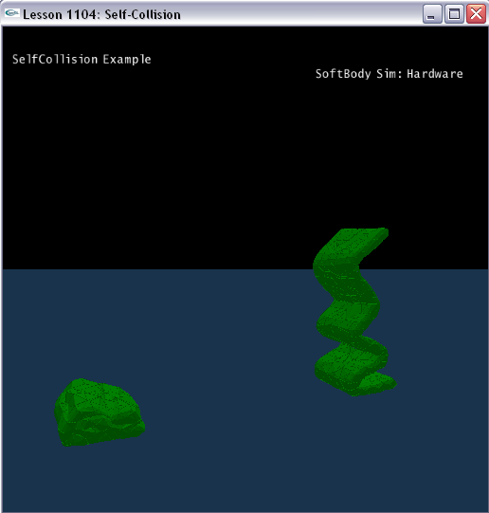

Introduction
We will demonstrate soft body self-collision in this lesson.

Create Self-Collision soft body
General steps in creating soft body are same as Lesson1101.

This lesson will create two soft body belts in SetupSelfCollisionScene (). One is general soft body, the other is enabled self-collision.

void SetupSelfCollisionScene()
{
sprintf(gTitleString, "SelfCollision Example");

NxSoftBodyDesc softBodyDesc;
softBodyDesc.setToDefault();
softBodyDesc.globalPose.t = NxVec3(-5,10,0);
softBodyDesc.particleRadius = 0.5;
softBodyDesc.volumeStiffness = 0.0f;
softBodyDesc.stretchingStiffness = 0.2f;
softBodyDesc.friction = 1.0f;

if (gHardwareSoftBodySimulation)
softBodyDesc.flags |= NX_SBF_HARDWARE;

gScene->setGravity(NxVec3(0.0f, -9.8f, 0.0f));

char *fileName = "belt_SB";

char tetFileName[256], objFileName[256], s[256];
sprintf(tetFileName, "%s.tet", fileName);
sprintf(objFileName, "%s.obj", fileName);

// The obj mesh is for mesh surface rendering, not physX mesh.

ObjMesh *objMesh = new ObjMesh();
objMesh->loadFromObjFile(FindMediaFile(objFileName, s));

MySoftBody *softBody = new MySoftBody(gScene, softBodyDesc, FindMediaFile(tetFileName,s), objMesh,0.2);
if (!softBody->getNxSoftBody())
{
printf("Error: Unable to create the SoftBody for the current scene.\n");
delete softBody;
} else
{
gSoftBodies.push_back(softBody);
gObjMeshes.push_back(objMesh);
}

softBodyDesc.globalPose.t = NxVec3(5,10,0);
softBodyDesc.flags |= NX_SBF_SELFCOLLISION;

softBody = new MySoftBody(gScene, softBodyDesc, FindMediaFile(tetFileName,s), objMesh,0.2);
if (!softBody->getNxSoftBody())
{
printf("Error: Unable to create the SoftBody for the current scene.\n");
delete softBody;
} else
{
gSoftBodies.push_back(softBody);
gObjMeshes.push_back(objMesh);
}
// set camera position and direction
gCameraPos.set(-10.0f, 5.0f, 15.0f);
gCameraForward.set(1,0,-2);
gCameraForward.normalize();
}

We fill out soft body descriptor with parameters for the soft body.

First we set the global position of the soft body.

softBodyDesc.globalPose.t = NxVec3(-5,10,0);

Next, we set the particle radius of the soft body.

softBodyDesc.particleRadius = 0.5f;

We set the stretching stiffness of the soft body.

softBodyDesc.stretchingStiffness = 0.2;

This defines how difficult it is to stretch the soft body.

Next we set the friction of the soft body.

softBodyDesc.friction = 1.0f;

This defines the damping of the velocities of soft body particles that are in contact.

We create two soft body belts in this lesson, one is general soft body, the other is with self-collision.

The soft body flag is default as NX_SBF_GRAVITY | NX_SBF_VOLUME_CONSERVATION. Here we apply NX_SBF_SELFCOLLISION to the soft body in order to make the soft body can collide among their particles. Self-collisions are only handled inbetween the soft body's particles, i.e., particles do not collide against the tetrahedra of the soft body. The user should therefore specify a large enough particleRadius to avoid most interpenetration.

Finally, we pass the soft body descriptor into our MySoftBody object constructor to build the soft body. We also push our soft body on the application’s stack of soft bodies.

MySoftBody *softBody = new MySoftBody(gScene, softBodyDesc, FindMediaFile(tetFileName,s), objMesh);

gSoftBodies.push_back (softBody);

Conclusion
We can compare the different behavior between general soft body and self-collision soft body.

Related Classes, Functions, and Parameters
NxSoftBodyDesc
particleRadius
stretchingStiffness

NxSoftBodyFlag
NxSoftBodyFlag {
NX_SBF_SELFCOLLISION(1<<3);
}

NxSoftBodyAttachmentFlag
NX_SOFTBODY_ATTACHMENT_TWOWAY = (1<<0),
NX_SOFTBODY_ATTACHMENT_TEARABLE = (1<<1)

