Lesson 1105 – SoftWheelCar

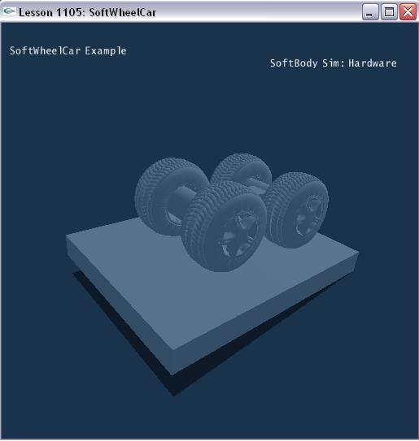

Introduction
We will demonstrate how soft body car wheel attach to axis. Thus we can design some funny scenarios by attachment of soft body.

Create soft wheel car
General steps in creating soft body are same as Lesson1101.

This lesson will create soft body tree in SetupSoftWheelCarScene ().
The car wheels are created by soft body, and the chassis is composed of box and capsules.

void SetupSoftWheelCarScene()
{
sprintf(gTitleString, "SoftWheelCar Example");

// Create the objects in the scene
//gGroundPlane = CreateGroundPlane();

NxSoftBodyDesc softBodyDesc;
softBodyDesc.particleRadius = 0.2f;
softBodyDesc.density = 1.0f;
softBodyDesc.volumeStiffness = 1.0f;
softBodyDesc.stretchingStiffness = 1.0f;
softBodyDesc.friction = 1.0f;
softBodyDesc.collisionResponseCoefficient = 0.9f;
softBodyDesc.attachmentResponseCoefficient = 0.8f;
softBodyDesc.solverIterations = 5;

if (gHardwareSoftBodySimulation)
softBodyDesc.flags |= NX_SBF_HARDWARE;

char *fileName = "wheelNormalized";

char tetFileName[256], objFileName[256], s[256];
sprintf(tetFileName, "%s.tet", fileName);
sprintf(objFileName, "%s.obj", fileName);

MySoftBody *softBody;

NxReal carHeight = 7.5f;
NxReal stiffness = 0.9f;
NxMat34 capsulePose = NxMat34(NxMat33(NX_IDENTITY_MATRIX), NxVec3(-4,carHeight,-5.0f));
capsulePose.M.rotX(NxHalfPiF32);
NxActor *caps1 = CreateOrientedCapsule(capsulePose, 7.1f, 1.3f, 1.0f);
capsulePose.t = NxVec3(4,carHeight,-5.0f);
NxActor *caps2 = CreateOrientedCapsule(capsulePose, 7.1f, 1.3f, 1.0f);

// The obj mesh is for mesh surface rendering, not physX mesh.

ObjMesh *objMesh = new ObjMesh();
objMesh->loadFromObjFile(FindMediaFile(objFileName, s));

NxMat33 rot;
rot.rotX(NxPiF32);
softBodyDesc.globalPose.t = NxVec3(4.0f, carHeight, 3.4f);
softBodyDesc.globalPose.M = rot;
softBodyDesc.stretchingStiffness = stiffness;
softBody = new MySoftBody(gScene, softBodyDesc, FindMediaFile(tetFileName,s), objMesh);
if (!softBody->getNxSoftBody())
{
printf("Error: Unable to create the SoftBody for the current scene.\n");
delete softBody;
} else
{
gObjMeshes.push_back(objMesh);

// attach soft body to colliding rigid body

softBody->getNxSoftBody()->attachToCollidingShapes(NX_SOFTBODY_ATTACHMENT_TWOWAY);

gSoftBodies.push_back(softBody);

……

// connect box and capsule to form the chassis

NxActor *box = CreateBox(NxVec3(0,carHeight,0), NxVec3(4.6f, 0.5f, 1.0f), 1.0f);
CreateRevoluteJoint(box, caps1, NxVec3(-4,carHeight,-3.5f), NxVec3(0,0,1));
CreateRevoluteJoint(box, caps2, NxVec3( 4,carHeight,-3.5f), NxVec3(0,0,1));
NxActor *ground = CreateBox(NxVec3(0,1,0), NxVec3(10.0f, 1.0f, 8.0f), 0.0f);
rot.rotZ(-0.1f);
ground->setGlobalOrientation(rot);
}
// set camera position and direction
gCameraPos.set(-17.0f, 20.0f, 20.0f);
gCameraForward.set(1.0f, -0.8f, -0.90f);
gCameraForward.normalize();
gCameraForward.normalize();
}

We fill out soft body descriptor with parameters for the soft body.

We set the particle radius of the soft body.

softBodyDesc.particleRadius = 0.2f;

We set the stretching stiffness of the soft body.

softBodyDesc.stretchingStiffness = 1.0;

This defines how difficult it is to stretch the soft body.

Next we set the friction of the soft body.

softBodyDesc.friction = 1.0f;

This defines the damping of the velocities of soft body particles that are in contact.

We set the volumeStiffness of the soft cube.

softBodyDesc.volumeStiffness = 1.0;

The range for volumeStiffness is 0 to 1 and only has effect if NX_SBF_VOLUME_CONSERVATION is set. This parameter defines how strongly the soft body counteracts deviations from the rest volume.

Set the attachment response value as following code:
softBodyDesc.attachmentResponseCoefficient = 0.8f;

Attachment response coefficient defines a factor for the impulse transfer from the soft body to attached rigid bodies. Only has an effect if the mode of the attachment is set to NX_SOFTBODY_ATTACHMENT_TWOWAY.

Finally, we pass the soft body descriptor into our MySoftBody object constructor to build the soft body. We also push our soft body on the application’s stack of soft bodies.

MySoftBody *softBody = new MySoftBody(gScene, softBodyDesc, FindMediaFile(tetFileName,s), objMesh);

gSoftBodies.push_back (softBody);

After soft body is created, we can attach soft body wheel to rigid body:
softBody->getNxSoftBody()
->attachToCollidingShapes(NX_SOFTBODY_ATTACHMENT_TWOWAY);

Conclusion
In this lesson, we learn a method that soft body is attached to colliding shapes with two-way.

Related Classes, Functions, and Parameters
NxSoftBodyDesc
particleRadius
stretchingStiffness

NxSoftBodyAttachmentFlag
NX_SOFTBODY_ATTACHMENT_TWOWAY = (1<<0),
NX_SOFTBODY_ATTACHMENT_TEARABLE = (1<<1)

