Lesson 1106 – Tearing

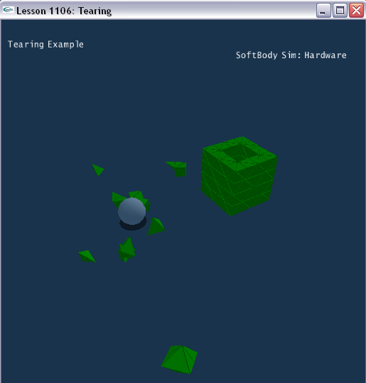

Introduction
In this lesson, we will learn how to make the soft body to be torn.

Create tearing soft body
General steps of creating soft body are same as Lesson1101.

This lesson will create soft body tree in SetupTearingScene ().

void SetupTearingScene()
{
sprintf(gTitleString, "Tearing Example");

NxSoftBodyDesc softBodyDesc;
……

softBodyDesc.tearFactor = 1.3;

softBodyDesc.flags |= NX_SBF_TEARABLE;

…..
MySoftBody* softBody = new MySoftBody(gScene,
softBodyDesc,SOFTBODY_BOX,3,3,3,1);
……

CreateSphere(NxVec3(4.0f, 7, 3.4f),1,5.5);

……
}

In order to create tear-able soft body, we should apply flag NX_SBF_TEARABLE and set its tear factor value.

The tear factor must be larger than 1. Make sure meshData.maxVertices and the corresponding buffers in meshData are substantially larger (e.g. 2x) then the number of original vertices since tearing will generate new vertices. When the buffer cannot hold the new vertices anymore, tearing stops.

Conclusion
Now we hold a tear-able soft body. It will be torn when rigid body sphere drop down to it.

Related Classes, Functions, and Parameters
NxSoftBodyDesc
tearFactor

NxSoftBodyFlag
NX_SBF_TEARABLE (1<<9)

