Lesson 202 – Joint Springs and Motors

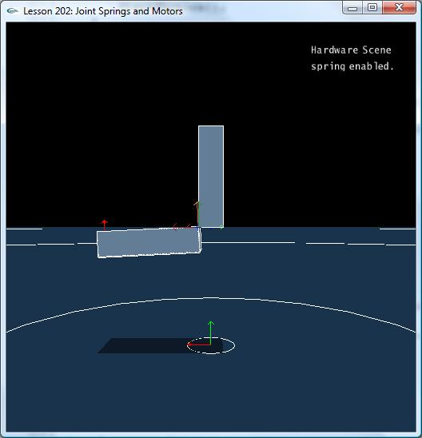

Introduction
Joint springs are a way to specify an angle between the jointed bodies that the bodies tend to move toward. They define a natural resting angle between the joint axes of the two jointed bodies. Joint motors are used to supply a relative torque between two bodies connected by a revolute or spherical joint.

Joint Springs
Box2 is once again hanging from kinematic box1 and swings from it by a revolute joint about the z-axis.

NxRevoluteJoint* CreateRevoluteJoint(NxActor* a0, NxActor* a1, NxVec3 globalAnchor, NxVec3 globalAxis)
{
NxRevoluteJointDesc revDesc;
revDesc.actor[0] = a0;
revDesc.actor[1] = a1;
revDesc.setGlobalAnchor(globalAnchor);
revDesc.setGlobalAxis(globalAxis);

revDesc.flags |= NX_RJF_SPRING_ENABLED;

NxSpringDesc springDesc;
springDesc.spring = 5000;
springDesc.damper = 50;
springDesc.targetValue = 0.5*NxPi;

revDesc.spring = springDesc;

return (NxRevoluteJoint*)gScene->createJoint(revDesc);
}

void InitNx()
{
…
box1 = CreateBox(NxVec3(0,5,0), NxVec3(0.5,2,1), 10);
box1->raiseBodyFlag(NX_BF_KINEMATIC);
box2 = CreateBox(NxVec3(0,1,0), NxVec3(0.5,2,1), 10);

box2->raiseBodyFlag(NX_BF_DISABLE_GRAVITY);

NxVec3 globalAnchor = NxVec3(0.5,5,-1);
NxVec3 globalAxis = NxVec3(0,0,-1);
revJoint = CreateRevoluteJoint(box1, box2, globalAnchor, globalAxis);

gSelectedActor = box2;
…
}

To put a spring on the joint, first we enable a spring on the revolute joint descriptor.

revDesc.flags |= NX_RJF_SPRING_ENABLED;

Then we attach a spring descriptor to the revolute joint descriptor.

NxSpringDesc springDesc;
springDesc.spring = 5000;
springDesc.damper = 50;
springDesc.targetValue = 0.5*NxPi;

revDesc.spring = springDesc;

The target value on the spring is the angle the local normal of box2 is pushed toward with respect to the local normal of box1 around the global axis, negative z. This angle is 0.5*NxPi, so box2 rotates about z so that it is perpendicular to the ground once the simulation begins.

springDesc.targetValue = 0.5*NxPi;

The force that pushes box1 toward its target value is 5000. The spring is damped to 50 so box1 doesn’t keep swinging back and forth around the target angle. It eventually loses energy and comes to rest.

springDesc.spring = 5000;
springDesc.damper = 50;

Hit “b” to see how the joint axes are aligned. When box2 is at rest, its local normal is rotated 90 degrees (0.5*NxPi) away from box1’s local normal around box2’s local axis.

Make box1 dynamic by taking out box1->raiseBodyFlag(NX_BF_KINEMATIC) and watch how the two boxes move with respect to each other. The actors will maintain a 90 degree angle with respect to each other unless otherwise forced apart.

Joint Motors
Take a look at the new CreateRevoluteJoint() and InitNx():

NxRevoluteJoint* CreateRevoluteJoint(NxActor* a0, NxActor* a1, NxVec3 globalAnchor, NxVec3 globalAxis)
{
NxRevoluteJointDesc revDesc;
revDesc.actor[0] = a0;
revDesc.actor[1] = a1;
revDesc.setGlobalAnchor(globalAnchor);
revDesc.setGlobalAxis(globalAxis);

revDesc.flags |= NX_RJF_MOTOR_ENABLED;

NxMotorDesc motorDesc;
motorDesc.velTarget = 1000;
motorDesc.maxForce = 500;
motorDesc.freeSpin = true;

revDesc.motor = motorDesc;

return (NxRevoluteJoint*)gScene->createJoint(revDesc);
}

void InitNx()
{
…
box1 = CreateBox(NxVec3(0,5,0), NxVec3(0.5,2,1), 10);
box1->raiseBodyFlag(NX_BF_KINEMATIC);
box2 = CreateBox(NxVec3(0,1,0), NxVec3(0.5,2,1), 10);

box2->raiseBodyFlag(NX_BF_DISABLE_GRAVITY);
box2->setAngularDamping(0);
box2->setMaxAngularVelocity(700);

NxVec3 globalAnchor = NxVec3(0.5,5,-1);
NxVec3 globalAxis = NxVec3(0,0,-1);
revJoint = CreateRevoluteJoint(box1, box2, globalAnchor, globalAxis);

gSelectedActor = box2;
…
}

We disable gravity and set the angular damping to 0 so we can see the motor at work without interference.

box2->raiseBodyFlag(NX_BF_DISABLE_GRAVITY);
box2->setAngularDamping(0);

We also do not make the boxes collidable so box2 can spin freely through box1. Finally, we set the maximum angular velocity to 700 so we can get box2 spinning at a good clip. The default maximum angular velocity for objects is 7 and is set this low for objects in general for computational and performance reasons. However, you can set the maximum angular velocity higher by changing the default or setting it higher on a per-actor basis, as above, to simulate objects like wheels or a spinning top which need to rotate at a higher velocity.

Starting the Motor
Run the lesson and hit “p” to unpause the physics. The lower body will start to accelerate around the kinematic upper body until it comes to a constant rotational velocity. The torque supplied to box2 is maxForce. The target rotational velocity is velTarget. The motor is set to freeSpin, so if the motor is turned off during the simulation (maxForce set to 0), box2 will continue spinning.

NxMotorDesc motorDesc;
motorDesc.velTarget = 1000;
motorDesc.maxForce = 500;
motorDesc.freeSpin = true;

revDesc.motor = motorDesc;

If freeSpin is not set, a braking force will be applied and box2 will eventually come to a halt.

Adjusting the Motor Velocity
When you run the demo, you'll notice that hitting “t” will toggle the speed of the motor. Hitting “t” calls the ShiftMotorVelocity() function.

void ShiftMotorVelocity()
{
NxRevoluteJointDesc revDesc;
revJoint->saveToDesc(revDesc);

if (revDesc.motor.velTarget == 1000)
revDesc.motor.velTarget = 10;
else
revDesc.motor.velTarget = 1000;

revJoint->loadFromDesc(revDesc);
}
You can adjust the motor on the fly by saving away the joint descriptor, changing the pertinent values, in this case, velTarget, the motor's target velocity, and loading the descriptor back into the joint. In this case, we save away the joint descriptor, change velTarget, the motor's target velocity, and load it back into the joint, adjusting the target velocity of the joint's motor. You can do this with other object descriptors as well, i.e., save away the descriptor, adjust values on the descriptor, then reload it into the object to change the properties of an object. You will eventually be doing this quite a bit with the 6 DOF joint descriptors to reconfigure the joint parameters on the fly.

Conclusion
Joint springs are very useful for making linked bodies that have a natural resting orientation the springs will pull them back to. You can make things like a rope or a mattress using joint springs. Divide the rope into segments, joint them together, then attach spring descriptors to the joints. You can apply a force to bend the rope, and the spring forces will cause the jointed bodies composing the rope to return to their rest configurations once the force is gone.

Related Classes, Functions, and Parameters
NxRevoluteJointDesc
spring
flags

NxSpringDesc
spring
damper
targetValue

NxRevoluteJointFlag
NX_RJF_SPRING_ENABLED

NxMotorDesc
velTarget
maxForce
freeSpin

NxRevoluteJointFlag
NX_RJF_MOTOR_ENABLED

NxRevoluteJoint
setMotor()

NxActor
setMaxAngularVelocity()

NxParameter
NX_MAX_ANGULAR_VELOCITY

