Lesson 203 – Spherical Joints

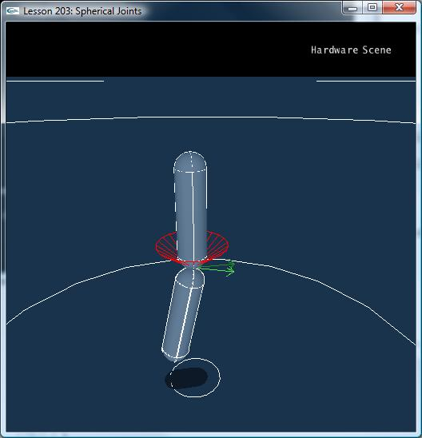

Introduction
Until now we have been using just the revolute joint, a joint with one degree of freedom, it may freely rotate about its primary axis.

We now introduce the spherical joint. Spherical joints allow three degrees of freedom: freedom to rotate about every joint axis while remaining in a fixed position.

Spherical joints are commonly used to simulate shoulder joints and other ball-and-socket joints. The joints are free to rotate about any axis, but may have limits placed on the amount they can rotate about each axis. For instance, you can swing your shoulder through a wide range parallel to your torso facing, but only about 90 degrees perpendicular to your torso facing. You can then twist your shoulder through about 90 degrees.

Spherical Joints
In InitNx(), we make two capsules, one above the other, and attach them by a spherical joint, much like we have been previously attaching the boxes by a revolute joint.

// Actor globals
NxActor* groundPlane = NULL;
NxActor* capsule1 = NULL;
NxActor* capsule2 = NULL;

// Joint globals
NxSphericalJoint* sphericalJoint = NULL;
…
void InitNx()
{
…
// Create the objects in the scene
groundPlane = CreateGroundPlane();

capsule1 = CreateCapsule(NxVec3(0,5,0), 3, 0.5, 10);
capsule1->raiseBodyFlag(NX_BF_KINEMATIC);
capsule2 = CreateCapsule(NxVec3(0,1,0), 3, 0.5, 10);
capsule2->setLinearDamping(0.5);

NxVec3 globalAnchor = NxVec3(0,5,0);
NxVec3 globalAxis = NxVec3(0,1,0);
sphericalJoint = CreateSphericalJoint(capsule1, capsule2, globalAnchor, globalAxis);

gSelectedActor = capsule2;
…
}

We create the spherical joint with CreateSphericalJoint():

NxSphericalJoint* CreateSphericalJoint(NxActor* a0, NxActor* a1, NxVec3 globalAnchor, NxVec3 globalAxis)
{
NxSphericalJointDesc sphericalDesc;
sphericalDesc.actor[0] = a0;
sphericalDesc.actor[1] = a1;
sphericalDesc.setGlobalAnchor(globalAnchor);
sphericalDesc.setGlobalAxis(globalAxis);

sphericalDesc.flags |= NX_SJF_SWING_LIMIT_ENABLED;
sphericalDesc.swingLimit.value = 0.3*NxPi;

sphericalDesc.flags |= NX_SJF_TWIST_LIMIT_ENABLED;
sphericalDesc.twistLimit.low.value = -0.05*NxPi;
sphericalDesc.twistLimit.high.value = 0.05*NxPi;

return (NxSphericalJoint*)gScene->createJoint(sphericalDesc);
}

Capsule1 is the upper, kinematic capsule. Capsule2 is the lower, dynamic capsule. The globalAxis of the spherical joint is (0,1,0) meaning the local axes of capsule1 and capsule2 both start at (0,1,0). Their local normals start at (0,0,1) and local binormals start at (-1,0,0).

We enable a swing limit, capsule2’s local axis is allowed to swing about its local normal and binormal up to 0.3*NxPi from its original position in any direction.

sphericalDesc.flags |= NX_SJF_SWING_LIMIT_ENABLED;
sphericalDesc.swingLimit.value = 0.3*NxPi;

We also enable a twist limit as well, which allows capsule2’s local normal to rotate from its original position to a minimum value of -0.05*NxPi and a maximum value of 0.05*NxPi.

sphericalDesc.flags |= NX_SJF_TWIST_LIMIT_ENABLED;
sphericalDesc.twistLimit.low.value = -0.05*NxPi;
sphericalDesc.twistLimit.high.value = 0.05*NxPi;

Try playing around with the lesson. Hit “b” and notice how the swing limit is shown as a red cone around capsule2’s local axis and the twist limit is shown as a red pie slice around capsule2’s local normal (the local binormal is not shown as it is not involved in the joint limits).

Conclusion
You now know how to construct a spherical joint. We will be keeping the CreateSphericalJoint() and CreateRevoluteJoint() functions as well as other joint creation functions that we encounter for use in future lessons.

Related Classes, Functions, and Parameters
NxSphericalJointDesc
swingLimit
twistLimit
flags

NxJointLimitPairDesc
high
low

NxJointLimitDesc
value
restitution

NxSphericalJointFlag
NX_SJF_SWING_LIMIT_ENABLED
NX_SJF_TWIST_LIMIT_ENABLED

NxSphericalJoint

