Lesson 205 – Cylindrical and Fixed Joints

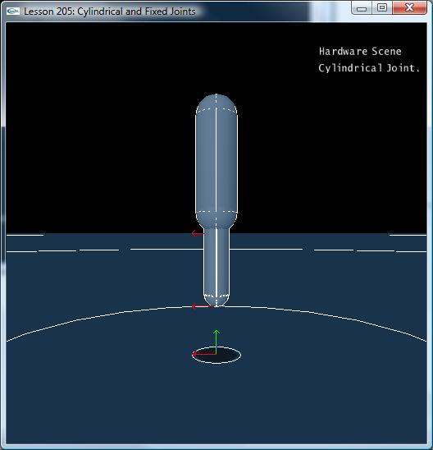

Introduction
Cylindrical joints are the first joint we introduce with both rotational and translational motion. The jointed actors are free to rotate about the primary axis like a revolute joint as well as translate about the primary axis like a prismatic joint.

Cylindrical Joints
Take a look at the new InitNx():

// Actor globals
NxActor* groundPlane = NULL;
NxActor* capsule1 = NULL;
NxActor* capsule2 = NULL;

// Joint globals
NxCylindricalJoint* cylJoint = NULL;
…
void InitNx()
{
…
capsule1 = CreateCapsule(NxVec3(0,5,0), 4, 0.85, 10);
capsule1->raiseBodyFlag(NX_BF_KINEMATIC);
capsule2 = CreateCapsule(NxVec3(0,3,0), 3, 0.5, 10);
capsule2 ->setLinearDamping(0.5);
capsule2->setAngularDamping(0.5);

NxVec3 globalAnchor = NxVec3(0,7,0);
NxVec3 globalAxis = NxVec3(0,1,0);
cylJoint = CreateCylindricalJoint(capsule1, capsule2, globalAnchor, globalAxis);

gSelectedActor = capsule2;
…
}

The setup for the cylindrical joint is almost identical to the prismatic joint, as is the cylindrical joint creation function.

NxCylindricalJoint* CreateCylindricalJoint(NxActor* a0, NxActor* a1, NxVec3 globalAnchor, NxVec3 globalAxis)
{
NxCylindricalJointDesc cylDesc;
cylDesc.actor[0] = a0;
cylDesc.actor[1] = a1;
cylDesc.setGlobalAnchor(globalAnchor);
cylDesc.setGlobalAxis(globalAxis);

NxJoint* joint = gScene->createJoint(cylDesc);

joint->setLimitPoint(globalAnchor);

// Add up-down limiting planes
joint->addLimitPlane(-globalAxis, globalAnchor + 1*globalAxis);
joint->addLimitPlane(globalAxis, globalAnchor - 1*globalAxis);

return (NxCylindricalJoint*)joint;
}

We add a limit point to the top of the lower capsule and limit planes that slice through the upper actor parallel to the ground. Use “umijkl” to move the lower actor up and down. Hit “f” to switch from Force Mode to Torque Mode and see how you can rotate the lower actor in place as well.

Conclusion
Cylindrical joints are very similar to prismatic joints with the exception that the actors are allowed to rotate about the joint’s primary axis as well as translate along it.

Related Classes, Functions, and Parameters
NxCylindricalJointDesc
NxCylindricalJoint

