Lesson 206 – Point-on-Line Joints

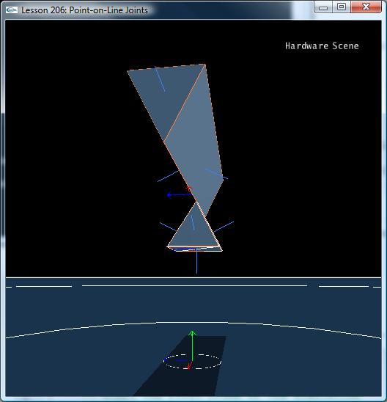

Introduction
You can think of a point-on-line joint as a spherical joint you can translate along one axis. It is free to rotate about all three joint axes and can translate about one axis. An example of a prismatic joint would be something like a hanger on a shower curtain rod (that is free as well to twist along its axis perpendicular to the rod).

Point-on-Line Joints
InitNx() is now set up as follows:

// Actor globals
NxActor* groundPlane = NULL;
NxActor* wedge = NULL;
NxActor* pyramid = NULL;

// Joint globals
NxPointOnLineJoint* polJoint = NULL;
…
void InitNx()
{
…
wedge = CreateDownWedge(NxVec3(0,6,0), NxVec3(5,1,1), 10);
wedge->raiseBodyFlag(NX_BF_KINEMATIC);
pyramid = CreatePyramid(NxVec3(0,4,0), NxVec3(1,1,1), 10);
pyramid->setLinearDamping(0.5);
pyramid->setAngularDamping(0.5);

NxVec3 globalAnchor = NxVec3(0,6,0);
NxVec3 globalAxis = NxVec3(1,0,0);
polJoint = CreatePointOnLineJoint(wedge, pyramid, globalAnchor, globalAxis);
…
gSelectedActor = pyramid;
…
}

We make a wedge and a pyramid. CreateDownWedge() creates a long V-shaped convex object, while CreatePyramid() creates a full, triangular pyramid, unlike the half-pyramid we used in the convex object lesson. We place the pyramid underneath the wedge so the tip of the pyramid intersects the bottom of the V-wedge. We then join the two actors by a point-on-line joint in the middle of the V-wedge, with the primary axis of the joint pointing along the x-axis (this is the direction the pyramid will move along the wedge).

NxPointOnLineJoint* CreatePointOnLineJoint(NxActor* a0, NxActor* a1, NxVec3 globalAnchor, NxVec3 globalAxis)
{
NxPointOnLineJointDesc polDesc;
polDesc.actor[0] = a0;
polDesc.actor[1] = a1;
polDesc.setGlobalAnchor(globalAnchor);
polDesc.setGlobalAxis(globalAxis);
polDesc.jointFlags |= NX_JF_COLLISION_ENABLED;

NxJoint* joint = gScene->createJoint(polDesc);

return joint->isPointOnLineJoint();
}

We have enabled collision between the two actors on the joint so the pyramid gets stopped by the geometry of the wedge if it tries to swing over the top. We have no collision geometry to stop the pyramid from translating off the wedge however. To stop the pyramid from going off either end of the wedge we use limit planes.

“Upcasting” from an NxPointOnLineJoint to an NxJoint
Instead of setting up the limit planes in the CreatePointOnLineJoint() function, we return the joint as an NxPointOnLineJoint and upcast it to an NxJoint in InitNx(). We then use the NxJoint functions to add the limit points and planes to the joint.

We explain this upcasting here as the NxPointOnLineJoint class is not actually derived from the NxJoint class. NxPointOnLineJoint class contains a pointer to its NxJoint which you must reference to get access to the limit point and plane functions.

The code contains two methods for this “upcast”.

void InitNx()
{
…
// UPCAST METHOD #1
NxJoint* jointPtr = &polJoint->getJoint();
jointPtr->setLimitPoint(globalAnchor);
// Add left-right limiting planes
jointPtr->addLimitPlane(-globalAxis, globalAnchor + 5*globalAxis);
jointPtr->addLimitPlane(globalAxis, globalAnchor - 5*globalAxis);
…
}

The first method accesses the NxJoint attached to the NxPointOnLine joint class by value. The second method is #if 0’d out.

void InitNx()
{
…
// UPCAST METHOD #2
NxPointOnLineJoint& polJointRef = *polJoint;
NxJoint& jointRef = polJointRef;
jointRef.setLimitPoint(globalAnchor);
// Add left-right limiting planes
jointRef.addLimitPlane(-globalAxis, globalAnchor + 5*globalAxis);
jointRef.addLimitPlane(globalAxis, globalAnchor - 5*globalAxis);
…
}

The second method access the NxJoint attached to the NxPointOnLine joint class by reference.

Remember this method of upcasting as the other types of joints build on NxJoint in the same way, and there are other classes in the SDK that use this style of inheritance in favor of standard C++ inheritance as well.

Conclusion
You now know how to use the point-on-line joint. You also know how to “upcast” from a “derived” joint class to the “base” joint class.

Related Classes, Functions, and Parameters
NxPointOnLineJointDesc
NxPointOnLineJoint

NxJointFlag
NX_JOINT_COLLISION_ENABLED

NxJoint
setLimitPoint()
addLimitPlane()
isPointOnLineJoint()

