Lesson 213 – 6DOF Motion Controller
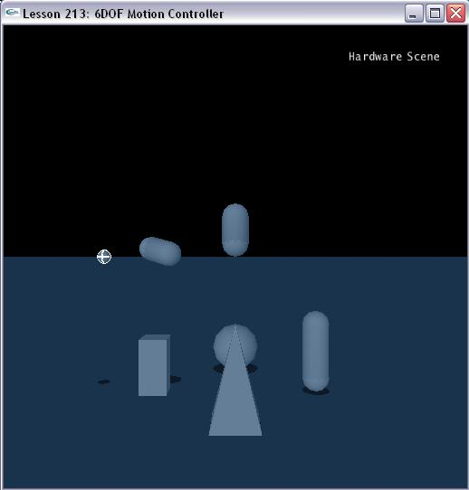

Introduction
The joints’ properties can be reconfigured on the fly. That is, you don’t need to destroy it as one type and recreate it as another. In this lesson, we will create a demo where you can match the joint to target actors’ behavior.

Six Degree of Freedom Joints
In InitNx(), we create some rigid actors and one six degree of freedom joint.

void InitNx()
{
…
d6Joint = CreateD6Joint(capsule1, capsule2, globalAnchor, globalAxis);
……

// Start the first frame of the simulation
if (gScene) StartPhysics();
}

We create the 6DOF joint with CreateD6Joint():

NxD6Joint* CreateD6Joint(NxActor* a0, NxActor* a1, const NxVec3& globalAnchor, const NxVec3& globalAxis)
{
NxD6JointDesc d6Desc;
d6Desc.actor[0] = a0;
d6Desc.actor[1] = a1;
d6Desc.setGlobalAnchor(globalAnchor);
d6Desc.setGlobalAxis(globalAxis);

d6Desc.twistMotion = NX_D6JOINT_MOTION_FREE;
d6Desc.swing1Motion = NX_D6JOINT_MOTION_FREE;
d6Desc.swing2Motion = NX_D6JOINT_MOTION_FREE;

d6Desc.xMotion = NX_D6JOINT_MOTION_FREE;
d6Desc.yMotion = NX_D6JOINT_MOTION_FREE;
d6Desc.zMotion = NX_D6JOINT_MOTION_FREE;

d6Desc.projectionMode = NX_JPM_NONE;

return (NxD6Joint*)gScene->createJoint(d6Desc);
}

Match target behavior
The joint’s behavior can be changed according to other objects’ movement.

void MatchTarget()
{
NxD6JointDesc d6Desc;
d6Joint->saveToDesc(d6Desc);

// fill the d6 joint descriptor to re-use it.

d6Desc.xDrive.driveType = NX_D6JOINT_DRIVE_POSITION;
d6Desc.xDrive.spring = 200;
d6Desc.xDrive.damping = 10;

….

NxMat33 orient = ball->getGlobalOrientation();
NxMat33 controlOrient;
controlOrient.setRow(0, orient.getRow(1));
controlOrient.setRow(1, orient.getRow(2));
controlOrient.setRow(2, orient.getRow(0));
NxQuat q(controlOrient);
d6Desc.driveOrientation = q;

d6Joint->loadFromDesc(d6Desc);
}

The drive orientation is changed by loadFromDesc to reflect the ball actor’s movement.

Conclusion
We learn how to change the joint’s properties during run-times in this lesson.

Related Classes, Functions, and Parameters
NxD6JointDesc

NxD6JointMotion

NxD6JointLockFlags

NxD6JointLimitFlags

NxD6JointDriveType

NxD6JointFlag

NxJointLimitPairDesc

NxJointLimitDesc

NxJointDriveDesc

NxJointProjectionMode

