Lesson 214 – Breakable Joints

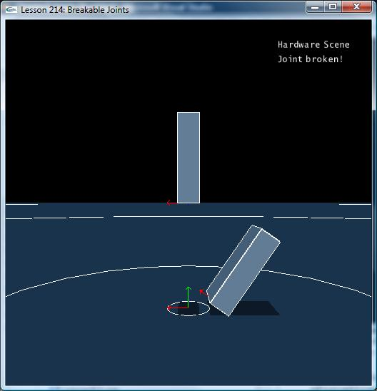

Introduction
Joints can be made to break, simulating things like a wooden door that can be kicked off its hinges, or an open car door that breaks off when it hits a mailbox or lamppost.

Breakable Joints
NxRevoluteJoint* CreateRevoluteJoint(NxActor* a0, NxActor* a1, NxVec3 globalAnchor, NxVec3 globalAxis)
{
NxRevoluteJointDesc revDesc;
revDesc.actor[0] = a0;
revDesc.actor[1] = a1;
revDesc.setGlobalAnchor(globalAnchor);
revDesc.setGlobalAxis(globalAxis);
revDesc.jointFlags |= NX_JF_COLLISION_ENABLED;

NxJoint* joint = gScene->createJoint(revDesc);

NxReal maxForce = 2000;
NxReal maxTorque = 100;
joint->setBreakable(maxForce,maxTorque);

return (NxRevoluteJoint*)joint;
}

Everything is set up the same in CreateRevoluteJoint() as in the last lesson, except we intercept the joint before it’s returned and we call

NxReal maxForce = 2000;
NxReal maxTorque = 100;
joint->setBreakable(maxForce, maxTorque);

maxForce is the maximum linear force the joint can withstand such as a force pulling the joint apart. maxTorque is the maximum rotational force the joint can withstand such as twisting a door beyond a stopping point on its hinge.

Try running the demo and push and twist box2 until the revolute joint breaks and it falls off. Try changing the maxForce and maxTorque values to see what it takes to get the joint to break.

Conclusion
Breakable joints are important in games as there are many objects that are meant to be destructible and have parts that fly off them under sufficient force. Breakable joints add a sense of realism in that the parts of objects won’t break off unless a physically sufficient force is applied.

Related Classes, Functions, and Parameters
NxJoint
setBreakable()

