Lesson 215 – 6DOF Linear Driver
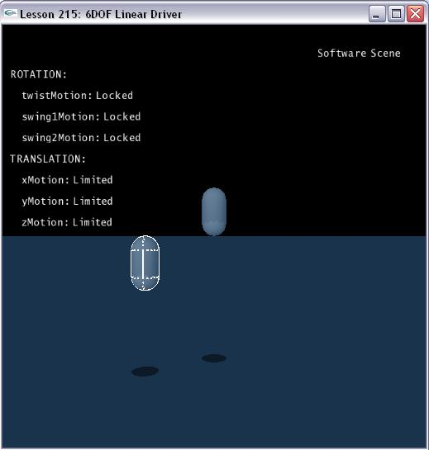

Introduction
In this lesson you will learn how to apply linear driver to six degree freedom joint.

Linear driver of 6DOF joint
We create the two capsules connected by the 6DOF joint as we did in the last one. This time, however, we lock rotation of the joint about all three axes and allow limited translation along all three axes.

NxD6Joint* CreateD6Joint(NxActor* a0, NxActor* a1, const NxVec3& globalAnchor, const NxVec3& globalAxis)
{
NxD6JointDesc d6Desc;
d6Desc.actor[0] = a0;
d6Desc.actor[1] = a1;
d6Desc.driveLinearVelocity = NxVec3(0, -2, 0);
d6Desc.setGlobalAnchor(globalAnchor);
d6Desc.setGlobalAxis(globalAxis);

d6Desc.twistMotion = NX_D6JOINT_MOTION_LOCKED;
d6Desc.swing1Motion = NX_D6JOINT_MOTION_LOCKED;
d6Desc.swing2Motion = NX_D6JOINT_MOTION_LOCKED;

d6Desc.linearLimit.value = 5;
d6Desc.linearLimit.damping = 50;
d6Desc.linearLimit.restitution = 0.8f;
d6Desc.linearLimit.spring = 100;

d6Desc.yDrive.driveType = NX_D6JOINT_DRIVE_VELOCITY;
d6Desc.yDrive.forceLimit = 500.0f;

d6Desc.xMotion = NX_D6JOINT_MOTION_LIMITED;
d6Desc.yMotion = NX_D6JOINT_MOTION_LIMITED;
d6Desc.zMotion = NX_D6JOINT_MOTION_LIMITED;

d6Desc.projectionMode = NX_JPM_NONE;

return (NxD6Joint*)gScene->createJoint(d6Desc);
}

The linear velocity is applied to joint descriptor by following code:

d6Desc.driveLinearVelocity = NxVec3 (0, -2, 0);

d6Desc.yDrive.driveType = NX_D6JOINT_DRIVE_VELOCITY;

Conclusion
A velocity drive in this case will deflect the drive from the desired position, just as an external force stretches the spring.

Related Classes, Functions, and Parameters
NxD6JointDesc
NxD6JointMotion

NxD6JointLockFlags
NX_D6JOINT_LOCK_X
NX_D6JOINT_LOCK_Y
NX_D6JOINT_LOCK_Z
NX_D6JOINT_LOCK_LINEAR
NX_D6JOINT_LOCK_TWIST
NX_D6JOINT_LOCK_SWING1
NX_D6JOINT_LOCK_SWING2
NX_D6JOINT_LOCK_ANGULAR

NxD6JointLimitFlags
NX_D6JOINT_LIMIT_TWIST
NX_D6JOINT_LIMIT_SWING
NX_D6JOINT_LIMIT_LINEAR

NxD6JointDriveType
NX_D6JOINT_DRIVE_POSITION
NX_D6JOINT_DRIVE_VELOCITY

NxD6JointFlag
NX_D6JOINT_SLERP_DRIVE
NX_D6JOINT_GEAR_ENABLED

NxJointLimitPairDesc

NxJointLimitDesc

NxJointDriveDesc

NxJointProjectionMode
NX_JPM_NONE
NX_JPM_POINT_MINDIST

