Lesson 216 – 6DOF Angular Driver
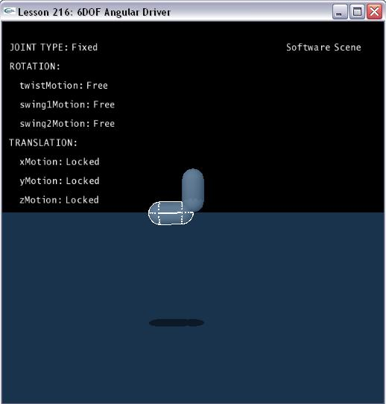

Introduction
In this lesson you will learn how to apply angular driver to six degree freedom joint.

Angular driver of 6DOF joint
We create the two capsules connected by the 6DOF joint as we did in the last one. This time, however, we free the rotation of the joint about all three axes.

NxD6Joint* CreateD6Joint(NxActor* a0, NxActor* a1, const NxVec3& globalAnchor, const NxVec3& globalAxis)
{
NxD6JointDesc d6Desc;
d6Desc.actor[0] = a0;
d6Desc.actor[1] = a1;
d6Desc.driveAngularVelocity = NxVec3(0, 2, 0);
d6Desc.setGlobalAnchor(globalAnchor);
d6Desc.setGlobalAxis(globalAxis);

d6Desc.twistMotion = NX_D6JOINT_MOTION_FREE;
d6Desc.swing1Motion = NX_D6JOINT_MOTION_FREE;
d6Desc.swing2Motion = NX_D6JOINT_MOTION_FREE;

d6Desc.swingDrive.driveType = NX_D6JOINT_DRIVE_VELOCITY;
d6Desc.swingDrive.forceLimit = 500.f;

d6Desc.xMotion = NX_D6JOINT_MOTION_LOCKED;
d6Desc.yMotion = NX_D6JOINT_MOTION_LOCKED;
d6Desc.zMotion = NX_D6JOINT_MOTION_LOCKED;

d6Desc.projectionMode = NX_JPM_NONE;

return (NxD6Joint*)gScene->createJoint(d6Desc);
}

The angular velocity is applied to joint descriptor by following code:

d6Desc.driveAngularVelocity = NxVec3 (0, 2, 0);

d6Desc.yDrive.driveType = NX_D6JOINT_DRIVE_VELOCITY;

And the twistMotion and swing1Motion/swing2Motion are free.

Conclusion
Angular drive differs from linear drive in a fundamental way: it does not have a simple and intuitive representation free from singularities. For this reason, the d6joint provides two angular drive models - twist and swing and Spherical Linear Interpolation.

Related Classes, Functions, and Parameters
NxD6JointDesc

NxD6JointMotion
NX_D6JOINT_MOTION_LOCKED
NX_D6JOINT_MOTION_LIMITED
NX_D6JOINT_MOTION_FREE

NxD6JointLockFlags
NX_D6JOINT_LOCK_X
NX_D6JOINT_LOCK_Y
NX_D6JOINT_LOCK_Z
NX_D6JOINT_LOCK_LINEAR
NX_D6JOINT_LOCK_TWIST
NX_D6JOINT_LOCK_SWING1
NX_D6JOINT_LOCK_SWING2
NX_D6JOINT_LOCK_ANGULAR

NxD6JointLimitFlags
NX_D6JOINT_LIMIT_TWIST
NX_D6JOINT_LIMIT_SWING
NX_D6JOINT_LIMIT_LINEAR

NxD6JointDriveType
NX_D6JOINT_DRIVE_POSITION
NX_D6JOINT_DRIVE_VELOCITY

NxD6JointFlag
NX_D6JOINT_SLERP_DRIVE
NX_D6JOINT_GEAR_ENABLED

NxJointLimitPairDesc

NxJointLimitDesc

NxJointDriveDesc

NxJointProjectionMode
NX_JPM_NONE
NX_JPM_POINT_MINDIST

