Lesson 301 – Actor Pair Filtering

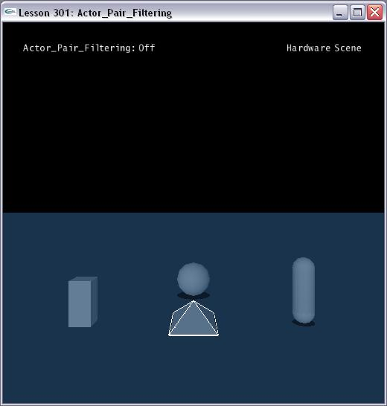

Introduction
It is possible to provide a custom method for actor pair filtering. This gives you total control over which actors can interact with which.

The Actor Pair Filtering
In ActorPairFilter.h, we define a class called UserActorPairFiltering.

class UserActorPairFiltering
{
public:
UserActorPairFiltering() : bNoCollision(false) {}

virtual void onActorPairs(NxActorPairFilter *filterArray, NxU32 arraySize)
{
……
}

public:
bool bNoCollision;
};

The virtual function onActorPairs() is a callback function. This callback will be called with arrays of actor pairs, for each of which you may specify whether to filter that pair out or not.

This class gets instantiated in Lesson301.cpp. Then pass it into the NxScene.

UserActorPairFiltering gActorPairFiltering;
......
void InitNx()
{
……
gScene->setUserActorPairFiltering(&gActorPairFiltering);
……
}

Set Actors Flag

Set the NX_AF_USER_ACTOR_PAIR_FILTERING flag for any actors you wish to involve in custom filtering.

void InitNx()
{
……
box->raiseActorFlag(NX_AF_USER_ACTOR_PAIR_FILTERING);
sphere->raiseActorFlag(NX_AF_USER_ACTOR_PAIR_FILTERING);
capsule->raiseActorFlag(NX_AF_USER_ACTOR_PAIR_FILTERING);
pyramid->raiseActorFlag(NX_AF_USER_ACTOR_PAIR_FILTERING);
……
}

Custom Method
We can iterate the filter array and specify whether to filter out or not for each pair. In this lesson, we omit the pair that involving the ground. For other pairs, we control the filter by a bool variable. Of cause, you can control it with any complex logic as you like

virtual void onActorPairs(NxActorPairFilter *filterArray, NxU32 arraySize)
{
for (NxU32 i = 0; i < arraySize; ++i)
{
NxActor* pActor0 = filterArray[i].actor[0];
NxActor* pActor1 = filterArray[i].actor[1];
if (groundPlane == pActor0)
{
filterArray[i].filtered = false;
continue;
}
if (groundPlane == pActor1)
{
filterArray[i].filtered = false;
continue;
}

filterArray[i].filtered = bNoCollision;
}
}

Change Strategy

Whenever you change the policy used in your callback, or change the callback itself, you need to also call NxActor::resetUserActorPairFiltering() for each actor that would change its filtering state with regard to any of its current interactions (to be safe you may want to simply call it for every actor with the flag set). Otherwise the changed policy would have no effect until the pair separated and contacted once more.

void SpecialKeys(unsigned char key, int x, int y)
{
switch (key)
{
case 'v': {
gActorPairFiltering.bNoCollision = !gActorPairFiltering.bNoCollision;
box->resetUserActorPairFiltering();
sphere->resetUserActorPairFiltering();
capsule->resetUserActorPairFiltering();
pyramid->resetUserActorPairFiltering();
……
break; }
default: { break; }
}
}
Note: User actor pair filtering overrides any other actor pair filtering.

Conclusion
The user actor pair filtering allows us to specify our own filter for the collision pair filtering.

Related Classes, Functions, and Parameters
NxUserActorPairFiltering
onActorPairs()
NxActorPairFilter

NxActorFlag
NX_AF_USER_ACTOR_PAIR_FILTERING

NxActor
resetUserActorPairFiltering()

NxScene
setUserActorPairFiltering()

