Lesson 303 – Contact Report

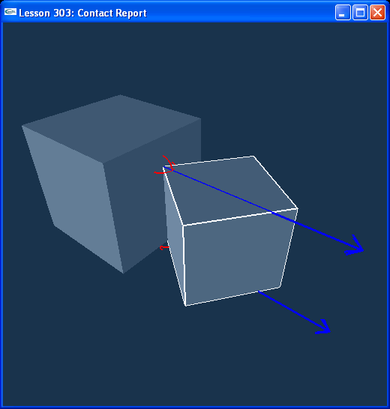

Introduction
In this lesson, we learn about the User Contact Report and the Contact Stream Iterator. We will make the two box actors in our scene into contact pairs, collect information on how they contact each other, and display this information using the debug renderer and our own drawing routines.

The Contact Report
We have added a new file to the project, ContactReport.h. This file contains a class called ContactReport which is derived from NxUserContactReport. We make an instance of this class which we attached to the SDK in InitNx().

void InitNx()
{
// Create the physics SDK
gPhysicsSDK = NxCreatePhysicsSDK(NX_PHYSICS_SDK_VERSION);
if (!gPhysicsSDK) return;
…
// Create the scene
NxSceneDesc sceneDesc;
sceneDesc.userContactReport = &gContactReport;
gScene = gPhysicsSDK->createScene(sceneDesc);
…
}

At the end of InitNx() we call gScene->setActorPairFlags() on the two actors to make them into a contact pair. We will get information on every contact pair we have set up this way every simulation step that they are in contact. When they are in contact, onContactNotify() in ContactReport.h is called, passing in a reference to the contact pair and the nature of the contact, whether the pair just started touching, whether they’ve been touching, or whether they have stopped touching, set up in setActorPairFlags() by the NX_NOTIFY_ON_START_TOUCH, NX_NOTIFY_ON_TOUCH, and NX_NOTIFY_ON_END_TOUCH flags.

// Actor globals
NxActor* groundPlane = NULL;
NxActor* box1 = NULL;
NxActor* box2 = NULL;
…
void InitNx()
{
…
// Create the objects in the scene
groundPlane = CreateGroundPlane();

box1 = CreateBox(NxVec3(-3,5,0), NxVec3(0.75,0.75,0.75), 5);
box2 = CreateBox(NxVec3(3,0,0), NxVec3(1,1,1), 5);

GameObject* Object1 = new GameObject;
Object1->id = 1;
Object1->events = 0;
box1->userData = Object1;

GameObject* Object2 = new GameObject;
Object2->id = 2;
Object2->events = 0;
box2->userData = Object2;

gSelectedActor = box1;

gScene->setActorPairFlags(*box1, *box2, NX_NOTIFY_ON_START_TOUCH |
NX_NOTIFY_ON_TOUCH |
NX_NOTIFY_ON_END_TOUCH);
…
}

Look at onContactNotify() in ContactReport.h. This is called every time the two boxes, the contact pair, are in contact. When it is called, userData on each actor is set, so the actor knows about the nature of the contact through its user data. (User data is a topic we will see more and more of later. It is important for linking game related data to our actors, shapes, etc.)

The Contact Stream Iterator
The SDK holds something called a contact stream, a list of all contact pairs in the simulation that are currently in contact, and the shapes, faces, and points of contact on the actors. In onContactNotify() in ContactReport.h, we get a contact stream iterator, i, that points to this stream, specifically at the location of the pair of actors in contact that we pass in. Using i, we can step through each shape, face, and point of contact between the two actors.

// Iterate through the contact points
NxContactStreamIterator i(pair.stream);

while(i.goNextPair())
{
while(i.goNextPatch())
{
const NxVec3& contactNormal = i.getPatchNormal();
while(i.goNextPoint())
{
const NxVec3& contactPoint = i.getPoint();
…
}
}
}

The NxPair has information on the normal forces and frictional forces between the two actors in the pair. Here we draw the forces at their contact points (as they are applied at their contact points).

Conclusion
New things you should have learned: how to attach an NxUserContactReport to the SDK to get information on contact pairs, how to make two actors into contact pair and flag them for particular contact information, how to use the contact stream iterator to get shapes, faces, and points of contact between two actors in a contact pair.

Related Classes, Functions, and Parameters
NxUserContactReport
onContactNotify()

NxContactStreamIterator
goNextPair()
goNextPatch()
goNextPoint()

NxScene
setActorPairFlags()

NxContactPair

NxContactPairFlag
NX_NOTIFY_ON_START_TOUCH
NX_NOTIFY_ON_END_TOUCH
NX_NOTIFY_ON_TOUCH

