Lesson 304 – Trigger Report

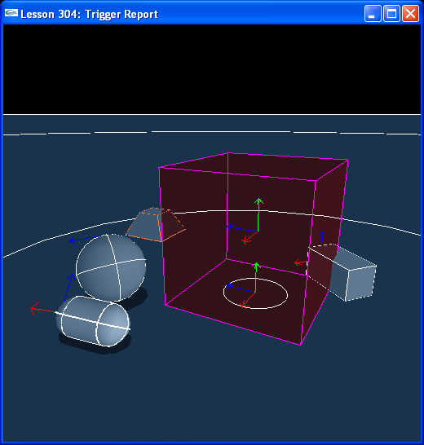

Introduction
In this lesson you will learn about triggers. Triggers are shapes used in games to cue events when particular objects intersect them. Trigger shapes are created by setting the NX_TRIGGER_ENABLE flag on the shape descriptor. For these shapes to work as triggers with code you supply, you need to attach a Trigger Report to the scene. A Trigger Report is a class derived from NxUserTriggerReport. This Trigger Report will call onTrigger() every frame the trigger is intersected by another shape, passing in a pointer to the trigger shape, the intersecting shape, and the state of the intersection, whether the intersecting shape has just entered the trigger, whether it has just left the trigger, or whether it has been inside the trigger for more than one frame.

Triggers
We create four regular rigid body actors, a box, a sphere, a capsule, and a pyramid, and place them around a trigger actor. The trigger actor is constructed in CreateTriggerBox().

// Create a static trigger
NxActor* CreateTriggerBox(const NxVec3& pos, const NxVec3& boxDim)
{
NxActorDesc actorDesc;

NxBoxShapeDesc boxDesc;
boxDesc.dimensions = boxDim;
boxDesc.shapeFlags |= NX_TRIGGER_ENABLE;

actorDesc.shapes.pushBack(&boxDesc);
actorDesc.globalPose.t = pos + NxVec3(0, boxDim.y, 0);

return gScene->createActor(actorDesc);
}

void InitNx()
{
…
box = CreateBox(NxVec3(-5,0,0), NxVec3(0.5,1,0.5), 10);
box->setLinearDamping(0.5);
sphere = CreateSphere(NxVec3(0,0,5), 0.5, 10);
sphere->setLinearDamping(0.5);
capsule = CreateCapsule(NxVec3(5,0,5), 1, 0.5, 10);
capsule->setLinearDamping(0.5);
pyramid = CreatePyramid(NxVec3(5,0,0), NxVec3(1,0.5,1), 10, pyramidConvexMeshDesc);
pyramid->setLinearDamping(0.5);

triggerBox = CreateTriggerBox(NxVec3(0,0,0), NxVec3(2,2,2));
triggerBox->userData = (void*)-1;
gScene->setUserTriggerReport(&gTriggerReport);

gSelectedActor = box;
…
}

The trigger actor is a box and it is static as it has no body descriptor. Trigger shapes are massless by definition. They are meant as trigger volumes, areas in a game that players and objects can enter which activate certain events, like a room in a dungeon might have a trigger shape filling up the doorway, signaling monsters to come out and attack the player once he enters the room.

Run the demo and push any of the regular rigid body actors into the green trigger box. Note that it turns red when any of them intersect the box and returns to green once they’re all out.

We have attached a Trigger Report to our scene in InitNx().

gScene->setUserTriggerReport(&gTriggerReport);

Note we have used NxScene::setUserTriggerReport() to attach the trigger report to the scene. We could have also added it to the scene descriptor when the scene was first created.

sceneDesc.userTriggerReport = &gTriggerReport;

These two methods can be used to add user callbacks to the scene. In “Lesson 303: Contact Report”, we could have used NxScene::setContactReport(&gContactReport) to attach the contact report to the scene.

The Trigger Report
You will find the User Trigger Report, gTriggerReport, defined in TriggerReport.h:

class TriggerReport : public NxUserTriggerReport
{
public:
virtual void onTrigger(NxShape& triggerShape, NxShape& otherShape, NxTriggerFlag status)
{
if (status & NX_TRIGGER_ON_ENTER)
{
// A body just entered the trigger area
gNbTouchedBodies++;
}
if (status & NX_TRIGGER_ON_LEAVE)
{
// A body just left the trigger area
gNbTouchedBodies--;
}
NX_ASSERT(gNbTouchedBodies>=0);
...
}
} gTriggerReport;

onTrigger() is called each frame each trigger shape is intersected by another shape. The SDK passes in the trigger shape, the intersecting shape, and the status of the intersection in the form of an NxTriggerFlag (which is an NxShapeFlag), either NX_TRIGGER_ON_ENTER, NX_TRIGGER_ON_LEAVE, or NX_TRIGGER_ON_STAY.

We keep track of the number of bodies touching the shape by subtracting the number of shapes that have left the trigger from the number of shapes that have entered the trigger.

Forcefields
Run the demo and hit “v”. You'll notice as you move selected actors into the trigger box, they get buoyed up as if there's some sort of wind field running through the box. The force is constant and uniform over the box.

We have created a forcefield from our trigger actor by marking actors that enter the trigger in our trigger report. The actors are marked by setting the UD_IS_INSIDE_TRIGGER bit on their user data flags field.

class TriggerReport : public NxUserTriggerReport
{
public:
virtual void onTrigger(NxShape& triggerShape, NxShape& otherShape, NxTriggerFlag status)
{
if (status & NX_TRIGGER_ON_ENTER)
{
// A body just entered the trigger area
gNbTouchedBodies++;
}
if (status & NX_TRIGGER_ON_LEAVE)
{
// A body just left the trigger area
gNbTouchedBodies--;
}
NX_ASSERT(gNbTouchedBodies>=0);

// Mark actors in the trigger area to apply forcefield forces to them
NxActor* triggerActor = &triggerShape.getActor();
if (((ActorUserData*)(triggerActor->userData))->flags & UD_IS_TRIGGER)
{
if (status & NX_TRIGGER_ON_STAY)
{
NxActor* otherActor = &otherShape.getActor();
((ActorUserData*)(otherActor->userData))->flags |= UD_IS_INSIDE_TRIGGER;
}
}
}
} gTriggerReport;

In Lesson304.cpp, we then apply forces to the marked actors.

// Simulation globals
...
bool bForcefieldOn = false;
...
void KeyboardUpCallback(unsigned char key, int x, int y)
{
gKeys[key] = false;

switch (key)
{
...
case 'v': { bForcefieldOn = !bForcefieldOn; break; }
...
}
}
...
void ApplyForcefieldToActors(const NxVec3 force)
{
NxU32 nbActors = gScene->getNbActors();
NxActor** actors = gScene->getActors();
for(NxU32 i = 0; i < nbActors; i++)
{
if (actors[i]->userData == (void*)3)
{
actors[i]->addForce(force);
actors[i]->userData = NULL;
}
}
}

void ProcessInputs()
{
...
// Apply an upward force of 1000 to actors caught in the trigger
if (bForcefieldOn)
{
ApplyForcefieldToActors(NxVec3(0,1000,0));
}
...
}

void RenderCallback()
{
...
if (gScene && !bPause)
{
GetPhysicsResults();
ProcessInputs();
StartPhysics();
}
...
}

You will want to tailor your force function to the type of forcefield you're building. For something like a gravity field about an object, you will probably want to create a spherical trigger shape, then in much the fashion done above, collect the actors that intersect it, find out the distance from the center of the trigger sphere to the actors in the forcefield, and apply a force toward the center that fades with the square of the distance of the actors from the center of the sphere.

Conclusion
You have now learned how to add trigger shapes to the scene and create a Trigger Report that will call code when the trigger is intersects other shapes in the scene. Triggers are important entities in games as many games use them to gauge when the player or other objects have entered or left an area, or remained there for a certain duration, providing important information about the whereabouts of the player and other objects and activating certain game-based events based on this information.

Related Classes, Functions, and Parameters
NxUserTriggerReport

NxTriggerFlag (typedef NxShapeFlag NxTriggerFlag)
NX_TRIGGER_ENABLE
NX_TRIGGER_ON_ENTER
NX_TRIGGER_ON_LEAVE
NX_TRIGGER_ON_STAY

NxShape
getActor()

