Lesson 307 – Notify

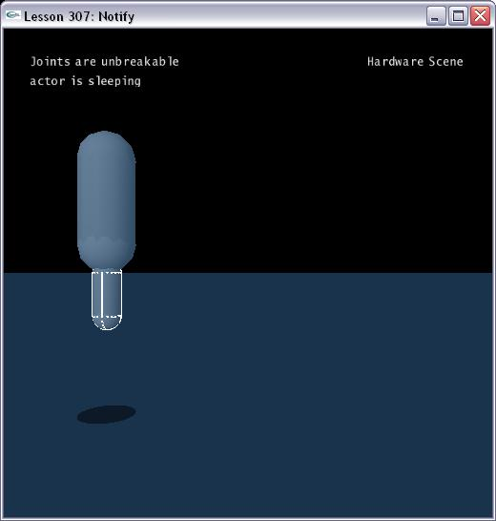

Introduction
The NxUserNotify allows you to receive onWake(), onSleep() and onJointBreak() events from any joints.

User Notify
In Lesson307.cpp, we define a class called MyJointNotify.

class MyJointNotify : public NxUserNotify
{
public:
virtual void onWake(NxActor** actors, NxU32 count)
{
hud.SetDisplayString(3, "actor is awake", 0.05f, 0.88f);
}
virtual void onSleep(NxActor** actors, NxU32 count)
{
hud.SetDisplayString(3, "actor is sleeping", 0.05f, 0.88f);
}

virtual bool onJointBreak(NxReal breakingImpulse, NxJoint& brokenJoint)
{
hud.SetDisplayString(2, "Joint broken!", 0.05f, 0.92f);
return true;
}
}

There are three virtual callback functions. The function onWake() will be called the actors which have just been woken up. The function onSleep() will be called the actors which have just been put to sleep. The function onJointBreak() will be called when a breakable joint breaks.

This class gets instantiated in Lesson307.cpp. Then pass it into the NxScene.

MyJointNotify gJointNotify;
......
void InitNx()
{
……
gScene->setUserNotify(&gJointNotify);
……
}

Set Breakable
You can set the breakable property after create a joint.

void SpecialKeys(unsigned char key, int x, int y)
{
……
NxReal maxForce = 100.0f;
NxReal maxTorque = 50.0f;
if (0 != pD6Joint)
pD6Joint->setBreakable(maxForce, maxTorque);
……
}

Conclusion
The User Notify is handy when you want to receive some information from joint.

Related Classes, Functions, and Parameters
NxUserNotify
onWake()
onSleep()
onJointBreak()

NxJoint
setBreakable()

