Lesson 308 – Output Stream

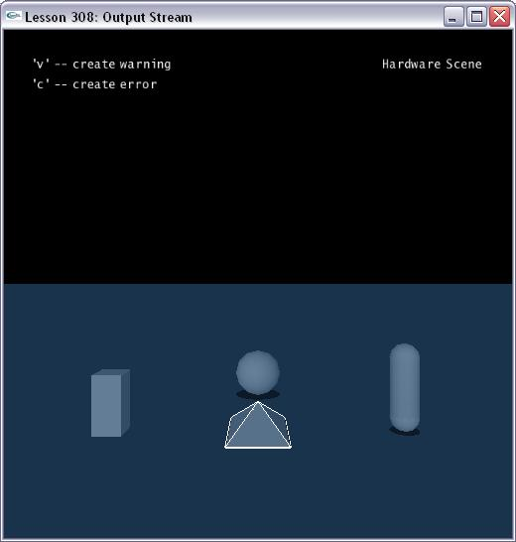

Introduction
The Output Stream allows you to use a custom defined stream class for error logging.

Output Stream
In errorstream.h, we define a class called ErrorStream.

class ErrorStream : public NxUserOutputStream
{
public:
void reportError(NxErrorCode e, const char* message, const char* file, int line)
{
printf("%s (%d) :", file, line);
……
printf(" : %s\n", message);
}

NxAssertResponse reportAssertViolation(const char* message, const char* file, int line)
{
printf("access violation : %s (%s line %d)\n", message, file, line);
……
}

void print(const char* message)
{
printf(message);
}
};

There are three virtual callback functions. The function reportError() will be called to report an error code. The function reportAssertViolation() will be called to report an assertion violation. The function print() will be called to simply prints some debug text.

This class gets instantiated and pass it while create PhysX SDK.

ErrorStream gErrorStream;
......
void InitNx()
{
……
gPhysicsSDK = NxCreatePhysicsSDK(NX_PHYSICS_SDK_VERSION, gAllocator, & gErrorStream);
……
}

Others
Note: No method from the SDK should be called from within the error reporting functions.
Threading: Errors are only reported in the context of the user thread, so it is not necessary to provide a thread safe error reporting callback.

Conclusion
The Physics SDK provides the possibility to supply a user defined stream class for error logging.

Related Classes, Functions, and Parameters
NxUserOutputStream
reportError()
reportAssertViolation()
print()

NxCreatePhysicsSDK()

