Lesson 309 – Scheduler

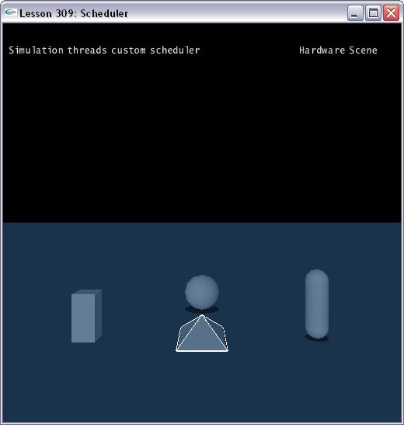

Introduction
The custom scheduler allows you to complete control of the way work items are executed.

Scheduler
In CustomScheduler.h, we define a class called CustomScheduler.

class CustomScheduler : public NxUserScheduler
{
public:
CustomScheduler();
~CustomScheduler();

void CreateThreads(const int count);
void KillThreads();

virtual void addTask(NxTask *task);
virtual void addBackgroundTask(NxTask *task);
virtual void waitTasksComplete();

private:
bool executeTask();
DWORD threadFunc();
static DWORD __stdcall threadFuncStatic(LPVOID userParam);

private:
CRITICAL_SECTION taskQueueCS;
std::deque<NxTask *> taskQueue;

int threadCount;
HANDLE *threadHandles;
HANDLE quitEvent;
HANDLE pendingEvent;

volatile long workingCount;
};

There are three virtual callback functions. The SDK calls addTask() method to add a task to the applications work queue, calls addBackgroundTask() method to add a background task to the applications work queue. And the SDK thread calls waitTasksComplete() function to suspend.

This class gets instantiated in Lesson309.cpp. Then pass it into the NxSceneDesc.

static CustomScheduler gCustomScheduler;
......
void InitNx()
{
……
// Create threads
gCustomScheduler.CreateThreads(2);

// Create the scene
NxSceneDesc sceneDesc;
sceneDesc.gravity = gDefaultGravity;
sceneDesc.simType = NX_SIMULATION_HW;
sceneDesc.flags |= NX_SF_ENABLE_MULTITHREAD;
sceneDesc.customScheduler = &gCustomScheduler;
gScene = gPhysicsSDK->createScene(sceneDesc);
……
}

Others
To enable custom scheduler, the user must specify the NX_SF_ENABLE_MULTITHREAD flag when creating the scene.

When specifying a user scheduler, the internalThreadCount and backgroundThreadCount members of NxSceneDesc should be set to zero and the pollForWork()/resetPollForWork() functions of NxScene should not be called.

Conclusion
The custom scheduler allows you to complete control of the way work items are executed.

Related Classes, Functions, and Parameters
NxUserScheduler
addTask()
addBackgroundTask()
waitTasksComplete()

NxSceneDesc
flags
customScheduler
internalThreadCount
backgroundThreadCount

NxSceneFlags
NX_SF_ENABLE_MULTITHREAD

