Lesson 401 – Rope

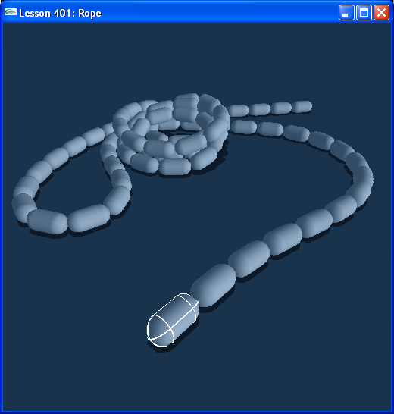

Introduction
From the first two chapters, you have learned all about rigid bodies and joints, the fundamentals of the SDK. You will now use what you have learned to create large scale physics effects.

In this lesson, we will create a rope out of rigid bodies connected together by spherical joints. The rope we create is an interactive effect and can be used to make rope, chains, firehoses, etc.

In these lessons we concentrate on “effects physics”: physics for the sake of visible effect. We will be creating highly interactive objects using lots of rigid bodies and joints: cloth, ragdolls, interlocking gears, gears driving a belt, a tank, and blades of grass. Most of these are taken straight from PhysX Rocket, and you can see how the PSCL scripts translate fairly easily to C++ code.

Rope
We call a function CreateRope() in InitNx().

// Actor globals
NxActor* groundPlane = NULL;
NxActor** ropeSegs = NULL;

// Joint globals
NxSphericalJoint** ropeLinks = NULL;

// Focus actor
NxActor* gSelectedActor = NULL;
…
void CreateRope(const NxVec3& pos, const NxReal segHeight, const NxReal segRadius, const int nbSegments, const NxReal density)
{
int i;

ropeSegs = new NxActor*[NbSegments];
ropeLinks = new NxSphericalJoint*[NbSegments-1];

for (i = 0; i < nbSegments; i++)
{
ropeSegs[i] = CreateCapsule(pos + NxVec3(0,i*(2*segRadius+segHeight),0), segHeight, segRadius, density);
}

for (i = 0; i < nbSegments - 1; i++)
{
ropeLinks[i] = CreateRopeSphericalJoint(ropeSegs[i], ropeSegs[i+1], pos + NxVec3(0,(i+1)*(2*segRadius+segHeight),0), NxVec3(0,1,0));
}
}

void InitNx()
{
..
// Create the objects in the scene
groundPlane = CreateGroundPlane();

CreateRope(NxVec3(0,0,0), 2, 0.5, 10, 10);
// CreateRope(NxVec3(0,0,0), 1, 0.5, 80, 10);
// CreateRope(NxVec3(0,0,0), 0.6, 0.4, 160, 10);

gSelectedActor = ropeSegs[0];
…
}

CreateRope() takes the ropeSegs capsule-shape actors and links them together with the ropeLinks spherical joints. Run the lesson and try pulling the rope around with “umijkl”. Take a look at CreateSphericalJoint() in Joints.cpp.

NxSphericalJoint* CreateRopeSphericalJoint(NxActor* a0, NxActor* a1, const NxVec3& globalAnchor, const NxVec3& globalAxis)
{
NxSphericalJointDesc sphericalDesc;
sphericalDesc.actor[0] = a0;
sphericalDesc.actor[1] = a1;
sphericalDesc.setGlobalAnchor(globalAnchor);
sphericalDesc.setGlobalAxis(globalAxis);

sphericalDesc.flags |= NX_SJF_TWIST_LIMIT_ENABLED;
sphericalDesc.twistLimit.low.value = -(NxReal)0.1*NxPi;
sphericalDesc.twistLimit.high.value = (NxReal)0.1*NxPi;

sphericalDesc.flags |= NX_SJF_TWIST_SPRING_ENABLED;
NxSpringDesc ts;
ts.spring = 500;
ts.damper = 0.5;
ts.targetValue = 0;
sphericalDesc.twistSpring = ts;

sphericalDesc.flags |= NX_SJF_SWING_LIMIT_ENABLED;
sphericalDesc.swingLimit.value = (NxReal)0.3*NxPi;

sphericalDesc.flags |= NX_SJF_SWING_SPRING_ENABLED;
NxSpringDesc ss;
ss.spring = 500;
ss.damper = 0.5;
ss.targetValue = 0;
sphericalDesc.swingSpring = ss;

return (NxSphericalJoint*)gScene->createJoint(sphericalDesc);
}

Hit “b” to go into Debug Mode. Notice we have given the joints fairly generous swing limits (-0.3*NxPi to 0.3*NxPi) with tighter twist limits (-0.1*NxPi to 0.1*NxPi). The segments can bend fairly easily with respect to each other, but twisting one will soon cause the others next to it to twist as well.

The swing and twist of the joints have springs on them so the rope tends to want to straighten out. Enough gravity and friction keeps it twisted.

Upping the Resolution
The rope is at a resolution where it looks like a bunch of sausage links. Comment out the first CreateRope() and uncomment the second.

CreateRope(NxVec3(0,0,0), 1, 0.5, 80, 10);

Note how this already looks a lot more like real rope. Comment out the second line and uncomment the third.

CreateRope(NxVec3(0,0,0), 0.6, 0.4, 160, 10);

With 160 segments, the rope now looks and feels much better than the first two. In creating your effects physics, you will need to play around with the resolution of your physics actors to achieve the results you want at the desired speed.

Conclusion
You have created your first large-scale physics effect. Congratulations once again! We will be creating several of these interactive effects in the coming lessons.

