Lesson 405 - Grass

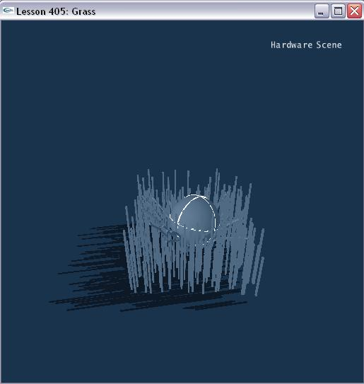

Introduction
This is a lesson on how to create grass. Much like rope, a blade of grass is a line of rigid bodies linked together by spherical joints. Making the joint with a limit and a spring helps define an object that tries to restore its original position.

Grass
We have a class Blade that we make our blades of grass from.

class Blade
{
public:
Blade(const NxVec3& pos, const NxReal height, const NxU32 numJoints)
{
NxReal partHeight = height / (NxReal)numJoints;
NxReal radius = 0.1;
NxVec3 globalAnchor;

bladeSegs = new NxActor*[numJoints];
bladeLinks = new NxSphericalJoint*[numJoints];

NxU32 i;
for (i = 0; i < numJoints; i++)
{
bladeSegs[i] = CreateBlade(pos+NxVec3(0, partHeight/2+radius+ (partHeight+radius*2)*I , 0), NxVec3(radius/2,(partHeight+2*radius)/2,radius/2), numJoints-i+1);
bladeSegs[i]->setLinearDamping(10);
SetActorGroup(bladeSegs[i],1);
}

// Anchor blade to ground
globalAnchor = bladeSegs[0]->getCMassGlobalPosition() - NxVec3(0, partHeight/2, 0);
bladeLinks[0] = CreateBladeLink(bladeSegs[0],NULL,globalAnchor, NxVec3(0,1,0));

for (i = 1; i < numJoints; i++)
{
globalAnchor = bladeSegs[i]->getCMassGlobalPosition() - NxVec3(0,partHeight/2,0);
bladeLinks[i] = CreateBladeLink(bladeSegs[i], bladeSegs[i-1], globalAnchor, NxVec3(0,1,0));
}
}

NxActor** bladeSegs;
NxSphericalJoint** bladeLinks;
};

The segments of the blade are box shapes and the links are spherical joints created in CreateBladeLink() in Joints.cpp.

NxSphericalJoint* CreateBladeLink(NxActor* a0, NxActor* a1, const NxVec3& globalAnchor, const NxVec3& globalAxis)
{
NxSphericalJointDesc sphericalDesc;
sphericalDesc.actor[0] = a0;
sphericalDesc.actor[1] = a1;
sphericalDesc.setGlobalAnchor(globalAnchor);
sphericalDesc.setGlobalAxis(globalAxis);

sphericalDesc.flags |= NX_SJF_SWING_LIMIT_ENABLED;
sphericalDesc.swingLimit.value = (NxReal)0.05*NxPi;
sphericalDesc.swingLimit.restitution = 0.75;
sphericalDesc.swingLimit.hardness = 0.5;

sphericalDesc.flags |= NX_SJF_SWING_SPRING_ENABLED;
sphericalDesc.swingSpring.spring = 0.75;
sphericalDesc.swingSpring.damper = 1;

sphericalDesc.flags |= NX_SJF_TWIST_LIMIT_ENABLED;
sphericalDesc.twistLimit.low.value = -(NxReal)0.05*NxPi;
sphericalDesc.twistLimit.low.restitution = 0.75;
sphericalDesc.twistLimit.low.hardness = 0.5;
sphericalDesc.twistLimit.high.value = (NxReal)0.05*NxPi;
sphericalDesc.twistLimit.high.restitution = 0.75;
sphericalDesc.twistLimit.high.hardness = 0.5;

sphericalDesc.flags |= NX_SJF_TWIST_SPRING_ENABLED;
sphericalDesc.twistSpring.spring = 0.75;
sphericalDesc.twistSpring.damper = 1;

return (NxSphericalJoint*)gScene->createJoint(sphericalDesc);
}

Each blade is attached to the ground by the same link.

Conclusion
This ends the lessons built from the PSCL scripts used in Rocket. Grass, trees, and other sorts of bendy vegetation can be built using the SDK.

