Lesson 408 – Fragmenting Objects

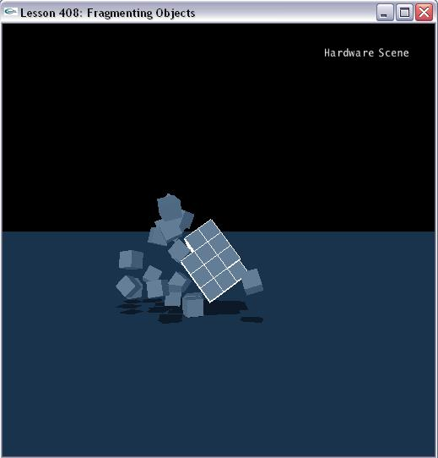

Introduction
In many games, you want to create destructible objects that break apart or explode into component and/or prefractured pieces. In this lesson we show how to construct an actor from pieces, the actor's shapes conforming to the pieces, then disengage the shapes from the main actor and building them into their own autonomous actors.

Creating the Cube of Cubes
We create a cube out of many smaller cubes, and then break off cubes one at a time to fragment the larger object.

In InitNx(), we call CreateMainObject().

This function loops through the cubes that will form the large, final cube. The number of cubes is specified by the cube of the global iNumBoxesOnSide, at the top of Lesson313.cpp.

The line:

boxDesc[ iCurrentIndex ].localPose.t.set( NxVec3( ((i-1) * fCubeSide * 2.0f), ((j-1) * fCubeSide * 2.0f), ((k-1) * fCubeSide * 2.0f)));

sets the local pose of each sub-cube so that they fit together to make a large cube of cubes. Each of these shapes is then pushed onto the array of shapes in actorDesc.

Breaking off a Cube
When you hit “g”, ReleaseRandomShape() is called. First, we check the number of shapes in our actor with:

NxU32 uiNumShapes = mainBox->getNbShapes();

and get the array of pointers to those shapes with:

NxShape** ppShapeArray = mainBox->getShapes();

You don't want to remove a shape if there is only one left, as that will leave you with a shape-less actor. We now record the global pose of the shape we are removing, so we can use it as the starting position of the new shape. You release a shape with:

mainBox->releaseShape( *pShapeToRelease );

where mainBox is your actor pointer, and pShapeToRelease is a pointer to a valid shape (in that actor) that you want to release. Here, we choose the first shape in the array ppShapeArray, but you might want to base it on other information (such as a contact point with a pointer to a shape). Now that the shape is released, it is important to call:

mainBox->updateMassFromShapes(fBoxDensity, 0.0f );

in order to recalculate the mass and inertial tensor for the object. You can either pass this function a density with the mass 0.0f, or the density 0.0f with a total mass. Rather than calculate the new mass ourselves, we just send the density (which is the same for every cube in our compound).

Finally, we create a new, simple box with the same dimensions and global pose as the shape we just released. You might consider giving it the same linear and angular velocity of the larger object, or a separating velocity, but in this demo it starts with zero velocity.

Maintaining “Hidden” Kinematic Piece Actors to Avoid Recalculating the Broad Phase
You will get a performance hit the more actors you add to the scene collision geometry on any given frame. This is because you are inserting new elements to be considered for collision, and the broad phase of collision detection has to sort these elements into arrays of potentially colliding objects.

You can see the potential hazard for this in this lesson and the next. In this lesson, we see the potential for spawn multiple piece actors in place of one large actor constructed from the pieces. In the next lesson, where we create a particle system, we see the potential for adding a great deal of objects into the scene simultaneously from a point source.

Maintaining “hidden” kinematic actors with contact generation enabled but collision response turned off is one way to avoid a massive recalculation of the broad phase when introducing new objects into a scene. You will eventual “unhide” these actors as you make them collidable and dynamic. For this example, you can spawn all of the piece actors up front, make them kinematic, then enable contact generation and disable collision response on them. You will need to set their positions and orientations each frame to shadow the movement of the shapes of the actor they will eventually replace when those shapes are removed.

The kinematic actors that form the piece actors have contact generation enabled, so they will be updated properly in the broad phase potentially collidable objects list as the simulation progresses. Because of this, introducing them into the scene by making them dynamic and turning on collision response will have no impact on the broad phase.

Conclusion
This is a method to simulate fragmentation. It costs very little while the object is not fragmented, but during the process of fragmenting there will be overhead in the form of creating a new actor and recalculating the old compound actor.

