Lesson 503 – Core Dump

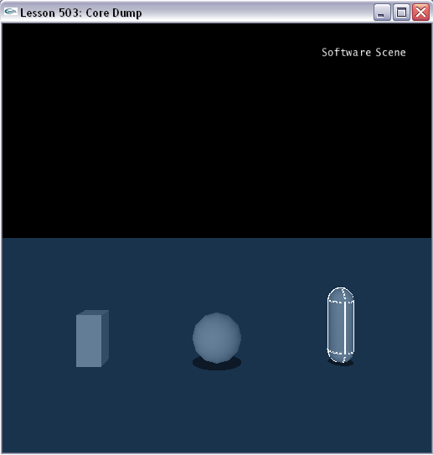

Introduction
In the third chapter on Tools, we describe how to do a core dump. The core dump is a means to save the state of a simulation to a file and load in the simulation state from a file. We realize the core dump function using the NxuStream which is provided in source codes under Tools\NxuStream2.

Core Dump
Look at ProcessInputs() in Lesson503.cpp.

bool bCoreDump = false;
bool bLoadCore = false;
bool bInstantiateCore = false;
...
void ProcessInputs()
{
...
// Core dump
if (bCoreDump)
{
bool ok = NXU::coreDump(gPhysicsSDK, fnameCD, NXU::FT_XML, true, false);
if(ok) {
printf("Output core dump successfully!\n");
} else {
printf("Output core dump failed!\n");
}
bCoreDump = false;
}

// Load core to core container
if (bLoadCore)
{
if(gPhysicsCollection) {
NXU::releaseCollection(gPhysicsCollection);
gPhysicsCollection = NULL;
}
gPhysicsCollection = LoadCoreDump(fnameCD);
if(!gPhysicsCollection) {
printf("Unable to load the core dump, please first save a core dump.\n");
}
bLoadCore = false;
}

if(bInstantiateCore) {
if(gPhysicsCollection) {
if(gPhysicsSDK) {
NxReleasePhysicsSDK(gPhysicsSDK);
gPhysicsSDK = CreatePhysics();
}
if(InstantiateCoreDump(gPhysicsSDK, gPhysicsCollection)) {
if(gPhysicsSDK->getNbScenes()) {
gScene = gPhysicsSDK->getScene(0);
AddUserDataToActors(gScene);
NxActor** actors = gScene->getActors();
gSelectedActor = *actors;
while(!IsSelectable(gSelectedActor))
{
gSelectedActor = *actors++;
}
}
}
}
bInstantiateCore = false;
}
...
}
...
void SpecialKeys(unsigned char key, int x, int y)
{
switch (key)
{
case 'c': { printf("Coredumping...\n"); bCoreDump = true; break; }
case 'v': { printf("Loading Core Dump to Container...\n"); bLoadCore = true; break; }
case 'n': { printf("Instantiating Core...\n"); bInstantiateCore = true; break; }
}
}

We have three options here:

- Save out a core dump file.
- Load a core dump file to a core container object.
- Instantiate a scene from a loaded core container object.

We discuss each option in detail.

Saving a Core Dump
Hit “c” to save out a core dump file. Hitting “c” sets the bCoreDump flag which calls NXU::coreDump().

We pass in four parameters. The first parameter is the physics sdk. The second is the name of the file we will be writing the core dump to, “MyCoreDump.xml”. The third flags whether or not the core dump file is binary. In this case the file is text (.xml) and not binary (.CDB). The fourth flags whether or not we will be saving away cooked mesh data. In this case, we won't be saving the cooked data.

Look over the CoreDump::coreDump() function to see how the scene data is saved.

After hitting “c”, take a look at the “MyCoreDump.xml” file in the “Core_Dump” directory of the training programs. You'll see all the objects in the simulation listed there along with their saved positions and velocities.

Loading a Core Dump to a Core Container
Hit “v” to load a core dump file to a core container. Hitting “v” sets the bLoadCore flag which calls LoadCoreDump() which is based on NXU::loadCollection().

NXU::NxuPhysicsCollection* LoadCoreDump(const char * strFileName, NXU::NXU_FileType fileType = NXU::FT_XML)
{
return NXU::loadCollection(strFileName, fileType);
}

Hitting “v” will load “MyCoreDump.xml” file from the “Core_Dump” directory of the training programs to the CoreContainer object.

Instantiating a Core Dump
Hit “n” to instantiate the core dump loaded to the core containter. Hitting “n” sets the bInstantiateCore flag which calls InstantiateCoreDump () which is based on NXU::instantiateCollection().

bool InstantiateCoreDump(NxPhysicsSDK* pSDK, NXU::NxuPhysicsCollection* c)
{
bool success = false;
NXU_userNotify notify;
success = NXU::instantiateCollection( c, *pSDK, NULL, NULL, &notify );
//NXU::releaseCollection(c);
return success;
}

Hitting “n” will now instantiate the CoreContainer object. We loaded this with the “MyCoreDump.xml” file from the “Core_Dump” directory. So the program will erase the current scene and reproduce the scene as it existed when you hit “v” to save the core dump file.

Conclusion
The core dump is a means to save away and load back a snapshot of the simulation.

