Lesson601_Forcefield_Creation
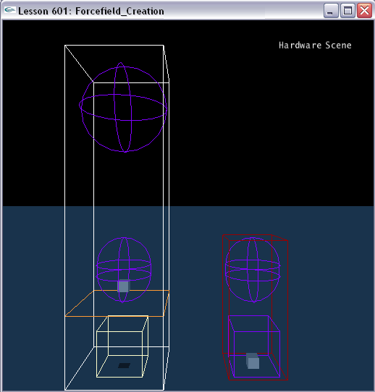

Introduction
Forcefields are SDK objects akin to actors, which affect cloth, soft bodies, fluid and rigid bodies that enter their area of influence. Force fields allow you to implement for example gusts of wind, dust devils, vacuum cleaners or anti-gravity zones.

Several factors should be concerned about in creating a Forcefield:
- Forcefield shapes, which determine the volume of space in which the force field is active.
- Forcefield kernels, which define how to computes a force and torque on a particle (or volume element or rigid body) with a particular position and linear velocity.
- Force field Coordinate Systems. You can use different kinds of coordinate systems to help creating various effects.
- Forcefield scaling. The force values obtained from the kernel are then scaled. Each kind of object (fluid, cloth, soft body, rigid body) has its own scaling properties

This lesson focuses on Forcefield shapes and ShapeGroups, and teaches you how to create a simple forcefield with several Forcefield shapes.

Forcefield shapes and shape group
As with actor shapes, force field shapes come in different types; for force fields, the available shapes are:
- Sphere
- Capsule
- Box
- Convex mesh
Unlike actors, you can specify some of the shape groups as exclude groups using the flag NX_FFSG_EXCLUDE_GROUP. Thus, the actual volume used is the union of all include shapes' volumes, minus the union of all exclude shapes' volumes. This provides a flexible means of shaping the force field just like you want it, with dead zones, irregular edges and the like.
A shape group is simply a collection of force field shapes. The rationale for shape groups is that a given force field (say, one that causes particles to swirl around an actor) may be instanced multiple times, once for each of a collection of actors - but each field is likely to have the same set of exclude shapes. To free the application from having to add this collection to each field it creates, a group of exclude shapes may be created which may then be attached to several fields.
The pose of the shapes in a force field group is relative to the world frame. The group flag (NX_FFSG_EXCLUDE_GROUP) defines whether all shapes inside this group are exclude volumes or include volumes. There is one special include group per force field which cannot be shared among other force fields and which is moving with the force field. The pose of the shapes in this include group is relative to the force field pose and the shapes are include volumes only.

Creating a simple Forcefield

The following code segment shows you how to create a simple Forcefield. There are 2 shape groups in this forcefield. The left shape group contains 1 box shape, 1 capsule shape, and 1 sphere shape. The right contains 1 box shape and 1 capsule shape, and its flag is set to NX_FFSG_EXCLUDE_GROUP. Therefore, no force is applied on the right box.

NxForceField* CreateForcefield()
{
// Create a Forcefield kernel
NxForceFieldLinearKernelDesc linearKernelDesc;
linearKernelDesc.constant = NxVec3(0.0f,19.6f,0.0f);
NxForceFieldLinearKernel* pLinearKernel;
pLinearKernel = gScene->createForceFieldLinearKernel(linearKernelDesc);

// The Forcefield descriptor
NxForceFieldDesc fieldDesc;
fieldDesc.kernel = pLinearKernel;
fieldDesc.rigidBodyType = NX_FF_TYPE_GRAVITATIONAL;

// A box forcefield shape descriptor
NxBoxForceFieldShapeDesc box;
box.dimensions.set(2, 2, 2);
box.pose.t.set(6, 2, 0);

// Create a Forcefield
// There is one special include group per force field which cannot be shared among other force fields and which is moving with the force field.
// The pose of the shapes in this include group is relative to the force field pose and the shapes are include volumes only.
// The special include group contains a box shape
fieldDesc.includeGroupShapes.push_back(&box);
NxForceField *pForceField;
pForceField = gScene->createForceField(fieldDesc);

// A capsule forcefield shape descriptor
NxCapsuleForceFieldShapeDesc capsule;
capsule.height = 1;
capsule.radius = 2.5f;
capsule.pose.t.set(6, 9, 0);

// A sphere forcefield shape descriptor
NxSphereForceFieldShapeDesc sphere;
sphere.radius = 4;
sphere.pose.t.set(6, 24, 0);

// Add two shapes to the first shape group
NxForceFieldShapeGroupDesc sgDesc1;
sgDesc1.shapes.pushBack(&capsule);
sgDesc1.shapes.pushBack(&sphere);
NxForceFieldShapeGroup* pIncludeGroup;
pIncludeGroup = gScene->createForceFieldShapeGroup(sgDesc1);

box.pose.t.set(-6, 2, 0);
capsule.pose.t.set(-6, 9, 0);

// Add two shapes to the second shape group
// The group flag (NX_FFSG_EXCLUDE_GROUP) defines that all shapes inside this group are exclude volumes.
NxForceFieldShapeGroupDesc sgDesc2;
sgDesc2.flags = NX_FFSG_EXCLUDE_GROUP;
sgDesc2.shapes.pushBack(&box);
sgDesc2.shapes.pushBack(&capsule);
NxForceFieldShapeGroup* pExcludeGroup;
pExcludeGroup = gScene->createForceFieldShapeGroup(sgDesc2);

// Add these two shape groups to the forcefield
pForceField->addShapeGroup(*pIncludeGroup);
pForceField->addShapeGroup(*pExcludeGroup);

return pForceField;
}

Conclusion
You have created your first Forcefield. Congratulations! Now, Please watch the boxes in the Forcefield. The left box moves up and down, since it is subjected to the gravity and the force from the Forcefield. The right box is keeping static, and it is because it is located in the Forcefield shapes whose flags are set to NX_FFSG_EXCLUDE_GROUP.

Related Classes, Functions, and Parameters
NxForceFieldDesc
NxMat34 pose
NxActor * actor
NxForceFieldCoordinates coordinates
NxArray< NxForceFieldShapeDesc * > includeGroupShapes
NxArray< NxForceFieldShapeGroup * > shapeGroups
NxCollisionGroup group
NxGroupsMask groupsMask
NxForceFieldKernel * kernel
NxForceFieldVariety forceFieldVariety
NxForceFieldType fluidType
NxForceFieldType clothType
NxForceFieldType softBodyType
NxForceFieldType rigidBodyType
NxU32 flags
const char * name
void * userData

NxForceFieldShapeDesc
NxMat34 pose
void * userData
const char * name

NxBoxForceFieldShapeDesc

NxCapsuleForceFieldShapeDesc

NxConvexForceFieldShapeDesc

NxSphereForceFieldShapeDesc

NxForceFieldShapeGroupDesc
NxU32 flags
NxArray< NxForceFieldShapeDesc * > shapes
const char * name
void * userData

NxForceFieldShapeGroupFlags
NX_FFSG_EXCLUDE_GROUP

