Lesson602_Forcefield_Coordinate
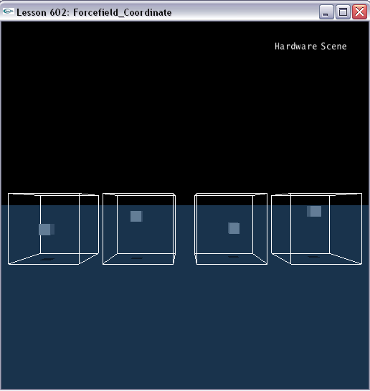

Forcefield coordinate systems
The force field does support different kinds of coordinate systems to help creating various effects with the linear kernel and to simplify custom kernel code. The force field class transforms the position and velocity of intersecting objects (rigid body, fluid, cloth, softbody) into the selected coordinate system and the force field's local frame. Those two variables are then passed to the force field kernel function as input parameters.
The variables are provided in the local, "tangential" coordinate system of the force field at the position of the object. For the coordinate type NX_FFC_CARTESIAN this is equivalent to the force field's own frame; for the other types the local axes shift depending on position:
- NX_FFC_SPHERICAL: The X axis is directed outwards from the center of the sphere; the Y and Z axes are the tangents of the spherical surface.
- NX_FFC_CYLINDRICAL: The X axis is directed outwards from the cylinder axis. The Y axis is the cylinder axis, and the Z axis is the cylindrical surface tangent (directed to make XYZ a right-handed system).
- NX_FFC_TOROIDAL: The X axis is directed outwards from the closest point on the torus' equator; the Y axis is the tangent of the equator at its closest point (directed in the clockwise direction as seen from the direction of the torus' axis), and the Z axis is normal to both forming a right-handed system XYZ.

Creating Forcefields with different coordinate systems

The following code segment shows you how to use coordinate systems. There are 4 forcefields in the scene with CARTESIAN, SPHERICAL, CYLINDRICAL and TOROIDAL, respectively.

void CreateForcefield()
{
// Create a Forcefield kernel
NxForceFieldLinearKernelDesc linearKernelDesc;
linearKernelDesc.constant = NxVec3(1.0f,-1.0f,-1.0f);
NxForceFieldLinearKernel* pLinearKernel;
pLinearKernel = gScene->createForceFieldLinearKernel(linearKernelDesc);

// A box forcefield shape descriptor
NxBoxForceFieldShapeDesc box;
box.dimensions.set(3, 3, 3);

// Create the 1st forcefield using NX_FFC_CARTESIAN Coordinate
// The force field class transforms the position and velocity of intersecting objects into the selected coordinate system and the force field's local frame.
NxForceFieldDesc fieldDesc1;
fieldDesc1.kernel = pLinearKernel;
fieldDesc1.coordinates = NX_FFC_CARTESIAN;
box.pose.t.set(12, 3, 0);
fieldDesc1.includeGroupShapes.push_back(&box);
gScene->createForceField(fieldDesc1);

// Create the 2nd forcefield using NX_FFC_SPHERICAL Coordinate
// NX_FFC_SPHERICAL: The X axis is directed outwards from the center of the sphere; the Y and Z axes are the tangents of the spherical surface. The y and z components of the p and v vectors in the function are always 0, and target position/velocity in these directions is ignored.
NxForceFieldDesc fieldDesc2;
fieldDesc2.kernel = pLinearKernel;
fieldDesc2.coordinates = NX_FFC_SPHERICAL;
box.pose.t.set(4, 3, 0);
fieldDesc2.includeGroupShapes.push_back(&box);
gScene->createForceField(fieldDesc2);

// Create the 3rd forcefield using NX_FFC_CYLINDRICAL Coordinate
// NX_FFC_CYLINDRICAL: The X axis is directed outwards from the cylinder axis. The Y axis is the cylinder axis, and the Z axis is the cylindrical surface tangent (directed to make XYZ a right-handed system). The z component of the p vector in the function is always 0, and the target position in this direction is ignored.
NxForceFieldDesc fieldDesc3;
fieldDesc3.kernel = pLinearKernel;
fieldDesc3.coordinates = NX_FFC_CYLINDRICAL;
box.pose.t.set(-4, 3, 0);
fieldDesc3.includeGroupShapes.push_back(&box);
gScene->createForceField(fieldDesc3);

// Create the 4th forcefield using NX_FFC_TOROIDAL Coordinate
// NX_FFC_TOROIDAL: The X axis is directed outwards from the closest point on the torus' equator; the Y axis is the tangent of the equator at its closest point (directed in the clockwise direction as seen from the direction of the torus' axis), and the Z axis is normal to both forming a right-handed system XYZ. See the figure below. The y and z components of the p vector in the function are always 0 and the target position in these directions is ignored. Note that this coordinate system is only available for linear kernels!
NxForceFieldDesc fieldDesc4;
fieldDesc4.kernel = pLinearKernel;
fieldDesc4.coordinates = NX_FFC_TOROIDAL;
box.pose.t.set(-12, 3, 0);
fieldDesc4.includeGroupShapes.push_back(&box);
gScene->createForceField(fieldDesc4);
}

Conclusion
You have finished this lesson. Great works! Now, please run the program, and you can find the different behaviors among 4 boxes in Forcefields with different coordinate systems.

Related Classes, Functions, and Parameters
NxForceFieldDesc
NxMat34 pose
NxActor * actor
NxForceFieldCoordinates coordinates
NxArray< NxForceFieldShapeDesc * > includeGroupShapes
NxArray< NxForceFieldShapeGroup * > shapeGroups
NxCollisionGroup group
NxGroupsMask groupsMask
NxForceFieldKernel * kernel
NxForceFieldVariety forceFieldVariety
NxForceFieldType fluidType
NxForceFieldType clothType
NxForceFieldType softBodyType
NxForceFieldType rigidBodyType
NxU32 flags
const char * name
void * userData

NxForceFieldCoordinates
NX_FFC_CARTESIAN
NX_FFC_SPHERICAL
NX_FFC_CYLINDRICAL
NX_FFC_TOROIDAL

NxForceFieldShapeDesc

NxBoxForceFieldShapeDesc

NxCapsuleForceFieldShapeDesc

NxConvexForceFieldShapeDesc

NxSphereForceFieldShapeDesc

NxForceFieldShapeGroupDesc

