Lesson603_Forcefield_Kernels
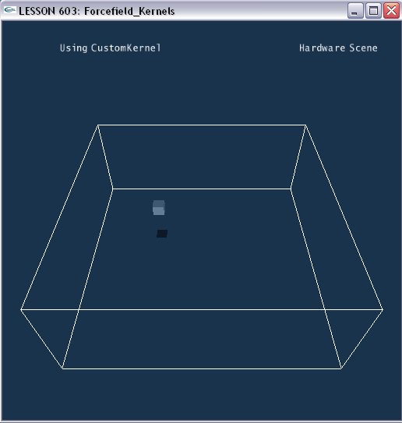

Forcefield kernels
The kernel is the function which computes a force and torque on a particle (or volume element or rigid body) with a particular position and linear velocity. The particle has to be inside the force field's activity volume defined by the shape groups. The force fields operate either with a linear kernel or a custom kernel.
The linear kernel is calculated through the following formula:
f_{i} = [K + M_{p}(P-p) + M_{v}(V-v) + N a_{noise}]_{i} / [1 + l_{i}|P_{i}-p_{i}| + q_{i}(P_{i}-p_{i})²]

- f is the resulting force (or acceleration, see below) on the particle
- K is the constant part, from NxForceFieldLinearKernelDesc.constant
- p is the position of the object, in the force field coordinate system
- M_{p} is the position dependence matrix, from NxForceFieldLinearKernelDesc.positionMultiplier
- P is the position target, from NxForceFieldLinearKernelDesc.positionTarget
- v is the velocity of the object, in the force field coordinate system
- M_{v} is the velocity dependence matrix, from NxForceFieldLinearKernelDesc.velocityMultiplier
- V is the velocity target, from NxForceFieldLinearKernelDesc.velocityTarget
- a_{noise} is the noise multiplier, from NxForceFieldLinearKernelDesc.noise
- N is a 3x3 matrix whose diagonal elements are three random numbers in the range [0, 1]
- l is the linear falloff term, from NxForceFieldLinearKernelDesc.falloffLinear
- q is the quadratic falloff term, from NxForceFieldLinearKernelDesc.falloffQuadratic
In words, the SDK calculates the difference between actual and target position/velocity, and uses the matrices M_{p} and M_{v} to calculate the response to these differences.
The falloff terms are used to attenuate the magnitude of the force with the distance to the target position.
The SDK arrow user to defined a custom kernel for convenient usage. A header file named "NxForceFieldKernelDefs.h" has to be included when using custom kernel. For more details, please refer to PhysX Documentation.

Using Forcefield kernels

- The following code segment shows you how to create a linear kernel.
NxForceFieldLinearKernel* CreateFFLinearKernel()
{
// Create a Linear kernel
NxMat33 m;
m.id();

NxForceFieldLinearKernelDesc lKernelDesc;
lKernelDesc.positionMultiplier = m;
lKernelDesc.positionTarget = NxVec3(0, 3.5, 0);

gLinearKernel = gScene->createForceFieldLinearKernel(lKernelDesc);
return gLinearKernel;
}

- The following code segment shows you how to create a custom kernel.
//define a custom forcefield---in Lesson603.h
#include "NxForceFieldKernelDefs.h"
NX_START_FORCEFIELD(Custom)
NxVConst(InitForce);
NX_START_FUNCTION
// If an object's velocity is zero, give it the initial force
force = InitForce;
NxVec3 v = Velocity;
NxFinishIf(v == NxVec3(0,0,0));

// While the object is moving, give it the force that is relative to its position
NxVec3 p = Position;
force = NxVec3(0,3.5,0) - p;
NX_END_FUNCTION
NX_END_FORCEFIELD(Custom)

NxForceFieldKernelCustom* CreateFFCustomKernel()//---in Lesson603.cpp
{
// Create a Custom Kernel
gCustomKernel = new NxForceFieldKernelCustom;
gCustomKernel->setInitForce(NxVec3(0, 0, 500));
return gCustomKernel;
}

Conclusion
Good! You have learned how to create a linear kernel and a custom kernel. In this program, you can switch between linear kernel and custom kernel by pressing “c” key.

Related Classes, Functions, and Parameters
NxForceFieldDesc
NxMat34 pose
NxActor * actor
NxForceFieldCoordinates coordinates
NxArray< NxForceFieldShapeDesc * > includeGroupShapes
NxArray< NxForceFieldShapeGroup * > shapeGroups
NxCollisionGroup group
NxGroupsMask groupsMask
NxForceFieldKernel * kernel
NxForceFieldVariety forceFieldVariety
NxForceFieldType fluidType
NxForceFieldType clothType
NxForceFieldType softBodyType
NxForceFieldType rigidBodyType
NxU32 flags
const char * name
void * userData

NxForceFieldLinearKernelDesc
NxVec3 constant
NxMat33 positionMultiplier
NxVec3 positionTarget
NxMat33 velocityMultiplier
NxVec3 velocityTarget
NxReal torusRadius
NxVec3 falloffLinear
NxVec3 falloffQuadratic
NxVec3 noise
const char * name
void * userData

NxForceFieldKernel

NxForceFieldShapeDesc

NxBoxForceFieldShapeDesc

NxForceFieldShapeGroupDesc

