Lesson604_Forcefield_Scaling
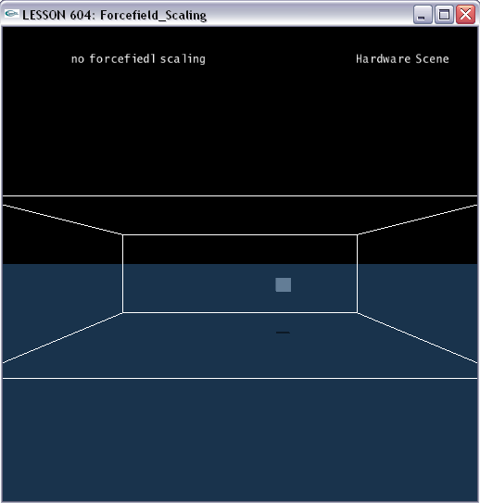

Forcefield scaling
The force value obtained from the kernel are then scaled. Each kind of object (fluid, cloth, soft body, rigid body) has its own scaling properties. Conceptually scaling depends on two orthogonal criteria: resolution independence (a property of the simulation) and charge value (a property of the way the field acts upon the object). Hence there are two scaling properties:
- Field Type: An integer defining the field type per feature:
  - NX_FF_TYPE_GRAVITATIONAL: Scales the force by the mass of the particle or body.
  - NX_FF_TYPE_OTHER: Does not scale the value from the force field.
  - NX_FF_TYPE_NO_INTERACTION: Does disable force field interaction with a specific feature.

- Volumetric Scaling: A flag which indicates whether the force is scaled by the amount of volume represented by the object if NX_FF_TYPE_OTHER is selected. This is true by default for all features. This allows fields to act on cloth, fluids and soft bodies to be independent of the discretization.
  - NX_FFF_VOLUMETRIC_SCALING_FLUID: Flag to enable volumetric scaling for fluids.
  - NX_FFF_VOLUMETRIC_SCALING_CLOTH: Flag to enable volumetric scaling for cloths.
  - NX_FFF_VOLUMETRIC_SCALING_SOFTBODY: Flag to enable volumetric scaling for softbodies.
  - NX_FFF_VOLUMETRIC_SCALING_RIGIDBODY: Flag to enable volumetric scaling for rigid bodies.

- Scaling Table: In addition there is a scaling table where the force field's variety and the feature's force field material index are used to index the table.

Using scaling Table

- The following code segment shows you how to use scaling table.

// Forcefield, ForceField Material, and ForceField Variety
NxForceField* gForceField;
NxForceFieldVariety gVar1;
NxForceFieldMaterial gMat1;
NxForceFieldVariety gVar2;

// Scaling table initiating
void InitScalingTable()
{
// create a new ForceField Variety index
gVar1 = gScene->createForceFieldVariety();
gVar2 = gScene->createForceFieldVariety();

// create a new ForceField Material index (index 0 is already created)
gMat1 = gScene->createForceFieldMaterial();

// change the scaling for the created pair
gScene->setForceFieldScale(gVar1, 0, 0.1f);
gScene->setForceFieldScale(gVar1, gMat1, 2.0f);
gScene->setForceFieldScale(gVar2, 0, 8.0f);
gScene->setForceFieldScale(gVar2, gMat1, 40.0f);
}

//press ‘c’ key to call this function to switch scaling
void ChangeScaling()
{
// Reset the box
NxMat33 m;
m.id();
box1->setGlobalOrientation(m);
box1->setGlobalPosition(NxVec3(4,3.5,0));
box1->setLinearVelocity(NxVec3(0,0,0));
box1->setAngularVelocity(NxVec3(0,0,0));

switch(gCounter%4)
{
case 0:
// change the variety of a force field
gForceField->setForceFieldVariety(gVar1);
// change the material of an object (box)
box1->setForceFieldMaterial(0);
hud.SetDisplayString(2, "forcefiedl scaling is 0.1\n", 0.14f, 0.92f);
break;
case 1:
// change the variety of a force field
gForceField->setForceFieldVariety(gVar1);
// change the material of an object (box)
box1->setForceFieldMaterial(gMat1);
hud.SetDisplayString(2, "forcefiedl scaling is 2.0\n", 0.14f, 0.92f);
break;
case 2:
// change the variety of a force field
gForceField->setForceFieldVariety(gVar2);
// change the material of an object (box)
box1->setForceFieldMaterial(0);
hud.SetDisplayString(2, "forcefiedl scaling is 8.0\n", 0.14f, 0.92f);
break;
case 3:
// change the variety of a force field
gForceField->setForceFieldVariety(gVar2);
// change the material of an object (box)
box1->setForceFieldMaterial(gMat1);
hud.SetDisplayString(2, "forcefiedl scaling is 40.0\n", 0.14f, 0.92f);
break;
}

gCounter++;
}

Conclusion
Congratulations! You have finished the last lesson. In this program, you can switch among different scaling levels by pressing “c” key.

Related Classes, Functions, and Parameters
NxForceFieldDesc
NxMat34 pose
NxActor * actor
NxForceFieldCoordinates coordinates
NxArray< NxForceFieldShapeDesc * > includeGroupShapes
NxArray< NxForceFieldShapeGroup * > shapeGroups
NxCollisionGroup group
NxGroupsMask groupsMask
NxForceFieldKernel * kernel
NxForceFieldVariety forceFieldVariety
NxForceFieldType fluidType
NxForceFieldType clothType
NxForceFieldType softBodyType
NxForceFieldType rigidBodyType
NxU32 flags
const char * name
void * userData

NxForceFieldLinearKernelDesc

NxForceFieldShapeDesc

NxBoxForceFieldShapeDesc

NxForceFieldShapeGroupDesc

NxActorDesc

NxCloth

NxFluid

NxScene

NxSoftBody

