Lesson 801 – Hardware Scene Manager

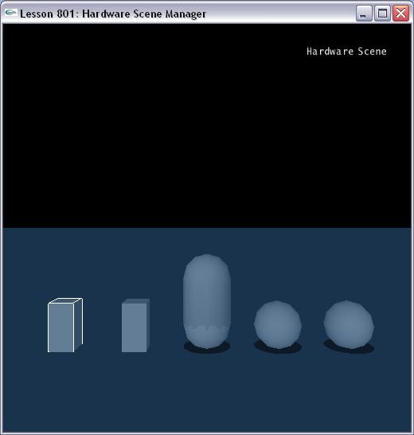

Introduction
In this lesson, we will set up a simple application to run on the hardware. If your code is set up to run completely asynchronously, the transition only requires setting a single scene flag.

Running on Hardware
You first need to make sure the hardware drivers and firmware are installed. The firmware is the microcode that runs on the card and the driver talks to the card to upload and reset the firmware. Go to the NVIDIA official website and walk through the instructions provided.

The Simulation Type
Take a look at InitNx().

void InitNx()
{
// Create a memory allocator
gAllocator = new UserAllocator;

// Create the physics SDK
gPhysicsSDK = NxCreatePhysicsSDK(NX_PHYSICS_SDK_VERSION, gAllocator, &gErrorStream);
if (0 == gPhysicsSDK) return;

// Check for hardware availability
NxHWVersion hwCheck = gPhysicsSDK->getHWVersion();
if (hwCheck == NX_HW_VERSION_NONE)
{
printf("Unable to find any AGEIA PhysX hardware, this sample requires hardware physics to run. Please make sure that you have correctly installed the latest version of the AGEIA PhysX SDK.\n");
gPhysicsSDK->release();
gPhysicsSDK = 0;
exit(1);
}

// Set the physics parameters
gPhysicsSDK->setParameter(NX_SKIN_WIDTH, 0.05);

// Set the debug visualization parameters
gPhysicsSDK->setParameter(NX_VISUALIZATION_SCALE, 1);
gPhysicsSDK->setParameter(NX_VISUALIZE_COLLISION_SHAPES, 1);
gPhysicsSDK->setParameter(NX_VISUALIZE_ACTOR_AXES, 1);
gPhysicsSDK->setParameter(NX_VISUALIZE_COLLISION_FNORMALS, 1);

CreateScenario();
}

bool CreateScenario()
{
DestroyScenario();

// Create the scene
NxSceneDesc sceneDesc;
sceneDesc.gravity = gDefaultGravity;
sceneDesc.simType = bHWScene? NX_SIMULATION_HW : NX_SIMULATION_SW;
gScene = gPhysicsSDK->createScene(sceneDesc);
if(0 == gScene)
{
bHWScene = !bHWScene;
sceneDesc.simType = bHWScene? NX_SIMULATION_HW : NX_SIMULATION_SW;
gScene = gPhysicsSDK->createScene(sceneDesc);
if(0 == gScene) return false;
}

……..

// Create compartment(HSM, managed hardware scene) attached to this scene
NxCompartmentDesc desc;
desc.type = NX_SCT_RIGIDBODY;
desc.deviceCode = NxU32(NX_DC_PPU_0);
gCompartmentHW = gScene->createCompartment(desc);

desc.deviceCode = NxU32(NX_DC_CPU);
gCompartmentSW = gScene->createCompartment(desc);

// Create objects
boxHW = CreateManagedBox(NxVec3(6, 0, 0), NxVec3(0.5, 1, 0.5), 20, gCompartmentHW);
boxSW = CreateManagedBox(NxVec3(3, 0, 0), NxVec3(0.5, 1, 0.5), 20, gCompartmentSW);
sphereHW = CreateManagedSphere(NxVec3(-6,0,0), 1, 10, gCompartmentHW);
sphereHW = CreateManagedSphere(NxVec3(-3,0,0), 1, 10, gCompartmentSW);
capsule = CreateManagedCapsule(NxVec3(0,0,0), 2, 1, 5, 0);

gSelectedActor = boxHW;

// Initialize HUD
InitializeHUD();

// Start the first frame of the simulation
StartPhysics();
return true;
}
We create two rigid body compartments in the scene. One compartment type is NX_DC_PPU_0.

desc.deviceCode = NxU32(NX_DC_PPU_0);

Another type is NX_DC_CPU.
desc.deviceCode = NxU32(NX_DC_CPU);

Run the simulation and watch your demo run on the hardware.

Conclusion
Congratulations! You can now using the hardware to simulate your scene.

Related Classes, Functions, and Parameters
NxCompartmentDesc
type
deviceCode

NxCompartmentType
NX_SCT_RIGIDBODY
NX_SCT_FLUID
NX_SCT_CLOTH

NxDeviceCode
NX_DC_CPU
NX_DC_PPU_0
NX_DC_PPU_AUTO_ASSIGN

