Lesson 802 – Multiple Scenes

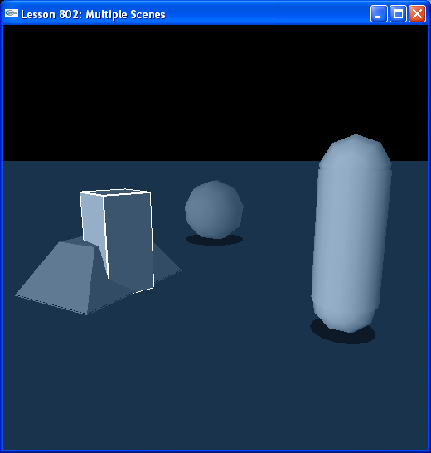

Introduction
You can run multiple scenes simultaneously, both on hardware and software. In this lesson, we demonstrate two software scenes running simultaneously.

Multiple Scenes
We create two scenes in InitNx().

// Physics SDK globals
NxPhysicsSDK* gPhysicsSDK = NULL;
NxScene* gScenes[2] = { NULL, NULL };
NxVec3 gDefaultGravity(0,-9.8,0);
...
// Actor globals
NxActor* groundPlanes[2] = { NULL, NULL };
NxActor* box = NULL;
NxActor* sphere = NULL;
NxActor* capsule = NULL;
NxActor* pyramid = NULL;

// Focus actor
NxActor* gSelectedActor = NULL;
NxScene* gSelectedScene = NULL;
...
void InitNx()
{
// Create a memory allocator
gAllocator = new UserAllocator;

// Create the physics SDK
gPhysicsSDK = NxCreatePhysicsSDK(NX_PHYSICS_SDK_VERSION, gAllocator);

if (!gPhysicsSDK) return;

// Set the physics parameters
gPhysicsSDK->setParameter(NX_SKIN_WIDTH, 0.01);

// Set the debug visualization parameters
gPhysicsSDK->setParameter(NX_VISUALIZATION_SCALE, 1);
gPhysicsSDK->setParameter(NX_VISUALIZE_COLLISION_SHAPES, 1);
gPhysicsSDK->setParameter(NX_VISUALIZE_ACTOR_AXES, 1);
gPhysicsSDK->setParameter(NX_VISUALIZE_COLLISION_FNORMALS, 1);

// Create two scenes
for (NxU32 i = 0; i < 2; i++)
{
NxSceneDesc sceneDesc;
sceneDesc.gravity = gDefaultGravity;
sceneDesc.broadPhase = NX_BROADPHASE_COHERENT;
sceneDesc.collisionDetection = true;

gScenes[i] = gPhysicsSDK->createScene(sceneDesc);

// Create the default material
NxMaterial* defaultMaterial = gScenes[i]->getMaterialFromIndex(0);
defaultMaterial->setRestitution(0.5);
defaultMaterial->setStaticFriction(0.5);
defaultMaterial->setDynamicFriction(0.5);
}

// Create the objects in the two scenes
groundPlanes[0] = CreateGroundPlane(0);
groundPlanes[1] = CreateGroundPlane(1);

box = CreateBox(0, NxVec3(5,0,0), NxVec3(0.5,1,0.5), 20);
sphere = CreateSphere(0, NxVec3(0,0,5), 1, 10);
capsule = CreateCapsule(1, NxVec3(-5,0,0), 2, 0.5, 10);
pyramid = CreatePyramid(1, NxVec3(0,0,0), NxVec3(1,0.5,1.5), 10);

AddUserDataToActors(gScenes[0]);
AddUserDataToActors(gScenes[1]);

gSelectedActor = box;

// Update the time step
UpdateTime();
NxReal deltaTime = UpdateTime();

// Run collision and dynamics for delta time since the last frame for both scenes
for (NxU32 i = 0; i < 2; i++)
{
if (gScenes[i])
{
gScenes[i]->simulate(deltaTime);
gScenes[i]->flushStream();
}
}

// Default gScene to gScenes[0]
gSelectedScene = gScenes[0];
}

We have two scenes, gScenes[0] and gScenes[1].

NxScene* gScenes[2] = { NULL, NULL };

We need to initialize and update each separately. We create a ground plane for each scene.

// Create the objects in the two scenes
groundPlanes[0] = CreateGroundPlane(0);
groundPlanes[1] = CreateGroundPlane(1);

The actor creation functions in the lesson take an index to specify which scene the actor is being created for.

NxActor* CreateGroundPlane(int sceneIndex)
{
// Create a plane with default descriptor
NxPlaneShapeDesc planeDesc;
NxActorDesc actorDesc;
actorDesc.shapes.pushBack(&planeDesc);
return gScenes[sceneIndex]->createActor(actorDesc);
}

We add a box and a sphere to gScene[0] and a capsule and a pyramid to gScene[1].

box = CreateBox(0, NxVec3(5,0,0), NxVec3(0.5,1,0.5), 20);
sphere = CreateSphere(0, NxVec3(0,0,5), 1, 10);
capsule = CreateCapsule(1, NxVec3(-5,0,0), 2, 0.5, 10);
pyramid = CreatePyramid(1, NxVec3(0,0,0), NxVec3(1,0.5,1.5), 10);

We kick off the simulation of both scenes.

// Run collision and dynamics for delta time since the last frame for both scenes
for (NxU32 i = 0; i < 2; i++)
{
if (gScenes[i])
{
gScenes[i]->simulate(deltaTime);
gScenes[i]->flushStream();
}
}

The initial scene objects will be selected from by the user is gScenes[0].

// Default gSelectedScene to gScenes[0]
gSelectedScene = gScenes[0];

Run the demo. You will be able to select between the box and the sphere at first to move around. These objects are in gScenes[0]. You will be able to move these objects through the objects in gScenes[1], the pyramid and the capsule. The two scenes run completely independently of each other. The box and sphere rest on groundPlanes[0] while the pyramid and the sphere rest on groundPlanes[1].

Hit “g” to switch scenes you are selecting actors from.

// Focus actor
NxActor* gSelectedActor = NULL;
NxScene* gSelectedScene = NULL;
...
void KeyboardUpCallback(unsigned char key, int x, int y)
{
gKeys[key] = false;

switch (key)
{
...
case 'g': {
if (gSelectedScene == gScenes[0])
{
gSelectedActor = pyramid;
gSelectedScene = gScenes[1];
}
else
{
gSelectedActor = box;
gSelectedScene = gScenes[0];
}
break;
}
...
}
}

Hitting “g” switches the focus actor and the focus scene.

Maintaining Two Scenes
You will see throughout the code that we need to account for the fact that we have two scenes instead of one.

Take RenderActors() for instance:

void RenderActors(bool shadows)
{
for (NxU32 i = 0; i < 2; i++)
{
if (gScenes[i])
{
// Render all the actors in the scene
NxU32 nbActors = gScenes[i]->getNbActors();
NxActor** actors = gScenes[i]->getActors();
while (nbActors--)
{
NxActor* actor = *actors++;
DrawActor(actor);

// Handle shadows
if (shadows)
{
DrawActorShadow(actor);
}
}
}
}
}

Here, we need to cycle through each scene and the list of actors in each scene. In other areas of the code where we previously referenced a single scene, we now loop through multiple scenes. You will need to do this for as many scenes as you create.

Conclusion
You have now learned how to build multiple scenes and simulate each of them.

Related Classes, Functions, and Parameters

