Lesson 903 – Fluids and Rigid Bodies
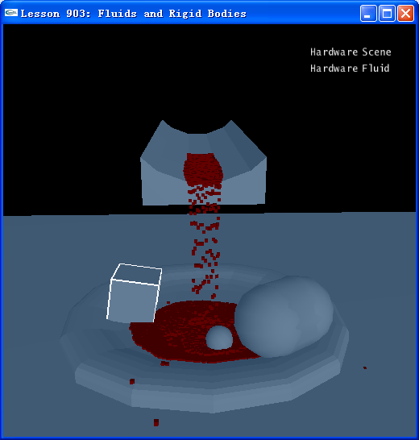

Introduction
In this lesson, we will load a flume ramp object (“..\TrainingPrograms\Programs\Data\ase\coolFlow.ase”), the fluid will fall onto the ramp and flow down to a bowl object (“..\TrainingPrograms\Programs\Data\ase\fluidSample.ase”).

Fluids and Rigid Bodies
Most interaction between fluids and the world will involve fluids colliding with static mesh geometry. A character blasted by a shotgun will spew blood onto the walls and floor of a game level. A health fountain will bubble over and fill up a solid bowl placed in the level. Gasoline will spill from barrels that have been shot or tipped over and flow over floors and around level objects before being set ablaze. Molten steel will cascade from cast-iron pots into pools of lava.

This geometry needs to be loaded and cooked to prepare it for collision with the fluid. Take a look at InitNx().

void InitNx()
{
…
bowl = CookASE("fluidSample.ase", gScene, NxVec3(1,0,0));
flume = CookASE("coolFlow.ase", gScene, NxVec3(1,-4,-0), NxVec3(1,0.2,1));

box = CreateBox(NxVec3(2,5-0.75,7), NxVec3(0.75,0.75,0.75), 1);
sphere = CreateSphere(NxVec3(0,4-0.4,1), 0.4, 1);
capsule = CreateCapsule(NxVec3(3,0-(1+0.5),8), 1, 1, 1);

CreateBox(NxVec3(0,-10-1,0), NxVec3(40,1,40), 0);

fluid = CreateFluid(NxVec3(0,1.5,0), 19, 0.1, gScene);

…
}

We call CookASE() on the two files, “fluidSample.ase” and “coolFlow.ase”.

bowl = CookASE("fluidSample.ase", gScene, NxVec3(1,0,0));
flume = CookASE("coolFlow.ase", gScene, NxVec3(1,-4,-0), NxVec3(1,0.2,1));

CookASE() is defined in CookASE.cpp.

Then we call CreateFluid() before kicking off the simulation.

void InitNx()
{
...
fluid = CreateFluid(NxVec3(0,2,0), 15, 0.1, gScene);

…
}

CreateFluid() is much as it was in Lesson901.cpp. It attaches a particle buffer to the fluid descriptor. The fluid will write out the positions of its particles to this buffer each frame of the simulation. CreateFluid() then builds a ball of fluid with NxScene::createFluid().

NxFluid* CreateFluid(const NxVec3& pos, NxU32 sideNum, NxReal distance, NxScene* scene)
{
// Create a set of particles
gParticleBufferNum = 0;
float rad = sideNum*distance*0.5;
for (unsigned i=0; i<sideNum; i++)
{
for (unsigned j=0; j<sideNum; j++)
{
for (unsigned k=0; k<sideNum; k++)
{
NxVec3 p = NxVec3(i*distance,j*distance,k*distance);
if (p.distance(NxVec3(rad,rad,rad)) < rad)
{
p += pos;
gParticleBuffer[gParticleBufferNum++] = p;
}
}
}
}

// Set structure to pass particles, and receive them after every simulation step
NxParticleData particles;
particles.numParticlesPtr = &gParticleBufferNum;
particles.bufferPos = &gParticleBuffer[0].x;
particles.bufferPosByteStride = sizeof(NxVec3);

// Create a fluid descriptor
NxFluidDesc fluidDesc;
fluidDesc.kernelRadiusMultiplier = KERNEL_RADIUS_MULTIPLIER;
fluidDesc.restParticlesPerMeter = REST_PARTICLES_PER_METER;
fluidDesc.motionLimitMultiplier = MOTION_LIMIT_MULTIPLIER;
fluidDesc.packetSizeMultiplier = PACKET_SIZE_MULTIPLIER;
fluidDesc.stiffness = 40; // 50
fluidDesc.viscosity = 22;
fluidDesc.restDensity = 1000;
fluidDesc.damping = 0;
fluidDesc.simulationMethod = NX_F_SPH; //NX_F_NO_PARTICLE_INTERACTION;

fluidDesc.initialParticleData = particles;
fluidDesc.particlesWriteData = particles;

if(!bHardwareFluid)
fluidDesc.flags &= ~NX_FF_HARDWARE;

fluid = gScene->createFluid(fluidDesc);
if(!fluid)
{
fluidDesc.flags &= ~NX_FF_HARDWARE;
bHardwareFluid = false;
}
fluid = gScene->createFluid(fluidDesc);
assert(fluid != NULL);
return fluid;
}

The mesh cooking is done for the user by the SDK and is completely opaque to the user. Recognize, however, that while all this is done for you “under the hood”, you still need to be careful adding geometry in the proximity of your fluid. The more you added, the more that needs to get cooked and will be tracked by the hardware. If too much is added, this can slow down your simulation considerable.

Our fluid is now ready to be simulated and rendered, and fluid will collide with triangle mesh actors, you can also create some dynamic actors by pressing “b”.

Conclusion
We have loaded two static mesh assets saved as ASE files, placed them in the scene, and cooked them so our fluid spills over and onto them.

Related Classes, Functions, and Parameters
NxCookTriangleMesh(…)

NxFluidDesc
staticCollisionRestitution
or
restitutionForStaticShapes
staticCollisionAdhesion
or
dynamicFrictionForStaticShapes

