Lesson 904 – Fluid and Drain
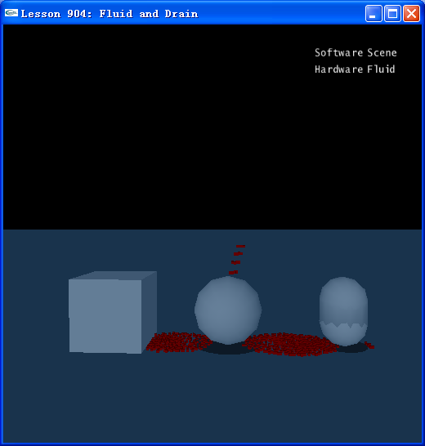

Introduction
Drains are an important method in keeping the particle count and spread under control. Place drains around the area in which a fluid is used to stop the fluid particles from spreading too far and negatively impacting performance.
In this lesson, we will learn how to create drains.

Fluid and Drain
It is easy to create drains for fluids, just need to add a flag to the actor’s shape.
// Create the drains in the scene
box = CreateBox(NxVec3(5,0,0), NxVec3(1.5,1.5,1.5), 1);
box->getShapes()[0]->setFlag(NX_SF_FLUID_DRAIN,true);
sphere = CreateSphere(NxVec3(0,0.0,0), 1.5, 1);
sphere->getShapes()[0]->setFlag(NX_SF_FLUID_DRAIN,true);
capsule = CreateCapsule(NxVec3(-5,0,0), 1, 1, 1);
capsule->getShapes()[0]->setFlag(NX_SF_FLUID_DRAIN,true);

Below is a list of currently supported static and dynamic drain shapes:
Box - NxBoxShape
Sphere - NxSphereShape
Capsule - NxCapsuleShape
Convex - NxConvexShape (Only dynamic shapes)
Plane - NxPlaneShape

Conclusion
Now you have created some drains successfully, the particles will be “killed” if the fluid touches the drain.

Related Classes, Functions, and Parameters
enum NxShapeFlag
NX_SF_FLUID_DRAIN

