Lesson 905 – Fluid Events
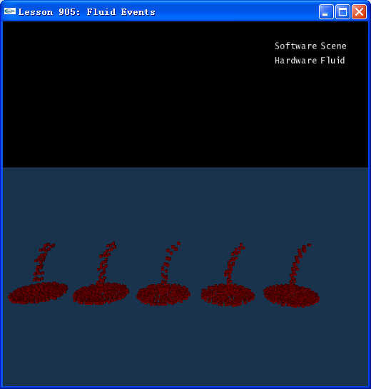

Introduction
We add two events for the user for making it easier to use the Fluid functionality. The events are raised when an emitter is empty and when a fluid is empty. The event callback class is called NxFluidUserNotify and controlled through the following interface:
void NxScene::setFluidUserNotify(NxFluidUserNotify* callback)
NxFluidUserNotify* NxScene::getFluidUserNotify() const
NxFluidUserNotify* NxSceneDesc::fluidUserNotify
The callback interface is described in the API documentation, but currently consists of the following two functions:
//The user needs to return whether he wants to delete the emitter, in the callback.
bool NxFluidUserNotify::onEmitterEvent(NxFluidEmitter& emitter, NxFluidEmitterEventType eventType)

//The user needs to return whether he wants to delete the fluid, in the callback.
bool NxFluidUserNotify::onEvent(NxFluid& fluid, NxFluidEventType eventType)

Fluid Events
At first, we define a class MyFluidUserNotify inherited from NxFluidUserNotify:

class MyFluidUserNotify : public NxFluidUserNotify
{
public:
virtual bool onEmitterEvent(NxFluidEmitter& emitter, NxFluidEmitterEventType eventType);
virtual bool onEvent(NxFluid& fluid, NxFluidEventType eventType);

virtual ~MyFluidUserNotify() {}
};

Then we implement two functions onEvent(…) and onEmitterEvent(…), in this lesson, we just print some information when the events happens.

bool MyFluidUserNotify::onEvent(NxFluid& fluid, NxFluidEventType eventType)
{
int a = (int)&fluid;
if(eventType ==NX_FET_NO_PARTICLES_LEFT)
{
for(int i =0;i< FLUID_NUMBER;i++)
{
if(a == gFluidArray[i])
printf("Fluid %d is empty now\n",i);
}
}
return false;
}

bool MyFluidUserNotify::onEmitterEvent(NxFluidEmitter& emitter, NxFluidEmitterEventType eventType)
{
int a = (int)&emitter;
if(eventType ==NX_FEET_EMITTER_EMPTY)
{
for(int i =0;i< FLUID_NUMBER;i++)
{
if(a == gEmitterArray[i])
printf("Emitter %d is empty now\n",i);
}
}
return false;
}

Finally, to receive the events, we just need to do the following things after the scene is created.

gUserNotify = new MyFluidUserNotify();
gScene->setFluidUserNotify(gUserNotify);

Conclusion
Now you have learned how to receive fluid events and fluid emitter events with the class of NxFluidUserNotify.

Related Classes, Functions, and Parameters
NxFluidUserNotify
NxScene::setFluidUserNotify
NxScene::getFluidUserNotify()
NxSceneDesc::fluidUserNotify

