Lesson 906 – Fluid UserData
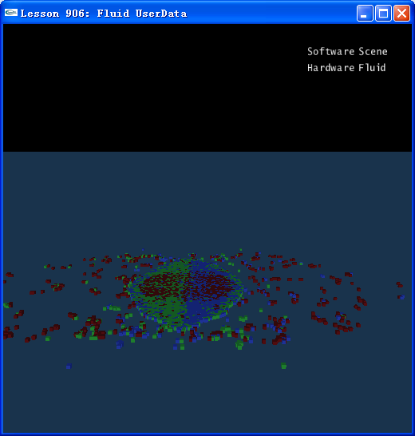

Introduction
Sometimes we need to readback the fluid particles’ information for rendering or other using, it is necessary to specify a buffer to write the appropriate particle information into when creating the fluid. This is done using the NxFluidDesc::particlesWriteData. After each simulation step, the SDK writes updated positions, etc., to these buffers.
When creating a fluid, you can specify the following buffers in particlesWriteData:
bufferPos - position of each individual particle.
bufferVel - velocity of each particle.
bufferLife - lifetime of each particle.
bufferDensity - density for each particle.
bufferId - SDK-generated unique particle ID.
bufferFlag - NxParticleFlag values for each particle.

For example, the lifetime is useful for fading out particles as they reach the end of their life. The velocity is useful for motion blur/elongated particles (e.g., when rendering sparks, etc.).

Besides the buffers in particlesWriteData, the members particleDeletionIdWriteData and particleCreationIdWriteData can be used to respond to the deletion or creation of particles by the SDK, graphically or gameplay-wise. Together with IDs, these provide the means to easily tracking individual particles over their lifetime.

In this lesson, we create three piles of fluids, and then we render them with three different colors by using fluid UserData.

Fluid UserData
At first we create the first part of fluids:

// initialize the particles' data buffer
CreateParticleSphere(gNewParticleData, gNewParticlesMax, false, fluidPos, fluidVel, gLifetime, gDistance, gSideNum);
…
NxFluid* fluid = gScene->createFluid(fluidDesc);

After fluid creation, we set color for this part of fluid

//Set color for first scoop --> red
//The NxScene::createFluid() function adds the NxFluidDesc::initialParticleData to the SDK.
//It also writes to the MyFluid::mCreatedParticleIds buffer, which was passed to the SDK
//(NxFluidDesc::particleCreationIdWriteData).
for (unsigned i=0; i< gCreatedIdsBufferNum; i++)
{
unsigned id = gCreatedIdsBuffer[i];
gParticlesColorBuffer[id].color = NxVec3(0.8f, 0.1f,0.1f);
}

Then we create the other two parts of fluids, this is done by using the function of NxFluid::addParticles(…)

//Create another two scoops. This time with NxFluid::addParticles().
//The NxFluid::addParticles() function adds new particles to the SDK.
//It also writes to the MyFluid::mCreatedParticleIds buffer, which was passed to the SDK
//(NxFluidDesc::particleCreationIdWriteData).
fluidPos.set(-2,2,0);
fluidVel.set(5,0,0);
CreateParticleSphere(gNewParticleData, gNewParticlesMax, false, fluidPos, fluidVel, gLifetime, gDistance, gSideNum);
fluid->addParticles(gNewParticleData);

//Set scoop color --> blue.
for (unsigned i=0; i<gCreatedIdsBufferNum; i++)
{
unsigned id = gCreatedIdsBuffer[i];
gParticlesColorBuffer[id].color = NxVec3(0.3f, 0.4f,1.0f);
}

fluidPos.set(2,2,0);
fluidVel.set(-5,0,0);
CreateParticleSphere(gNewParticleData, gNewParticlesMax, false, fluidPos, fluidVel, gLifetime, gDistance, gSideNum);
fluid->addParticles(gNewParticleData);

//Set scoop color --> green.
for (unsigned i=0; i< gCreatedIdsBufferNum; i++)
{
unsigned id = gCreatedIdsBuffer[i];
gParticlesColorBuffer[id].color = NxVec3(0.3f, 1.0f,0.3f);
}

Finally, we render these three piles of fluids with different colors:

void RenderFluid()
{
// Render fluid
glColor4f(1.0f, 0.0f, 0.0f, 1.0f);
for (NxU32 p=0; p<gNewParticlesNum; p++)
{
const ParticleSDK& particle = gNewParticles[p];
const MyParticle& particlesColorBuffer = gParticlesColorBuffer[particle.id];
glColor4f(particlesColorBuffer.color.x, particlesColorBuffer.color.y, particlesColorBuffer.color.z, 1.0f);
glPushMatrix();
glTranslatef(particle.position.x,particle.position.y,particle.position.z);
glutSolidCube(0.1); // glutSolidSphere(0.1,8,5);
glPopMatrix();
}
glColor4f(1.0f, 1.0f, 1.0f, 1.0f);
}

Conclusion
Using fluid UserData, fluids are rendered with different colors.

Related Classes, Functions, and Parameters
NxParticleData
numParticlesPtr
bufferPos
bufferPosByteStride
bufferLife
bufferLifeByteStride
bufferId
bufferIdByteStride

NxParticleIdData
numIdsPtr
bufferId
bufferIdByteStride

NxFluidDesc
initialParticleData
particlesWriteData
particleCreationIdWriteData
particleDeletionIdWriteData

