**A Log Likelihood fit for extracting the $D^{0}$ lifetime**

1. **Abstract**

This report investigates the fraction of background in a dataset of $D^{0}$ meson decay lifetimes. A Negative Log likelihood function for the average decay lifetimes was obtained for the cases of no background and background noise and a comparison was made of the values deduced for the average lifetimes in each case. An average lifetime value of x was obtained when the background was assumed negligible, compared to $\left(0.4097 ± 0.005\right)$ x ${10}^{-12}s$ when the background was considered non-negligible. The fraction of the sample attributable to actual decays was found to be $\left(0.98 ± 0.008\right)$ x ${10}^{-12}s$. A minimum of 247500 data points were found to be needed for an accuracy of ${10}^{-15}s$ on the estimation of the decay lifetime.

1. **Introduction**

Decays witnessed in bubble chambers at SLAC show us that the electromagnetic force can react with a proton to produce a pair of D mesons with a measured decay length**1.** i.e. $γ+p→ D^{+}+ {\overline{D}}^{0}+n$. At production, the aforementioned pair are moving at speeds close to the speed of light. We must therefore account for time dilation in attempting to measure their respective decay times, as shown in equation (1)

${ t}_{o}= γt_{D}$ (1)

Where ${ t}_{o}$, represents the observed decay time, $t_{D}$ the decay time in the rest frame of the meson and $γ$ the gamma factor. We find that the meson decay in a process outlined by figure 1 through the strong interaction.



Figure showing a D meson decaying into a pion and Kaon through the strong force**2.**

(1) tells us that these decays must be of the order of ${10}^{-12}s$, hence would be impossible to measure in a laboratory. The momentum of the decaying meson as well as the vector displacement connecting its production and decay points can be easily measured and combined to give a value of the decay time. This is shown by equation**3** (2).

(2)

Where $x$ is the aformentiond displacement vector, $p$ the momentum of the meson and $m$ the mass of the meson. The decay times of many particles would be expected to follow the exponential distribution shown in equation

(3)

$f\left(t\right)= \frac{1}{τ}\exp\left(\frac{-t}{τ}\right) if t≥0$ (3)

where $τ$ is the average decay lifetime and the value of $f\left(t\right)$ is 0 unless $t≥0$. We can account for the uncertainty of the calculated times by convoluting the result obtained in (3) with a Gaussian of width $σ$. (4) is the resulting distribution

$f\left(t\right)= \frac{1}{2τ}\exp\left(\frac{σ^{2}}{{2τ}^{2}}-\frac{t}{τ}\right)erfc(\frac{1}{\sqrt{2}}(\frac{σ}{τ}-\frac{t}{σ}))$ (4)

where $erfc($) corresponds to the error function. By carrying out an appropriate parameter estimation technique we can deduce the average decay lifetime.

The limited detector resolution will make it difficult to discern between actual decay lifetimes and background in the sample because they are smeared in the same way. The background will have exactly 0 lifetime and hence can be approximated by the delta function at $t=0$. (5) is the distribution taking this background into consideration, where $f_{sig}\left(t\right)$ represents the signal from actual decays , $f_{bkg}(t)$ that which is from the background and $a$ the fraction of the sample which is from actual decays. (6) shows the form of the background signal

$f\left(t\right)=af_{sig}\left(t\right)+(1-a)f_{bkg}(t)$ (5)

$f_{bkg}(t)= \frac{1}{σ\sqrt{2π}}\exp\left(\frac{-t^{2}}{2σ^{2}}\right)$ (6)

Carrying out another parameter estimation technique will give another estimation for the average decay lifetime and an estimation of the fraction of the signal that is due to actual decays.

1. **Theory**

Given a function assumed to be dependent on a set of parameters $\underline{θ}$, we can usually derive an estimation for the set of parameters, $\hat{ \underline{θ} }$, by minimising the chi-squared of the parameters and data points observed as shown in (7).

$χ^{2}\left(\underline{θ};y\right)= \sum{{(\frac{y_{i}-f(x_{i} \underline{θ})}{σ_{i}})}^{2}}$ (7)

where $y_{i}$ are the observed data points, $σ_{i}$ their corresponding errors, $x_{i}$ the variable with which $y_{i}$ depends and $f(x_{i} \underline{θ})$, the fitting function for the data with the sum taken over all data points. We would then perform a minimisation with respect to each parameter $θ_{j}$ giving an estimate for the parameter. We cannot perform this minimisation for the proposed fit functions (5) or (4) because the value of each decay time error, $σ_{i},$ varies with the decay time. Maximising a log-likelihood function with PDF functions (5) or (4) (which must normalise to 1) would provide the best parameter estimation. The form of the likelihood is shown in (8)

$L\left(\underline{θ};\underline{x}\right)= \prod{p(x_{i};\underline{θ})}$ (8)

where the multiplicative sum again is taken over all the data points and $p(x_{i};\underline{θ})$ is the probability density function of a measurement $x_{i}$ given the parameters $\underline{θ}$. By taking the logarithm of (8) we can deduce two different ways to obtain an error on our estimated parameters.

Performing a Taylor expansion to second order near the maximum of the log-likelihood gives (9)

$\ln{L\left(θ\right) }= \ln{L\left(\hat{θ}\right) } + \frac{d^{2}\ln{L }}{dθ^{2}} \frac{{(θ-\hat{θ})}^{2}}{2}$ (9)

where the second derivative is taken at $θ=\hat{θ}$, and will be negative since we are evaluating it at the maximum.

Taking exponentials of both sides of (9) in equation (10), we find that the likelihood dependence on the parameters turns out to be approximately Gaussian for a large number of data points.

$L\left(θ\right)≈ L\left(\hat{θ}\right)exp⁡(- \frac{{(θ-\hat{θ})}^{2}}{2b^{2}})$ (10)

with the magnitude of $\frac{d^{2}\ln{L }}{d{\hat{θ}}^{2}}=\frac{1}{b^{2}}$. The error on the parameter $\hat{θ}$ can therefore be estimated from the second derivative of the log-likelihood function. Errors in non-Gaussian PDFs can be determined by defining $θ=\hat{θ}±b$, where $\hat{θ}$ is the value of the parameter that maximises the log-likelihood and $b$ is the standard deviation.

The value of the log-likelihood at $θ$ can then be found via (11), which simplifies to (12)

$\operatorname{Ln}{L\left(θ\right) }= \ln{L\left(\hat{θ}\right) } - \frac{{\left(\hat{θ} ± b- \hat{θ}\right)}^{2}}{2b^{2}})$ (11)

$\operatorname{Ln}{L\left(θ\right) }= \ln{L\left(\hat{θ}\right) } - \frac{1}{2}$ (12)

The uncertainty in the parameter estimation is therefore the range over which the log-likelihood changes by $- \frac{1}{2}$. The above is analogous to determining the minimum of the negative log-likelihood.

1. **Computational methodology**

A dataset containing 10,000 pairs of decay lifetimes and their corresponding errors was extracted and a histogram plotted to verify that the data resembled an exponential function convoluted with a Gaussian as suggested by the fit function obtained from (4), which was also plotted. The integral of the function was checked to be unity (a PDF must integrate to unity) and independent of the value for the average decay lifetime and error in each decay time. A negative log-likelihood (NLL) function was constructed with (4) as its PDF. The background was initially considered negligible and so the NLL was only a function of the average decay lifetime, $τ$. The NLL was plotted against $τ$ and the position of the minimum gauged visually.

A second order Lagrange polynomial was fitted on three points around the aforementioned minimum, and a parabolic minimisation (Appendix 1) carried out to return another point closer to the minimum. This process was repeated until the change in the returned values of $τ$ was within a tolerance of 10-5. The last value of $τ$ would be the estimate of the average decay lifetime. The NLL was then examined close to the minimum and the values of $τ$ where the NLL was first 0.5 above the value at minimum were noted. The difference between the minimum value of $τ$ and these values was calculated; this would be the first estimate of the uncertainty on the average lifetime. This was then compared to the error obtained from (10). A graph of the parabolic error against number of lifetime readings was obtained and the number of data pairs needed for an accuracy of 10-15s was noted. This was done my assuming the error was $∝\frac{1}{\sqrt{N}}$ and extrapolating a line of best fit until the error was equal to 10-15s. The constant of proportionality was assumed to be 1 at first. A tolerance of 0.3 was used for the parabolic minimiser – this ensured the computation didn’t lag for too long.

A contour plot of the negative log-likelihood function derived from (5) (background non-negligible) was plotted and its minimum gauged visually. The gradient method (Appendix 2) was used to ascertain the minimum from an initial guess. Chosen because it was found to be more efficient than the univariate method. Similar to the previous case, the errors on the estimated values of $τ$ and a were determined by looking at the contour of the NLL at a height of 0.5 above the minimum, the difference between the boundary values and the estimated minimum was the error.

1. **Results and discussion**

The distribution of the dataset matched that of the fit function (4) as shown in figure 2. The integral of the fit function was found (via the trapezium method) to be unity (to 5 significant figures) and independent of the values of $τ$ and $σ$, thereby suitable to be used as a PDF for the NLL.

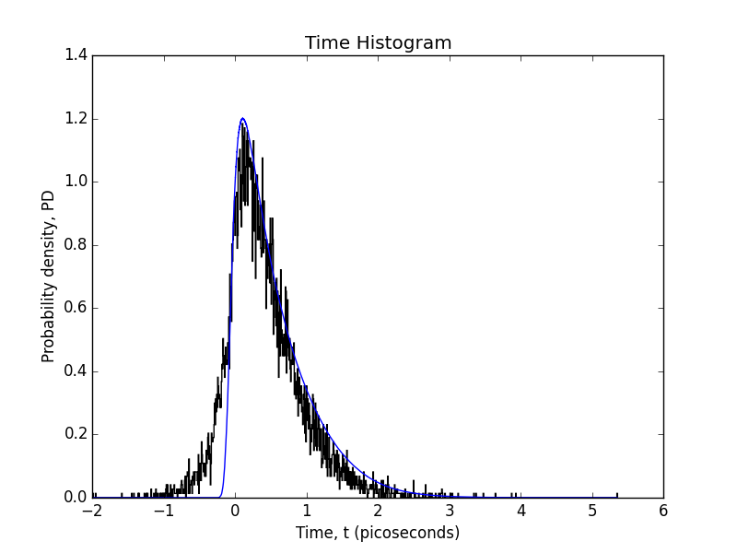

Figure Graph showing the normalised distribution of the dataset(black histogram) and the PDF(blue) derived from equation (4)

The NLL was seen to be minimised between (0.3-0.5)x ${10}^{-12}s$ as shown in figure 3. (0.3,0.4 and 0.5) x ${10}^{-12}s$ where therefore taken as the initial points in the parabolic minimiser which yielded a minimum at 0.4045 x ${10}^{-12}s$.

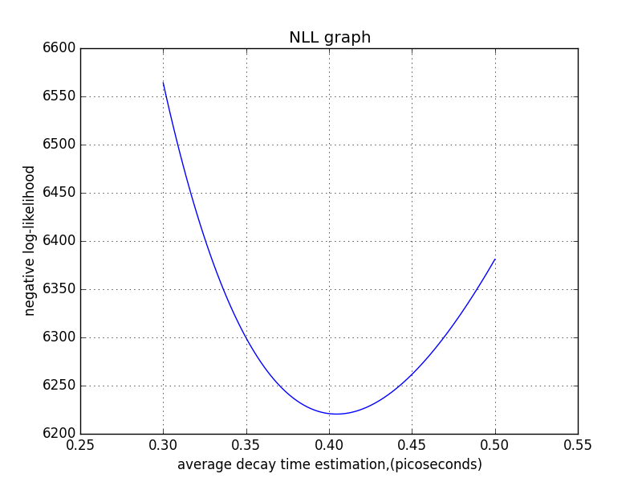

Figure Graph showing the NLL was minimised between 0.3 and 0.5 picoseconds

The curvature of the last parabolic fit yielded an uncertainty of 0.0047 x ${10}^{-12}s$. The NLL changed by 0.5 0.0045 x ${10}^{-12}s$ above and below the estimated minimum value of $τ$. The latter value was chosen because the shape of the PDF shown in figure 2 wasn’t entirely Gaussian. A minimum of 247500 data points were found to be needed for an accuracy of ${10}^{-15}s$ on the estimation of the decay lifetime. This is illustrated by figure 4 and 5. The constant of proportionality between the error and $\frac{1}{\sqrt{N}}$ was found to be (0.497 ± 1.6e-06) x ${10}^{-12}s$.

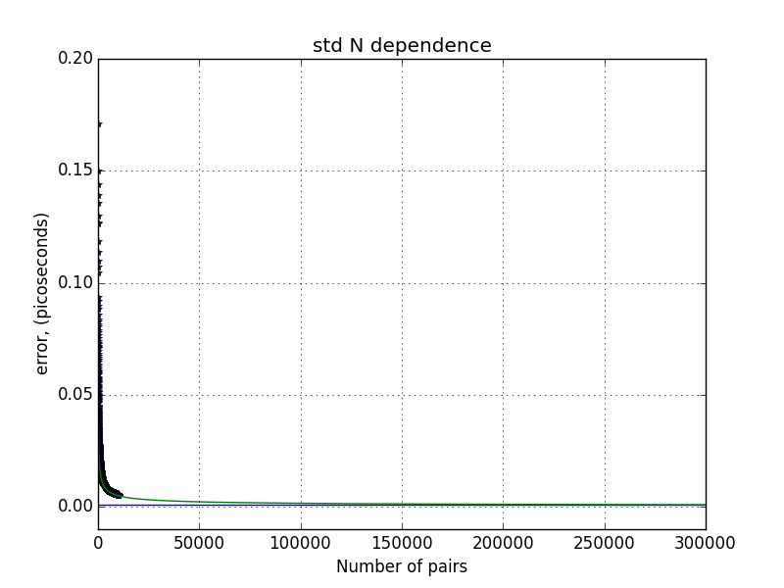

Figure Graph showing a $\frac{1}{\sqrt{N}}$ relationship between the error and the Number of data pairs. (std-standard deviation. Black dots are calculated errors from the dataset, green line is this extrapolated and blue line is the ${ 10}^{-15}s$ boundary.

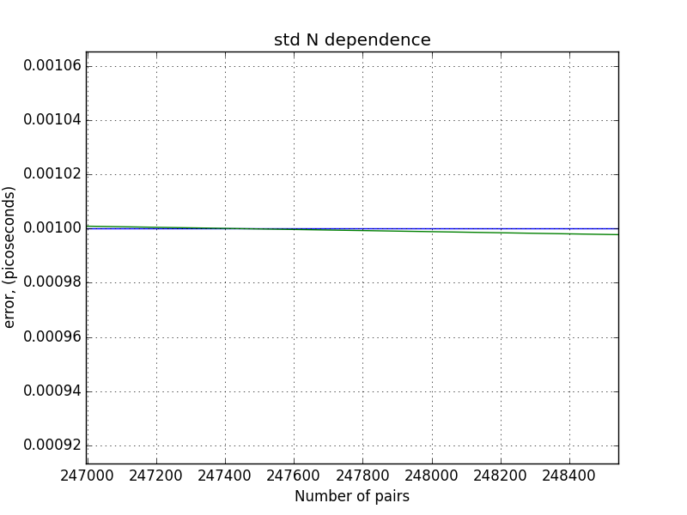

Figure Graph showing the critical number of data pairs for a ${10}^{-15}s$ accuracy is 247500. (std-standard deviation). Green line(extrapolated fit function ) crosses blue line $({10}^{-15}s)$ at 247500

The fraction of the dataset attributable to actual decays was assumed to be large (between 0.9 and 1.0). A contour plot of the NLL as function of $τ$ and a was made and is shown in figure 6. The minimum can be seen to be above $τ=0.4$ and $a=0.9$. The gradient minimiser was therefore instantiated with the aforementioned as a starting guess. A minimum coordinate of $(τ=\left(0.4097± 0.005\right) x {10}^{-12}s, a=0.98 ± 0.008)$ was found. The fraction of the signal $(a$) in the dataset was large as expected explaining why the values obtained for $τ$ were similar within the error, suggesting the background was indeed negligible.

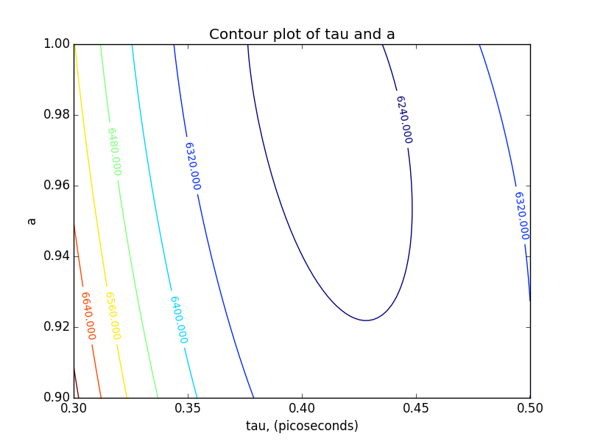

Figure A contour plot of tau and a, showing minimum is above tau = 0.4 and a =0.9

1. **Conclusion**

In conclusion, this report investigated the fraction of background in a dataset of $D^{0}$ meson decay lifetimes. A Negative Log likelihood function for the average decay lifetimes was obtained for the cases of no background and background noise and a comparison was made of the values deduced for the average lifetimes in each case. An average lifetime value of x was obtained when the background was assumed negligible, compared to $\left(0.4097 ± 0.005\right)$ x ${10}^{-12}s$ when the background was considered non-negligible. This was within the error of the published value (410.1 ± 1.5) × 10-15s. The fraction of the sample attributable to actual decays was found to be $\left(0.98 ± 0.008\right)$ x ${10}^{-12}s$,and hence the background signal negligible. A minimum of 247500 data points were found to be needed for an accuracy of ${10}^{-15}s$ on the estimation of the decay lifetime. Results could have been improved by using the covariance matrix between $τ$ and $a$ to compute their respective errors. The method applied assumed them to be independent.

1. **References**
2. http://hyperphysics.phy-astr.gsu.edu/hbase/Particles/dmeson.html,D mesons, Hyperphysics, accessed on the 13/12/16
3. https://inspirehep.net/record/779705/plots, Measurement of exclusive D meson decays to eta and eta-prime final states and SU(3) amplitude analysis, CLEO collaboration, accessed on the 13/12/16
4. Imperial College London, 2016-2017, 3rd year Computational Physics, Project B1 pg.1
5. **Appendix**
6. The parabolic minimiser works by approximating the minimum of a function to a parabola and fitting a second order LaGrange polynomial, $P_{2}$, through a set of points e.g. $x0,x1,x2$. By setting the derivative of $P_{2}$ to 0, we can obtain a better estimate of the minimum $x3$ via (13)

$x3= \frac{1}{2}\frac{\left({x2}^{2}-{x1}^{2}\right)y0+\left({x0}^{2}-{x2}^{2}\right)y1+\left({x1}^{2}-{x0}^{2}\right)y2}{\left(x2 - x1\right)y0+\left(x0 – x2\right)y1+(x1 – x0)y2}$ (13)

1. $x_{n+1}= x_{n}- αd(x_{n})$, (14)

where $x_{n+1}$ is closer to the minimum than $x_{n}$, and $d\left(x_{n}\right)$ represents the gradient of the function at $x_{n}$. (14) requires that $α≪1$. The gradient is always perpendicular to the contour lines and so get to minimum via a shorter path than univariate minimisation

**words: ~ 1930**