End-to-End Validation Screenshot:

- Kubernetes Pod creation, training and status check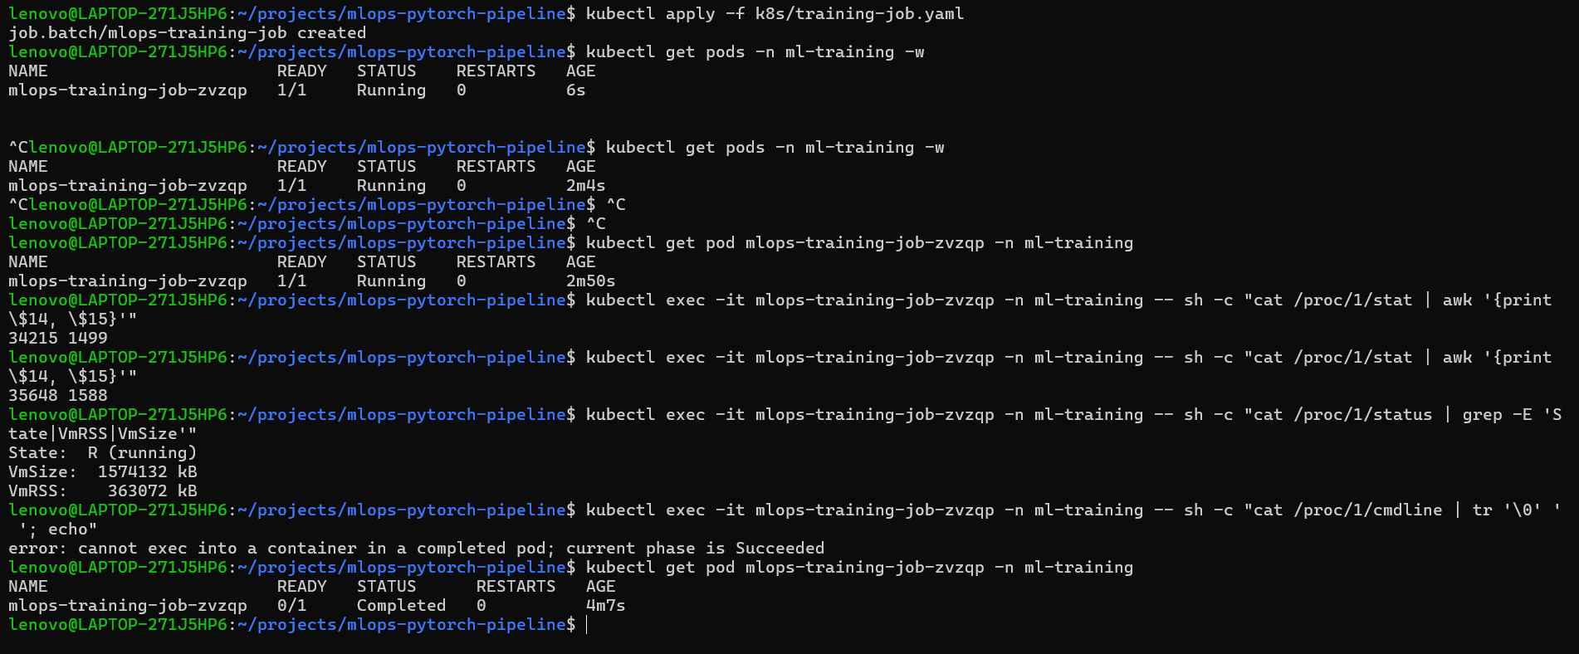
- Kubernetes Job , ConfigMap Verification and Training Logs
Verified dynamic runtime configuration via training-config ConfigMap mounting /app/configs/training_config.yaml. Confirmed architecture: cnn, dataset fashion_mnist, and 1 training epoch. Screeshot confirming execution completion.
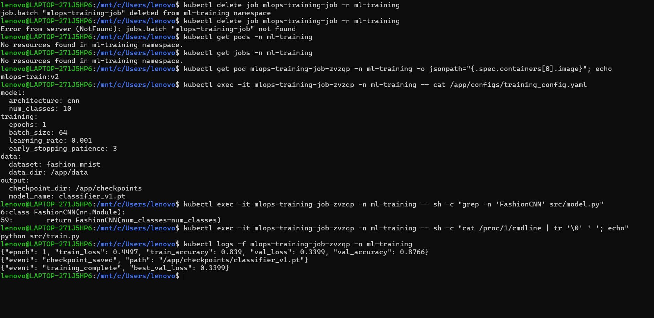

- Checkpoint Verification
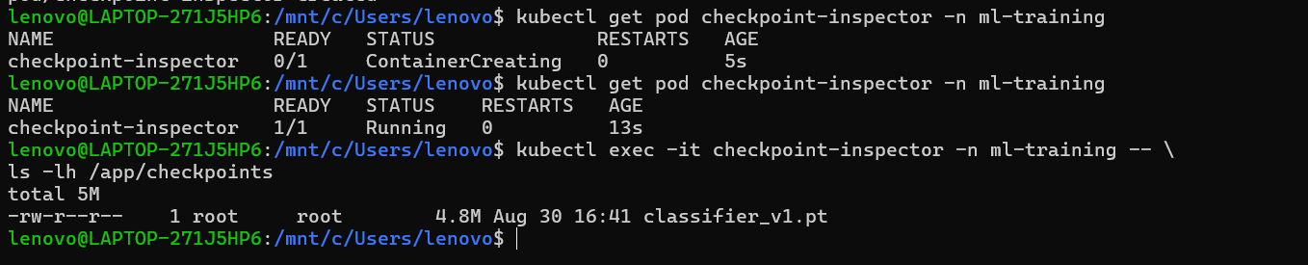

- Serving layer replicas
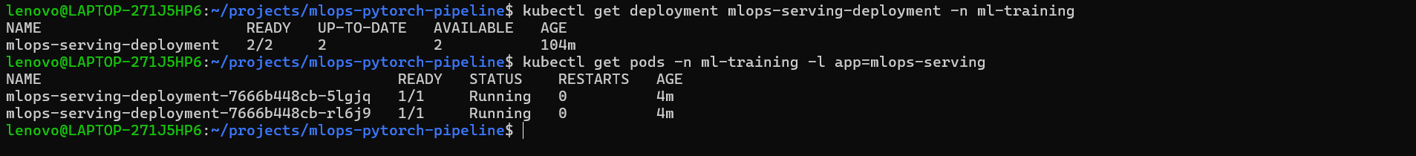
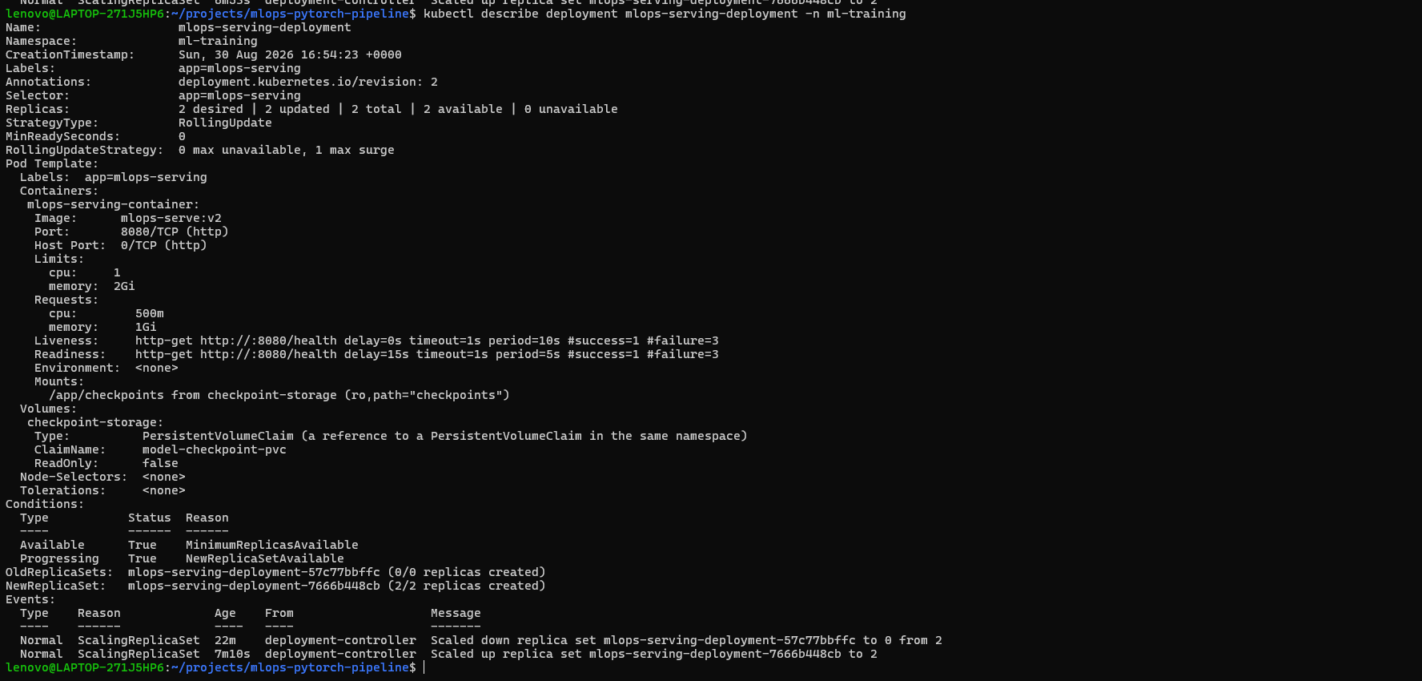
- Health Verification: Liveness & Readiness of model, Sent HTTP GET request to /health endpoint via local port-forwarding. Returned HTTP 200 OK.
- Serving Layer Deployment : Deployment maintained 2/2 healthy replicas (mlops-serving-deployment-7666b448cb-5lgjq and rl6jq). Executed direct filesystem check inside the serving pod to confirm read-only mount of classifier_v1.pt.
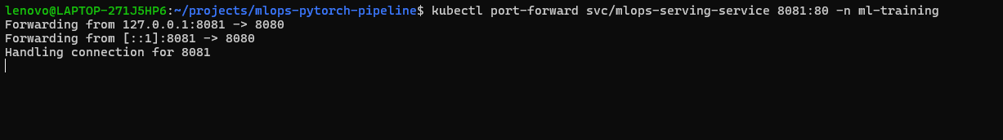 7. Prediction/ inference layer: Executed POST request using test_image.png to evaluate serving performance. Ankle boot image is given as present in repository and same is predicted with 99.78 % probability or per se confidence.

- Complete Final Screenshot


