End-to-End Validation Screenshot:

- Kubernetes Pod creation, training and status check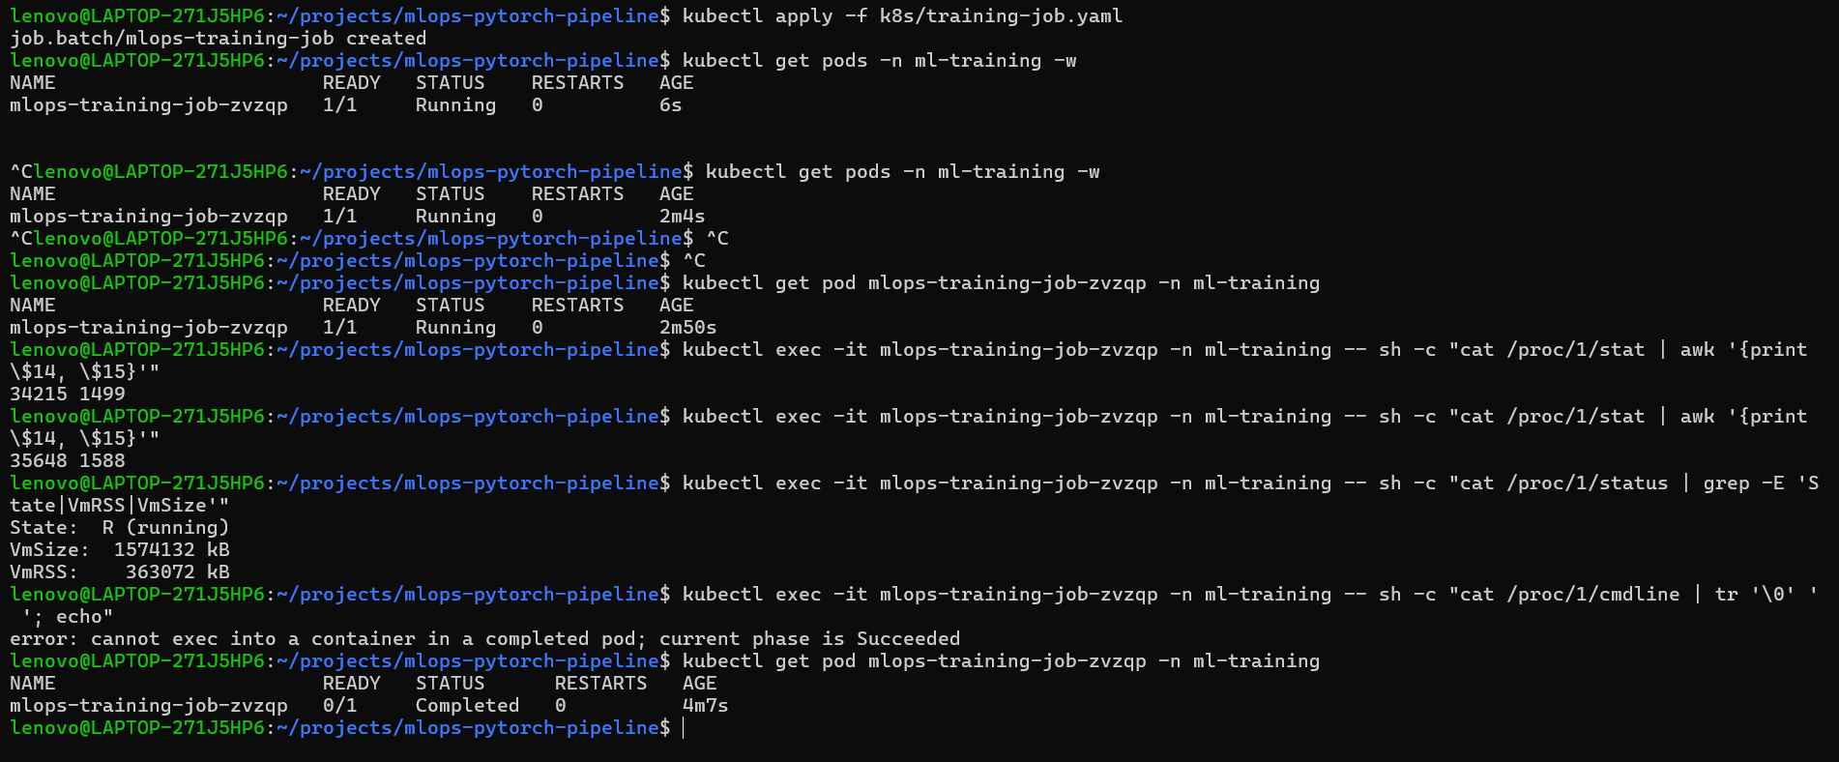
- Kubernetes Job , ConfigMap Verification and Training Logs
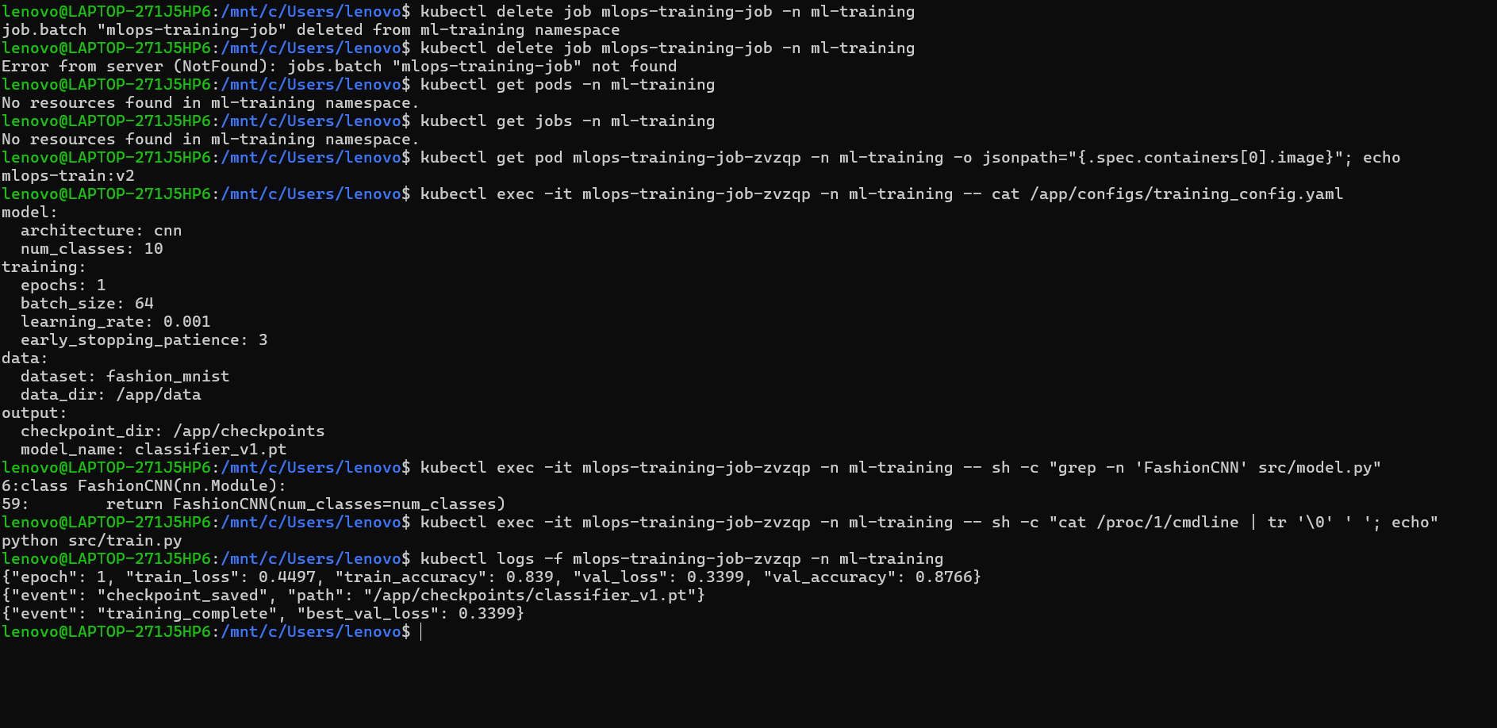

- Checkpoint Verification
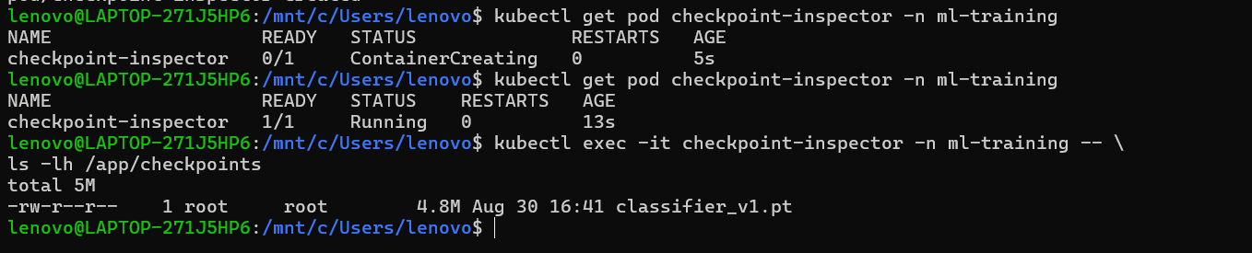

- Serving layer replicas
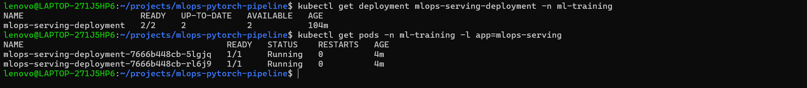
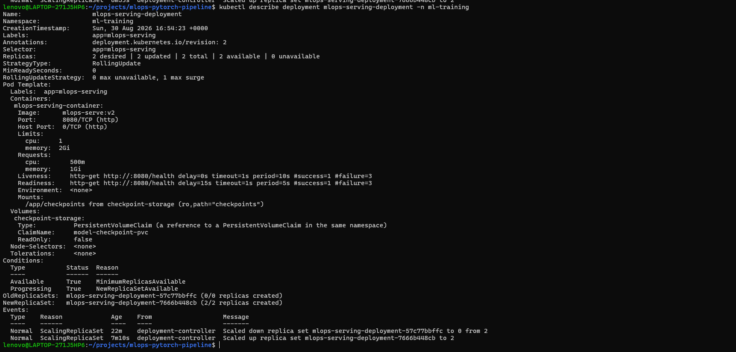
- Health Verification
- Serving Layer
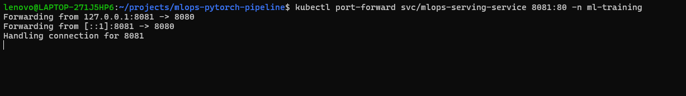 7. Prediction
Ankle boot image is given as present in repository and same is predicted with 99.78 % probability or per se confidence.

- Complete Final Screenshot


