Kubernetes Pod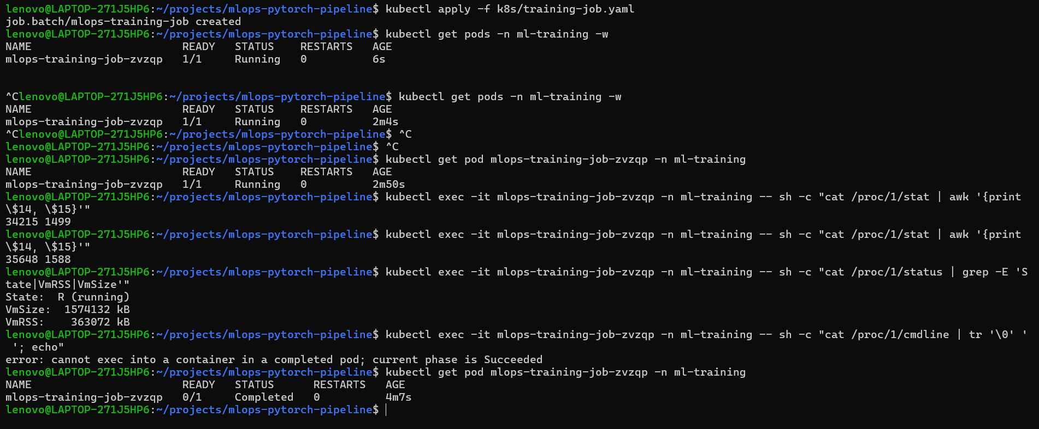
Kubernetes Job , ConfigMap Verification and Training Logs
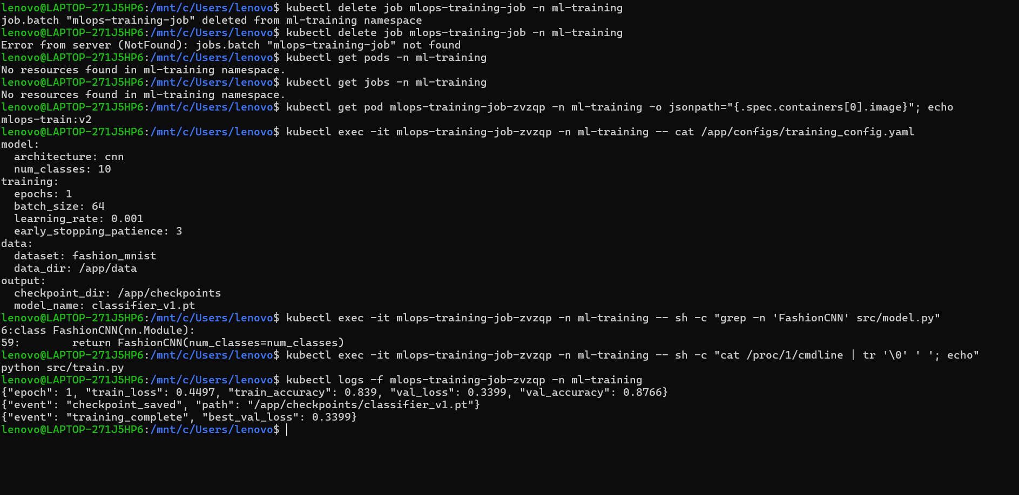

Checkpoint Verification
