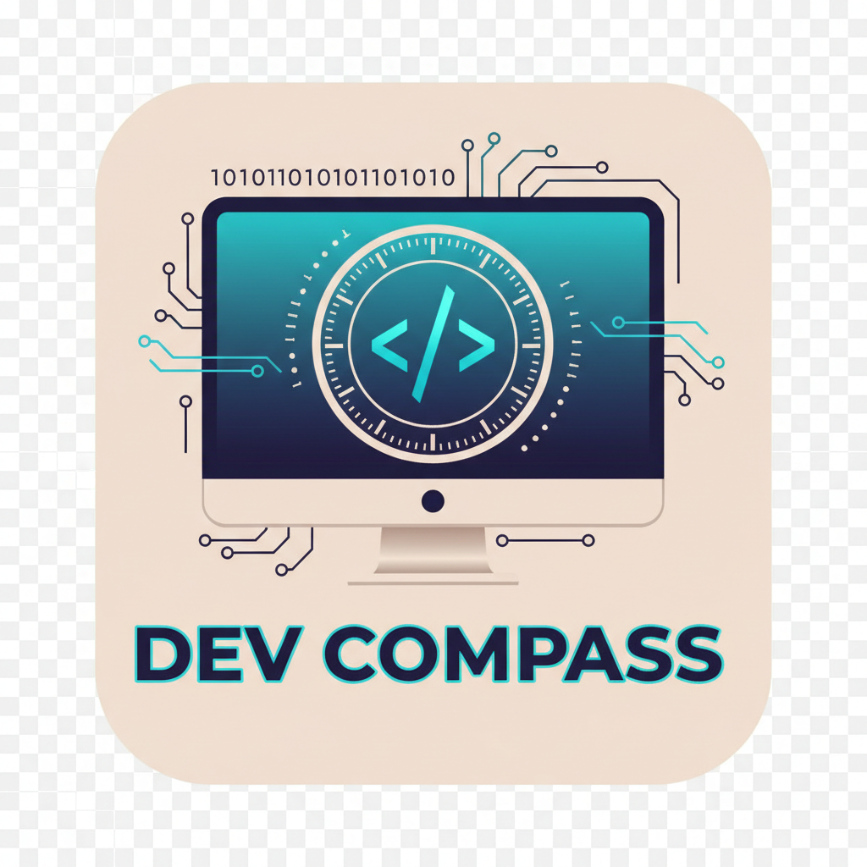
DEVCOMPASS

Software Requirements
Specification
PROJECT REPORT · PROGRAM CODE EDITION
A document-grounded assistant for understanding project files
Prepared from the DevCompass implementation
28 October 2026

ABSTRACT
DevCompass helps people get oriented in a software project without searching every document by hand. A user can add supported project files, ask a question in the browser, and receive an answer based on indexed text. When available, the answer can point back to its source document.
The application is a browser-based frontend connected to a Python FastAPI service. The service handles guest and signed-in sessions, file parsing, retrieval-augmented generation (RAG), and calls to configured language-model providers. MongoDB stores account and application records; document chunks and embeddings are managed by the retrieval layer, which can use Atlas Vector Search and local ChromaDB. The frontend is bundled with esbuild, and a local launcher starts the API and frontend services.
This report introduces the system in plain language, describes its functional requirements and component flows, and presents essential program-code excerpts. Frontend listings appear first. A screenshot of the running website follows the frontend code, before the backend listings. The report closes with repository-based testing notes, practical strengths, and current limitations. Code is selected from the project’s base files folder; larger or incomplete snapshots are represented by bounded excerpts rather than presented as complete files. Credentials and user-uploaded data are deliberately excluded.
Keywords: document assistant, FastAPI, React, RAG, MongoDB, source code

INDEX
The chapters move from the project background to system behaviour, diagrams, source listings, and verification. Chapter 4 contains the code in the requested order.
Chapter | Chapter title | Contents
1 | INTRODUCTION | Purpose, objectives, scope, approach, and operating requirements.
2 | FUNCTIONAL REQUIREMENTS | User journeys, document handling, chat, persistence, and API boundaries.
3 | DIAGRAMS | Architecture, document question flow, and workspace boundaries.
4 | PROGRAM CODE | Essential frontend code, website screenshot, then backend and run configuration.
5 | TESTING | Repository test coverage, representative cases, and release checks.
6 | ADVANTAGES & LIMITATIONS | Practical benefits, known constraints, and realistic next steps.

CHAPTER 1: INTRODUCTION

1.1 Introduction
Joining a codebase often means piecing together information from READMEs, setup notes, design documents, and notebooks. Even when an answer is already written down, a new teammate may not know which file to open or what wording to search for. DevCompass gives those files a shared question-and-answer entry point.
The user adds a document in the chat interface and asks a question in ordinary language. The backend extracts text, divides it into searchable passages, and retrieves material relevant to the question. A configured language model uses that retrieved material to draft a response. The goal is not to replace source files; it is to make them easier to navigate and to keep answers traceable.

1.2 Objectives
- Make project documentation easier to search with questions instead of exact keywords.
- Keep document, chat, and account data within the appropriate signed-in or guest workspace.
- Show source-file information when a response is grounded in indexed content.
- Provide a local startup path and a deployable frontend/backend arrangement.
- Keep database and AI credentials on the server rather than in browser code.

1.3 Scope
This specification describes the implementation represented by the project base files. The browser application includes account entry, guest use, chat, a file library, document upload, dashboard, and profile settings. The API supports user/session operations, document indexing, retrieval, and chat. The main documented upload formats are PDF, plain text, and Markdown; notebook parsing is available in parts of the repository, but the copied base UI and API snapshot is the source of truth for this code edition.
The report covers the implemented software and its runtime configuration. It does not specify a new product design, guarantee answer accuracy, or claim that third-party MongoDB and model-provider services are always available. It excludes real environment secrets, generated vector data, uploaded user files, and dependency-installation directories.

1.4 Development and documentation approach
This report was prepared by reading the supplied project files and describing the behaviour they implement. The source-code chapter uses the copies in the base files folder so a reviewer can trace the report to one consistent set of files. The diagrams summarize the main paths; they are explanatory views, not additional production components.
- Review the user-facing pages, API routes, and runtime configuration.
- Group behaviour into account, upload, retrieval, chat, and persistence flows.
- Describe interfaces and limits that can be verified in the source.
- List essential source files in readable code blocks.
- Compare documented flows with the repository’s automated tests.

1.5 Hardware requirements
No special end-user hardware is required beyond a device that can run a modern web browser and reach the deployed API. Local development needs enough memory and disk space for Python and Node dependencies, the configured embedding model, and the local index. Production capacity depends on document volume, embedding workload, and hosting/database tiers; this specification does not assume a fixed server size.

1.6 Software requirements
Area | Requirement represented by the project
Browser | Current browser with JavaScript, cookies, and file-upload support.
Frontend | Node.js/npm build; React and esbuild are declared in frontend/package.json.
Backend | Python service using FastAPI/Uvicorn and other/requirements.txt.
Persistence | MongoDB; retrieval can use Atlas Vector Search and local ChromaDB.
AI answers | At least one provider key (Gemini, Groq, or OpenRouter) for generated answers.
Configuration | Backend environment settings; secrets must not be put in browser code.

CHAPTER 2: FUNCTIONAL REQUIREMENTS
The requirements below describe what a person can do and how DevCompass responds. They are grounded in the supplied implementation. Where a feature depends on hosting credentials or an external service, that dependency is stated plainly.

2.1 User and session management
A visitor can use chat in guest mode, while a registered user can sign in to keep account activity and saved chats. The backend creates and checks session cookies and determines the user workspace from those cookies; the browser does not choose an account identifier.
- The system shall allow account creation and sign-in using the available account forms.
- The system shall provide a guest session for visitors who do not sign in.
- The system shall keep authenticated records scoped to the resolved account.
- The system shall keep guest documents scoped to the guest workspace.
- The system shall allow signed-in users to update profile settings and sign out.

2.2 Document upload and library
The chat composer provides a file picker. On selection, the UI shows the filename and upload progress, then sends a multipart request to the API. The backend checks the extension and size, reads the document, extracts text, and indexes it in the current workspace. Files that are oversized, unsupported, unreadable, or empty should produce an understandable error instead of appearing ready.
- Users shall be able to add supported PDF, TXT, and Markdown files.
- The backend shall limit an upload to 10 MB in the code represented by the base files.
- The system shall sanitize stored filenames and reject unsupported extensions.
- The system shall extract readable text before indexing; image-only PDFs need OCR, which is not guaranteed.
- The library shall list indexed documents available to the active workspace.
- A selected document shall be available as chat context and may be cleared.

2.3 Question and answer
A user writes a question in the chat composer. The frontend sends the question, optional chat identifier, and optional document identifier. The backend retrieves passages within the caller’s workspace, builds an answer request, and returns the response and any source metadata. If no provider is configured, the API reports that configuration is needed.
- The system shall accept a natural-language question from guest or signed-in chat.
- The system shall retrieve passages from the active document when one is selected.
- The system shall avoid mixing passages across another user’s workspace or document boundary.
- The system shall return source information when retrieval provides it.
- Signed-in chat turns may be saved for later history; guest use does not require an account.

2.4 Dashboard and settings
Signed-in users can review document and question counts, recent activity, and account settings. The dashboard and settings views obtain data from API endpoints and display a status when a request fails. Profile settings cover display name, appearance, answer style, and profile picture.

2.5 Data and security requirements
- Passwords must not be stored as plain text; the backend uses salted PBKDF2-SHA256 hashing.
- Session tokens are protected through HTTP-only cookies and represented by digests in persistence.
- MongoDB and model-provider credentials must remain server-side.
- Uploaded files, vector data, and account records must not be included in the source listings.
- User-facing errors should be useful without exposing database URIs or provider secrets.

2.6 Main interfaces
Interface | Purpose | Typical response
GET /guest/session | Start or reuse guest identity. | Guest cookie / session status.
POST /auth/signup | Create account and session. | User summary or validation error.
POST /auth/login | Authenticate account. | User summary or safe error.
GET /documents | List files for the workspace. | Indexed document list.
POST /upload | Receive and index a multipart file. | Filename and document identifier.
POST /ask | Answer a chat question. | Answer and optional source data.
GET /chat/history | Load signed-in saved chats. | Chat summaries.
GET /status | Report API/vector readiness. | Health status and readiness detail.

Uploads use multipart/form-data; ordinary chat and account payloads use JSON. Exact response shapes and availability depend on the deployed version.

CHAPTER 3: DIAGRAMS
These diagrams put the implementation into view without asking the reader to follow every function. Browser screens call the API; the API owns workspace checks, document processing, retrieval, persistence, and provider calls.

3.1 System architecture
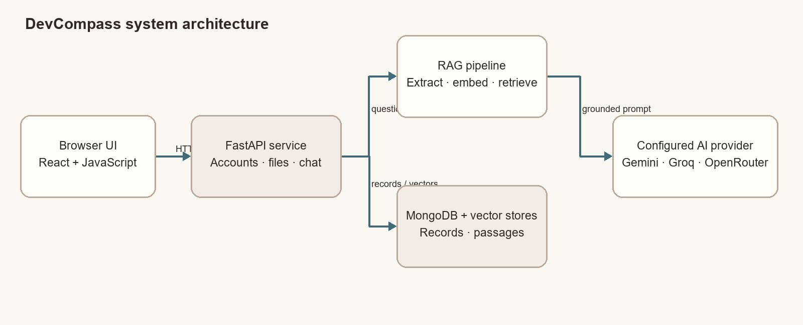
Figure 3.1: Browser, API, retrieval, persistence, and model-provider components.
The browser presents screens and sends requests. Authentication, workspace decisions, parsing, retrieval, database access, and provider credentials remain in the backend. Vector retrieval can use Atlas and a local Chroma store, according to configuration.

3.2 Document question flow
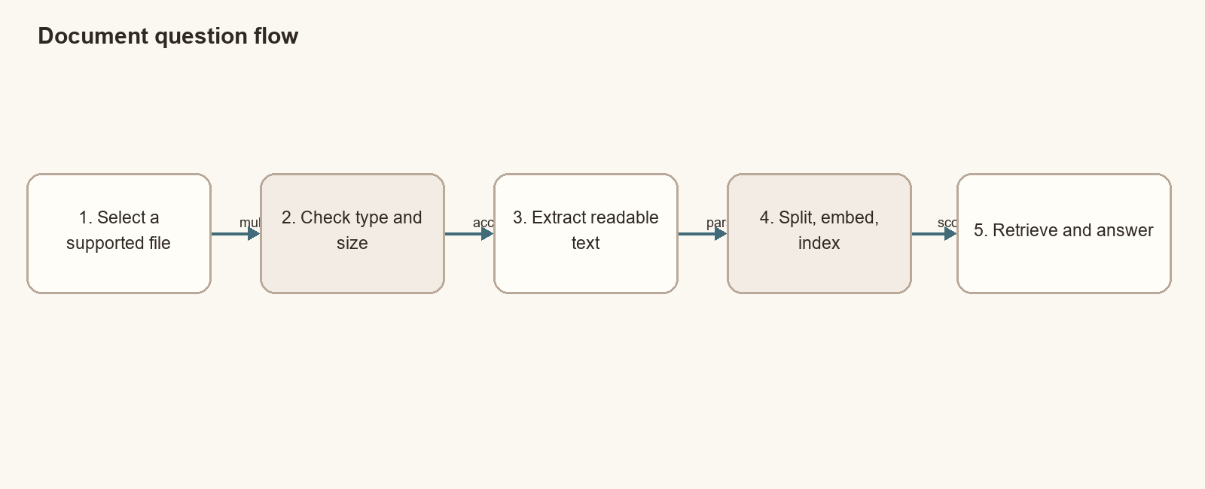
Figure 3.2: From a selected document to a source-aware answer.
An upload is ready only after parsing and indexing succeed. A file can be structurally valid but contain no extractable text; the service should treat that as a parsing problem and explain the limitation.

3.3 Workspace and privacy boundaries
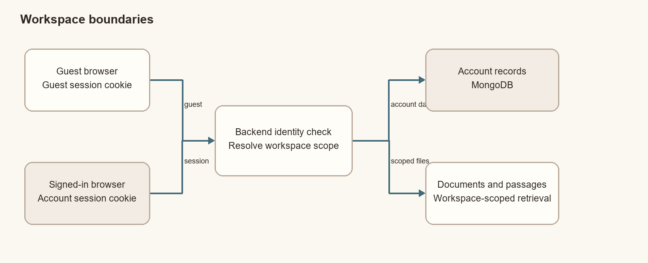
Figure 3.3: Guest and signed-in requests resolve to separate workspace scopes.
Workspace identity is resolved on the server from the incoming session or guest cookie. Retrieval and persistence use that resolved scope so one workspace’s document is not intended to appear in another workspace’s results.

CHAPTER 4: PROGRAM CODE

4.1 Program code overview
DevCompass is delivered as a static browser application connected to a Python API. The frontend is listed first because it is what a user sees; the screenshot follows the frontend listings. Backend application and startup files come after the screenshot. Small, self-contained files are shown in full, while larger application files are represented by selected excerpts from the project’s base files folder. The curated copies of some large files are incomplete, so an excerpt is explicitly labeled and should not be treated as a standalone program. The frontend logo is an image asset, so it is identified but not printed as source code.
Layer | Essential files | Role
Frontend | index.html, src/main.jsx, selected app.js and styles.css | Page shell, React mount, selected browser workflows, and design tokens.
Frontend build | build.mjs, package.json | Bundles the selected frontend sources and static assets.
Backend | Selected excerpts from backend/bridge.py | Document parsing, passage indexing, grounded prompts, and provider fallback.
Runtime | other/start_app.py, other/requirements.txt | Local startup and Python dependencies.
Configuration | other/.env.example, render.yaml | Safe setting names and Render service configuration.

4.2 Frontend essential files
The small structural and build files are shown in full. The larger browser application and stylesheet are represented by short, line-numbered excerpts covering API communication, upload feedback, and shared visual rules. The full React application and npm lockfile are intentionally omitted.

frontend/index.html
Complete page shell: metadata, stylesheet, and application mount.
<!doctype html>
<html lang="en">
<head>
<meta charset="UTF-8">
<meta name="viewport" content="width=device-width, initial-scale=1.0">
<meta name="theme-color" content="#f7f7f4">
<title>DevCompass</title>
<link rel="icon" type="image/png" href="logo.png">
<link rel="stylesheet" href="assets/app.css">
</head>
<body>
<div id="app"></div>
<script src="assets/app.js" defer></script>
</body>
</html>

frontend/src/main.jsx
Complete React entry point and application renderer bridge.
import React, { useLayoutEffect, useState } from 'react'
import { flushSync } from 'react-dom'
import { createRoot } from 'react-dom/client'
import '../styles.css'
import '../app.js'
function App() {
const [markup, setMarkup] = useState('')
useLayoutEffect(() => {
window.renderDevCompassMarkup = (nextMarkup) => {
flushSync(() => setMarkup(nextMarkup))
}
window.startDevCompass()
}, [])
return <div dangerouslySetInnerHTML={{ __html: markup }} />
}
createRoot(document.querySelector('#app')).render(<App />)

frontend/app.js (selected excerpt, lines 1-28)
Selected API configuration and request-helper excerpt.
const routes = ['home', 'dashboard', 'chat', 'settings', 'welcome', 'login', 'signup']
let activeDocument = null, currentUser = null, chatHistoryEntries = [], activeChatId = null
let availableDocuments = [], editingTurn = null
const configuredApiBase = process.env.DEVCOMPASS_API_BASE.trim().replace(/\/+$/, '')
const isNetlifySite = window.location.hostname.endsWith('.netlify.app')
const renderBackendBase = window.location.hostname === 'dev-compass-1.onrender.com' ? 'https://dev-compass.onrender.com' : ''
const API_PROTOCOL = window.location.protocol === 'https:' ? 'https' : 'http'
const API_HOST = window.location.hostname || '127.0.0.1'
const API_BASE = configuredApiBase || renderBackendBase || (window.location.protocol === 'file:' || ['5173', '8001'].includes(window.location.port)
? `${API_PROTOCOL}://${API_HOST}:8000` : window.location.origin)
function apiFetch(path, options = {}) {
if (isNetlifySite && !configuredApiBase) throw new Error('Login is unavailable because the FastAPI backend is not connected to this Netlify site.')
return fetch(`${API_BASE}${path}`, { ...options, credentials: 'include' })
}
async function readApiResponse(response) {
if (!response.headers.get('content-type')?.includes('application/json'))
throw new Error(`The API returned a non-JSON response (HTTP ${response.status}). Check the backend URL and deployment.`)
return response.json()
}
async function ensureGuestSession() {
if (currentUser) return
const r = await apiFetch('/guest/session')
if (!r.ok) throw new Error('Could not start a guest session.')
}

frontend/app.js (selected excerpt, lines 396-424)
Selected upload-response and progress-feedback excerpt.
async function readUploadResponse(response) {
const body = await response.text(); let data = null
if (body.trim()) {
try { data = JSON.parse(body) } catch { throw new Error(response.ok ? `The server returned an invalid response (HTTP ${response.status}).` : body.slice(0, 240)) }
}
if (!response.ok) throw new Error(data?.detail || `Upload failed (HTTP ${response.status}).`)
if (!data) throw new Error(`The server returned an empty response (HTTP ${response.status}).`)
return data
}
function createUploadProgress(file) {
const m = document.createElement('div'); m.className = 'upload-composer-card'
m.innerHTML = `<div class="upload-card"><div class="upload-file"><strong></strong><small></small></div><div class="upload-progress"><span></span></div><div class="upload-status"><span class="pulse-dot"></span><span></span></div></div>`
m.querySelector('.upload-file strong').textContent = file.name
m.querySelector('.upload-file small').textContent = `${Math.ceil(file.size / 1024)} KB`
m.querySelector('.upload-status span:last-child').textContent = 'Adding to your files…'
return m
}
const updateUploadProgress = (m, i) => { m.querySelector('.upload-progress span').style.width = `${Math.min(35 + i * 25, 85)}%` }
const finishUploadProgress = (m, detail) => {
m.classList.add('upload-complete'); m.querySelector('.upload-progress span').style.width = '100%'
m.querySelector('.upload-status').innerHTML = '<span class="material-symbols-outlined">check_circle</span><span></span>'
m.querySelector('.upload-status span:last-child').textContent = `Ready · ${detail}`
}
const failUploadProgress = (m, error) => {
m.classList.add('upload-failed')
m.querySelector('.upload-status').innerHTML = '<span class="material-symbols-outlined">error</span><span></span>'
m.querySelector('.upload-status span:last-child').textContent = `Upload failed · ${error}`
}

frontend/styles.css (selected excerpt, lines 1-52)
Selected theme, shared layout, and button-style excerpt.
@import url('https://fonts.googleapis.com/css2?family=Newsreader:opsz,wght@6..72,400;6..72,500;6..72,600;6..72,700&family=Space+Grotesk:wght@400;500;600&family=Space+Mono:wght@400;500;700&family=Material+Symbols+Outlined:opsz,wght,FILL,GRAD@20..48,300..700,0,0');
:root{
font-family:'Space Grotesk',sans-serif;color:#28221d;background:#fbf8f1;
--paper:#fffdf9;--canvas:#fbf8f1;--muted:#f5efeb;--well:#ede6d8;--line:#decfc0;
--ink:#28221d;--soft:#5a4e46;--accent:#c05a3e;--blue:#306575;--danger:#ba1a1a;
--accent-light:#fbeee9;--blue-light:#e6f1f4;--success:#2b7a4b;
--shadow:0 4px 16px rgba(40,34,29,.06);
}
*{box-sizing:border-box}
html{scroll-behavior:smooth}
body{margin:0;min-width:320px;background:var(--canvas)}
button,input,textarea,select{font:inherit}
button,a{cursor:pointer}
button{border:0}
a{color:inherit;text-decoration:none}
.app{min-height:100vh;background:var(--canvas);display:flex;flex-direction:column}
.material-symbols-outlined{font-size:18px;line-height:1;vertical-align:middle}
.site-header{position:sticky;top:0;z-index:10;background:rgba(251,248,241,.94);
backdrop-filter:blur(12px);border-bottom:1px solid var(--line)}
.header-inner{height:58px;max-width:1280px;margin:auto;padding:0 32px;
display:flex;justify-content:space-between;align-items:center;gap:24px}
.header-actions,.header-left,.desktop-nav,.button-row,.logo,.panel-title,.answer-title,
.section-head,.chat-head>div,.message,.message>div,.doc-item>div,.library-label,.index-status{
display:flex;align-items:center}
.header-left{gap:28px}
.logo{background:none;gap:9px;color:var(--ink);font:600 21px Newsreader,serif;padding:0}
.logo-mark,.auth-logo{display:grid;place-items:center;background:var(--accent);color:#fff;
border:1px solid #a2442a}
.logo-mark{width:28px;height:28px;border-radius:7px;font:700 21px Newsreader,serif}
.desktop-nav{display:flex;align-items:center;gap:4px;flex-wrap:nowrap}
.nav-link,.quiet-button{display:inline-flex;align-items:center;justify-content:center;
min-width:82px;background:transparent;color:var(--soft);padding:8px 14px;border-radius:7px;
font-size:13px;white-space:nowrap}
.nav-link.active,.nav-link:hover,.quiet-button:hover{background:var(--well);color:var(--ink)}
.nav-link.active{color:var(--accent);border:1px solid var(--line)}
.header-actions,.button-row{gap:10px}
.primary-button,.secondary-button{display:inline-flex;align-items:center;justify-content:center;
gap:8px;min-height:42px;padding:0 20px;border-radius:9px;font-size:14px;font-weight:600;
transition:.2s}
.primary-button{background:var(--accent);color:#fff;border:1px solid #a2442a;
box-shadow:0 2px 6px #c05a3e40}
.primary-button:hover{background:#ac4e35}
.primary-button.small{min-height:34px;padding:0 14px;font-size:13px}
.secondary-button{background:var(--paper);color:var(--ink);border:1px solid var(--line)}
.secondary-button:hover{background:var(--well)}
.secondary-button.small{min-height:34px;padding:0 13px;font-size:12px}
.full{width:100%}
.container{max-width:1152px;margin:auto;padding-left:32px;padding-right:32px}
.section{padding:76px 0;border-bottom:1px solid var(--line)}
.hero{padding-top:88px}
.hero-grid{display:grid;grid-template-columns:1.2fr .8fr;gap:60px;align-items:center}
.hero-copy{max-width:700px}

frontend/build.mjs
Complete esbuild configuration and static asset-copy step.
import { copyFile, mkdir } from 'node:fs/promises'
import { dirname, join } from 'node:path'
import { fileURLToPath } from 'node:url'
import { build } from 'esbuild'
const frontendDirectory = dirname(fileURLToPath(import.meta.url))
const outputDirectory = join(frontendDirectory, 'dist')
await mkdir(outputDirectory, { recursive: true })
await build({
entryPoints: [join(frontendDirectory, 'src', 'main.jsx')],
bundle: true,
minify: true,
sourcemap: true,
outdir: join(outputDirectory, 'assets'),
entryNames: 'app',
define: {
'process.env.DEVCOMPASS_API_BASE': JSON.stringify(process.env.DEVCOMPASS_API_BASE || ''),
},
})
await Promise.all([
copyFile(join(frontendDirectory, 'index.html'), join(outputDirectory, 'index.html')),
copyFile(join(frontendDirectory, 'logo.png'), join(outputDirectory, 'logo.png')),
])

frontend/package.json
Complete frontend scripts and direct dependency declarations.
{
"name": "devcompass-frontend",
"version": "1.0.0",
"private": true,
"scripts": {
"build": "node build.mjs"
},
"dependencies": {
"react": "^19.1.0",
"react-dom": "^19.1.0"
},
"devDependencies": {
"esbuild": "^0.25.5"
}
}
The DevCompass logo is supplied separately as frontend/logo.png. It is an image resource copied into the build output, not a text-based source listing.

4.2.1 Frontend screenshot
The following screenshot shows DevCompass running on the project’s Render deployment. It is placed between the frontend and backend code sections as requested.
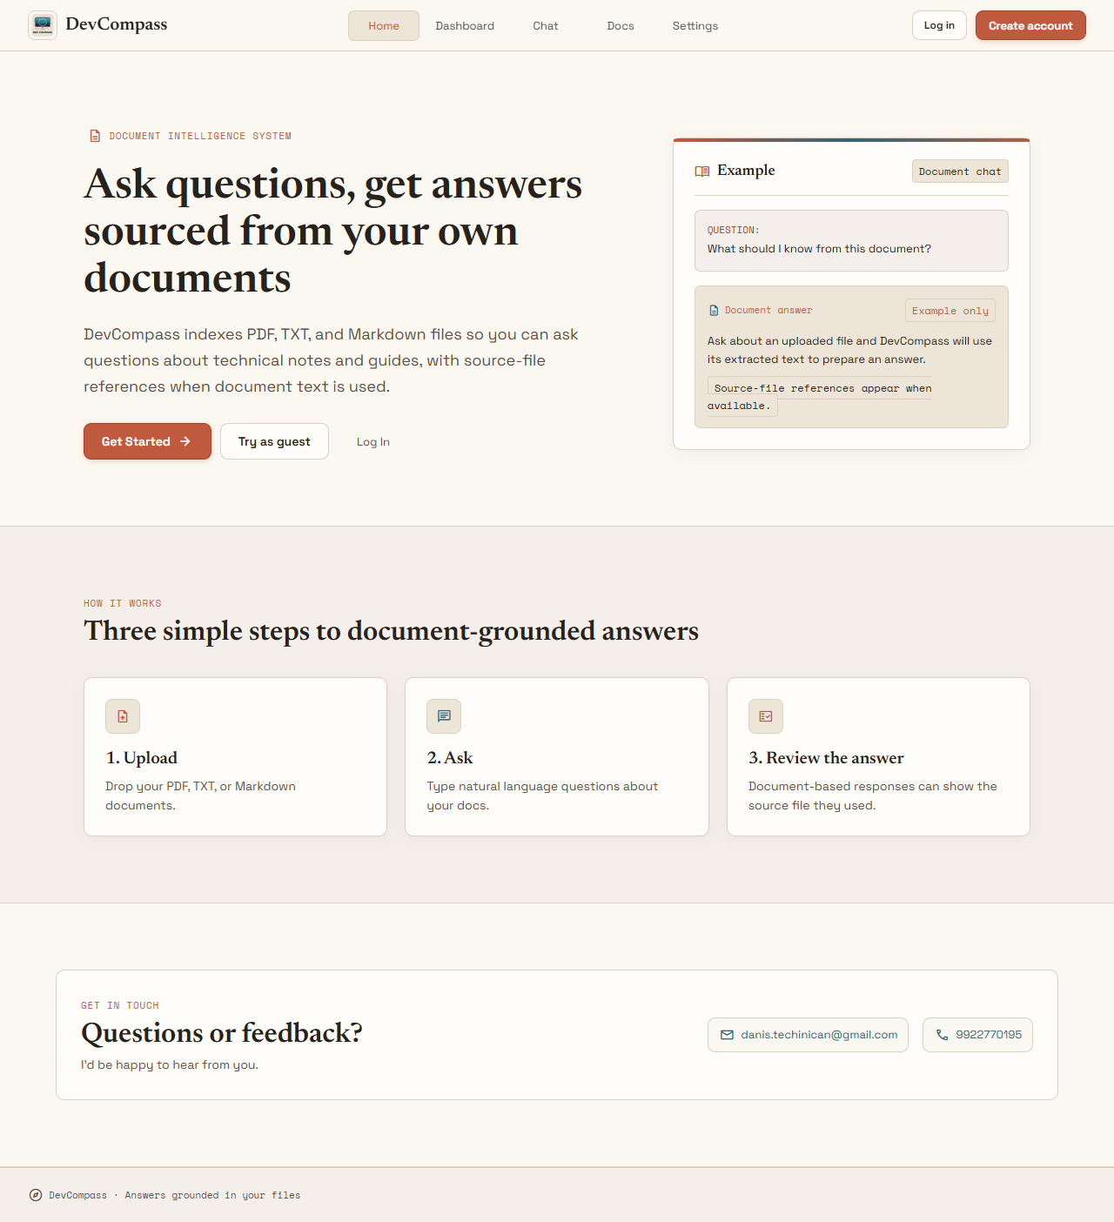
Figure 4.1: DevCompass home page on Render, captured 28 October 2026.

4.3 Backend essential files
The backend excerpts focus on extracting uploaded document text, parsing notebooks, splitting and indexing passages, building context-grounded prompts, and trying configured model providers. They are selected from the curated base-files snapshot and are not the complete API server. The local launcher and concise configuration files are shown in full.

backend/bridge.py (selected excerpt, lines 341-348)
Selected document-text extraction excerpt.
def read_uploaded_document(self, filename, contents):
suffix = Path(filename).suffix.lower()
if suffix == '.pdf':
return '\n'.join(p.extract_text() or '' for p in PdfReader(BytesIO(contents)).pages).strip()
if suffix == '.ipynb':
return self.read_notebook(contents)
return contents.decode('utf-8', errors='ignore')

backend/bridge.py (selected excerpt, lines 349-365)
Selected Jupyter notebook parsing excerpt.
def read_notebook(self, contents):
try:
nb = json.loads(contents.decode('utf-8-sig'))
except (UnicodeDecodeError, json.JSONDecodeError) as e:
raise ValueError('The Jupyter notebook is not valid UTF-8 JSON.') from e
if not isinstance(nb, dict) or not isinstance(nb.get('cells'), list):
raise ValueError('The Jupyter notebook does not contain a valid cells list.')
cells = []
for i, cell in enumerate(nb['cells'], 1):
if not isinstance(cell, dict) or cell.get('cell_type') not in {'markdown', 'code'}:
continue
src = cell.get('source', '')
if isinstance(src, list):
src = ''.join(p for p in src if isinstance(p, str))
if isinstance(src, str) and src.strip():
cells.append(f"[{'Markdown' if cell['cell_type'] == 'markdown' else 'Code'} cell {i}]\n{src.strip()}")
return '\n\n'.join(cells)

backend/bridge.py (selected excerpt, lines 384-450)
Selected passage chunking and vector-indexing excerpt.
def chunk_text(self, text, size=500, overlap=50):
clean = ' '.join(text.split())
chunks, start = [], 0
while start < len(clean):
end = min(start + size, len(clean))
piece = clean[start:end].strip()
if piece:
chunks.append(piece)
if end == len(clean):
break
start = max(end - overlap, start + 1)
return chunks
def rebuild_index(self, user_id=None, documents=None):
uid = self.effective_user_id(user_id)
documents = self.load_documents(user_id=uid) if documents is None else documents
chunks = []
for doc in documents:
for n, text in enumerate(self.chunk_text(doc['text'])):
chunks.append({'id': hashlib.sha1(f"{doc['user_id']}:{doc['document_id']}:{n}:{text}".encode()).hexdigest(),
'text': text, 'source': doc['source'], 'document_id': doc['document_id'],
'user_id': doc['user_id'], 'chunk': n})
embeddings = []
if chunks:
embeddings = self.embedding_model.encode([c['text'] for c in chunks])
if hasattr(embeddings, 'tolist'):
embeddings = embeddings.tolist()
atlas = None
if os.getenv('MONGODB_URI', '').strip():
if any(len(e) != self.vector_dimensions for e in embeddings):
raise ValueError(f'The configured embedding model must produce {self.vector_dimensions}-dimensional vectors for Atlas Vector Search.')
atlas = self.vector_collection
ops = [ReplaceOne({'_id': c['id']}, {'_id': c['id'], 'embedding': [float(v) for v in e], 'text': c['text'],
'source': c['source'], 'document_id': c['document_id'], 'user_id': c['user_id'], 'chunk': c['chunk']}, upsert=True)
for c, e in zip(chunks, embeddings)]
for i in range(0, len(ops), 100):
atlas.bulk_write(ops[i:i + 100], ordered=False)
existing = self.collection.get(
where={'user_id': {'$eq': uid}} if documents is None else
{'$and': [{'user_id': {'$eq': uid}}, {'document_id': {'$in': [d['document_id'] for d in documents]}}]},
).get('ids', [])
if existing:
self.collection.delete(ids=existing)
if documents is None:
if atlas is not None:
atlas.delete_many({'user_id': uid, **({'_id': {'$nin': [c['id'] for c in chunks]}} if chunks else {})})
elif atlas is not None:
doc_ids = [d['document_id'] for d in documents]
if doc_ids:
atlas.delete_many({'user_id': uid, 'document_id': {'$in': doc_ids},
**({'_id': {'$nin': [c['id'] for c in chunks]}} if chunks else {})})
if chunks:
self.collection.upsert(
ids=[c['id'] for c in chunks], documents=[c['text'] for c in chunks],
metadatas=[{'source': c['source'], 'document_id': c['document_id'],
'user_id': c['user_id'], 'chunk': c['chunk']} for c in chunks],
embeddings=embeddings)
if atlas is not None:
db = mongo_database()
for d in documents:
db['user_documents'].update_one({'_id': d['document_id']},
{'$set': {'user_id': uid, 'filename': d['source'], 'chunks': len(self.chunk_text(d['text'])),
'updated_at': datetime.now(timezone.utc)}}, upsert=True)
if not chunks:
return {'documents': len(documents), 'chunks': 0, 'document_id': None}
return {'documents': len(documents), 'chunks': len(chunks), 'document_id': self.active_document_id(user_id=uid)}

backend/bridge.py (selected excerpt, lines 557-598)
Selected grounded-prompt and AI-provider fallback excerpt.
def build_prompt(self, question, matches, response_style='concise'):
context = '\n\n'.join(f"Source: {m['source']} (chunk {m['chunk']})\n{m['text']}" for m in matches)
guidance = 'Give a concise, practical answer.' if response_style == 'concise' else 'Give a thorough, well-structured explanation with useful details.'
return ('You are DevCompass, a careful technical documentation assistant.\n\n'
'Use only the supplied context to answer this document question. Do not guess, fill gaps, or use general knowledge to create a confident-sounding '
"answer. If the context does not clearly support the answer, say: 'I could not find that in the uploaded documents.' "
f'{guidance} Mention the source filename only when the context supports the claim.\n\nContext:\n{context}\n\nQuestion: {question}')
def build_chat_prompt(self, question, response_style='concise'):
guidance = 'Keep the answer concise and practical.' if response_style == 'concise' else 'Give a thorough, well-structured explanation with useful details.'
return ('You are DevCompass, a friendly and practical AI assistant for developers.\n'
f'Have a normal conversation and answer naturally. {guidance} Do not pretend you searched documents and do not invent citations.\n\nUser: {question}')
def ask_gemini(self, prompt):
if not self.gemini_client:
raise RuntimeError('GEMINI_API_KEY is not configured')
return self.gemini_client.models.generate_content(model=os.getenv('GEMINI_MODEL', 'gemini-2.0-flash'), contents=prompt).text
def ask_openai_style(self, client, model, prompt):
if not client:
raise RuntimeError('Provider key is not configured')
return client.chat.completions.create(model=model, messages=[{'role': 'user', 'content': prompt}], temperature=0.1).choices[0].message.content
def has_any_provider_key(self):
return any((os.getenv('GEMINI_API_KEY'), os.getenv('GROQ_API_KEY'), os.getenv('OPENROUTER_API_KEY')))
def call_providers(self, prompt):
if not self.has_any_provider_key():
raise AIProviderNotConfiguredError('No AI provider is configured. Add GEMINI_API_KEY, GROQ_API_KEY, or OPENROUTER_API_KEY before enabling chat responses.')
providers = [
('gemini', lambda: self.ask_gemini(prompt)),
('groq', lambda: self.ask_openai_style(self.groq_client, os.getenv('GROQ_MODEL', 'llama-3.1-8b-instant'), prompt)),
('openrouter', lambda: self.ask_openai_style(self.openrouter_client, os.getenv('OPENROUTER_MODEL', 'openai/gpt-4o-mini'), prompt)),
]
errors = []
for name, call in providers:
try:
return call(), name
except Exception as e:
errors.append(f'{name}: {e}')
raise RuntimeError('All model providers failed. ' + ' | '.join(errors))

other/requirements.txt
Complete Python runtime and RAG dependency list.
chromadb
fastembed
pypdf
google-genai
groq
openai
python-dotenv
fastapi
uvicorn
python-multipart
pymongo

other/start_app.py
Complete local launcher for the frontend and API.
import json
import os
import socket
import subprocess
import sys
import time
import webbrowser
from pathlib import Path
from urllib.error import URLError
from urllib.request import urlopen
PROJECT_ROOT = Path(__file__).resolve().parent.parent
FRONTEND_SOURCE_DIRECTORY = PROJECT_ROOT / "frontend"
FRONTEND_DIRECTORY = FRONTEND_SOURCE_DIRECTORY / "dist"
VENV_PYTHON = PROJECT_ROOT / ".venv" / (
"Scripts/python.exe" if os.name == "nt" else "bin/python"
)
BACKEND_PYTHON = str(VENV_PYTHON if VENV_PYTHON.is_file() else Path(sys.executable))
NPM_COMMAND = "npm.cmd" if os.name == "nt" else "npm"
BACKEND_URL = "http://127.0.0.1:8000"
FRONTEND_URL = "http://127.0.0.1:8001/"
def port_in_use(port: int) -> bool:
"""Return whether a local service is listening on the given port."""
with socket.socket(socket.AF_INET, socket.SOCK_STREAM) as sock:
return sock.connect_ex(("127.0.0.1", port)) == 0
def backend_is_ready() -> bool:
"""Return whether port 8000 serves the DevCompass API."""
try:
with urlopen(f"{BACKEND_URL}/openapi.json", timeout=1) as response:
document = json.load(response)
api_paths = document.get("paths", {})
required_paths = {
"/auth/signup",
"/auth/login",
"/dashboard",
"/chat/history",
}
return (
document.get("info", {}).get("title") == "DevCompass RAG Bridge"
and required_paths.issubset(api_paths)
and "/account/data" not in api_paths
)
except (OSError, URLError, ValueError):
return False
def frontend_is_ready() -> bool:
"""Return whether port 8001 serves the DevCompass frontend shell."""
try:
with urlopen(FRONTEND_URL, timeout=1) as response:
page = response.read(4096).decode("utf-8", errors="replace")
return (
"<title>DevCompass</title>" in page
and ("assets/app.js" in page)
)
except (OSError, URLError, ValueError):
return False
def wait_until_ready(readiness_check, process, timeout=45) -> bool:
"""Wait until a service responds or its newly started process exits."""
deadline = time.monotonic() + timeout
while time.monotonic() < deadline:
if readiness_check():
return True
if process.poll() is not None:
return readiness_check()
time.sleep(0.25)
return readiness_check()
def start_or_reuse(service_name, port, command, readiness_check, processes):
"""Reuse a healthy service or start and verify a new child process."""
if readiness_check():
print(f"{service_name} is already running and ready.")
return
if port_in_use(port):
if service_name == "Backend":
raise RuntimeError(
"An outdated or different service is using port 8000. Stop the old DevCompass "
"backend, then run other\\start_app.py again to load account and dashboard routes."
)
raise RuntimeError(
"An older or unrelated frontend is using port 8001. Stop that service, "
"then run other\\start_app.py again to serve the React build."
)
process = subprocess.Popen(
command,
cwd=str(PROJECT_ROOT),
creationflags=creation_flags,
)
processes.append((service_name, process))
if not wait_until_ready(readiness_check, process):
exit_code = process.poll()
detail = (
f"process exited with code {exit_code}"
if exit_code is not None
else "readiness timed out"
)
raise RuntimeError(
f"{service_name} did not become ready ({detail}). "
"Check its console for the startup error."
)
print(f"{service_name} started and is ready.")
def stop_started_processes(processes):
"""Stop launcher-owned child processes without touching reused services."""
for name, process in reversed(processes):
if process.poll() is not None:
continue
print(f"Stopping {name}...")
process.terminate()
try:
process.wait(timeout=5)
except subprocess.TimeoutExpired:
process.kill()
process.wait(timeout=5)
def build_frontend() -> None:
"""Build the React frontend before starting the local static file server."""
try:
subprocess.run(
[NPM_COMMAND, "run", "build"],
cwd=str(FRONTEND_SOURCE_DIRECTORY),
check=True,
)
except FileNotFoundError as error:
raise RuntimeError(
"Node.js and npm are required. Install Node.js, then run "
"npm install --prefix frontend."
) from error
except subprocess.CalledProcessError as error:
raise RuntimeError("The frontend build failed; check the build output.") from error
backend_cmd = [
BACKEND_PYTHON,
"-m",
"uvicorn",
"backend.bridge:app",
"--host",
"127.0.0.1",
"--port",
"8000",
]
frontend_cmd = [
sys.executable,
"-m",
"http.server",
"8001",
"--directory",
str(FRONTEND_DIRECTORY),
]
creation_flags = getattr(subprocess, "CREATE_NEW_CONSOLE", 0)
def main() -> int:
"""Start or reuse the local services and manage their launcher-owned lifetimes."""
processes = []
try:
build_frontend()
start_or_reuse("Backend", 8000, backend_cmd, backend_is_ready, processes)
start_or_reuse("Frontend", 8001, frontend_cmd, frontend_is_ready, processes)
webbrowser.open(FRONTEND_URL)
print("DevCompass is ready")
print("Backend:", BACKEND_URL)
print("Frontend:", FRONTEND_URL)
if processes:
print("Press Ctrl+C to stop services started by this launcher.")
while True:
for name, process in processes:
if process.poll() is not None:
raise RuntimeError(
f"{name} exited unexpectedly with code {process.returncode}."
)
time.sleep(1)
return 0
except KeyboardInterrupt:
print("Stopping DevCompass services started by this launcher.")
return 0
except RuntimeError as error:
print(f"Startup failed: {error}", file=sys.stderr)
return 1
finally:
stop_started_processes(processes)
if __name__ == "__main__":
raise SystemExit(main())

other/.env.example
Complete safe environment-variable template; contains no secret values.
# Copy these settings into the local .env file. Keep the real Atlas URI private.
MONGODB_URI=
MONGODB_DATABASE=devcompass
MONGODB_VECTOR_COLLECTION=document_chunks
MONGODB_VECTOR_INDEX=devcompass_vector
# Set at least one provider key to enable AI-generated answers.
GEMINI_API_KEY=
GROQ_API_KEY=
OPENROUTER_API_KEY=

render.yaml
Complete Render service build, start, environment, and routing configuration.
services:
- type: web
name: devcompass-frontend
runtime: static
buildCommand: npm ci --prefix frontend && npm run build --prefix frontend
staticPublishPath: frontend/dist
envVars:
- key: DEVCOMPASS_API_BASE
value: https://dev-compass.onrender.com
routes:
- type: rewrite
source: /*
destination: /index.html
- type: web
name: dev-compass
runtime: python
buildCommand: python -m pip install -r other/requirements.txt && python -c "from fastembed import TextEmbedding; TextEmbedding(model_name='sentence-transformers/all-MiniLM-L6-v2', cache_dir='backend/storage/fastembed', threads=1)"
startCommand: python -m uvicorn backend.bridge:app --host 0.0.0.0 --port $PORT
envVars:
- key: PYTHON_VERSION
value: 3.11.11
- key: FASTEMBED_CACHE_PATH
value: backend/storage/fastembed
- key: MONGODB_URI
sync: false
- key: MONGODB_DATABASE
value: devcompass
- key: MONGODB_VECTOR_COLLECTION
value: document_chunks
- key: MONGODB_VECTOR_INDEX
value: devcompass_vector
- key: GEMINI_API_KEY
sync: false
- key: GROQ_API_KEY
sync: false
- key: OPENROUTER_API_KEY
sync: false
The actual .env file is not included. An operator supplies the database URI and any required AI-provider key through private backend environment configuration.

CHAPTER 5: TESTING
Testing matters most at the seams: a file should not appear ready before it can be parsed and indexed, an answer should stay within the right workspace, and a failure should not leak credentials. The repository includes automated tests for account handling, database errors, uploads, extraction, and retrieval scope.

5.1 Testing approach
- Unit tests exercise helpers such as password hashing, document parsing, and embedding adapters.
- API tests use mocks to verify account, database, upload, and chat behaviour without depending on live services.
- Retrieval-scope tests verify user/document filters and file-boundary behaviour.
- A frontend production build checks that entry files, assets, and esbuild configuration resolve.
- A deployment check should verify cookies, upload CORS, indexing, and a real question against configured services.

5.2 Representative functional cases
ID | Test action | Expected result | Verification
TC-01 | Create an account with valid details. | Account is created; password is stored as a hash. | Automated account test
TC-02 | Submit invalid login or malformed values. | Request fails safely with a clear error. | Automated API tests
TC-03 | Upload a readable text document. | File is parsed and indexed for its workspace. | Upload integration test
TC-04 | Upload an unsupported extension. | API rejects the file before indexing. | Endpoint validation
TC-05 | Upload a file larger than 10 MB. | API returns a size-limit error. | Upload size test
TC-06 | Upload an unreadable or empty document. | Parsing issue is reported; file is not ready. | Parser test
TC-07 | Ask with one active file. | Retrieved context is limited to that document. | Retrieval-scope test
TC-08 | Ask from another workspace. | Other workspace chunks are not returned. | Isolation test
TC-09 | Request an answer without provider configuration. | API reports missing provider configuration. | Provider error test
TC-10 | Trigger database connection failure. | Safe error is returned; URI is not exposed. | Database failure test
TC-11 | Run the frontend production build. | Static assets and application bundle are produced. | npm run build
TC-12 | Open Render and check backend status. | Frontend renders and readiness is reported. | Deployment smoke test

5.3 Test execution results
The backend regression suite was run with the project’s unittest discovery command while preparing this report. All 36 tests passed. The frontend build was also verified during the recent interface updates. Checks that require a live account, upload, MongoDB, or model-provider credential still depend on the deployed environment.
Check | Command or location | Result
Backend regression suite | python -m unittest discover -s other/tests -v | 36 tests passed.
Frontend build | npm run build --prefix frontend | Build completed successfully.
Live service checks | Render /status and browser upload/chat | Environment-dependent; verify before release.

5.4 Acceptance checks before release
- Open the deployed home page and confirm the page and static assets load.
- Start a guest session and confirm a guest cookie is established.
- Upload a small supported text-based PDF or TXT file and wait for indexing.
- Ask a question whose answer is present in that file and inspect the source reference.
- Repeat in a separate workspace and verify its files do not appear in the first workspace.
- Check errors for unsupported, unreadable, and over-limit files.
- Verify secrets are configured only in the backend environment.

CHAPTER 6: ADVANTAGES & LIMITATIONS

6.1 Advantages
- People can phrase questions naturally instead of guessing exact keywords in a long project guide.
- Browser, API, persistence, and retrieval responsibilities are separated.
- Guest sessions let visitors try the chat before creating an account.
- Workspace filters provide a clear basis for isolating retrieved content.
- Source-file references help readers check generated answers against original documents.
- The project includes local startup tooling and Render deployment configuration.

6.2 Current limitations
- Answer quality depends on readable text, a healthy retrieval index, and a configured AI provider.
- Scanned image-only PDFs need OCR; text extraction alone cannot interpret page images.
- The represented upload limit is 10 MB.
- MongoDB, vector search, and AI-provider availability depend on external services.
- The base files are a project reference snapshot and should be checked against a release before production use.
- Generated answers can omit nuance; users should check cited source files for important decisions.

6.3 Future improvements
- Add OCR for scanned PDFs and clearer per-file extraction diagnostics.
- Show indexing state in more detail and allow safe retry after transient errors.
- Add broader accessibility and cross-browser checks to frontend validation.
- Record operational metrics without logging sensitive document content.
- Synchronize the SRS source listings whenever the base files change.

6.4 Conclusion
DevCompass offers project teams a practical route from scattered notes to source-aware answers. Its key boundary is that the browser provides the experience while the backend owns identity, document processing, retrieval, and credentials. This report records the implementation as it stands, together with the conditions required for it to work reliably.

6.5 References
- DevCompass repository source and configuration files in the base files folder.
- FastAPI documentation: https://fastapi.tiangolo.com/
- React documentation: https://react.dev/
- MongoDB documentation: https://www.mongodb.com/docs/
- Chroma documentation: https://docs.trychroma.com/
- esbuild documentation: https://esbuild.github.io/

