Cairo University  
Faculty of Computers and Artificial Intelligent

**CS251**

**Software Engineering I**

Parking Garage Application

Software Design

Team Names

Somaya Mohamed Youssef

Dina Ahmed Abdelrady

Mariam Alaa El-Deen Ahmed

Eman Ibrahim Shaban Gad

May 2022

Contents

Team 3

Document Purpose and Audience 3

System Models 3

I. Class diagrams 3

Important Algorithm 4

II. Sequence diagrams 5

Class - Sequence Usage Table 8

Ownership Report 9

Policy Regarding Plagiarism: 9

# Team

|  |  |  |  |
| --- | --- | --- | --- |
| **ID** | **Name** | **Email** | **Mobile** |
| 20200234 | سميه محمد يوسف محمد | sooma3mohammed@gmail.com | 01122515843 |
| 20201061 | دينا احمد عبدالراضي | da449393@gmail.com | 01102693753 |
| 20201038 | ايمان ابراهيم شعبان جاد | emanelkaser@gmail.com | 01012395893 |
| 20200525 | مريم علاء الدين احمد الامين | mariemalaa2002@gmail.com | 01155086103 |

# Document Purpose and Audience

* **Document Purpose:** the purpose of this document is to descript a Parking Garage application as it will describe how the system make the application done user’s purpose from using this application and describe all component of the system.
* **Audience:** Designers and Developers.

# System Models

## I. Class diagrams

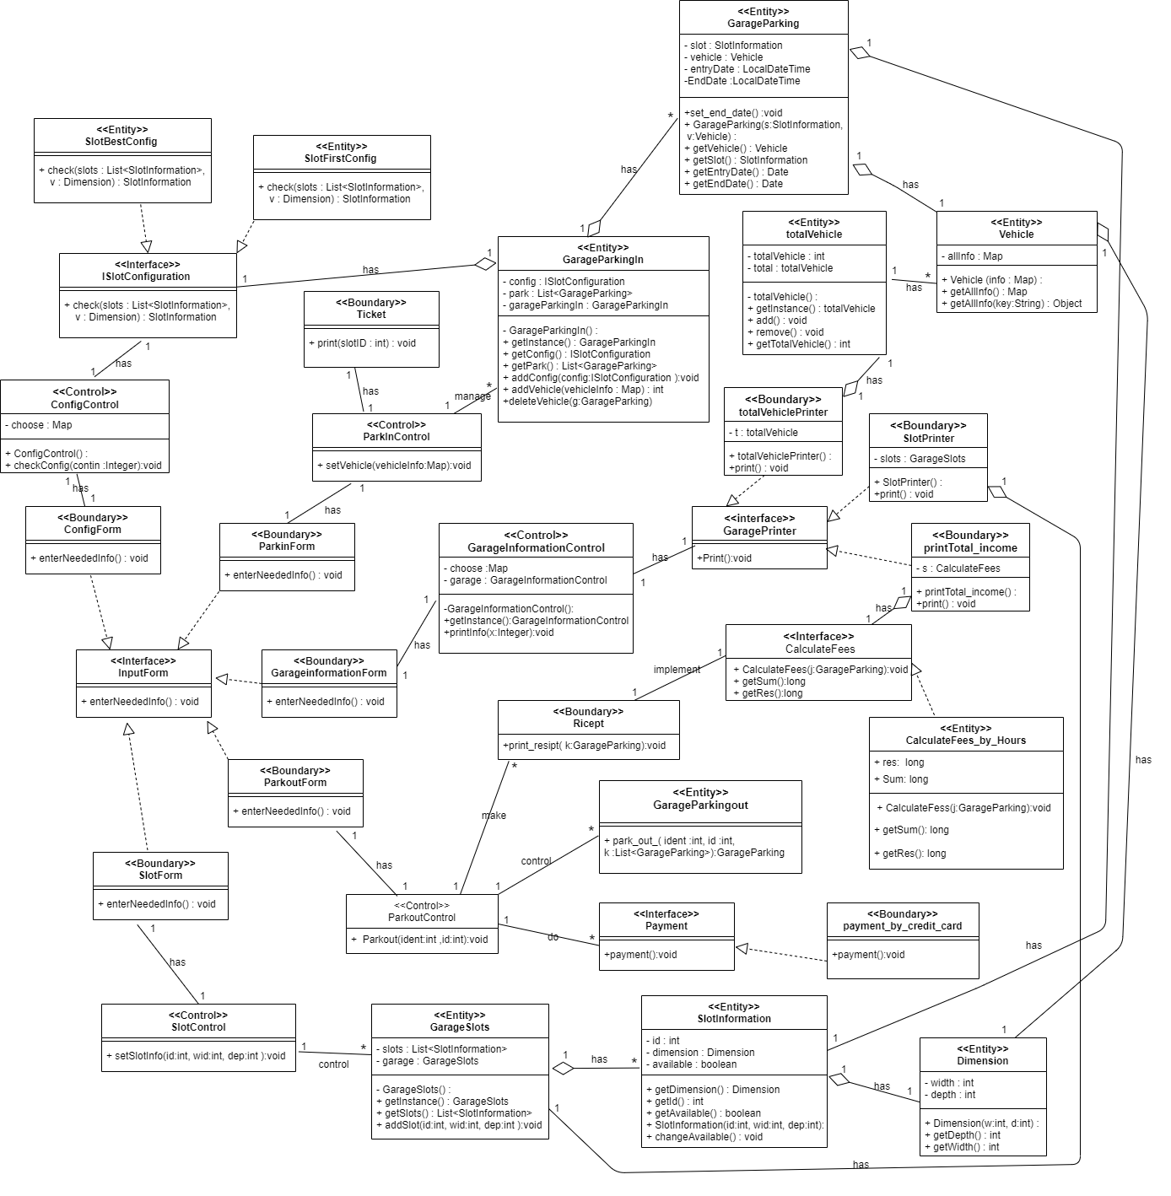

| **Class ID** | **Class Name** | **Description & Responsibility** |
| --- | --- | --- |
| C1 | InputForm | It’s interface class that used to model the interaction between the system and the several owners. |
| C2 | SlotControl | it is responsible sending information to garage class to add new slots. |
| C3 | GarageSlots | It is used to get slots information and add new slot in the garage. |
| C4 | SlotInformation | This method stores all slot information it is get Dimension (width and depth), get id, add new slot to garage and change available slot |
| C5 | Dimension | This method uses to get width and depth. |
| C6 | SlotForm | it is used to model the interaction between the system and the garage owner as it takes the required formation to all slots. |
| C7 | ParkoutControl | it is responsible for the park-out operations, as it receives car data from the input form and then verifies them in order to complete the park-out process. |
| C8 | ParkoutForm | it is used to model the interaction between the system and the vehicle owner as it takes the needed information for parking out process. |
| C9 | Payment | It’s interface class that is responsible for completing the payment process. |
| C10 | Payment_by_credit_card | That is methods for user to payment by credit card. |
| C11 | GarageParkingOut | It is used for get vehicle by unique identification number. |
| C12 | Ricept | It is used to display fees. |
| C13 | CalculateFees_by_Hours | It is responsible for calculating the required hourly fees. |
| C14 | GarageInformationForm | it is used to model the interaction between the system and the garage owner as it asks the garage owner to choose the data about the garage that he wants to see. |
| C15 | CalculateFees | It’s interface class that is responsible for calculating the value of the fees to be paid in order to complete the bark out process. |
| C16 | ConfigForm | it is used to model the interaction between the system and the garage owner as it asks him to Select park-in configuration. |
| C17 | ParkInForm | it is used to model the interaction between the system and the vehicle owner as it takes the needed information for parking in process. |
| C18 | GarageInformationControl | it is responsible for the operations of the garage, as it receives the response of the garage owner from the input form and then completes the required operation. |
| C19 | GaragePrinter | It’s interface class that is responsible for printing all the data for the garage. |
| C20 | printTotal_income | It is used to print income of the garage. |
| C21 | SlotPrinter | it is used to model the interaction between the system and the garage owner as it prints to him the information of available slots. |
| C22 | ParkInControl | It is responsible for the operations of the park in which it receives the data of the car from the input form and then checks it in order to add that car in the garage and prints a card for the customer with the number of this car. |
| C23 | ConfigControl | It is responsible for doing the Selected park-in configuration. |
| C24 | totalVehiclePrinter | It is used to print total vehicle of the garage. |
| C25 | Ticket | it is used to model the interaction between the system and the vehicle owner as it prints to him a ticket with his slot information. |
| C26 | ISlotConfiguration | It’s interface class that is responsible for checking the dimensions of the car to choose the most appropriate way to park in. |
| C27 | GarageParkingIn | This method used to save slot configuration, add new vehicle in my garage, remove vehicle from garage and get slot information. |
| C28 | totalVehicle | This method uses to save information about total vehicles that parking in the garage |
| C29 | Vehicle | It saves vehicle’s information. |
| C30 | GarageParking | It is set all parking information (the entry and exit date for parking this vehicle and save slot’s information that the vehicle parking in and vehicle information). |
| C31 | SlotBestConfig | This is method to get the best available slot for vehicle’s dimension. |
| C32 | SlotFirstConfig | this is method to know first available slot suitable for vehicle’s dimension (width and depth) |

### 

### Important Algorithm

* None

## II. Sequence diagrams

Sequence ID: setting

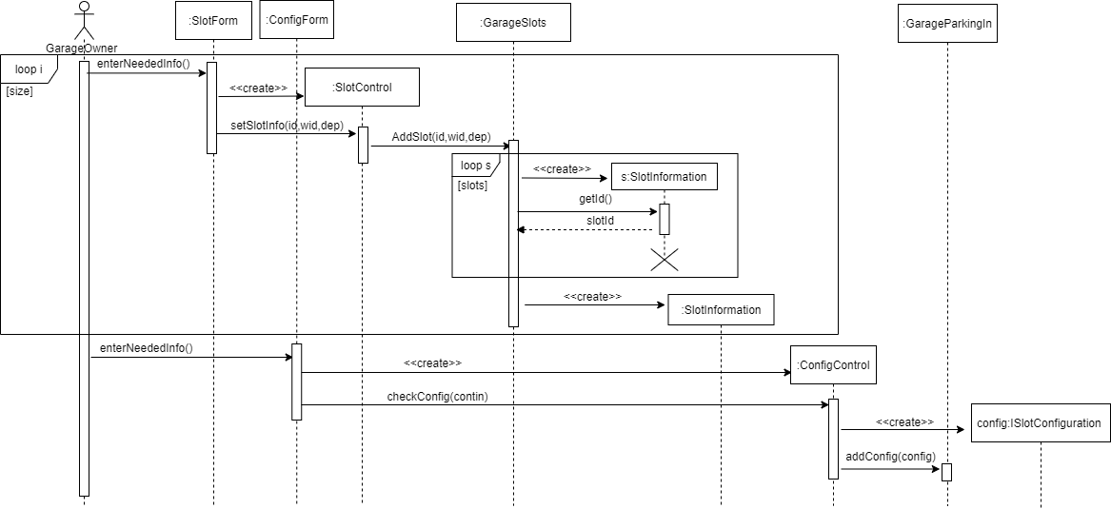

Sequence ID: displaySlots

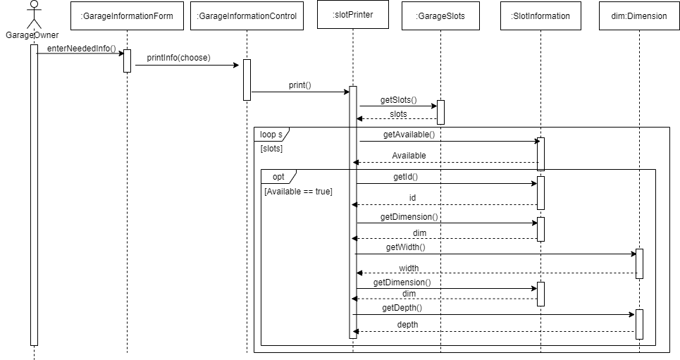

Sequence ID: totalVehicle

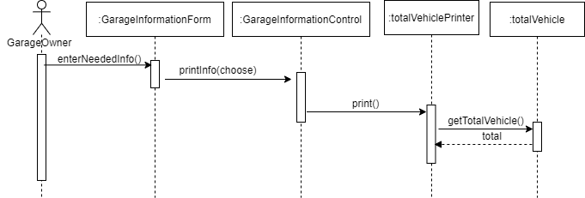

Sequence ID: parkin

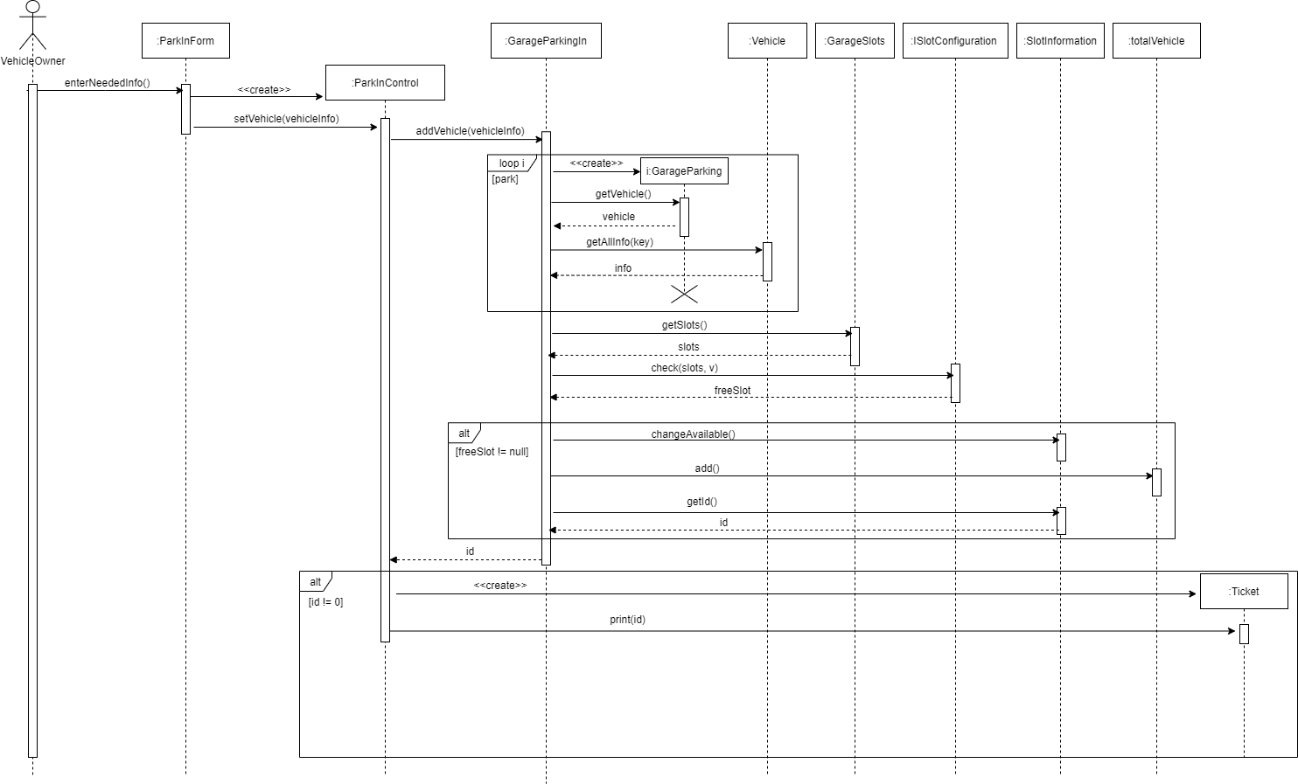

Sequence ID: parkout

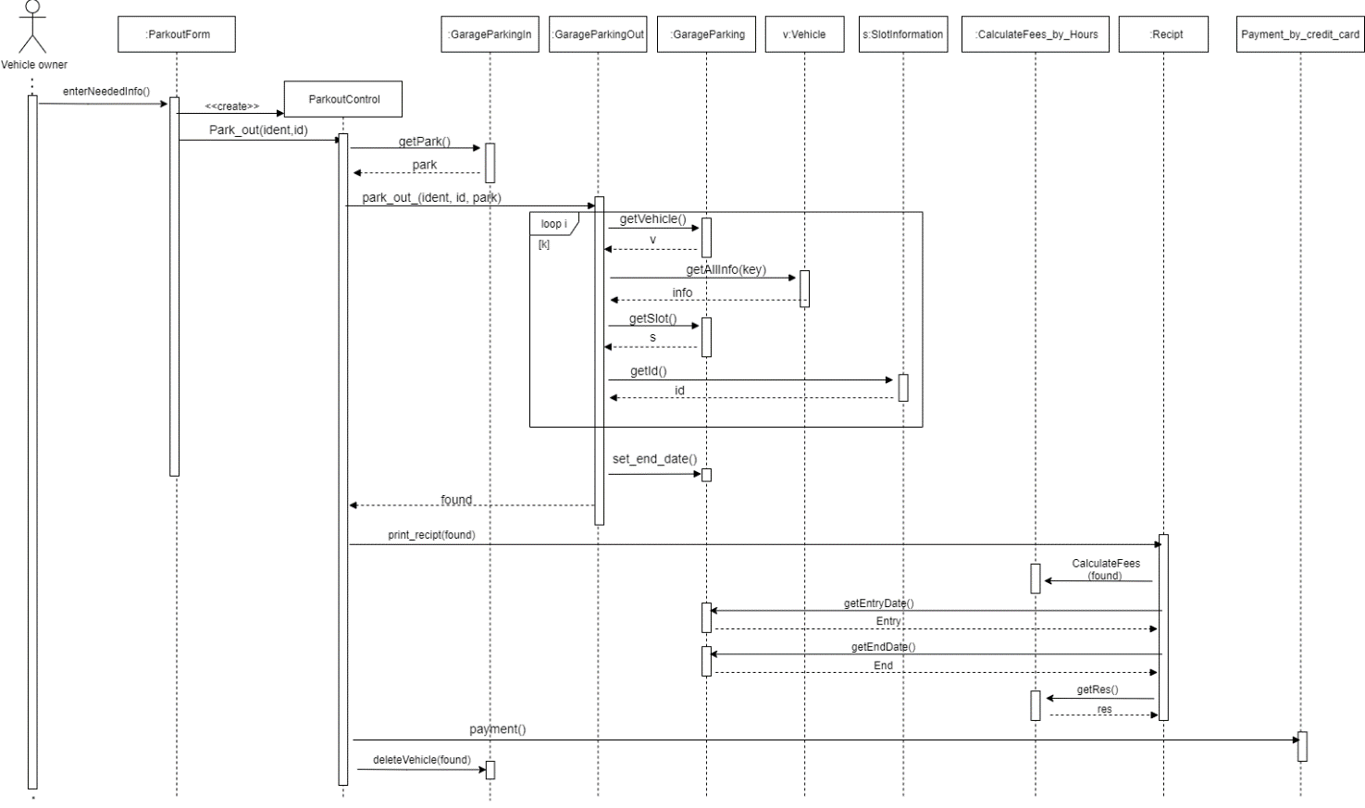

Sequence ID: total_income

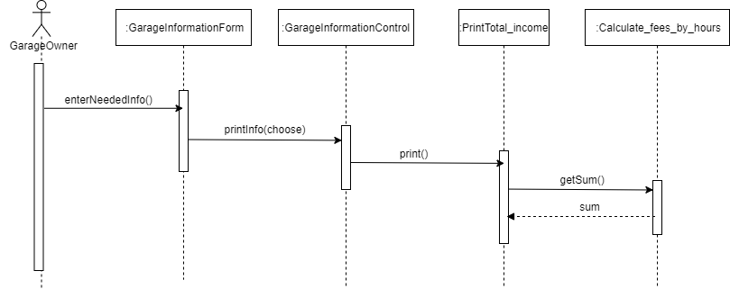

### Class - Sequence Usage Table

| **Class Name** | **Sequence Diagrams** | **Overall used methods** |
| --- | --- | --- |
| SlotForm | setting | enterNeededInfo |
| ConfigForm | setting | enterNeededInfo |
| SlotCOntrol | setting | setSlotInfo |
| GarageSlots | setting, displaySlots, parkin | AddSlot, getSlots |
| SlotInformation | setting, displaySlots, parkin, parkout | getId, getAvailable, getDimension |
| ConfigControl | setting | checkConfig |
| GarageParkingIn | setting, parkin, parkout | addConfig, addVehicle, getPark, deleteVehicle |
| ISlotConfiguration | setting, parkin | check |
| GarageInformationForm | displaySlots, totalVehicle, total_income | enterNeededInfo |
| GarageInformationControl | displaySlots, totalVehicle, total_income | printInfo |
| slotPrinter | displaySlots | print |
| Dimension | displaySlots | getWidth, getDepth |
| totalVehiclePrinter | totalVehicle | print |
| totalVehicle | totalVehicle, parkin | getTotalVehicle, add |
| ParkInForm | parkin | enterNeededInfo |
| ParkInControl | parkin | setVehicle |
| GarageParking | parkin, parkout | getVehicle, getSlot, set_end_date,getEntryDate, getEndDate |
| Vehicle | parkin | getAllInfo |
| Ticket | parkin | print |
| ParkoutForm | parkout | enterNeededInfo |
| ParkoutControl | parkout | Park_out |
| GarageParkingOut | parkout | Park_out_ |
| CalculateFees_by_Hours | parkout, total_income | CalculateFees, getRes, getSum |
| Recipt | parkout | Print_recipt |
| Payment_by_credit_card | parkout | payment |
| PrintTotal_income | total_income | print |

# Ownership Report

|  |  |
| --- | --- |
| **Item** | **Owners** |
| Document Purpose and Audience | Somaya |
| System Models | All |

# Policy Regarding Plagiarism:

**Students have collective ownership and responsibility of their project. Any violation of academic honesty will have severe consequences and punishment for ALL team members.**

1. تشجع الكلية على مناقشة الأفكار و تبادل المعلومات و مناقشات الطلاب حيث يعتبر هذا جوهريا لعملية تعليمية سليمة
2. ساعد زملاءك على قدر ما تستطيع و حل لهم مشاكلهم فى الكود و لكن تبادل الحلول غير مقبول و يعتبر غشا.
3. أى حل يتشابه مع أى حل آخر بدرجة تقطع بأنهما منقولان من نفس المصدر سيعتبر أن صاحبيهما قد قاما بالغش.
4. قد توجد على النت برامج مشابهة لما نكتبه هنا أى نسخ من على النت يعتبر غشا يحاسب عليه صاحبه.
5. إذا لم تكن متأكدا أن فعلا ما يعد غشا فلتسأل المعيد أو أستاذ المادة.
6. فى حالة ثبوت الغش سيأخذ الطالب سالب درجة المسألة ، و فى حالة تكرار الغش سيرسب الطالب فى المقرر.