BURN TO BECOME
❖
The Life You Could Have Lived
BAZOOKA

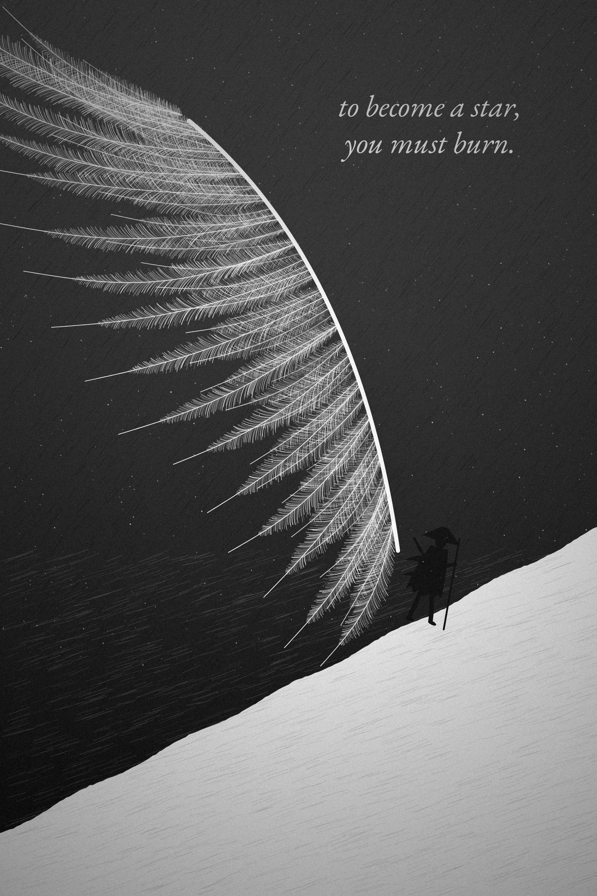

Copyright © 2026 Bazooka. All rights reserved.
No part of this book may be reproduced, stored in a retrieval system, or transmitted in any form or by any means without the prior written permission of the author, except for brief quotations used in reviews and critical articles.
This book offers reflection and general information. It is not a substitute for professional medical, psychological, financial, or legal advice. If you are struggling, please speak to a qualified professional or someone you trust.
The historical chapters draw on published sources listed in the Notes. Where the historical record is uncertain, the text says so.
All illustrations in this edition are original to it. See “A Note on the Illustrations.”
First edition. Working manuscript, 6 × 9 inches.
ISBN: [to be assigned]

For anyone standing in front of a door they already know they need to open.

“It is not that we have a short time to live, but that we waste a great deal of it.”
— Seneca, On the Shortness of Life

CONTENTS

AUTHOR’S NOTE
Before You Begin
❖
This book began with a question: what happens when a person becomes very good at surviving a life they never consciously chose?
The answer is not a single trick, a perfect routine, or another burst of motivation. It is a slower process of noticing, choosing, practicing, failing, and choosing again.
The language of fire runs through these pages on purpose. Fire can warm, illuminate, forge, and destroy. So can ambition. The aim here is not to romanticize exhaustion, pain, or self-punishment. Difficulty is not automatically growth, and rest is not weakness. The useful kind of discipline is the kind that helps you carry what matters without turning your own life into an enemy.
This is also not a book that will tell you that you can become anything you want. Adult life is more complicated than that, and you already know it. It asks a narrower and more useful question: within the life you actually have, with the limits you did not choose and the possibilities you have not yet tested, where is your agency?

How the book is built
Part I asks you to look honestly at the life you are living now. Part II examines the internal patterns that keep you repeating yourself. Part III studies six real lives—not as heroes to copy, but as evidence, contradictions included. Part IV asks what freedom is for once you leave a cage. Part V turns to the largest questions: time, loss, meaning, and what you want your one life to have been about.
After the Epilogue you will find a Field Manual: thirty days of short, concrete practices drawn from the chapters, with worksheets. Read the book straight through and return to the Field Manual, or work through them together.

How to read the stories
The historical chapters are not motivational legends. Alexander was a conqueror whose campaigns killed and enslaved people. Much of what is repeated about Musashi cannot be verified. Athletes succeed inside systems of coaching, money, health, and luck. Viktor Frankl’s survival of the Holocaust is not a lesson in positive thinking. Each chapter tries to say plainly what is known, what is uncertain, and what the popular version leaves out. Sources are gathered in the Notes at the back of the book.

How to read the exercises
Every exercise in this book is meant to produce information, not guilt. When a question makes you uncomfortable, the goal is not the harshest answer. It is the most accurate one.
Read slowly. Argue with the book. Mark the pages that irritate you. Ignore any advice that does not fit your actual circumstances. Keep what helps, and test it in ordinary life.
The purpose of these pages is not to give you a new identity to perform. It is to help you become more honest about the life you are already living—and more deliberate about the one you still have time to build.
Keep a notebook nearby. You will need it.


PART I

THE LIFE YOU ARE SLEEPWALKING THROUGH

You wake up and reach for your phone before you have properly opened your eyes. For a few minutes, other people’s lives arrive before your own does. There are messages waiting for replies, videos waiting to be watched, advertisements telling you what you are missing, photographs of places you are not, bodies you do not have, careers you have not built, and people who appear to have figured something out.
You scroll. The minutes disappear quietly enough that you barely register them. Then you get up and begin your day.
Perhaps you have responsibilities. Perhaps you work, study, care for people, solve problems, pay bills, answer messages, train your body, or carry expectations that nobody sees. From the outside, your life may look perfectly reasonable. You may even be proud of how well you keep it together.
And yet there may be a question that returns when everything becomes quiet: if you are doing so much, why does it sometimes feel as though your life is standing still?
The question is uncomfortable because it does not necessarily arise from disaster. Your life does not have to be terrible for you to suspect that it is not entirely yours. You can love your family and still want something different. You can be grateful for what you have and still feel the pressure of an unlived possibility. You can succeed at the things other people value and still wonder whether you ever stopped long enough to decide what you value.
We often imagine that a life changes through dramatic decisions: the career you choose, the person you marry, the country you move to, the business you start, the dream you finally pursue. But most of life does not happen at those moments. It happens in the smaller spaces around them: in what you do with an empty hour, what you repeatedly postpone, what you tolerate, what you make time for, what you stop noticing, and what you keep telling yourself you will do later.
The danger is not that one of these choices will ruin your life. The danger is that thousands of them may quietly construct one.
This book begins there. Not with the promise that you can become anything you want, because that promise is too simple for an adult life. Circumstances matter. Money matters. Family matters. Geography matters. Health matters. Opportunity is unevenly distributed. Some people begin with support, safety, education, and connections that others spend years trying to find. There are limits you did not choose and losses you cannot think your way out of.
So the question is not whether everything is your fault. The question is more useful: within the life you actually have, where is your agency? Where are you making a choice? Where are you avoiding one? Where is a limitation genuinely outside your control, and where have you turned fear into a permanent fact about yourself?
You may discover things here that you would rather not know. You may realize that you are not as busy as you claim. You may discover that approval matters to you more than you admit. You may notice that some ambitions were inherited rather than chosen, or that preparation has become a substitute for action. You may find that the reason you keep restarting is not that you are incapable, but that finishing would force you to be seen.
You may also discover something kinder and more unsettling: that you are tired, that you need help, that a goal no longer fits, or that the life you keep trying to optimize is not the life you actually want.
This is not a book about becoming a machine. It is a book about becoming harder to fool, including by yourself.
Before you change a life, you have to be willing to see it: not the life you describe, not the life you post, not the life you intend to begin one day, but the life visible in your calendar, your habits, your attention, your relationships, your unfinished work, and the ordinary shape of your days.
That is where the truth lives. And that is where we begin.

CHAPTER ONE

THE LIFE YOU DIDN’T CHOOSE
❖

The Life That Happened
There is a particular kind of regret that does not begin with a mistake. It begins with recognition.
You wake up one morning and realize you have become very good at continuing. You know the route to class or work, the conversations you are expected to have, the things you are supposed to care about, the habits that fill the gaps in your day. You know which responsibilities cannot be ignored and which promises to yourself can be postponed without anyone else noticing.
Nothing has necessarily gone wrong. That is what makes the realization difficult.
A life does not have to collapse before you can lose your sense of authorship over it. You can be doing reasonably well and still feel as though you are moving along a road that was laid down before you thought to ask where it leads. You can be surrounded by people who love you and still realize that much of what you are pursuing is being pursued because it was simply the next expected thing.
Inertia has no ideology. It does not care whether the destination is meaningful or empty. It only asks that tomorrow resemble today. The longer that happens, the more convincing the routine becomes. What was once a choice starts to feel like a fact.
This is why the first question of this book is not “What is your purpose?” That question is too large to be useful when you have not yet examined your actual life. Start closer to the ground. What do you do on an ordinary day? What receives your best attention? What have you made time for without needing to be reminded? What have you wanted for years but somehow never entered in the calendar?
The answers are not a complete definition of who you are, but they are evidence.

Later
The first lie is usually small: “I’ll do it later.”
Sometimes later is wise. You may be exhausted. The timing may be wrong. You may need more information. Real life contains obligations that do not disappear because you have found a dream worth pursuing. There is nothing noble about confusing recklessness with courage.
But “later” becomes dangerous when it has no date. Then it stops being a plan and becomes a sedative. It allows you to preserve the idea that you are still capable of becoming the person you imagine. You can be a writer without writing, an entrepreneur without building, an athlete without competing, an artist without showing anyone the work. Potential remains perfect as long as it remains untested.
The moment you act, the fantasy becomes vulnerable to evidence. You may discover that you are not as talented as you hoped. You may discover that you are better than you expected. You may discover that the work is much harder than the fantasy, or that the fantasy was never what you wanted in the first place. All of these outcomes can be uncomfortable, and the mind is very good at finding reasonable ways to postpone them.
Read another book. Watch another video. Make another plan. Wait until you are confident. Tell yourself that you are preparing.
You can spend an astonishing amount of your life standing beside the starting line while convincing yourself that you are preparing to run.
Potential is undefeated because potential has never entered the arena.

The Door
Imagine a room that has become so familiar that you no longer notice its walls. There is a chair, a screen, a routine, and everything you need to stay occupied. Across the room is a door.
You know what is on the other side only in outline. There may be embarrassment, failure, rejection, responsibility, discovery. There may also be opportunity, friendship, skill, freedom, and a version of yourself you cannot meet from inside the room.
So you study the door. You read about people who opened similar doors. You compare their journeys. You search for the safest route. You wait for confidence.
Then, one day, you put your hand on the handle. It moves.
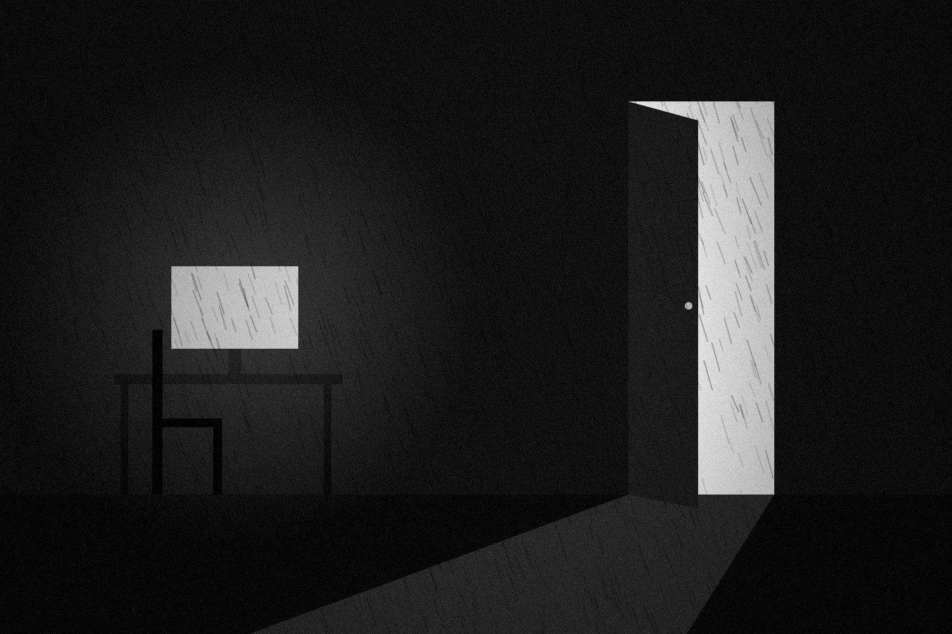
Figure 1. The door is rarely locked. It is only unopened.
The metaphor is simple, but the experience behind it is not. We often wait for certainty before acting, even though certainty is frequently created by action. You learn what you can handle by handling things. You discover what you want by trying. You build confidence by accumulating evidence that you can survive the consequences of being a beginner.
That does not mean every door should be opened. Some doors lead into genuine danger. Some lead to obligations you do not actually want. Wisdom is not refusing to act; it is learning to distinguish danger from discomfort.
TRY THIS
The Five-Year Projection
If your current habits remained largely unchanged for five years, what kind of life would they quietly build? Write it down in plain sentences.
Then ask the reverse: what would have to become different in the next year for that future to change?
Do not answer with an abstract version of yourself. Name the behavior. Put one real thing on the calendar.

A life you consciously choose is not created in one dramatic declaration. It is built by repeatedly making your actions agree with what you say matters.
The first task is not to run outside. It is to notice the door.

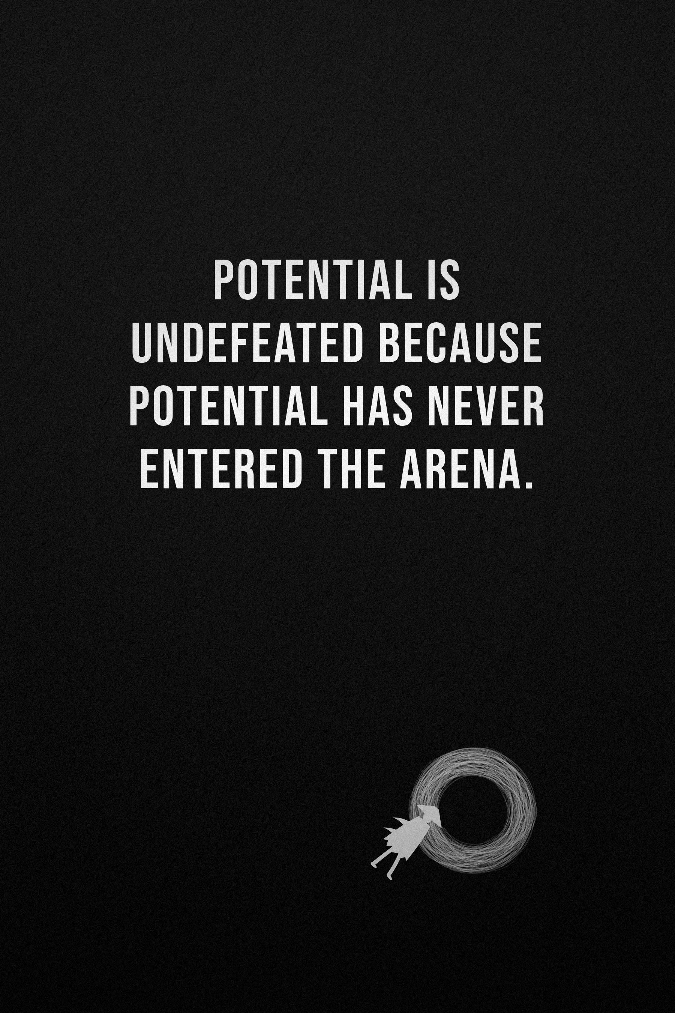

CHAPTER TWO

THE COMFORTABLE CAGE
❖

Comfort Is Necessary
We speak about comfort as though it were a moral failure. It is not. Rest is necessary. Safety matters. Familiarity can be healing. There are seasons in which surviving is the achievement, and anyone who turns every form of comfort into weakness has misunderstood what human beings require.
The problem begins somewhere else. Comfort becomes dangerous when it stops being a place you return to and becomes a place you refuse to leave.
There is a difference between recovery and avoidance. Recovery restores your capacity to act. Avoidance protects you from the feeling that would accompany action. From the outside they can look almost identical: you are sitting down, doing something easy, giving yourself a break. The difference becomes visible afterward. Recovery leaves you more able to return. Avoidance makes returning harder.

How the Cage Learns
Most cages are not constructed in one afternoon. They are assembled out of decisions that make immediate sense. You postpone the difficult email because you are tired. You skip the workout because the day has been stressful. You avoid the application because you are not ready. You open your phone because you need a break. You tell yourself you will start tomorrow.
Nothing seems important enough to be called a turning point.
But relief teaches. When an uncomfortable task appears and you escape it, the immediate drop in tension rewards the escape. The next time a similar situation arrives, avoiding it feels even more natural. Researchers who study procrastination describe it less as a time-management problem than as a mood-management one: we put things off because putting them off makes us feel better now, and we pay for that relief later.
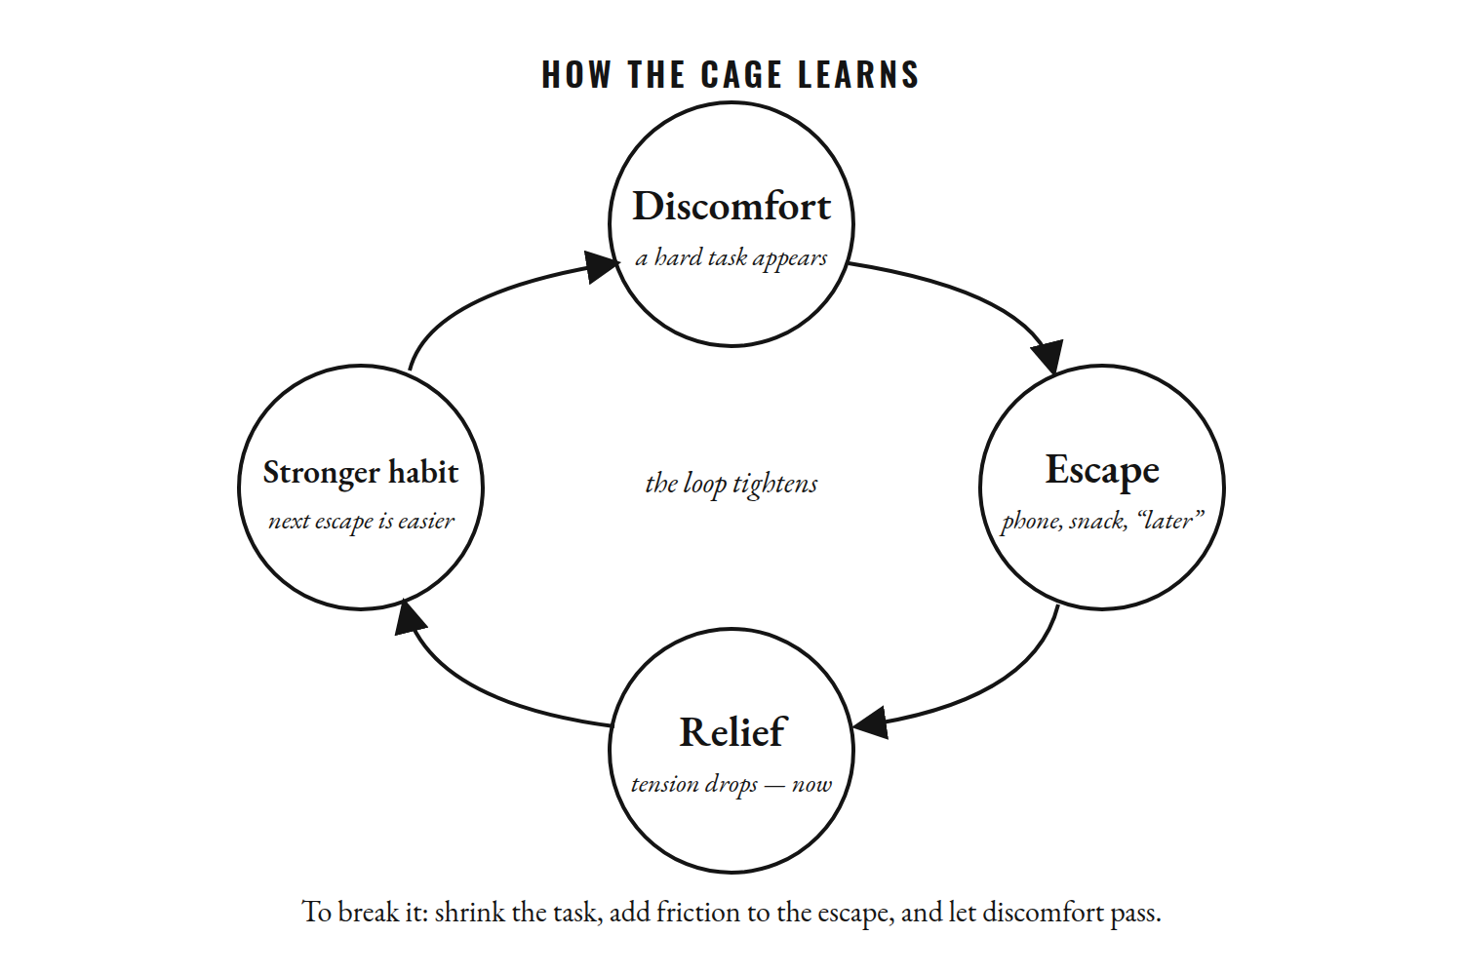
Figure 2. How the cage learns: every escape is rewarded with relief, and the reward makes the next escape easier.
This is one reason knowing what you should do is not always enough to make you do it. The short-term emotional reward of escape competes with a much larger reward that exists somewhere in the future, and the present is a very persuasive negotiator.
Shame rarely solves that problem. Understanding the sequence can. What triggers the avoidance? What does it give you immediately? What does it cost you later? What could reduce the friction of approaching the task?
These are better questions than “Why am I so lazy?” They turn a moral judgment into a pattern that can be examined.

The First Movement
Confidence is often described as a feeling. Much of what people experience as confidence, however, is accumulated evidence.
You take an action that scares you and discover that nothing catastrophic happens. You do it again. You make a mistake and discover that recovery is possible. You perform badly and discover that performance can improve. You ask for help and discover that asking did not destroy your independence.
The point is not that every attempt ends well. Sometimes it doesn’t. The point is that you begin collecting information about your capacity.
That is why the first movement can be deliberately small. Send the application. Open the document. Make the call. Walk for ten minutes. Ask the question. Stay with the task for twenty minutes before deciding whether you feel motivated.
Small actions can look unimpressive from the outside. Their psychological value is that they create evidence.
You may not feel ready. Readiness is often imagined as a feeling that arrives before action, but for many meaningful goals it is partly produced by action. There are situations that require preparation, expertise, and caution; starting early is not a universal virtue. But perfect readiness does not exist. At some point, preparation has to become contact with reality.
TRY THIS
Recovery or Avoidance?
The next time you take a break, ask one question afterward: do I feel more able to return, or less?
If more, that was recovery. Protect it.
If less, that was avoidance. Do not punish yourself. Write down what you were escaping and what the smallest possible first movement toward it would be.

A door does not have to be kicked down. Sometimes it only needs to open far enough for you to step through.

CHAPTER THREE

YOU ARE VERY GOOD AT LYING TO YOURSELF
❖

The Internal Lawyer
Most lies are easier to recognize when someone else tells them. The difficult ones are the explanations we invent because they protect something we do not want to examine.
“I’ve been busy.”
“I work better under pressure.”
“This isn’t the right time.”
“I’m just waiting for the right opportunity.”
“I don’t really care that much.”
“I could do it if I wanted to.”
Any of these statements may be true. That is why self-deception is rarely ridiculous. It usually borrows the language of reason.
There is an internal lawyer in most of us, forever preparing a defense for the person we already are. The lawyer is not necessarily an enemy. People need coherent stories about themselves. We need explanations that help the past make sense. But the lawyer can become too competent. Instead of asking whether the argument is accurate, we become satisfied that it is convincing.
And convincing is not the same as true.

Your Life Leaves Receipts
If you want to know what matters to you, look at the evidence. Your calendar records where time went. Your bank account records where money went. Your messages record who received your attention. Your unfinished work records some of what you repeatedly postponed. Your relationships show what you gave, what you withheld, and what you tolerated.
None of these records tells the whole story. A calendar cannot measure grief. A bank account cannot measure generosity. An unfinished project does not prove laziness. Context matters.
But your life still leaves receipts, and sooner or later the story you tell about yourself has to meet the life you can actually point to.
You say health matters, but your behavior does not support it. You say creativity matters, but every free hour disappears into consumption. You say your family matters, but they receive what remains after everything else. You say freedom matters, but you repeatedly choose the option that makes tomorrow smaller.
The purpose of noticing a mismatch is not humiliation. It is information.

Honesty Without Cruelty
There are two easy ways to look at yourself badly.
The first is denial: everything is fine, nothing needs to change, the circumstances are always to blame.
The second is contempt: everything is my fault, I am weak, I am behind, I have wasted my life.
Both distort reality. Honesty sits between them. Honesty can say, “I did not handle that well,” and also, “That situation was genuinely difficult.” It can say, “I need to change,” and also, “I need help.” It can say, “I want this,” and also, “I do not want this anymore.”
The goal is not the harshest interpretation. It is the most accurate one.
TRY THIS
The Receipts Week
For one week, keep a private record of what you actually do. Not the person you intend to be—the person who shows up.
Where does your best attention go? What do you avoid? What gives you energy? What numbs you? Which promises do you keep, and which ones repeatedly migrate into the future?
At the end of the week, ask one question: “What does my behavior seem to believe that my words do not?”

The answer may surprise you. Let it.

CHAPTER FOUR

WHAT ARE YOU ACTUALLY AFRAID OF?
❖

Fear Changes Clothes
Fear is rarely considerate enough to announce itself as fear.
Sometimes it looks exactly like fear: a racing heart, a tightened chest, an urge to leave. But sometimes it wears better clothes. It becomes procrastination. It becomes perfectionism. It becomes endless research. It becomes sarcasm, indifference, or the sentence “I don’t really care.”
The surface behavior can be treated for years while the underlying fear remains protected. You keep reorganizing the plan instead of starting. You keep improving the idea instead of showing it to anyone. You keep waiting until you are confident. You call yourself realistic because the alternative is admitting that you are scared.
The important question is not whether fear exists. It is what the fear is protecting.

What Failure Might Reveal
Failure is obvious, so we talk about it constantly. But many people are frightened less by failure itself than by what failure might reveal.
If you try, perhaps you will discover that your current ability is nowhere near the level you imagined. Perhaps you will discover that people were right about you. Perhaps you will discover that the dream is not yours.
Then there is the fear of being seen. Trying publicly means other people can judge the attempt.
There is the fear of success, which is less often discussed. Success can create new expectations. It can change relationships. It can remove the comforting excuse that you were “going to” do something someday.
There is the fear of being ordinary: what if you give everything you have and still become only good rather than extraordinary?
And there is another fear beneath many of the others: What if I waste my life?
Avoiding the attempt cannot answer that question. It can only prevent you from discovering what is actually true.

The Hidden Bargain
Perfectionism can sound like ambition. You care about quality. You have standards. You do not want to release mediocre work. Sometimes that is healthy.
Sometimes perfection is armor.
If the first draft must be brilliant, you can postpone writing indefinitely. If the business idea must be certain, you never have to make an offer. If the first public performance must be impressive, you never have to be a beginner in front of other people.
Psychologists have a name for one version of this: self-handicapping. People sometimes arrange their own obstacles—too little preparation, too late a start, too little effort—so that a poor result can be blamed on the circumstances rather than on their ability. It protects the ego in the short term and quietly guarantees the outcome it fears.
The hidden bargain is simple: if I do not truly try, I never have to find out.

The Four Voices
When you face a meaningful decision, listen for four voices.
Fear asks, “What if this goes badly?”
Ego asks, “What will this say about me?”
Approval asks, “What will they think?”
Values ask, “What matters to me even if the outcome is uncertain?”
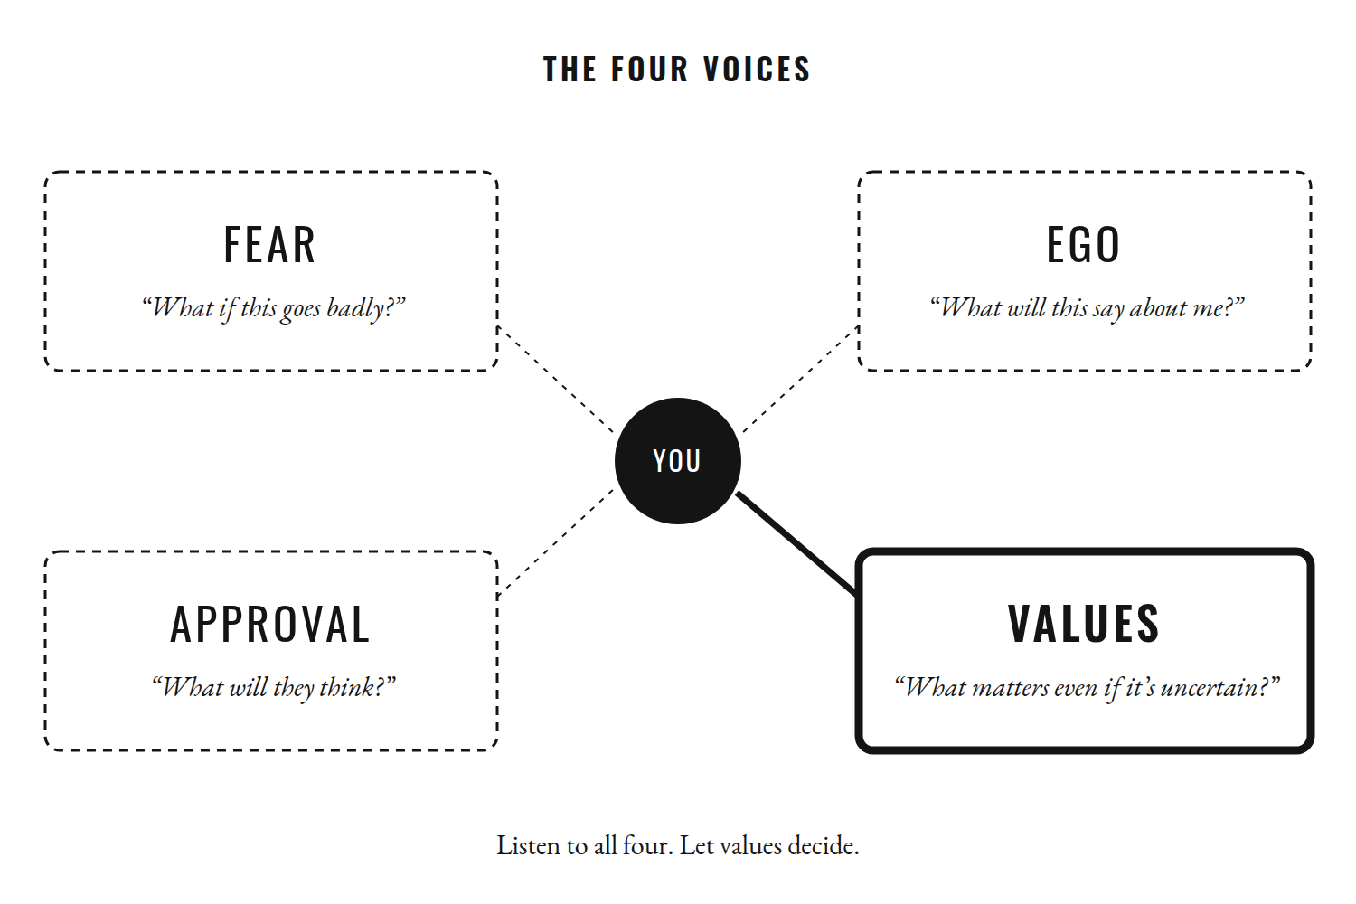
Figure 3. Four voices speak in every meaningful decision. Only one of them should get the final word.
The first three voices are not enemies. Fear can identify real danger. Ego can reveal what you are protecting. Approval can remind you that relationships matter. But none of them deserves automatic control.
Courage is not a personality type. It is a behavior, and behavior can happen while fear is present.
TRY THIS
Name the Fear
When you notice yourself delaying something important, replace “Why am I procrastinating?” with a more precise question: “What am I afraid will become true if I try?”
Write the answer in one sentence.
Then ask the question we usually avoid: “What might become true if I never do?”

CHAPTER FIVE

THE PSYCHOLOGY OF ALMOST
❖

Always About to Begin
There is a life built around almost. Almost started. Almost finished. Almost launched. Almost called. Almost published. Almost changed.
The person living this life may not look passive. They research, plan, buy equipment, watch tutorials, create schedules, and speak confidently about the future. The problem is not preparation. The problem is preparation that never has to meet reality.
The fantasy beginning is clean. The real beginning is not. Real work contains awkward drafts, technical mistakes, rejection, boredom, bad days, and the discovery that your current ability is smaller than your imagination. That gap is where many people turn around.
There is a particular comfort in remaining “someone who could.” As long as the attempt has not become real, the possibility remains intact. You can still imagine the best version of yourself without having to test what that person can actually do.

The Beautiful Beginning and the Boring Middle
Beginnings are attractive because beginnings contain possibility. The first day at the gym. The first page of the book. The first customer. The first public post. The first week of a new routine.
Then the middle arrives.
You are no longer new enough to live on excitement, but you are nowhere near skilled enough to live on mastery. The work becomes familiar enough to be boring and difficult enough to remain humbling.
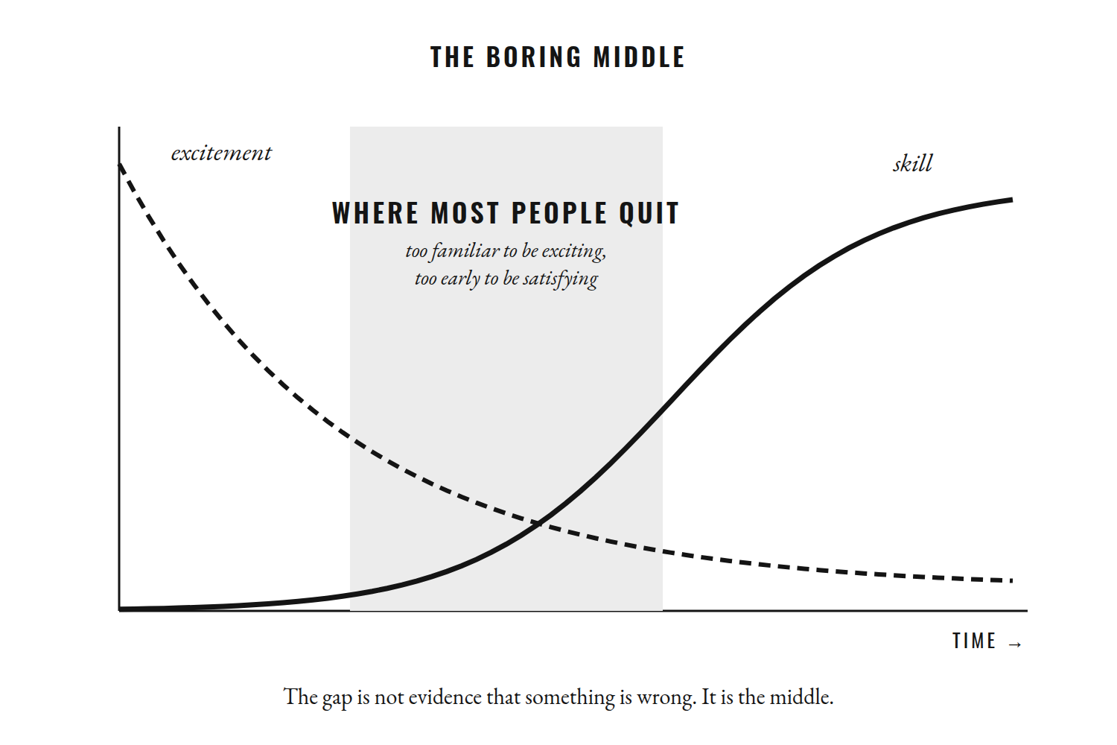
Figure 4. Excitement fades before skill arrives. Most people quit in the gap between them.
This is where continuity matters. The world celebrates visible transformation because visible transformation makes a good story. But most transformation is too gradual to feel like a story while it is happening. You practice, correct, repeat, and improve by an amount too small to notice today.
Then months pass. Someone sees the result and calls it sudden.
It was not sudden. It was accumulated.

Let Reality Answer
Starting over gives you something completion cannot: a clean identity. On day one, anything is possible again. You can imagine the perfect schedule, forgive yourself for the previous attempt, and tell yourself that this time you know what you are doing.
Finishing is different. Finishing creates evidence. The book is either written or it is not. The application was sent or it was not. The offer was made or it was not. Evidence is less comfortable than potential because evidence can contradict the story you prefer.
This is why restarting can become addictive. A new plan gives you hope without demanding proof.
The cure is not another perfect system. It is contact with reality. Write one page. Make one offer. Attend one session. Have one conversation. Complete one difficult task before consuming more information about it.
Then look at what reality tells you.
Maybe the plan is wrong. Good. Now you know.
Maybe you are better at it than you thought. Good. Now you know.
Maybe the dream is not yours. Good. Now you know.
Reality is useful in a way fantasy cannot be. It gives you something to work with.
At some point, you have to stop asking whether you could become the person you imagine and start collecting evidence about the person you can become through action.
Almost is not failure. But staying almost forever is a decision.

CHAPTER SIX

THE DEATH OF POTENTIAL
❖

The Compliment That Can Become a Trap
“You have so much potential.”
It may be one of the most flattering things someone can say to you. It can also be a strange place to live.
Potential is possibility before it becomes performance. It describes what might happen, not what has happened. That makes it hopeful, but it also makes it easy to protect.
A talented person can go years without finding out what disciplined practice would produce. An intelligent person can keep learning without ever creating. A gifted athlete can avoid competition because competition turns possibility into a scoreboard. A person can become attached to being “someone who could” rather than becoming someone who did.
The danger is not having potential. The danger is becoming emotionally invested in preserving the idea of it.

Reality Gives You Numbers
There is a reason measurement can feel threatening. Measurement removes some of the freedom of imagination.
Before you test your ability, you can believe almost anything. Maybe you are brilliant. Maybe you are naturally gifted. Maybe you would succeed if you really tried.
Once you act, reality answers with something more specific: pages written, hours practiced, projects completed, applications submitted, competition results, skills learned, habits kept.
These measurements are not verdicts on your human worth. They are information about a particular effort at a particular moment. That distinction matters. A poor result does not make you a poor person. A strong result does not make you permanently exceptional. Both are temporary measurements.
But without measurement, you are left with imagination, and imagination can keep you comfortable for a very long time.

The Fantasy Self
There is a version of you that exists entirely in possibility. They are disciplined. Confident. Creative. Financially free. Respected. They finish what they start.
They can remain flawless because you never ask them to do anything.
The psychologist Gabriele Oettingen spent years studying what happens when people vividly imagine their desired future. The surprising finding was that pleasant fantasies about success, on their own, often predicted less effort and poorer results, not more. The mind can treat the imagined achievement as a partial reward, and the energy to pursue the real one drains away. What helped was pairing the wish with a clear look at the obstacle standing in the way.
The danger comes when you compare your real self to that imaginary one. Reality will always lose. Reality has bad mornings, weak drafts, awkward conversations, unfinished attempts, and limits. The fantasy self has none of these because the fantasy self has never had to live.
The answer is not to kill ambition. It is to stop protecting fantasy from reality. Let your first attempt be worse than your imagination. Let your current ability disappoint you. Let the information sting. Then use it.
TRY THIS
Wish, Then Obstacle
Write down one thing you genuinely want this year. Then write the best outcome you can imagine, in one sentence.
Now write the main obstacle inside you—not outside—that is most likely to stop you. A feeling, a habit, a belief.
Finally, write a plan in this shape: “If [the obstacle appears], then I will [specific action].”

You are not required to fulfill every possibility you possess. That would be impossible. There are too many possible careers, places, skills, relationships, and versions of yourself. Choosing one direction necessarily leaves other lives unexplored.
The goal is not to exhaust your potential. It is to stop letting potential become an excuse for inaction.
If there is something you genuinely want to try, do not spend another decade protecting yourself from the answer.
Potential is a door. Action is how you find out what is on the other side.


PART II

THE WAR INSIDE YOU

Awareness is not transformation.
You can understand yourself and still repeat yourself. You can know exactly why you procrastinate and still procrastinate tomorrow. You can recognize the pattern, explain the psychology behind it, underline the research, tell someone else what they should do—and then do the opposite the moment discomfort arrives.
That is where the real difficulty begins. Once you can see the cage, you have another problem: you still have to leave it.
The enemy is rarely one dramatic weakness. It is usually a collection of small negotiations.
Five more minutes. Tomorrow instead. I’ll start when I’m ready. This isn’t the right time. I deserve a break. I’ll do it properly next week. I work better under pressure. I need to learn more first. Maybe I’m just not that kind of person.
Each sentence is small. None of them feels like a life-changing decision. But a life is built from decisions that feel too small to matter.
That is why the battle is difficult. There is rarely a villain standing outside the door. Sometimes the person keeping you where you are is the same person who desperately wants to leave.
This is also why discipline is so often misunderstood. People imagine it as an act of force: a stronger version of yourself dragging a weaker version forward. Sustainable change is rarely that simple. You are a person with competing motives.
One part of you wants the future. Another wants relief now. One wants the body you could build. Another wants the comfort of the bed. One wants meaningful work. Another wants the certainty of familiar work. One wants to be seen. Another is terrified of being judged. One wants freedom. Another is frightened by everything freedom requires.
You do not have to hate the weaker part. You have to understand it—and then decide which part gets the final vote.
There will be days when motivation helps and days when it disappears. Days when the goal feels exciting and days when it feels pointless. Days when you believe in yourself and days when you don’t. The person who acts only when the internal weather is perfect will spend much of life waiting for clear skies.
You need something more reliable than a feeling. A relationship with your own word. A reason. A system. A willingness to begin badly, and to continue after the novelty disappears. And, perhaps most importantly, the ability to return after you fail.
This part of the book is about that return. It is about comfort and avoidance, motivation and identity, self-deception and discipline, failure, attention, ambition—and the stories you tell yourself when nobody is listening.
It is not a war against yourself. It is a war against the patterns that keep making your world smaller. Some of those patterns will feel so familiar that, at first, you may mistake them for personality. They are not always personality. Sometimes they are simply practice.
And what has been practiced can be practiced differently.
You will not win this war once. There is no final morning when you wake up permanently disciplined, permanently courageous, permanently focused. There will be no version of you that never wants the easy option again. That person does not exist.
The aim is not permanent victory. It is becoming better at choosing—again, and again, and again—until the choices begin to shape the person making them.
That is where becoming starts.

CHAPTER SEVEN

IT IS YOU VS. YOU
❖

Two Futures in the Same Body
There are days when the obstacle is obvious. The deadline is real, the opportunity is visible, the work is sitting in front of you, and still you do not move.
The confusion comes from wanting two things at once. You want the future and you want relief from the present. You want the result of effort without having to experience the effort. You want confidence without risking embarrassment, the finished book without the terrible first draft, freedom without uncertainty, strength without the period in which you are still weak.
These contradictions do not make you broken. They are part of being human. Immediate rewards are concrete; future rewards are imagined. The bed is real. The notification is real. The snack is real. The goal that exists five years from now is an idea. Behavioral scientists have documented this tilt for decades: rewards lose their pull on us the further away they are, and they lose it fast.
The question, then, is not how to eliminate the part of you that wants comfort. The question is which part gets the final vote when your motives disagree.

Make the Better Choice Easier
Your future self has legitimate interests. That future person will need the health you build now, the skills you practice now, the relationships you care for now, and the financial stability you create over years.
But the present self has legitimate needs too. You need rest, pleasure, connection, and recovery. A life that sacrifices every present need to an abstract future is not freedom either.
The useful work is often environmental rather than heroic. One of the more surprising findings in self-control research is that people who appear to have great willpower often use less of it. They experience fewer temptations in the first place, because they have arranged their lives so that the hard choice rarely has to be made.
If your phone is beside you while you work, distraction requires almost no effort. If the thing you are trying not to eat is always within reach, restraint has to be exercised repeatedly. If the people around you reinforce the habit you are trying to change, the environment itself becomes resistance.
Make the desired action easier and the unwanted action harder. Prepare what you need. Put the phone away. Choose the time in advance. Reduce the number of decisions you have to make when you are tired.
The goal is not to become a machine. It is to remove unnecessary negotiations.

Self-Trust
There is another form of discipline that matters even more than forcing yourself through a difficult afternoon: keeping small promises.
If you repeatedly tell yourself you will do something and repeatedly do not, your intentions begin to lose credibility. You stop believing yourself, the way you would stop believing a friend who never shows up.
The answer is not to make bigger promises. Make smaller ones and keep them. Read five pages. Write one paragraph. Walk for ten minutes. Send the email. Train for the amount you can responsibly train today.
When you keep a promise, you create evidence that your word means something.
Eventually, “you versus you” stops sounding like a war. It becomes a negotiation about which version of you gets strengthened by repetition. The person who wants immediate relief is still there. So is the person who cares about what happens next year. Every ordinary choice is a small vote.
You will never eliminate the conflict. You can, however, become better at choosing which voice gets to speak last.



CHAPTER EIGHT

THE ADDICTION TO EASY
❖

A World With Almost No Friction
Modern life is exceptionally good at removing friction. Food can arrive at your door. Entertainment begins instantly. A question can be answered before curiosity has had time to develop. A notification can pull your attention away from a task in less than a second.
Convenience is not the enemy. Much of it is genuinely useful. The problem begins when ease becomes the default condition of your attention.
When every moment of boredom is immediately filled, boredom begins to feel like a problem. When every difficult task can be interrupted, sustained attention becomes harder to practice. When every uncomfortable emotion can be escaped within seconds, staying with the feeling can begin to feel abnormal.
In one widely discussed set of experiments, researchers asked people to sit alone in a room with nothing to do but think for six to fifteen minutes. Many found it unpleasant. In one study, a substantial share of participants—most of them men—chose to give themselves a mild electric shock rather than simply sit with their thoughts.
The question is not whether technology is evil. The question is whether you have become so accustomed to immediate relief that ordinary effort now feels unnecessarily painful.

The Reward Before the Work
Easy choices are seductive because they pay immediately. You press a button and something happens. You scroll and receive novelty. You order and receive food. You refresh and receive information.
Meaningful goals often work in the opposite direction. Exercise gives you discomfort before adaptation. Learning gives you confusion before understanding. Writing gives you awkward sentences before good ones. Building something gives you uncertainty before it gives you traction. Relationships require vulnerability before intimacy.
Difficulty is not automatically valuable. Some difficulty is pointless, and some suffering is simply damage. But worthwhile goals often contain useful resistance. If you remove every moment of resistance, you may also remove opportunities to practice staying with something after the first impulse to escape.
This is why boredom is worth examining. You do not need to romanticize it. You simply need to know whether you can experience an empty moment without immediately demanding a new stimulus.
TRY THIS
The Friction Test
For one part of your day, remove the easiest escape. Put the phone in another room. Work without opening another tab. Walk without filling every silence. Read something difficult without checking for a notification.
Notice what happens before you judge the experiment. Restlessness may appear. You may suddenly remember several things you supposedly need to check. The urge to leave the task may feel surprisingly strong.
Then notice something else: the discomfort rises, changes, and usually does not remain at its maximum forever.

The point is not to make life harder. It is to reclaim the ability to choose effort when effort is meaningful.
The easiest choice is not always the freest choice. Sometimes freedom is the capacity to stay when nothing is entertaining you.

CHAPTER NINE

WHY MOTIVATION KEEPS BETRAYING YOU
❖

The Feeling of Beginning
Motivation feels like certainty. You watch a speech, read a story, hear an idea, and for a moment the future becomes unusually clear. Tomorrow will be different. You will wake up earlier, train, study, write, build, stop wasting time, and finally become serious about the life you keep imagining.
The feeling is real. But a feeling is not a system.
The problem begins when you build a life that requires the feeling to return before the work can continue. The night before, you were certain. The next morning you are tired. The goal feels distant. The room is cold. The novelty is gone. You wonder what happened to the person who felt so powerful a few hours earlier.
Nothing happened. Motivation did what motivation does. It changed.

Build for the Day You Do Not Feel Like It
A useful system answers the question, “What will I do when I do not want to?” It makes the first action concrete. The time is chosen. The materials are ready. The task has a clear starting point. You do not have to debate with yourself from zero each day.
Instead of “I should exercise more,” decide what happens at a particular time and place. Instead of “I should write,” define when the writing begins and what counts as beginning. Psychologists call these implementation intentions—plans in the form “When situation X arises, I will do Y”—and across many studies they have helped people follow through on goals more reliably than good intentions alone. They do not guarantee behavior, but they turn a wish into something you can actually test.
Then make the minimum version small enough to survive an ordinary bad day. A minimum is not the final goal. It is the bridge that keeps the behavior connected to your identity when life becomes inconvenient.
Consistency does not mean performing at maximum intensity every day. It means maintaining contact with what matters.
TRY THIS
Write Your “When–Then”
Choose one goal. Write one sentence: “When it is [time] and I am in [place], I will [first physical action].”
Then write your minimum: the smallest version you will still do on your worst ordinary day.

Maybe It Is the Wrong Mountain
There is another reason motivation can disappear: the goal may not belong to you.
You can build an excellent system for a life you do not actually want. You can become disciplined at climbing someone else’s mountain.
Before asking how to stay motivated, ask why the goal matters. Would you still want it if nobody knew? Would you still want the ordinary Tuesday version of the life it creates? Would you accept the price if the result took much longer than expected?
If the answers are still yes, build the structure and let motivation become a useful visitor rather than a landlord.
And when motivation disappears again, do not immediately conclude that you have failed. Check the system. Check the goal. Check your energy. Then decide. Sometimes the right response is to continue. Sometimes the right response is to change the way you are doing it. Sometimes the right response is to stop.

CHAPTER TEN

THE IDENTITY TRAP
❖

When a Description Becomes a Sentence
There is power in saying, “This is who I am.” Identity can organize behavior. If you see yourself as someone who trains, training can become easier to imagine as part of your life. If you see yourself as a writer, sitting down to write can feel less like a strange experiment and more like something people like you do.
But identity can become a cage when the description hardens into a verdict.
“I have never been disciplined.”
“I am bad at talking to people.”
“I am not creative.”
“I always procrastinate.”
“I am just not that kind of person.”
These sentences often sound like observations. Sometimes they are predictions disguised as observations. Once a story about yourself becomes familiar, evidence that contradicts it can feel strangely uncomfortable.

Do Not Replace One Cage With Another
The answer is not to construct a new rigid identity and defend it just as fiercely. “I am disciplined.” “I never miss.” “I am obsessed.” “I am the strongest.”
What happens when you fail?
If your identity depends on perfect behavior, ordinary mistakes become existential threats. A more flexible identity describes direction rather than perfection. “I am someone who returns.” “I am someone who practices.” “I am someone who learns.” “I am becoming more reliable.”
These statements leave room for a bad week without requiring you to abandon the entire story.

Let Evidence Change the Story
Behavior may change before identity does. You can train for months and still feel like someone who is “trying to get fit.” You can write for a year before “writer” feels natural. You can practice boundaries and still feel guilty while you are doing it.
That lag is not evidence that the change is fake. Give the new behavior time to accumulate evidence.
You do not have to destroy the person you were. That person contains experiences you still need. The goal is to stop allowing old patterns to make every new decision.
Sometimes the most useful identity is not “I am finished.” It is “I am the kind of person who returns to what matters.”

CHAPTER ELEVEN

THE THINGS YOU DO NOT WANT TO KNOW ABOUT YOURSELF
❖

The Truth Beneath the Explanation
There are truths about yourself that are useful precisely because they are uncomfortable.
Maybe you are more afraid than you admit. Maybe you want status more than mastery. Maybe a goal you have defended for years was never really yours. Maybe you are not lazy but exhausted. Maybe you need help. Maybe the environment really is the problem. Maybe your environment is not the problem at all, and changing it would force you to confront a pattern you have been carrying with you.
The mind is capable of defending almost any story if the story protects something important. The danger is not that you have self-serving explanations. The danger is never testing them.

An Inventory Without a Verdict
Take an honest inventory of several parts of your life: health, work, relationships, attention, money, time, promises, and goals. For each one, write what you say, what you actually do, and what the gap might mean.
Do not fill the third column with insults. A gap between intention and behavior does not automatically mean weakness. It might mean your system is bad. It might mean your expectations are unrealistic. It might mean you are exhausted. It might mean you are afraid. It might mean your goal has changed.
The purpose of the inventory is not to build a courtroom argument against yourself. It is to collect accurate information. You will find a worksheet for it in the Field Manual at the back of this book.

What Emotions Can Tell You—and What They Cannot
Envy can reveal something you want without proving that the person you envy does not deserve what they have. Anger can tell you that something feels wrong without proving that your interpretation of the situation is correct. Shame can tell you that your behavior conflicts with an important value without proving that you are permanently defective.
Feelings are information. They are not automatically conclusions.
And sometimes the most honest sentence is the simplest one: “I don’t know.”
I don’t know why I keep doing this. I don’t know whether this goal is mine. I don’t know how to fix this. I don’t know what I want yet.
That sentence can feel weaker than certainty, but it is often stronger than a confident lie.
You cannot change what you refuse to see. The first honest answer does not need to be a solution. It only needs to be true.

CHAPTER TWELVE

THE WAR IS SPIRITUAL
❖

Attention Is a Life Resource
The word spiritual can sound abstract. Here it means something simple: what receives the best of your attention eventually receives the best of your life.
Your attention is limited. Every day, something receives the freshest hours, the deepest concentration, and the emotional energy you have left after everything else.
You may say your health matters. What receives your attention?
You may say your relationships matter. What receives your attention?
You may say your work matters. What receives your attention?
Your intentions tell one story. Your attention often tells another.

What Are You Willing to Sacrifice?
Ask yourself a strange question: what do you worship?
Not necessarily in a religious sense. What receives your sacrifice? What are you willing to lose sleep for? What can you never stop checking? What loss feels unbearable? What do you repeatedly choose even when you say something else matters more?
The answers can reveal a hierarchy of values more honestly than a list of principles.
This matters because the modern environment is built to compete for attention. Every platform has another stimulus. Every notification asks for a small piece. Every feed offers another comparison. Studies of office work have found that after an interruption, people often work faster to compensate—and report more stress, frustration, and time pressure for it. The cost of a fractured day is not only the minutes lost. It is the way the whole day feels.
None of this means you must reject technology or retreat from modern life. It means you must decide that your attention is not public property.

The War Between Easy and Meaningful
Some people keep themselves constantly occupied because stillness might allow an uncomfortable thought to surface. Others keep consuming information because consumption feels like progress without requiring the vulnerability of action.
The war is not against comfort itself. It is between what is easy and what is meaningful, between what demands your attention and what deserves it.
Protecting attention is not merely a productivity strategy. It is a way of deciding what your life will contain.
You cannot give everything your best hours. Choosing what receives them is already a philosophy.

CHAPTER THIRTEEN

THE PRICE OF COMFORT
❖

The Costs You Do Not Put on the Receipt
Comfort has a price, although the price is rarely printed where you can see it.
Sometimes it costs time. Sometimes money. Sometimes opportunity. But the quieter costs can be more difficult to notice: possibilities never tested, skills never developed, self-trust weakened by repeated postponement, experiences that never happened because the first step felt uncomfortable.
None of this means comfort is bad. Rest restores capacity. Recovery matters. A safe place can be the reason a person survives a difficult season.
The problem is confusing restoration with disappearance.

What Is the Goal Really Buying?
Every meaningful goal has a price. A degree costs years. A business costs uncertainty. A strong body costs repeated effort. A creative life costs rejection. A close relationship costs vulnerability. Even a quiet life has trade-offs. Choosing one kind of life necessarily means not choosing several others.
This is why “What do I want?” is incomplete. Ask what you are willing to pay, then ask whether the price is worth it to you.
You can want something intensely and still decide that the cost is too high. You can change your mind. You can choose a smaller goal because it creates a better life. You can discover that the life you imagined is not worth the life required to achieve it.

Remove the Audience
There is a useful test for ambition: remove the audience.
Imagine that nobody will ever see the result. No announcement, no followers, no status, no opportunity to make people impressed. Would the work still matter?
Sometimes the answer will be yes. That answer is worth protecting.
Sometimes the answer will expose a hunger for recognition. That is not a moral failure. It is information.
Ambition becomes healthier when it is an expression of curiosity, contribution, craft, love, or challenge rather than a courtroom argument for your worth.
You do not need to stop wanting more. You need to know what the “more” is actually for.

CHAPTER FOURTEEN

DO HARD THINGS
❖

Hard Is Not the Same as Good
“Do hard things” is useful advice until it becomes a belief that difficulty itself is virtuous. It is not.
You can suffer for no reason. You can train badly. You can work yourself into exhaustion. You can stay in a harmful situation because leaving feels like weakness. You can pursue the wrong goal with extraordinary discipline.
Pain is information. It is not automatically a purpose.
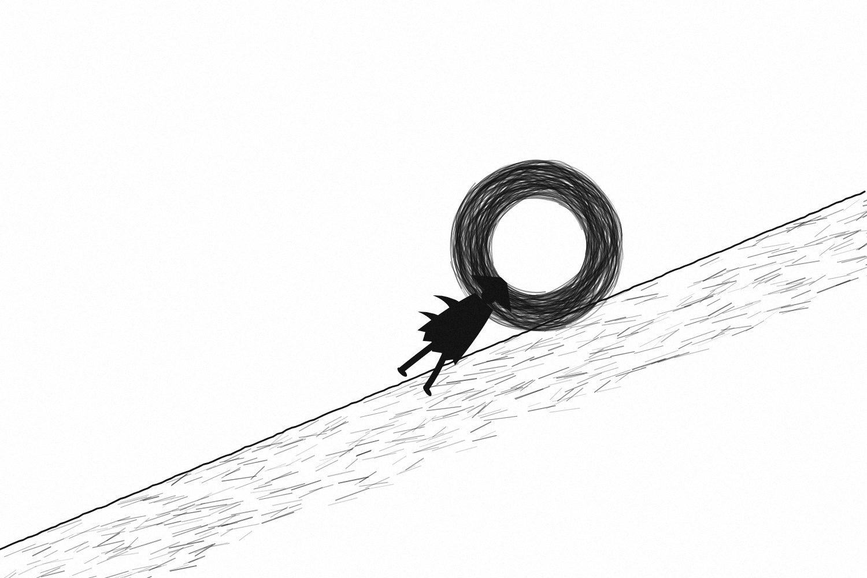
Figure 5. Not every boulder deserves to be pushed. Choose the one that is worth the hill.

Choose Useful Difficulty
Some forms of resistance are exactly what growth feels like: learning something difficult, having the honest conversation, showing your work, practicing while you are still bad, tolerating boredom, accepting rejection, beginning again.
Other pain is a warning.
The mature question is not “How much can I suffer?” It is “What difficulty is worth carrying?”
There is the hard that builds capacity. There is the hard imposed by circumstances you did not choose. And there is the hard you create unnecessarily because you think suffering proves seriousness. Do not confuse them.
A strong person can push when pushing is useful and stop when stopping is necessary. They can ask for help without turning help into a confession of weakness. They can recover without believing that recovery cancels the work.

Your Difficulty Needs a Destination
A meaningful life will contain difficulty. That is unavoidable. But difficulty without direction is simply strain.
If a hard season is taking you toward something you value, it may be worth carrying. If it is only feeding an identity built around being tougher than everyone else, ask what the toughness is for.
The point is not to make life easy. It is to make the difficulty count.

CHAPTER FIFTEEN

THE DAY MOTIVATION DIES
❖

The Middle Arrives
Eventually the excitement disappears.
The first days of a serious pursuit can feel almost cinematic. You make a plan, imagine the result, and experience the energy of beginning. Then the middle arrives. The work becomes repetitive. Progress becomes harder to see. Nobody is impressed anymore.
You are no longer new enough to be carried by novelty and not yet skilled enough to be carried by mastery.
Many people interpret this moment as evidence that something has gone wrong. Often, it is simply the part that was always going to be there.

Build a Relationship With Process
The person who wants to write a book does not need to feel inspired every morning. They need a way to sit down often enough for pages to accumulate. The athlete does not need to feel powerful before every session. They need a way to train intelligently through ordinary days while respecting recovery. The student does not need to love every subject. They need a way to return to the material.
A goal tells you where you want to go. A process gives you something to do today.
Habits help here, and they take longer to form than the popular myths suggest. In one well-known study of people building a new daily health behavior, the time it took for the behavior to feel automatic ranged from a few weeks to most of a year, with a median of around two months. Missing a single day did not meaningfully derail the process. What mattered was returning.
When the result is distant, the process is what keeps the relationship alive.

Know When Motivation Is Information
Still, “never quit” is incomplete advice.
Sometimes disappearing motivation is resistance. Sometimes it is information. Perhaps the goal no longer fits. Perhaps the method is wrong. Perhaps the price has become unreasonable. Perhaps you need rest. Perhaps the environment needs to change.
So when motivation disappears, do not immediately obey it and do not immediately attack it. Investigate it. Then decide whether the answer is persistence, adjustment, recovery, or departure.
The skill is not staying forever. It is knowing what deserves another attempt.

CHAPTER SIXTEEN

THE FIRST 1,000 FAILURES
❖

The Beginner’s Humiliation
Beginnings are humiliating because reality is rarely as good as imagination.
The first drawing does not look like the picture in your head. The first video feels awkward. The first business offer gets ignored. The first competition exposes weaknesses you were able to hide while training alone.
This is why people often quit before learning. They did not stop caring. They stopped wanting to be beginners.
The phrase “first 1,000 failures” is not a literal target. It is a way to change your relationship with early mistakes. You expect the beginning to contain evidence that you are not yet good enough, because that is what a beginning means.
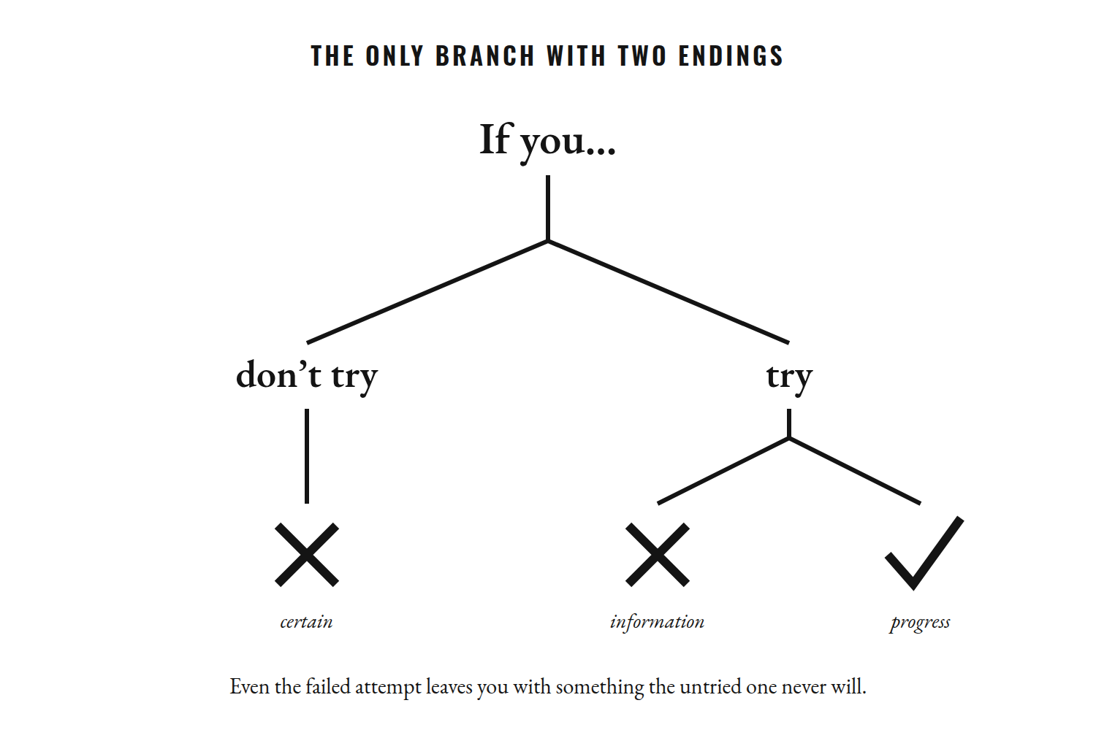
Figure 6. Not trying guarantees one outcome. Trying is the only branch with more than one.

Failure Is an Event, Not an Identity
“I failed” describes something that happened. “I am a failure” describes who you think you are. Those sentences are not equivalent.
But failure only becomes useful when you extract information from it. If you repeat the same mistake without adjustment, repetition alone is not growth. You need feedback: try, observe, adjust, try again. Researchers who study expertise make the same point—the practice that builds skill tends to be deliberate: focused on specific weaknesses, with feedback, just beyond current ability.
This is also why talent needs to be understood carefully. Some people begin with advantages. Some have better instruction. Some have more time, better equipment, stronger bodies for a particular task, better networks, or simply better luck. Large reviews of the research on practice have found that even deliberate practice explains only part of the difference between performers. Effort matters. It is not the only variable.
That makes the story more honest, not less hopeful. You cannot control every advantage. You can control whether you learn from the attempts you make.

Build a Failure Portfolio
Keep a record of attempts that did not work. What did you try? What happened? What did you learn? What will you change?
Over time, the record can become a strange source of confidence. Not because failure stopped hurting, but because you have evidence that embarrassment did not kill you, rejection did not end your ability to act, and mistakes did not have the final word.
Some failures will be unfair. Some will be your fault. Some will cost you more than they teach you.
The response is still the same question: What happens next?

CHAPTER SEVENTEEN

THE PERSON YOU KEEP TRYING TO PROVE
❖

The Invisible Audience
Sometimes ambition has an audience you never invited. A parent who underestimated you. A former friend. A rival. A teacher. Someone who rejected you. A version of yourself you desperately want to redeem.
You work, train, build, and improve while imagining the moment when they finally see.
This can be powerful fuel for a while. It can also become a cage, because if your life is organized around proving something to another person, they remain central to your decisions. Even your success keeps them in the room.

Remove the Witness
Imagine that nobody will ever know about your next achievement. No announcement. No applause. No social media. No opportunity to tell anyone that you did it.
Would you still want to do it?
If yes, something important is there. If no, that is not shameful. It is information. Perhaps the goal is really recognition. Perhaps recognition has been filling a need that the achievement itself will not satisfy.
This is also why the finish line can keep moving. You achieve something and immediately change the standard. The body is not enough. The money is not enough. The degree is not enough. The title is not enough.
There is nothing wrong with ambition. But ambition without moments of enough can become an appetite that no accomplishment can feed.

You Do Not Have to Prove Your Worth
There is a difference between wanting to accomplish something and requiring accomplishment as evidence that you deserve to exist. The first can be healthy. The second can consume you.
Psychologists who study self-esteem describe this second pattern as contingent self-worth: when your sense of value rises and falls with success in a particular domain—grades, looks, approval, performance. People whose worth is heavily contingent tend to feel bigger highs after success and deeper lows after failure. The scoreboard stops being information and becomes a verdict.
Ask what remains when the scoreboard is put away. What do you enjoy when nobody is impressed? Which relationships would you protect if there were nothing to gain? What work would you continue if it never became prestigious?
Your life does not need to be a courtroom argument for your worth. Achievement can be part of your life without becoming the judge of your life.

CHAPTER EIGHTEEN

THE IDENTITY YOU BUILD IN THE DARK
❖

Who You Are When Nobody Sees
There is a version of you that exists when nobody is watching. That person is built from repetition rather than declarations. What you do privately becomes easier to do publicly because you have practiced being that person.
If you want to become reliable, keep small promises. If you want to write, write. If you want to become stronger, train intelligently. If you want to become calmer, practice responding rather than reacting. If you want to become generous, give.
You do not have to announce the identity before you have lived it.

Labels Should Point, Not Trap
A label can be useful as a direction. It becomes dangerous when you use it to predict your limits.
“I am a procrastinator.” “I am a failure.” “I am a perfectionist.” “I am just bad with people.”
Such statements make complicated patterns sound permanent. A more useful question is: “What am I practicing?”
That question leaves room for change. You may have practiced avoidance for years. You can practice approach. You may have practiced quitting. You can practice returning. You may have practiced people-pleasing. You can practice boundaries.

Give the New Person Time
Behavior often changes before identity catches up. You may do the right thing repeatedly while still feeling like the old person. Do not panic. Identity is a story about continuity, and new evidence takes time to change a familiar story.
Create an evidence file. Record the promises you kept, the difficult things you attempted, the moments when you returned instead of quitting, the decisions that were different from your old pattern.
Not to impress yourself. To remember.
One day the behavior you had to force may simply feel normal.

CHAPTER NINETEEN

THE MOUNTAIN YOU DIDN’T CHOOSE
❖

What If You Are Climbing Someone Else’s Mountain?
There is a question that can save you years: What if the mountain is not yours?
It is possible to become extremely disciplined while pursuing an inherited goal. Your family wants one future. Your culture rewards another. Your peers are moving in a particular direction. Social media presents a narrow picture of success, and advertising quietly teaches you what a successful person is supposed to want.
None of those things has to be malicious. They simply become dangerous when you stop asking whether the goal belongs to you.

Translate Envy
Envy can sometimes help you identify a desire, but the object of envy may not be the real goal.
You may think you want someone’s career when what you actually want is autonomy. You may think you want their money when what you want is security. You may think you want their popularity when what you want is connection.
Ask what sits underneath the symbol. This is how you separate the mountain from the sign pointing toward it.

The Ordinary Tuesday Test
Do not judge a life by its highlight reel. Imagine the ordinary Tuesday.
The commute. The emails. The difficult customer. The training session. The repetitive work. The loneliness. The uncertainty. The responsibilities.
Can you still imagine meaning there?
If the answer is yes, pay attention. If only the fantasy is attractive, pay attention to that too.
And remember that changing your mind is allowed. The years you have already spent on a path are not a debt that must be repaid with the rest of your life.
Sometimes courage means continuing. Sometimes it means turning around. The important thing is that you know whose mountain you are climbing.

CHAPTER TWENTY

THE COST OF BECOMING
❖

Growth Contains Loss
Every transformation contains a loss. Not necessarily a tragic one. Sometimes it is simply the loss of familiarity.
The routine that once kept you comfortable no longer fits. The friendship built around an older version of you changes. The habits that helped you survive a difficult period become habits that keep you there.
We talk about becoming as though it is pure addition: more confidence, more knowledge, more discipline, more strength. But becoming also involves subtraction.

Outgrowing Without Becoming Superior
You may change and discover that some relationships cannot remain exactly as they were. That can hurt.
But outgrowing someone does not automatically make you better than them. Growth can become an ego costume if you turn improvement into a hierarchy.
The person you were had less information, less experience, fewer skills, and perhaps fewer choices. You do not need to despise them to move forward. You can thank the old version of yourself without obeying it.
And when people around you resist your change, listen carefully. Sometimes they are protecting a relationship. Sometimes they are seeing a real problem you cannot see. Sometimes they simply preferred the version of you that was easier for them.
Disappointment is not always evidence that you did something wrong.

The Price of Choosing
Every serious commitment closes possibilities. A “yes” to one direction contains a “no” to others.
That is not failure. That is what choice means.
You cannot keep every possible life alive forever. At some point, possibility must become reality, and reality requires trade-offs.
The task is not to find a life with no loss. It is to decide which losses you are willing to carry for the sake of what you value.

CHAPTER TWENTY-ONE

THE PERSON YOU BECOME WHEN NOBODY IS COMING
❖

The Rescue Fantasy
There is a fantasy many people carry quietly: someone will come.
Someone will notice. Someone will understand. Someone will give you the opportunity, explain the next step, remove the uncertainty, or rescue you from the consequences of your own indecision.
Sometimes someone does come. People matter enormously. A teacher can open a door. A friend can keep you alive through a difficult season. A mentor can shorten years of confusion. Asking for help is not weakness.
But there are moments when nobody is coming with the exact answer you want. That is where agency becomes real.

The Next Honest Step
You make the appointment. You send the application. You ask the question. You admit that you need help. You begin with incomplete information and learn through movement.
This does not mean doing everything alone. Sometimes the most responsible action is to find someone qualified to help. The point is that you stop waiting for permission to participate in your own life.
You do not need the whole route before taking the next turn. Try the course. Talk to the person. Submit the application. Train for the month. Build the first version. Gather evidence. Then decide again.
This is not certainty. It is experimentation.

What Strength Really Looks Like
The person you become when nobody is coming is not a person who needs nobody. It is a person who can take responsibility for the next honest step while still knowing when to reach for another hand.
That distinction matters. Self-reliance without connection can become isolation. Dependence without agency can become paralysis.
A mature kind of strength holds both truths at once: I am responsible for what is mine to do. And I am allowed to ask for help with what I cannot carry alone.

CHAPTER TWENTY-TWO

THE FIRST STEP IS NOT THE HARDEST
❖

The Myth of the Dramatic Beginning
People often imagine that the hardest part of changing a life is the first step. It sounds convincing, because beginnings are dramatic. The application is sent. The conversation happens. The gym bag is packed. The camera is turned on. The first public attempt feels like a line drawn between two versions of you: the old one on one side, the new one on the other.
But the first step is rarely the hardest part. The harder part is what comes after you have proved to yourself that you can begin.
A beginning gives you emotion. Continuation gives you information. A beginning lets you imagine who you might become. Repetition forces you to meet who you actually are today.

The Collector of Beginnings
This is why people can spend years collecting beginnings. A new notebook. A new routine. A new course. A new promise made at midnight. A new Monday.
The ritual changes, but the pattern underneath it does not. Starting feels like movement, and movement feels like progress. Sometimes it is. Sometimes it is simply a more attractive form of postponement.

Figure 7. A beginning is one footprint. A direction is the line they make together.

A Quieter Way to Begin
Make the first step so small that it cannot carry your fantasy away with it.
Do not promise yourself a complete transformation. Spend fifteen honest minutes on the thing you keep saying matters. Write one page. Read five pages. Make one call. Walk for ten minutes. Practice the skill badly. Put the phone in another room and stay with the task long enough to become uncomfortable.
The point is not that fifteen minutes will change your life. The point is that fifteen minutes can change your relationship with evidence.

Evidence Closes the Gap
Evidence matters because your mind can argue with almost anything except what it has watched you do repeatedly.
You can tell yourself that you are disciplined while having little experience of keeping promises. You can call yourself a writer while avoiding the page. You can say you want independence while choosing every option that keeps you dependent on other people’s approval. The gap between the person you describe and the person you practice being is where much of the confusion in a life lives.
Small action closes that gap. Not all at once. Not permanently. But enough to give you something real to work with.
The first honest action says, “This is possible.” The next says, “I can repeat it.” The tenth says, “This is becoming normal.” Eventually the identity you kept trying to announce becomes less interesting, because it no longer needs announcing. You have evidence.

Let the First Attempt Be Ugly
A polished beginning is often another fantasy. The beginner who waits to look ready is waiting for a feeling that may never arrive. The beginner who accepts awkwardness gets something more useful: contact with reality.
Reality tells you what skill you actually have, what you misunderstood, where you are weak, what the task costs, and what support you need. None of those answers is an insult. They are the map.
The first step does not need to feel like destiny. It only needs to be real.

The Sequence Beneath the Story
A serious life is not built through one heroic decision. It is built through a long sequence of decisions small enough to make and meaningful enough to matter. Some will be courageous. Some will be boring. Some will be wrong, and you will have to reverse them. You will discover that a few of the mountains you planned to climb were never yours. That is not a failure of the process. It is one of its purposes.
So do not wait for the first step to feel like destiny. Let it feel ordinary. Let it be a little disappointing. Let it reveal the real distance between intention and action. Then take another step. And another.
The extraordinary part of a life is often hidden inside ordinary acts that a person kept choosing after the emotion had disappeared.
The next chapters turn toward people whose lives became large enough to attract mythology. Study them carefully. Do not copy their surface. Look instead at the sequence beneath it: the beginnings, the repetition, the support, the luck, the mistakes, the costs, the limits, and the decisions that could not be undone.
The point is not to borrow someone else’s ambition. It is to learn to see your own more clearly.


PART III

THE PEOPLE WHO REFUSED TO REMAIN SMALL

There is a danger in reading about extraordinary people. You can turn them into mythology.
You see the championship, the empire, the painting, the invention, the record, the undefeated streak. You see the finished monument and forget the unfinished person who stood where the monument began.
You forget the uncertainty. The embarrassing attempts. The institutions that made their rise possible. The teachers, teammates, rivals, family members, managers, coaches, and strangers who affected the outcome. You forget the accidents. You forget the opportunities that arrived at the right time. You forget the people who paid part of the price.
And sometimes you forget the damage. A great life is rarely a clean story.
That matters because these chapters are not here to give you heroes to copy. They are here to give you human beings to study.
Alexander can teach you something about ambition, and also about the danger of an ambition that cannot recognize enough. Musashi can teach you something about practice, and also about the gap between a historical figure and the legend later generations built around him. Jordan can teach you about competitiveness without making competitiveness a moral virtue. Ronaldo can teach you about sustained development without pretending discipline exists independently of talent, opportunity, coaching, and circumstance. Kobe can teach you about returning to work after failure while leaving room for the complexity that every success story hides. Frankl can teach you about meaning while reminding us that suffering itself is not a gift.
Their lives are not formulas. They are evidence.
Read them with suspicion as well as admiration. Ask what the popular version leaves out. Ask what a person’s success cost, who helped make it possible, what the person could not control, and where the lesson becomes dangerous when simplified.
The point is not to become Alexander or Jordan or Musashi. The point is to become more difficult to fool about your own life.
Sometimes another person’s contradiction is the mirror you need.

CHAPTER TWENTY-THREE

ALEXANDER: WHEN THE MOUNTAIN KEEPS MOVING
❖

The River
In 326 BCE, after years of campaigning across an enormous territory, Alexander reached the Hydaspes River—today’s Jhelum—in the region that is now part of Pakistan.
On the opposite bank stood King Porus. The river was swollen by the season. Porus had elephants. Alexander had an army that had already travelled thousands of miles and fought through landscapes, cities, deserts, mountains, and kingdoms far from Macedonia.
The battle that followed became one of Alexander’s major victories. Porus was defeated but, according to the ancient accounts, Alexander allowed him to continue ruling and expanded his territory under Macedonian authority.
Alexander did not stop. He moved onward.
A few months later he reached another river: the Hyphasis, now generally identified with the Beas. This time the enemy was not an Indian king.
It was his own army.

Figure 8. The Hyphasis, 326 BCE: the river where the army would go no farther.

The Boy Who Inherited a War
Alexander is often introduced as though he appeared from nowhere: a young man with impossible ambition who simply decided to conquer the world. History is less dramatic and more interesting.
He was born in 356 BCE, the son of Philip II of Macedon. Philip had spent years turning Macedonia into a major military power and had brought much of Greece under Macedonian dominance. He had also prepared for a campaign against the Persian Empire. Alexander inherited not an empty stage, but a powerful state, a highly developed military system, experienced commanders, political resources, and a project already in motion. His tutor, for several years of his youth, was Aristotle.
Alexander became king in 336 BCE, after Philip’s assassination. He was twenty.
The scale of what happened afterward can make the age seem almost unreal. Within a few years he had defeated the Persian king Darius III in major battles, taken Egypt, moved through the former Persian imperial territories, and pushed eastward into Central Asia. His campaigns eventually reached the Indus River and the Punjab region.
The speed was extraordinary. The cost was real. Cities were besieged. People were killed or enslaved. Lands were occupied. Political systems were dismantled or rearranged. When the city of Tyre fell in 332 BCE after a long siege, the ancient sources report thousands killed and many thousands more sold into slavery.
Alexander’s victories were celebrated by later generations, but they were not experienced as inspiration by everyone who stood in his way.
This distinction is important. Power can be impressive without being innocent.

When Success Changes the Question
At some point, Alexander’s problem was no longer whether he could conquer another territory. He had to decide where conquest ended.
That question may be harder than the first one.
Beginning is simple. There is an enemy ahead. There is a city to take. There is a campaign to win. The next objective is visible.
But what happens after you achieve the objective? If the reward for reaching one mountain is simply another mountain, how do you know when the journey has become appetite rather than purpose?
Alexander kept moving. Part of that movement can be explained strategically. New territories needed to be secured. Political control had to be maintained. Armies had logistical demands. Borders did not magically become stable because a king declared victory. But the ancient sources also portray Alexander as driven by what Arrian called a longing—the Greek word is pothos—to go farther, to see what lay beyond.
At the Hyphasis, the question finally became impossible to avoid. His soldiers had limits. He did too, whether he knew it or not.

The Men Who Said No
After the Hydaspes, Alexander wanted to continue eastward. His troops did not.
They had been campaigning for years. Many had been away from Macedonia for the better part of a decade. They had seen extraordinary victories, but they had also seen deaths, injuries, exhaustion, monsoon rains, and the constant possibility that the next campaign would be worse than the last.
At the Hyphasis, the resistance was serious enough that the army refused to advance. Calling the episode simply a “mutiny” can hide the complexity. In Arrian’s account, an officer named Coenus spoke for the men, telling the king that they longed to see their parents, their wives, and their children again. The exact words are a later historian’s reconstruction, but the basic turning point is clear: Alexander wanted to go farther, and his army would not.
For once, the man who had spent years making the world move according to his plans had reached a boundary he could not command away.
He reportedly withdrew into his tent for three days. Then, after sacrifices for the crossing proved unfavorable, he turned back.
The decision matters because it exposes a truth that ambition does not like:
There are things even determination cannot overcome.

The Mountain Was Never the Point
Imagine being Alexander. You have spent your life moving toward the next objective. Your father gave you an army and a kingdom. You cross into Asia. You defeat an empire. You take cities. You move through Egypt and Persia and Central Asia. You fight at the Hydaspes and win.
Then someone asks you to stop.
What would stopping mean? Would it be weakness? Would it mean the previous victories were not enough? Would it mean the thing you had spent your life chasing had never had a final destination?
This is where ambition becomes psychologically dangerous. A person can become so attached to forward motion that stopping feels like failure even when stopping is rational. The goal keeps moving because the person keeps moving.
There is always another number. Another title. Another record. Another competitor. Another proof. Another mountain.

The Price of a Moving Finish Line
You do not need an empire to experience the same pattern.
A student gets the grade and immediately wants the next one. An athlete reaches a target and raises it before they have even experienced the achievement. An entrepreneur reaches a revenue milestone and immediately decides that the number must double. A person reaches the body they once dreamed of having and finds another flaw to fix. A career goal becomes a promotion, then a larger promotion, then status, then recognition, then the fear of losing the position that was supposed to create freedom.
There is nothing wrong with wanting to improve. The danger is when improvement becomes incapable of recognizing completion. If no achievement is ever allowed to become enough, then every achievement becomes another demand.
The question is not whether you should stop growing. It is whether you know what growth is for.

Alexander’s Contradiction
Alexander’s story is therefore more useful when it is stripped of the motivational poster.
He was extraordinarily effective. He was also capable of immense destruction, and of violence toward his own circle: in a drunken quarrel he killed Cleitus, an officer who had once saved his life. His campaigns helped produce the Hellenistic world that followed him, spreading Greek language and culture across a vast territory, while conquest also brought violence, displacement, and coercion. His own empire did not survive him as a unified political structure; within a generation his generals had divided it among themselves.
He died in Babylon in 323 BCE, not yet thirty-three, about thirteen years after becoming king.
He had spent much of his adult life moving east. The world he was trying to possess would outlive him without asking his permission.

The Question He Leaves Behind
The most interesting lesson is not “dream bigger.” It is more uncomfortable:
What happens when you get what you asked for?
What will you do when the milestone arrives? Will you be able to recognize enough? Will you know the difference between ambition and appetite? Will you know when a goal has stopped serving your values and started serving your identity?
And perhaps the hardest question: if nobody had been watching, would you still have needed to keep climbing?
Alexander’s mountain kept moving. Maybe yours does too.
The answer is not necessarily to stop. It is to know why you are walking.
And to remember that a boundary is not always a defeat. Sometimes a boundary is the first piece of wisdom the mountain gives you.

CHAPTER TWENTY-FOUR

MUSASHI: THE ART OF BECOMING DANGEROUS TO YOUR OLD SELF
❖

The Man Behind the Legend
Miyamoto Musashi is difficult to study for the same reason he is so easy to admire: the legend is cleaner than the historical record.
He is remembered as the wandering swordsman, the undefeated duelist, the severe philosopher, the man who fought with two swords and eventually wrote The Book of Five Rings. Later generations turned him into a symbol of discipline and individual mastery. Eiji Yoshikawa’s novel Musashi made him a national hero in the twentieth century, and modern manga and film have carried that image far beyond seventeenth-century Japan.
But the historical Musashi is more interesting than the myth. He was a swordsman, strategist, writer, painter, and craftsman. Museum collections hold his ink paintings—a shrike on a dead branch, a heron, the monk Daruma—alongside his calligraphy. He lived from roughly 1584 to 1645, during a period in which Japan was moving from generations of civil war toward political unification and a much more settled society.
And some of the stories repeated about him are uncertain. Musashi himself wrote that he fought his first duel at thirteen and more than sixty contests without defeat before he was thirty. Those claims are important evidence of how he understood his own life, but they are not independently verified by a complete contemporary record. His most famous duel, against Sasaki Kojirō on the island of Ganryūjima in 1612, comes to us mainly through accounts written long after his death, and its details differ from telling to telling.
That distinction matters. A person can be remarkable without every legend being true.

A Life Built Through Practice
What can be seen more clearly is the pattern of a life spent practicing.
Musashi was not content to treat swordsmanship as a single physical technique. His mature writing describes strategy as something that required perception, timing, adaptability, judgment, and an understanding of broader principles. “From one thing,” he wrote, “know ten thousand things.”
That idea becomes more powerful when you notice what happened to him later. The man remembered primarily for the sword also painted. He practiced calligraphy. He carved. He wrote. He taught. In his later years, his life moved away from dueling and toward the organization of knowledge.
This matters because mastery is often misunderstood as a narrow tunnel. You practice one thing until you become excellent. But deep mastery can do something more interesting. It can change the way you see.
A musician begins hearing structure everywhere. A writer begins noticing rhythm in conversation. A fighter learns to see timing rather than movement alone. A designer begins noticing proportion in ordinary objects.
Practice alters perception. And once perception changes, the work changes with it.
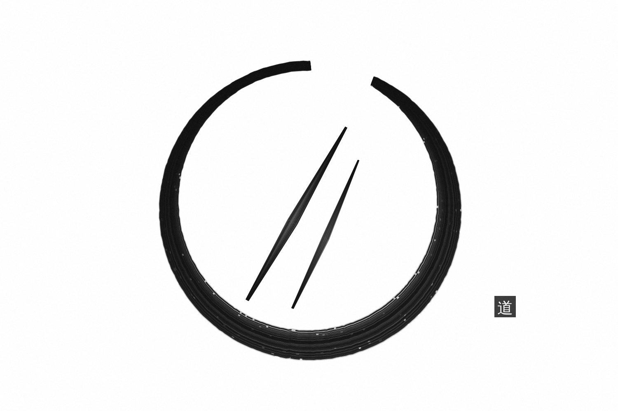
Figure 9. Practice alters perception. Once perception changes, the work changes with it.

The Beginner’s Problem
Most people want the identity before they want the repetitions that create it.
They want to be a writer. They want to be strong. They want to speak confidently. They want to understand business. They want to be excellent at a craft.
What they do not necessarily want is the humiliating period in which they are visibly inexperienced. That period cannot be skipped.
Musashi’s story is useful here not because swords are relevant to your life, but because mastery makes the same demand everywhere: you must allow yourself to be bad long enough to become better. “A thousand days of training to forge,” he wrote, “ten thousand days of training to polish.”
There is no elegant entrance into competence. You make mistakes that are obvious to you. Someone corrects you. You repeat the mistake. You become slightly better. Then a different problem appears. You solve it. Another appears. This can continue for years.
The fantasy of mastery is clean because it contains the result without showing the repetitions.

Adaptation Over Ego
One of the deepest ideas associated with Musashi’s strategy is adaptability. A method that works in one context may fail in another. A technique becomes a trap when you worship it instead of understanding the principle beneath it. Musashi warned against having a favorite weapon, or a favorite anything, because attachment makes you predictable.
The same problem appears outside combat. People build routines and then protect them even when their circumstances change. They choose a business model and refuse to adjust it after the market changes. They train according to an old plan while ignoring what their body or performance is telling them. They hold onto an identity because abandoning it would force them to admit that their understanding has changed.
Adaptation requires humility. You have to be willing to say, “This worked then. It may not work now.”
That sentence can feel like defeat. Sometimes it is the opposite. It means you are paying attention.

The Work Nobody Sees
There is a reason private practice matters so much. Public performance is the visible part of mastery. Private repetition is the invisible part.
No one applauds the awkward hour. No one sees the discarded page. No one celebrates the tenth failed attempt to understand something. No one posts the month in which progress was too small to photograph.
Yet those hours become the structure beneath the result.
This is why the person you build in the dark matters. You are teaching yourself what you do when there is no audience. Do you return? Do you correct? Do you become defensive? Do you blame the circumstances? Do you ask for better instruction? Do you keep practicing the same weak method because changing it would bruise your ego?
Every answer is shaping you.

Not Everything in the Legend Should Be Copied
There is also a temptation to turn Musashi into an excuse for isolation. The lone swordsman is an attractive fantasy. No distractions. No dependence. No one to answer to. Pure discipline.
But real mastery rarely grows in a vacuum. Instruction, rivalry, culture, material resources, opportunity, and time all matter. Even a highly independent historical figure exists inside a network of people and institutions. Musashi’s final years depended on the patronage of a powerful lord.
The romantic image of total solitude can also hide something else: human beings need relationships. And a culture of dueling was also a culture of killing; the legend’s violence is not a lifestyle to admire.
The lesson is not to become alone. It is to become less dependent on applause. Work when nobody is impressed. Learn when nobody calls you talented. Practice when progress is too small to announce. And remain teachable when your preferred story about yourself is challenged.

The Last Years
Musashi’s final years are especially revealing because they complicate the image of endless combat.
In 1640 he became a guest of the Hosokawa lords in Kumamoto, on the island of Kyushu, and spent his later life teaching, writing, and producing art. The Book of Five Rings was written in 1643–45, during his final years, and tradition places him in the cave of Reigandō as he worked on it. He finished it weeks before his death.
The book is not a diary of a superhero. It is an attempt by an aging practitioner to explain a craft he had spent decades thinking about.
That changes the meaning of mastery. Mastery is not simply the accumulation of victories. It is the ability to extract principles from experience and make them understandable enough to pass on.
At the end of a life, what do you know that you did not know at the beginning? And can you explain it without pretending you were never confused?

Become Dangerous to Your Old Self
The title of this chapter does not mean becoming dangerous to other people. It means becoming dangerous to the habits that depend on you remaining unchanged.
The version of you that quits easily should begin to encounter a person who returns. The version that needs applause should encounter someone willing to work privately. The version that protects its ego from correction should encounter someone capable of saying, “I was wrong.” The version that clings to one method should encounter someone willing to adapt.
This is what practice can do. It does not merely improve a skill. It changes your relationship with difficulty.
And eventually the question becomes less about whether you are talented enough to become the person you imagine. It becomes:
What are you willing to practice until the person you imagine becomes unnecessary?
Because at some point, you do not need to imagine being disciplined. You simply sit down and work. You do not need to imagine being a writer. You write. You do not need to imagine being resilient. You return.
The old identity is not defeated by argument. It is outnumbered by evidence.

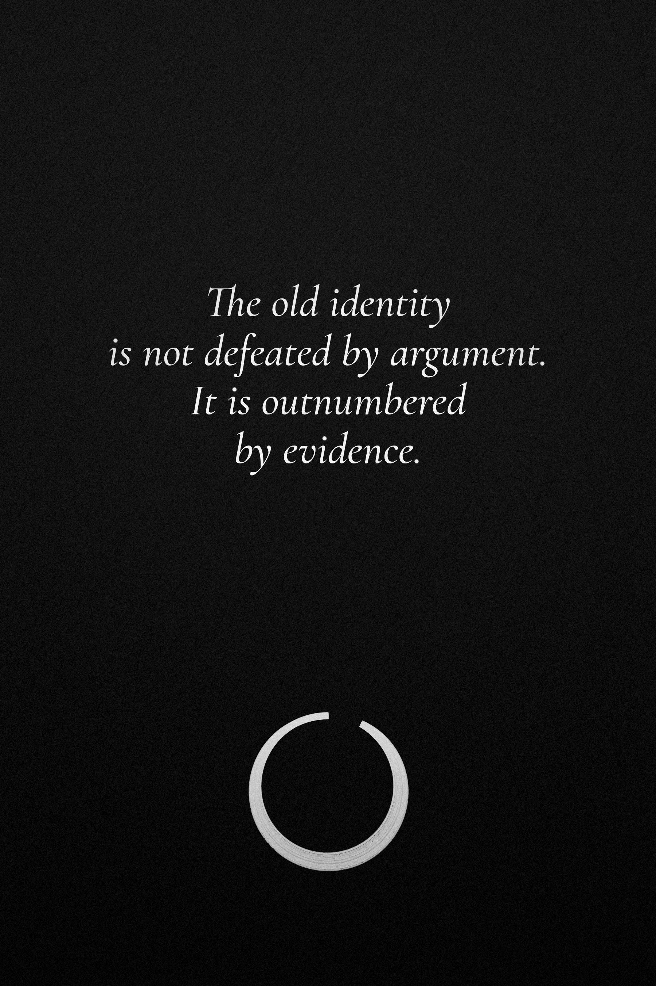

CHAPTER TWENTY-FIVE

MICHAEL JORDAN: THE PRICE OF NEVER BEING SATISFIED
❖

The Cut
The story is almost too perfect. A teenage Michael Jordan gets cut from his high-school varsity basketball team. He goes home disappointed. He works harder. He grows. He returns. He becomes Michael Jordan.
The story is repeated so often that the human being can disappear inside it.
The actual story is more ordinary and more useful. Jordan was a sophomore at Emsley A. Laney High School in Wilmington, North Carolina, when he was left off the varsity roster and placed on the junior varsity team instead. He had not yet had his growth spurt; before his junior year he grew several inches. He eventually became a high-school All-American and went to the University of North Carolina, where, as a freshman in the 1982 NCAA championship game, he hit the winning shot against Georgetown.
The point is not that the cut “created” Jordan. It did not. A person is never explained by one embarrassing afternoon.

What the Story Leaves Out
What the popular version often removes is everything that cannot fit neatly into a motivational sentence.
Jordan had physical ability. He had access to organized basketball. He had coaches—including Dean Smith, one of the most respected in the college game. He had teammates. He had a family and a competitive environment. He grew taller. He entered a major university program. He was drafted by an NBA team that gave him the opportunity to develop.
Work mattered enormously. So did context.
This is important because self-improvement stories often become unfair when they pretend that extraordinary outcomes come from effort alone. Effort can determine much of what happens after you begin. It cannot manufacture every starting condition.
Jordan’s story is therefore not “work hard and you will become Michael Jordan.” It is closer to this: When disappointment reveals a gap, what will you do with the information?

The Scoreboard
Jordan’s career became a remarkable accumulation of achievements: six NBA championships, five regular-season MVP awards, six Finals MVP awards, fourteen All-Star selections, ten scoring titles, and an enduring place in basketball history.
The numbers are real. They also create a problem for anyone trying to extract a philosophy from them. What happens when a person learns to live according to a scoreboard?
At first, the scoreboard is useful. It tells you whether you won. It tells you what still needs work. It gives competition structure.
But a scoreboard can become an identity. If winning makes you valuable, losing becomes a threat to the self rather than an event in a season. Then success does not end the pressure. It intensifies it.

The Pistons
Before the championships came repeated failure.
The Detroit Pistons and their “Jordan Rules”—a physical defensive scheme designed specifically to wear him down—became a barrier the Bulls could not simply wish away. Chicago lost to Detroit in three consecutive playoff series from 1988 to 1990. Jordan was already an exceptional player. The team still had not reached the place it wanted to reach.
This is an important kind of failure because it was not solved by a single inspirational speech. The Bulls changed. Under coach Phil Jackson, they committed to the triangle offense, a system that asked Jordan to trust his teammates more. The roster matured. Jordan himself developed physically and as a player. In 1991 they swept Detroit and won their first championship.
The lesson is easy to miss: Sometimes the answer to failure is not greater intensity. Sometimes it is a better system.

The First Retirement
In 1993, after his father’s murder and years of extraordinary professional pressure, Jordan announced his first retirement from basketball. He later pursued professional baseball, playing a season for the Birmingham Barons in the Chicago White Sox organization before returning to the NBA in 1995. He then helped the Bulls win three more championships from 1996 through 1998.
The mythology tends to treat the return as proof that competitive people can never stay away. A more interesting interpretation is that his life contained seasons in which the central goal changed.
That matters. Your identity does not have to be a straight line. Sometimes stepping away is not surrender. Sometimes you need to discover who you are when the thing that once measured you is temporarily gone.

Never Satisfied
There is a useful phrase hidden inside Jordan’s story: never satisfied.
Used carefully, it can mean refusing stagnation. Used carelessly, it can mean permanent dissatisfaction with your existence. Those are not the same.
You can want to improve without believing that the current version of you is unacceptable. You can pursue another championship while still appreciating the one you already won. You can train harder without treating rest as weakness. You can be competitive without turning every person around you into an opponent.
Jordan’s own Hall of Fame induction speech in 2009 is often remembered less for gratitude than for a long list of old slights he had never let go—including the coach who had promoted another player to varsity over him. Decades after the victories, the grievances were still there. Whatever one thinks of the speech, it raises a real question: what does it cost to keep an enemy alive inside you so that you can keep competing against him?
The danger of a scoreboard is that it has no natural ending. There is always another season.

When the Game Ends
Imagine removing the scoreboard. No championships. No statistics. No sneaker sales. No magazine covers. No one watching.
What remains?
The answer matters because eventually every external measure becomes less useful. A career ends. A body changes. A record is broken. A rival retires. A number is surpassed. If the self you built can only exist while winning, then victory has made you fragile.
Jordan’s career can be read as a story of relentless competitiveness. It can also be read as a question about the price of making achievement central to identity.
How much of yourself are you willing to let the scoreboard define? And who are you when the game is over?

CHAPTER TWENTY-SIX

CRISTIANO RONALDO: THE DISCIPLINE OF BECOMING
❖

Before the Stadiums
Long before the stadiums, there was a boy from Madeira who wanted a very specific life.
Cristiano Ronaldo grew up in Funchal and, at twelve, left his family and his island to join Sporting CP’s youth system in Lisbon. He has spoken of crying from homesickness in those first years. By sixteen he was training with Sporting’s first team.
That part of the story matters. Not because wanting something guarantees that you will get it. It doesn’t. It matters because desire gave the years a direction, and because the direction had a cost that a twelve-year-old paid.

The Eighteen-Year-Old
In August 2003, Manchester United signed the eighteen-year-old Ronaldo from Sporting for a fee reported at around £12 million. His debut, as a substitute against Bolton, came days later.
Accounts of his early career describe a teenager whose most obvious qualities were pace, skill, and elaborate footwork. He was talented. But talent was only the beginning.
He arrived as a winger whose game depended heavily on speed, dribbling, and spectacle. Critics called him a show pony. Over the following years, Manchester United’s coaching staff worked to make him more effective within the team. Retrospectives on his development describe changes in his movement, physicality, decision-making, and finishing as he became less dependent on tricks and more complete as a player.
That is the part worth studying. He did not become great by protecting the teenager he was. He became better by changing him.

The Right to Outgrow Yourself
There is a strange misunderstanding of authenticity. People often use authenticity to mean staying the same. “This is just who I am.”
But a young person cannot remain unchanged and still become an adult. A beginner cannot remain a beginner in the name of authenticity. A person learning a skill has to become different from the person who started.
Ronaldo’s development is a useful example of this without requiring us to romanticize every part of his lifestyle. The teenager who dazzled defenders had to learn movement without the ball. He had to become stronger. He had to learn timing. He had to improve his finishing. He had to become more dangerous in spaces where raw dribbling was not enough.
The self you start with is not sacred. It is raw material.

The Loss That Teaches
Portugal reached the final of UEFA EURO 2004, on home soil, in Ronaldo’s first major tournament. They lost 1–0 to Greece. Ronaldo was nineteen, and he left the pitch in tears. He later described the defeat as one of the most painful of his career—and as part of what football taught him: nothing is certain.
That is a useful kind of lesson because it is not inspirational in the cheap sense. You can prepare and lose. You can be talented and lose. You can care deeply and lose. The fact that an outcome matters does not make the outcome yours to command.
Twelve years later, Portugal won the European Championship in France. Ronaldo was injured early in the final and spent much of the match on the touchline, shouting instructions. The trophy he had wanted for over a decade arrived on a night when his own legs could not win it.

The Long Work
By 2008, Ronaldo had won the UEFA Champions League with Manchester United and received the Ballon d’Or and FIFA World Player of the Year awards after a season in which he scored forty-two goals in all competitions.
Later came Real Madrid, more tactical adaptation, enormous scoring output, more trophies, and a career sustained far longer than most athletes can maintain at the highest level.
The public sees the records. The important part is what the records hide: thousands of ordinary training decisions. The body has to be maintained. Technique has to be refined. Sleep, food, recovery, coaching, injury management, and competition all become part of the ecosystem.
Discipline is not one dramatic act. It is the management of many small variables over a very long time.

When Discipline Becomes an Idol
Ronaldo’s career also carries a warning. People can watch the visible discipline of an elite athlete and turn it into a universal prescription. That is a mistake.
A professional footballer lives inside a highly specialized environment. Their work is their physical performance. Their support systems, incentives, coaching, medical resources, and daily schedule are different from those of an ordinary person.
You do not need to imitate every habit of an elite athlete to take your own work seriously. You need to understand the principle beneath it: consistent attention to development compounds.
The goal is not to become ruthless. The goal is to become deliberate.

What Are You Willing to Practice?
Ronaldo’s most interesting transformation is not from poor to rich, unknown to famous, or young to old. It is from one kind of player to another. The teenager did not disappear. He was developed.
That should change the way you think about identity. Perhaps you are not waiting to discover your “true self.” Perhaps you are participating in its construction.
What skill would change if you practiced it for seven years? What relationship would change if you treated it as something to maintain rather than something to assume? What would happen if you stopped demanding that your current ability represent your final ability?
The person you are today is not necessarily the person you are obligated to remain.
Be careful with the word “potential.” Then prove it wrong by practicing.

CHAPTER TWENTY-SEVEN

KOBE BRYANT: THE FIRST 1,000 FAILURES
❖

Four Shots
On May 12, 1997, Kobe Bryant was eighteen years old and playing his first NBA season.
The Lakers were facing the Utah Jazz in Game 5 of the Western Conference semifinals, facing elimination. The game went to overtime. Bryant launched four shots in the closing minutes that did not even reach the rim—airballs—each one more memorable because of what it represented: an eighteen-year-old rookie being trusted with an enormous moment and discovering, in public, that he was not yet ready to control it.
Salt Lake City’s Deseret News covered the game; the four airballs became a fixture of every retrospective that followed. Bryant later described the night as something that helped shape him.
Imagine how the moment could have been interpreted. You failed. You embarrassed yourself. Perhaps you are not ready for this level. Perhaps you are not the player you thought you were.
All of those thoughts would have been understandable. None of them had to become the conclusion.

The Gym After Failure
Accounts of what happened next have become part of Kobe Bryant’s mythology. After returning to Los Angeles, he went to a nearby high-school gym and kept shooting. Bryant later described going directly back to work after the game; some retellings have him in the gym through the night.
It is tempting to turn this into a simple moral: He worked while everyone else slept. Therefore, work harder than everyone else.
But that misses the useful part.
The useful part was not the suffering. It was the response to information. The shots had not reached the rim. His legs had not been strong enough for the length of an NBA season. So something had to change. The next action became practice, and in the off-season, strength training.

Work Is Not Magic
Kobe’s career became extraordinary. He won five NBA championships, one regular-season MVP, and two Finals MVP awards, earned eighteen All-Star selections, and finished with 33,643 regular-season points. In 2006 he scored eighty-one points in a single game against the Toronto Raptors, one of the greatest scoring performances in league history.
Those numbers can make the story look inevitable. They were not.
Work alone does not produce every outcome. Health matters. Coaching matters. Teammates matter. Organization matters. Opportunity matters. Physical ability matters. Luck matters. Bryant grew up the son of a professional basketball player and spent part of his childhood in Italy, where his father played. He entered the NBA directly from high school, which almost no one is allowed or able to do.
That is not an insult to effort. It is what makes the story believable. Effort is part of the equation. It is not the entire equation.

The Mamba Trap
The phrase “Mamba Mentality” eventually became larger than the person who used it. That can be useful when it means commitment to preparation, learning, competitiveness, and responsibility.
It becomes dangerous when it becomes a costume.
A person hears about Kobe waking up early, practicing endlessly, refusing excuses, and they decide that exhaustion is evidence of seriousness. It is not. A person can work very hard and still be working badly. A person can be disciplined and still need rest. A person can be mentally tough and still need other people. A person can have enormous ambition without turning ambition into self-punishment.
The lesson is not to copy the extremes of an elite athlete. It is to understand the willingness to return to a problem after reality has shown you that your current ability is insufficient.

The Last Game
On April 13, 2016, Bryant played his final NBA game against the Utah Jazz and scored sixty points. The Lakers won 101–96.
The symmetry is difficult to miss. Nearly nineteen years earlier, Utah had been the opponent on one of the most painful nights of his rookie career. Now it was the opponent in the final game of his professional basketball career.
The easy story is redemption. A harder story is continuity. The teenager who failed publicly did not become a different species of human being. He remained someone who could miss, adjust, age, lose, and eventually leave the game.
The final score did not erase the first one. It gave it context.
Less than four years later, in January 2020, Bryant died in a helicopter crash near Calabasas, California, along with his thirteen-year-old daughter Gianna and seven others. He was forty-one. Whatever the work was for, it was never going to be finished.

What Do You Do With the First Failure?
The phrase “first 1,000 failures” is not a quota. It is permission. Permission to be bad for a while. Permission to produce work that exposes your current limits. Permission to be corrected. Permission to fail without immediately making the failure a biography.
The real test comes after the emotional reaction. Can you look at what happened? Can you identify what was under your control? Can you change something? Can you try again?
Maybe the second attempt is still bad. Try again.
Maybe the goal turns out to be wrong. Change it.
Maybe you discover that you do not actually want the thing. Leave it.
Failure is not valuable because it hurts. Failure is valuable when you can learn from what it reveals.

The Question Beneath the Work
Kobe’s story eventually returns to the same question that every serious pursuit must answer: What is the work for?
If the answer is only “to prove that I am worthy,” the work can consume you. If the answer is craft, contribution, love, curiosity, mastery, or the desire to test yourself honestly, the work has somewhere to go.
The first thousand failures do not make you strong. What you do with them might.

CHAPTER TWENTY-EIGHT

VIKTOR FRANKL: WHEN ACHIEVEMENT IS NOT ENOUGH
❖

Do Not Turn a Camp Into a Lesson
There are some lives that should make you speak more quietly. Viktor Frankl’s is one of them.
Frankl was an Austrian psychiatrist and neurologist whose ideas about meaning later became known as logotherapy. During the Holocaust he was imprisoned in four camps: Theresienstadt, Auschwitz, and Kaufering and Türkheim, subcamps of Dachau. His father died in Theresienstadt. His mother and his brother were murdered at Auschwitz. His young wife, Tilly, died in Bergen-Belsen. He survived.
It is tempting, especially in a book like this one, to turn this immediately into a lesson. That would be a mistake.
The Holocaust was not an obstacle course designed to produce stronger people. It was the systematic, state-sponsored persecution and murder of six million European Jews by Nazi Germany and its allies and collaborators, alongside the persecution and murder of millions of others. It was a system of imprisonment, forced labor, starvation, terror, and mass killing.
We should not use the suffering of victims as a motivational device. We should instead ask what Frankl’s thinking can teach us about meaning—and be precise about what his experience can and cannot prove.

Figure 10. A single light does not explain the darkness. It only refuses to be absorbed by it.

The Work That Came Before
One detail is especially important. Frankl’s ideas about meaning did not begin in the camps.
Before his deportation, he was already developing the psychological approach that would become logotherapy, and had worked for years with suicidal patients in Vienna. He had begun a book, later published as The Doctor and the Soul. By his own account, he carried the manuscript sewn into the lining of his coat when he arrived at Auschwitz, and it was taken from him there.
This matters because it prevents a common distortion. Frankl did not enter Auschwitz with a theory that suffering had given him. His intellectual work preceded the camps. The camps profoundly shaped his later writing and understanding, but the theory was not simply manufactured by catastrophe.
After liberation, he reconstructed the book and, in a matter of days in 1945, dictated another—the account known in English as Man’s Search for Meaning.

What Meaning Is
Frankl argued that people can orient themselves around meaning. Meaning is not necessarily a grand mission. In his framework it can be found in three broad ways: by creating a work or doing a deed; by experiencing something—goodness, truth, beauty—or loving another person; and by the attitude one takes toward suffering that cannot be avoided.
But even here, caution is necessary. Not all suffering is meaningful. Some suffering should be prevented. Some suffering should be resisted. Some suffering is simply unjust. Frankl himself insisted that suffering which can be avoided should be removed; only unavoidable suffering calls for the third path.
His work is often simplified into the sentence “find meaning in your suffering.” That version is too shallow. A better reading asks what a person does when reality contains conditions they cannot immediately change, while still recognizing that some conditions should be fought or escaped whenever possible.

The Prison of the Wrong Question
Most people ask life questions in the language of achievement. What should I accomplish? How successful should I become? How much money should I make? What should people remember?
Frankl offers a different direction. Instead of treating life as something that owes us a particular outcome, consider what a particular situation is asking of us.
The shift is subtle. You stop asking only, “What do I want from life?” You also ask, “Given the life that is actually here, what responsibility is mine now?”
Sometimes the answer is to create. Sometimes to care for someone. Sometimes to endure a difficult but temporary season. Sometimes to seek help. Sometimes to leave. Sometimes to resist.
There is no universal script.

Achievement Is Not Meaning
This is where Frankl becomes essential to the rest of this book.
You can win and still be empty. You can achieve the career, the money, the body, the title, and the recognition, then discover that none of them answered the question you were actually asking.
Achievement can solve practical problems. It can create freedom. It can reduce financial stress. It can give you access to experiences. It can provide evidence of skill.
But it cannot guarantee that your life feels worth living. That is a different question. And it is possible to spend decades answering the first while avoiding the second.
Frankl had a phrase for the condition that follows: the existential vacuum—a life full of means and empty of meaning, often filled with distraction, pleasure-seeking, or the pursuit of power.

The Cost of the Invisible Audience
Imagine achieving everything you once wanted. Then imagine that nobody knows. No one is impressed. No one is jealous. No one changes their opinion of you.
Would the life still matter?
This thought experiment returns us to a pattern we have seen before. We can organize our lives around an invisible audience: parents, rivals, strangers online, people from our past, an imagined future version of ourselves.
Frankl’s work offers a counterweight because meaning is not fundamentally a performance for an audience. A life can matter in private. A person can matter to one other person. A task can matter because it needed to be done. A day can matter even if nobody photographs it.

Survival Is Not a Simple Formula
One final caution matters.
Because Frankl survived and later wrote about meaning, it is easy to read his story as proof that people who find meaning survive while those who do not somehow fail. History does not justify that conclusion.
People survived concentration camps under extraordinarily different circumstances, and many people who had purposes, loved ones, faith, or hopes were still murdered. Survival was determined by countless factors, including circumstance, health, labor assignments, timing, and chance. Frankl himself wrote that the best of those in the camps did not return.
His reflections can tell us about one survivor’s experience and philosophy. They cannot reduce the Holocaust to a psychological formula.
That distinction is not a footnote. It is the moral center of the chapter.

When the Trophy Room Goes Quiet
One day, your own trophy room will become quieter. Maybe not literally. Perhaps the certificates will still be on a wall. The photographs will still exist. The numbers will still be in the record.
But you will eventually notice that achievement is only one language in which a life can be described.
There is another language. Who did you love? Who trusted you? What did you create? What did you repair? What did you protect? What did you refuse to become? What did you give your attention to? What did you do when nobody could reward you?
Those questions do not make achievement meaningless. They put it back in proportion.

What Is Life Asking of You?
You do not need to discover one grand sentence that explains your entire existence. Meaning may be less like finding a hidden answer and more like responding to the realities that keep appearing.
There is the person in front of you. The responsibility you accepted. The work that needs doing. The relationship that needs repair. The truth you have been avoiding. The talent you have neglected. The suffering you cannot immediately remove. The choice that only you can make.
Meaning can be quiet. That may be why it is so easy to miss.

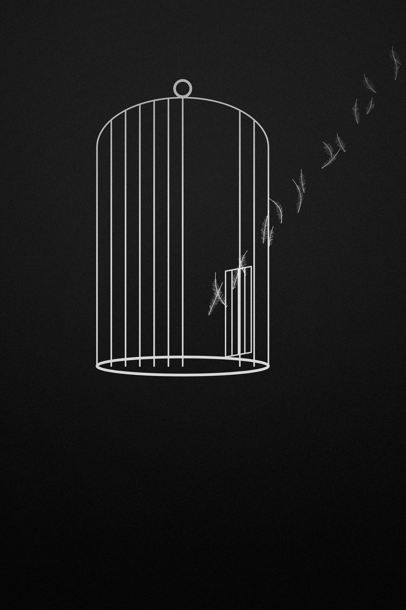
PART IV

THE CAGE AND THE OPEN DOOR

Some cages have bars you can see. Most do not.
The first three parts of this book asked you to look at yourself: the life you are living, the war inside you, the people whose contradictions can teach you something. This part turns outward again, to the world you live in every day and the structures that shape your choices before you notice you are choosing.
Some of those structures fit in your pocket. They show you other people’s lives before you have begun your own, and they hand you deadlines you never agreed to.
Some are comfortable enough that you have decorated them. The job is fine. The routine works. The apartment is warm. Nothing is broken, so nothing needs to change—except the quiet sense that you stopped choosing a long time ago.
And some cages are only discovered after you leave them, when you realize that escape is the dramatic part and building is the long part.
This is not a call to burn your life down. Most of the time, the answer is not a grand departure. It is a clearer look at what you are living inside, why you are still there, and what you would build if the door were open.
It usually is.

CHAPTER TWENTY-NINE

THE CAGE IN YOUR POCKET
❖

The Comparison Begins Before You Notice It
There is a peculiar thing that happens when you wake up and immediately look at other people’s lives.
Before you have decided what your own day means, you have already been shown dozens of other people’s outcomes. Someone is travelling. Someone is building a company. Someone is leaner, richer, younger, more confident, more popular, more productive. Someone seems to have found the thing you are still searching for.
The problem is not that any one of these lives is false. The problem is that you are seeing fragments. You see the photograph, not the ordinary Tuesday that produced it. You see the announcement, not the uncertainty beforehand. You see the result, not the years of practice, the support systems, the opportunities, the setbacks, or the private cost.
Your mind is then asked to compare your unfinished life with someone else’s selected frame.
That is not a fair competition.
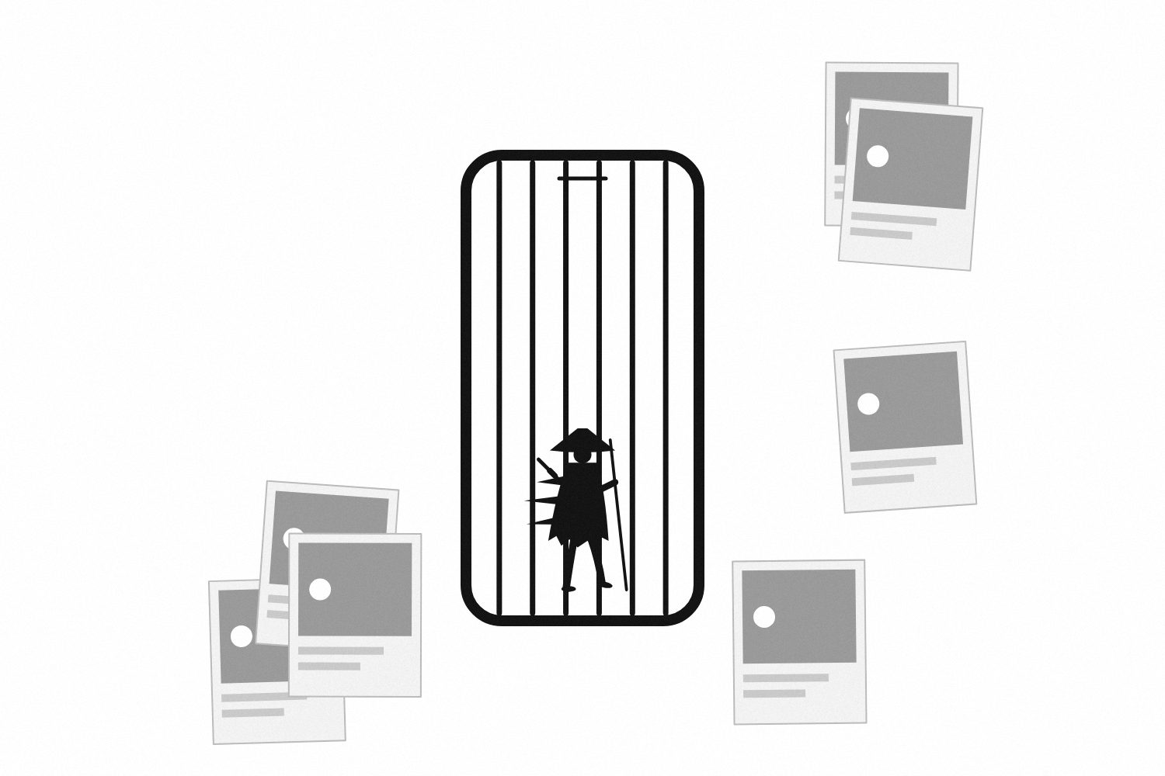
Figure 11. The bars are made of other people’s highlights.

The Psychology of Looking Up
Social comparison is not a modern invention. In 1954 the psychologist Leon Festinger proposed that people evaluate themselves largely by comparing themselves with others, especially when there is no objective standard available. Human beings have always looked sideways to understand where they stand. The difference is that the comparison environment in a phone can be almost continuous.
Recent research does not support the simple idea that all social-media use is automatically harmful. A 2024 systematic review and meta-analysis of fifty-one studies, covering more than 680,000 people, found that the relationship with well-being depended on how use was defined: excessive use by itself showed no significant overall association in that analysis, while problematic use—use that feels compulsive and crowds out other parts of life—was associated with lower subjective and psychological well-being.
That distinction matters. The problem is not “social media” as a single substance. What matters is what the behavior does, why you are using it, and what kind of comparison it creates.
Comparison itself is where the evidence is sharper. A 2025 meta-analysis of eighty-three studies found a moderate association between online social comparison and greater body-image concerns and eating-disorder symptoms.
You do not need to turn these findings into another rule.
You need to notice your own pattern.

The Wrong Scoreboard
Imagine training for a race while constantly checking someone else’s stopwatch. You could finish a difficult workout feeling proud. Then you see someone else’s time and decide your effort was worthless.
The same thing happens with careers, bodies, relationships, money, and creative work. You begin evaluating your life according to measurements that were never chosen for your life.
Followers become evidence of worth. Income becomes evidence of intelligence. Appearance becomes evidence of discipline. Productivity becomes evidence of morality.
These equations are invented.
A number can tell you something about performance. It cannot tell you whether the thing being measured deserves the best years of your life.
This is why envy can be useful without becoming a command. When you notice yourself wanting what someone else has, ask what exactly you want.
Their money? Or the freedom you imagine money would provide?
Their body? Or the confidence you believe would come with it?
Their audience? Or the feeling of being seen?
The object of envy is sometimes only the wrapping.
TRY THIS
Seven Days Without a Borrowed Deadline
For one week, notice every moment when someone else’s life changes how you evaluate your own. Do not merely count screen time. Record the comparison.
What did you see? What story did your mind tell? What did you suddenly believe you were behind in?
What did you want to change because you had genuinely chosen it, and what did you want to change because somebody else had made you feel late?
At the end of the week, ask: “If I had never seen another person’s progress, what would I still want?”

The answer will not solve your life.
But it may remove a deadline you never agreed to.

CHAPTER THIRTY

THE CAGE YOU DECORATED
❖

A Comfortable Life Can Still Be Avoidance
Some cages become difficult to recognize because they look like success.
The job is respectable. The apartment is comfortable. The schedule is predictable. The people around you approve. There is enough entertainment to fill the evenings and enough work to make the week feel justified.
Nothing is obviously broken. So why would you change it?
That is the status quo’s quiet advantage. The familiar option does not need to prove itself. It already exists. Changing it requires effort, uncertainty, and a reason strong enough to justify leaving something that technically works.
Economists named this tendency status quo bias in the 1980s: given a choice, people disproportionately stick with whatever is already in place. Later brain-imaging work found that the pull of the default grows stronger as decisions get harder.
The lesson is not “always reject the default.” Defaults are useful precisely because you cannot reconsider everything all the time.
The lesson is to notice when you are defending a life simply because it is already assembled.

The Upgrade Trap
There is another version of the comfortable cage: constant improvement.
You buy better equipment. You optimize the routine. You redesign the workspace. You download another productivity system. You track another metric. You consume another course about becoming more disciplined.
Self-improvement can become a sophisticated form of avoidance because it feels virtuous while requiring very little contact with the question underneath it.
Are you actually moving toward a life you value? Or have you become obsessed with becoming a more efficient person without deciding what the efficiency is for?
There is nothing wrong with better systems. Systems matter. Habits matter. Environment matters. Research on habits emphasizes that changing them often requires changing cues, context, and friction rather than relying on knowledge or good intentions alone.
But a better system is still only a tool. A beautifully organized cage is still a cage if you never ask whether you want to remain inside it.

The Finish Line Moves
Hedonic adaptation offers another explanation for the strange dissatisfaction that can follow improvement. Positive changes become ordinary. What once felt extraordinary becomes the new baseline, and the mind begins noticing what is missing rather than what changed.
In a classic 1978 study, researchers compared lottery winners with people who had not won, and found that within a relatively short time, the winners were not reliably happier—and took less pleasure from ordinary events. Later work has refined and qualified that picture, but the basic tendency has held up: we adapt, and we adapt faster to gains than we expect.
This can create a permanent upgrade cycle. A little more money. A little better body. A little larger room. A little more recognition. A little more control. Then another threshold appears.
The danger is not enjoying progress. It is forgetting to experience it.
You can reach a goal and move the goalpost before you have even had the chance to inhabit what you achieved.

The Ten-Year Mirror
Imagine meeting yourself ten years from now and discovering that almost nothing important changed.
Would you feel peaceful? Would you feel relieved? Would you feel trapped?
Do not answer according to what sounds ambitious. Answer according to the kind of ordinary life you could actually tolerate living.
Perhaps the result is that you need to leave. Perhaps it is that you need to stay and become more present. Perhaps the life is good and your mind has simply been trained to believe that it must always be upgraded.
Freedom is not automatically somewhere else.
Sometimes freedom begins when you stop treating every uncomfortable feeling as evidence that your entire life needs to be replaced.

CHAPTER THIRTY-ONE

WHAT WILL YOU DO WITH YOUR FREEDOM?
❖

Escape Is Not Direction
There is a moment after leaving that nobody advertises.
You finally escape the thing you hated. The job. The relationship. The routine. The city. The expectation. The identity.
And then you discover something uncomfortable. You are free. But you do not know what to do.
People often imagine freedom as the opposite of restriction. Remove the walls and the problem is solved. But an empty field is not a destination.
Freedom creates responsibility because once external pressure is reduced, your own choices become harder to hide behind. You have to decide what is worth doing when nobody is forcing you.

Autonomy Without Isolation
A useful psychological framework comes from self-determination theory, developed by Edward Deci and Richard Ryan. It proposes three basic psychological needs: autonomy, competence, and relatedness. Autonomy in this sense does not mean independence from other people. It means acting from a sense of choice—endorsing what you do rather than feeling controlled into it. And the theory treats competence and connection as just as essential to healthy motivation.
This matters because freedom is not the absence of relationships or obligations.
You can choose a life freely and still care deeply about other people. You can build a business and owe something to your employees. You can choose a career and still have responsibilities to a family. You can live independently without pretending that dependence is weakness.
Freedom becomes richer when it produces responsibility rather than isolation.

The Difference Between Wanting and Choosing
You can want thousands of things. You can only choose some.
That is where freedom becomes difficult.
A person who believes freedom means keeping every option open can spend years refusing commitment. They never choose a city because another might be better. They never choose a field because another might be more profitable. They never commit to the relationship because another person might be waiting somewhere.
The result looks like freedom from the outside. Inside, it can feel like paralysis.
Choosing closes doors. That is not the failure of freedom. It is one of its conditions.

Build Through Experiments
You do not need to discover your life’s purpose before taking a meaningful step.
Experiment. Take the course. Volunteer. Build the small version. Talk to someone already doing the work. Spend a month living differently before making a permanent commitment.
Try things that produce information.
Purpose does not always arrive as a revelation. Sometimes it becomes clearer through repeated contact with reality.
The question is not “What should I do with my entire life?” It can be: “What is worth trying next?”

What Would You Choose Without an Audience?
Strip away the audience one more time. No followers. No applause. No family pressure. No need to prove that you made the right decision.
What would you choose?
The answer does not have to become your career. It may point toward a relationship, a craft, a responsibility, a community, or a way of living.
And remember that purpose is not synonymous with happiness. A meaningful life will contain grief, boredom, uncertainty, sacrifice, and days that feel ordinary.
Freedom is not the right to feel good all the time.
It is the capacity to choose what is worth feeling the difficult parts for.

CHAPTER THIRTY-TWO

THE LIFE YOU BUILD AFTER THE ESCAPE
❖

Leaving Is the Dramatic Part
Leaving gets the story. Building gets the years.
It is easier to make a film about quitting than about showing up every Tuesday for three years. It is easier to celebrate moving out than learning how to manage a household. It is easier to announce a new identity than to live with the boring obligations that make the identity real.
This is why escape can be intoxicating. It gives you a visible before and after.
But freedom without construction is temporary.

You Can Rebuild the Same Life
A person can leave one unhealthy routine and recreate it in a different location. The job changes, the city changes, the relationship changes, but the underlying pattern follows.
Because environments influence behavior, changing the environment can matter. So can changing the cues, friction, routines, and people surrounding the behavior. Habit research suggests that much of daily behavior is triggered by context rather than deliberate choice, and that major life transitions—a move, a new job—can be unusually good moments to change habits, precisely because the old cues are gone.
But environment is not destiny. It is one of the forces you can arrange.
The work is to ask what kind of life your new environment makes easier to live.

Design the Ordinary Tuesday
Do not design your life around the best day. Design it around the ordinary one.
Where do you wake up? What does your morning require? How long does work take? When do you train? Who do you see? What do you eat? How much time is left? What happens when you are tired? What happens when your plan breaks?
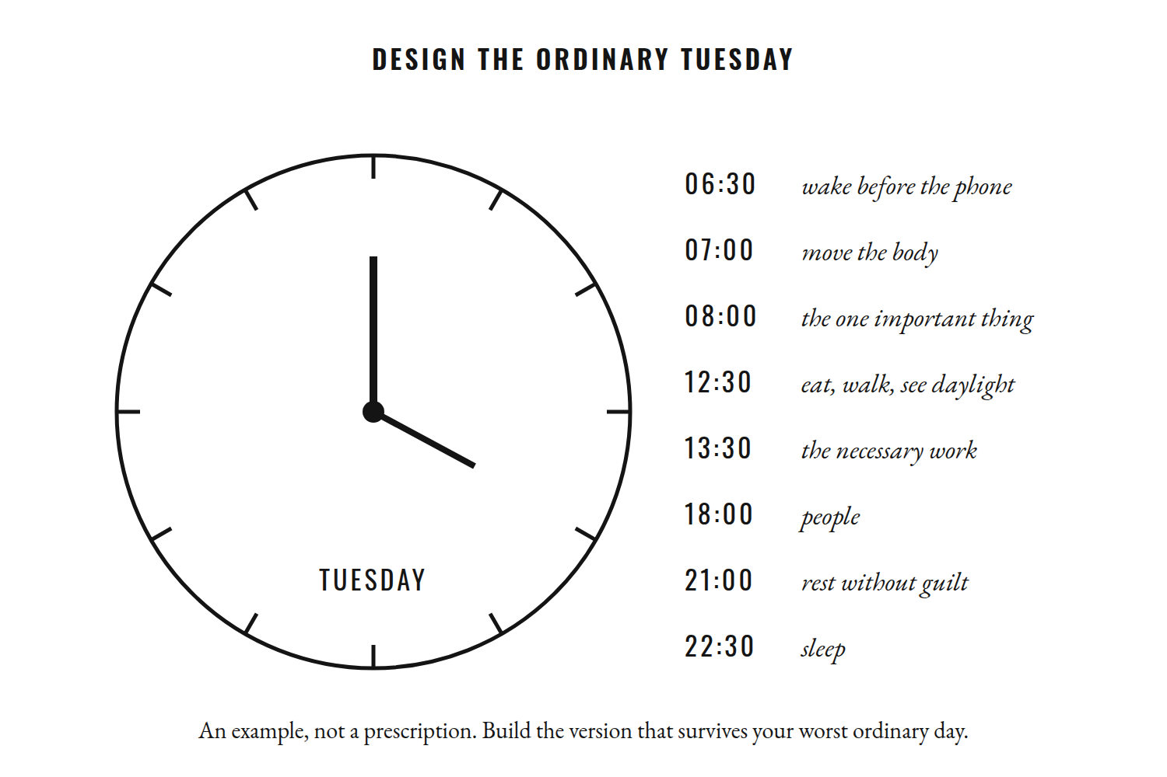
Figure 12. Design your life around the ordinary Tuesday, not the highlight reel.
A life that only works when you are rested, motivated, financially comfortable, emotionally stable, and uninterrupted is not a resilient life.
Build something that survives reality.

Your Calendar Is an Architectural Drawing
A calendar is more than a scheduling tool. It is a rough drawing of the life your choices are constructing.
If every evening belongs to work, your relationships will eventually receive the leftovers. If every free hour belongs to screens, your attention will eventually become trained around screens. If every day contains ambitious plans and no recovery, your system will eventually become brittle.
If nothing on the calendar belongs to what you say matters, the absence is information.
You do not need to schedule every minute. You need enough structure that the important parts of your life are not always waiting for the leftover pieces.

Build a Life You Do Not Need to Escape From
The deeper goal is not endless escape. It is construction.
Build a room you like returning to. Build work that asks something meaningful of you. Build friendships that can survive honesty. Build habits that support rather than punish you. Build enough margin that an unexpected problem does not destroy the entire week. Build a relationship with ambition that allows you to stop sometimes.
This is not as dramatic as breaking out of a cage. It is harder.
Because once the door is open, you have to decide what kind of life you will build on the other side.


PART V

WHAT THE FIRE IS FOR

Every serious attempt to change a life eventually runs into a larger question than “How?”
How do I become disciplined? How do I stop wasting time? How do I leave the cage? These are important questions, and most of this book has been about them. But they all rest on something underneath: for what?
Discipline for what? Freedom for what? Success, strength, money, recognition—for what?
Without an answer, even a well-built life can feel strangely empty. You can become excellent at climbing and never ask whether the mountain was worth the years.
This final part of the book turns toward the questions that are hardest to answer and most dangerous to postpone: what is worth your life, what you are willing to lose, who you are when the plan breaks, what happens after you get what you wanted, and what will remain when the striving is over.
None of these questions has a final answer. That is not a reason to avoid them. It is the reason to keep asking.
The fire in the title of this book was never meant to be self-destruction. It is attention, commitment, and care, pointed at something worth burning for.
This part is about finding out what that is.

CHAPTER THIRTY-THREE

WHAT IS WORTH YOUR LIFE?
❖

The Currency You Cannot Earn Back
We are comfortable talking about money because money can be counted. Time is harder.
You do not receive a statement at the end of the month telling you exactly how many hours you spent being alive and where they went. There is no account balance you can inspect before bed and refill tomorrow.
Yet time is the currency underneath every other currency.
You can earn more money. You can rebuild a career. You can replace an object. You can learn a skill you neglected. You cannot purchase yesterday afternoon.
This does not mean every hour must become productive. That would turn time into another prison. Rest is part of life. Play is part of life. Sitting with someone you love and doing nothing that produces a measurable result can be one of the best uses of an afternoon.
The point is not to maximize every minute. It is to notice that every minute is already being spent.

The Problem With More
A strange thing happens when a person becomes good at achieving. The target moves.
The degree becomes the career. The career becomes the promotion. The promotion becomes leadership. Leadership becomes influence. Influence becomes recognition. Recognition becomes the fear of losing recognition.
This can continue indefinitely because “more” has no natural stopping point. The same thing happens with money, fitness, productivity, followers, status, possessions, even knowledge. There is always another level.
That is why the question “How much is enough?” is not a financial question alone. It is a philosophical one.
Enough for what? Enough to feel safe? Enough to support a family? Enough to buy back time? Enough to create work you care about? Enough to stop saying yes to things you do not want?
The number matters less than the life the number is supposed to make possible. If you do not know what the money is for, it can become a game that never ends.

The Goal and the Life Around It
Goals are useful because they direct effort. But a goal can hide the life required to reach it.
You want the qualification but not the years of study. You want the company but not the uncertainty. You want the body but not the routine. You want the platform but not the public judgment. You want the relationship but not the vulnerability. You want the freedom but not the responsibility.
This is why goals need a second question. Not only “What do I want?” but “What kind of life does pursuing this create?”
Imagine that the goal succeeds. Now live the ordinary Tuesday. What time do you wake? What work fills the afternoon? Who is around you? What does the responsibility feel like? What does the success ask you to keep doing?
If you still want the Tuesday, the goal may belong to you. If you only want the photograph at the end, be careful.

Meaning Does Not Require Greatness
There is a quiet danger in the language of this book. Words like greatness, potential, becoming, and extraordinary can make an ordinary life sound like a failure by comparison.
That is not the conclusion.
A meaningful life does not need to be spectacular. A person can build something enormous and feel that the life was empty. Another person can teach for thirty years, raise children, care for parents, make beautiful things, help neighbors, do honest work, and never become famous.
Which life is more meaningful? The book cannot answer for you. That is precisely the point.
Meaning is not a prize handed out by an audience. It is something you participate in through what you value, what you commit to, and what you give your attention to.

The Questions That Survive the Scoreboard
Imagine that every external measurement disappeared. No income. No followers. No title. No trophy. No grades. No body measurement. No public recognition.
What would still matter?
The answer may include people. It may include making something. It may include learning, service, faith, curiosity, freedom, beauty. It may include simply being present for the people who need you.
Do not rush to make the answer impressive. A quiet answer can be more honest than a grand one.

What Is Worth Your Life?
The question sounds dramatic until you remember what it actually asks. You are already giving your life to things. The question is whether you know what they are.
Every week contains a negotiation between what you say matters and what receives your time. You do not need to become perfectly consistent. Nobody is. But a meaningful life cannot exist entirely inside your intentions.
So look at the next year. Then the next month. Then the next week.
What deserves a larger place? What deserves a smaller one? What have you been treating as urgent that is not important? What have you treated as optional even though you know it matters?
The answer is not a perfect schedule. It is a clearer hierarchy.
You cannot give everything your whole life. Choose what is worth some of it.

CHAPTER THIRTY-FOUR

WHAT ARE YOU WILLING TO LOSE?
❖

Every Choice Has a Shadow
We are taught to think about decisions in terms of what we gain. Choose the career. Take the opportunity. Start the relationship. Move to the new city. Build the business. Say yes.
But every serious yes contains a no.
When you choose one career, other careers become less likely. When you commit to one city, other places become unlived possibilities. When you give ten years to mastery, those years cannot simultaneously become ten years of something else.
This is not a defect in human existence. It is the condition of having a finite life. You cannot live every life that is available to your imagination.

The Grief of Unlived Lives
Sometimes the hardest part of choosing is not choosing the thing. It is mourning the things you are not choosing.
There is the musician you could have become. The person you could have married. The city you could have lived in. The business you could have started. The family you could have built. The version of you who stayed. The version who left.
Every serious decision closes possibilities. This can create a strange form of grief, because nothing necessarily went wrong. You simply understood that reality has limits.
Maturity is not learning how to keep every option open. It is learning how to choose without needing to pretend the other possibilities never mattered.

Sunk Cost and the Seduction of “Too Far to Quit”
There is another problem with loss: once we have already invested heavily in something, leaving can feel like wasting what we have already spent. Years. Money. Reputation. Effort. People.
The thought becomes: “I have come this far. I cannot stop now.”
Decision researchers call this the sunk-cost effect. In a well-known set of experiments, people who had paid more for a season ticket attended more performances—not because they enjoyed them more, but because they had paid more. The money was gone either way. Only the future evenings were still theirs to spend.
The past cannot be recovered by sacrificing more of the future. What you already spent is gone whether you continue or leave. The decision in front of you is about the resources you still possess.
That does not mean quitting is automatically wise. Sometimes persistence is exactly what the situation requires. The useful question is:
If I were starting today, knowing what I know now, would I choose this path again?
Not perfectly. Not without uncertainty. Just honestly.

What Are You Willing to Lose for What You Value?
A relationship can require the loss of convenience. Ambition can require the loss of some leisure. Truth can require the loss of approval. Health can require the loss of certain habits. A creative life can require the loss of predictable security. Rest can require the loss of another opportunity.
Every value becomes real when it has a price.
You do not discover what matters only by listing your values. You discover it when two values compete and you have to choose.

When Quitting Is the Courageous Choice
The language of this book can easily become dangerous if every act of persistence is treated as courage. Sometimes the courageous choice is to stop.
To leave the job. To end the project. To admit that the relationship is unhealthy. To abandon the version of success you inherited. To say, “I was wrong.”
Quitting can be an escape from discomfort. It can also be an honest response to evidence.
The difference is not how painful the decision feels. The difference is whether you are moving away from something merely because it became difficult, or moving toward a more truthful life because the old direction no longer deserves the cost.

Choose What Is Worth Losing
There is no decision in which you keep every possibility. So do not ask only what you want. Ask what you are willing to release.
Some things deserve to go. Some things deserve to be protected. Some opportunities are worth missing. Some risks are worth taking. Some identities are worth outgrowing. Some relationships are worth fighting for. Some ambitions are worth abandoning.
Your life becomes clearer when you stop trying to make every choice painless.
Choose what is worth losing for the sake of what you are choosing to keep.

CHAPTER THIRTY-FIVE

THE PERSON THEY WANT YOU TO REMAIN
❖

Old Versions Have Witnesses
Every version of you exists in a social world.
People know you as the quiet one. The funny one. The reliable one. The difficult one. The person who never says no. The one who is “not really ambitious.” The one who is “definitely going to make it.” The one who has always been available. The one who has always been struggling.
These descriptions can become invisible contracts. People build expectations around who you have been, and eventually you start maintaining the role because changing it creates friction.
The problem is not that other people have expectations. The problem is when their expectations become more authoritative than your own judgment.

Why People Resist Change
Not every negative reaction to your growth is evidence that you are doing the right thing. That would be a convenient story.
Sometimes someone is uncomfortable because you have become arrogant. Sometimes a friend is questioning you because they see something you do not. Sometimes a family member is afraid of losing closeness. Sometimes a colleague genuinely sees a practical risk. And sometimes a person simply preferred the version of you that was easier for them.
You have to separate these possibilities. Listen before you defend yourself. Ask what the person is actually saying. Look for information rather than emotional permission.
Growth does not mean becoming impossible to criticize.

Disappointing People Is Not the Same as Betraying Them
There are moments when a healthy decision will disappoint someone. You do not take the career they expected. You move. You set a boundary. You decline the favor. You stop participating in a family pattern. You become more private. You become more ambitious. You become less interested in proving anything.
Disappointment is an emotion, not automatically a verdict.
A person can be disappointed and still love you. A parent can disagree with you and still care deeply. A friend can dislike a decision and still respect you.
You do not need universal approval to make an adult decision.

The Revenge Version of Growth
There is another reason people change: revenge.
You will show them. You will become successful enough that they regret what they did. You will build something so impressive that nobody can dismiss you. You will make the person who hurt you feel small.
Revenge can produce motion. But it keeps the other person in the center. Every achievement becomes another message to an audience that may not even be watching.
Eventually you have to decide whether you want your life back or simply a more impressive way of remaining connected to the people you are trying to escape.
Build because it belongs to you.
TRY THIS
The Feedback Test
Before rejecting criticism, ask three questions. Is there evidence? Would I still believe this if I were calmer? Does this person have access to information about me that I am ignoring?
Then ask the reverse: Is their criticism really about my behavior, or about the fact that my choices no longer fit their expectations?
The purpose is not to win the argument. It is to become harder to manipulate and harder to fool.

Become Someone You Can Respect
You are allowed to become someone people did not expect. But do not use freedom as an excuse for carelessness.
If you become more ambitious, do not become cruel. If you become more independent, do not become incapable of love. If you become stronger, do not use strength to humiliate weakness. If you become successful, do not make other people’s insecurity your entertainment.
Growth that requires contempt is often just ego wearing better clothes.
The real test is quieter: are you becoming someone you can respect when nobody is watching? Someone who can change without needing to destroy. Someone who can disappoint people without punishing them. Someone who can leave without needing revenge. Someone who can remain kind without remaining obedient.
That is a harder form of freedom.

CHAPTER THIRTY-SIX

WHO ARE YOU WHEN THE PLAN DOESN’T WORK?
❖

The Plan Will Break
At some point, reality will interrupt you.
You will get rejected. The money will not arrive. The body will not respond as quickly as you expected. The person will say no. The business will fail. The opportunity will disappear. The examination will go badly. The diagnosis will change what you thought was possible. The person you trusted will leave. Something you spent years building will stop making sense.
This is where planning reaches its limit. A plan is a map, not a promise.
The question is not whether you can design a perfect route. It is who you become when the route disappears.

Separate What You Control
One useful way to respond to uncertainty is to separate three categories: what you can control, what you can influence, and what you cannot control.
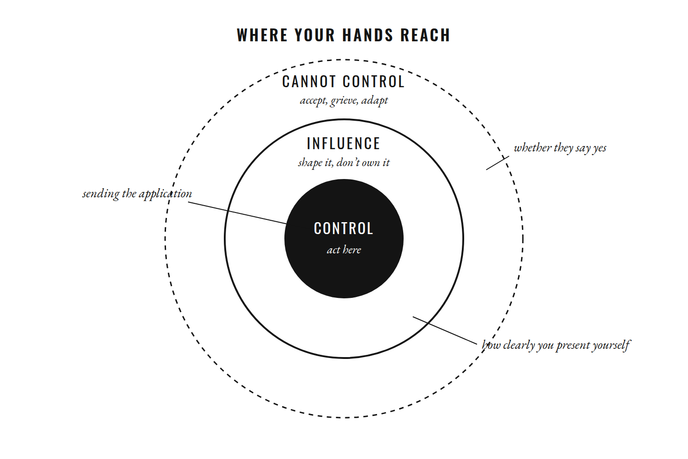
Figure 13. Spend your energy where your hands actually reach.
You can control whether you send the application. You can influence how clearly you present yourself. You cannot control whether another person chooses you.
You can control whether you train responsibly. You can influence adaptation through your habits. You cannot control every biological outcome.
The idea is ancient. Nearly two thousand years ago the Stoic teacher Epictetus opened his handbook with it: some things are within our power and some are not. The distinction prevents a common mistake—spending enormous emotional energy trying to command what reality never placed in your hands.

The First Hours After Failure
Failure often produces emotion before it produces insight. You are angry. Embarrassed. Sad. Confused. Maybe ashamed. You may want to decide what the failure means immediately.
Do not always trust that first interpretation. Give yourself enough distance to feel what happened without turning the feeling into a biography.
“I am disappointed” is different from “my life is ruined.” “I lost this opportunity” is different from “I will never get another one.” “This relationship ended” is different from “nobody will ever love me.”
The first statement describes reality. The second tries to predict the future while you are hurt.

Reappraisal Without Pretending
There is useful psychological work on cognitive reappraisal: the practice of changing how you interpret a stressful event rather than denying that the event occurred. A 2024 meta-analysis of fifty-five studies, involving nearly thirty thousand people, found a substantial positive association between reappraisal and personal resilience.
Reappraisal is not saying that the bad thing was secretly good. It is not saying the loss did not matter. It is not forcing yourself to feel grateful for pain. It is asking whether there is another accurate way to understand what happened.
“I failed at this” may become “I have information about what did not work.”
“I was rejected” may become “This particular person or institution said no.”
“I lost time” may become “I cannot recover the time, but I can decide what the next year contains.”
The event stays real. Your interpretation becomes less final.

Resilience Is Not Invulnerability
Resilience is often described as toughness, but a more useful picture is adaptation. You bend. You recover. You learn. You ask for support. You change the plan. You grieve what was lost. You continue where continuing makes sense.
Research increasingly treats resilience as a dynamic process shaped by protective factors and context rather than as a fixed personality trait. A 2024 umbrella review, drawing together forty-four reviews covering more than half a million participants, found that protective factors—personal, social, and community resources—and resilience-promoting interventions were both associated with better adaptation after adversity.
This matters because the solitary-warrior version of resilience is incomplete. Sometimes resilience looks like getting back to work. Sometimes it looks like calling someone. Sometimes it looks like admitting that you cannot do this alone. Sometimes it looks like changing direction.

Persistence or Stubbornness?
There is a subtle difference between persistence and stubbornness. Persistence responds to new information. Stubbornness ignores it.
Persistence says, “The plan failed. What can I change?” Stubbornness says, “The plan must work because I have already invested too much.”
Persistence can change strategy while keeping the value. You can stop pursuing one business model without abandoning entrepreneurship. You can leave one career without abandoning your desire to contribute. You can stop competing in one sport without abandoning movement. You can leave a relationship without abandoning the possibility of love.
Sometimes the goal is still right and the method is wrong. Sometimes the goal itself is wrong. Your job is to learn the difference.

Self-Compassion Is Not Surrender
After failure, people sometimes become brutal with themselves because they are afraid that kindness will make them lazy. But self-criticism and accountability are not the same thing.
You can say, “I made a mistake,” and also, “I am still worthy of care.” You can take responsibility without turning yourself into an enemy.
The evidence here is encouraging. In a series of experiments, people who were encouraged to respond to a failure or a moral mistake with self-compassion were more motivated to improve afterward, not less—they studied longer for a retest and were more committed to not repeating the mistake.
That matters because shame often makes people hide, and hiding makes learning harder. A healthier response is specific: what happened, what was my part, what can I repair, what support do I need, and what happens next?
You are not required to hate yourself into improvement.

Your Second Life
Every major failure creates an unwanted question: Now what?
The question is painful because it contains no guarantee. But it also contains possibility. The plan you had is gone, so you get to learn something new about yourself.
Maybe the failure reveals that the goal was never yours. Maybe it reveals a skill you need. Maybe it reveals a boundary you should have had earlier. Maybe it reveals that you were building too much on one outcome. Maybe it reveals nothing except that sometimes bad things happen.
You do not need to turn every failure into a beautiful lesson. You only need to decide whether it will be the final sentence.
You can say: “I don’t know yet. But I know I am not finished.”

CHAPTER THIRTY-SEVEN

WHAT HAPPENS AFTER YOU GET WHAT YOU WANTED?
❖

The Day After the Photograph
There is a strange disappointment that can arrive after a goal is achieved.
You thought the achievement would change the texture of your life. You imagined the promotion, the degree, the body, the business, the relationship, the move, the number in the bank account. You imagined the moment when the uncertainty would finally be over.
Then the moment arrives. People congratulate you. You take the photograph. You look at the result.
And the next morning, the alarm still rings. The dishes still need washing. There are still messages. There is still work. You are still yourself.
The achievement mattered. It may have changed your circumstances in important ways. But it did not turn you into a different species of human being.
That can feel like disappointment only if you expected achievement to solve a problem it was never capable of solving. The psychologist Tal Ben-Shahar has a name for that expectation: the arrival fallacy—the belief that once we reach a particular destination, we will be lastingly happy.

Arrival Is Not a Permanent State
Part of what happens next is hedonic adaptation: positive changes become familiar, and the emotional lift associated with them declines as the new circumstance becomes normal.
This does not mean success is pointless. A higher income can reduce financial pressure. A qualification can expand opportunity. Better health can make ordinary life easier. A loving relationship can add depth and stability. A successful business can create freedom for the people who built it.
The mistake is asking any of these achievements to answer every existential question.
The car can move you. It cannot tell you where to go.
The money can buy options. It cannot choose which options deserve your life.
The trophy can prove that you won. It cannot tell you whether the game was worth playing.

When the Goal Disappears
Try a thought experiment. Imagine you reach the goal completely. Nothing remains to prove. Now remove the goal from your identity.
Who are you on the day after? What do you do with your Tuesday? Who do you call? What do you care about? What work remains worth doing when the work is no longer necessary for validation?
Many people discover that they were using the goal as a container for meaning. Without it, the rest of life becomes strangely quiet.
That quiet is not necessarily emptiness. It can be an invitation to build a larger life around the achievement rather than asking the achievement to become the entire life.

Let It Count
Ambition has a habit of refusing to celebrate.
You finish the degree and immediately ask what comes next. You reach the physical goal and immediately identify the next flaw. You build the company and immediately start comparing it with someone else’s. You win and immediately begin preparing to defend the win.
There is nothing wrong with continuing. But if every achievement is instantly converted into another demand, your mind learns that progress does not deserve satisfaction.
Stop sometimes. Look back. Say, without exaggeration and without apology: I did that.
Let the moment exist. Gratitude is not complacency. Being satisfied with something you achieved does not require you to stop caring about the future.

The Summit Is Not a Home
A goal is a place you can reach. It is not necessarily a place you can live.
Once the goal is achieved, there is still a life around it. People still need you. Your body still needs care. Your attention still needs protection. Your relationships still need maintenance. Your character still gets practiced.
The achievement becomes part of the story. It does not have to become the story.

What If This Is Already Enough?
This question can feel almost offensive to ambition. What if this is enough?
Not forever. Not as a command to stop. Enough for today. Enough to enjoy. Enough to acknowledge. Enough that you do not need to hate the present in order to justify the future.
The healthiest form of ambition may not belong to the person who is permanently dissatisfied. It may belong to the person who can hold two truths without letting either destroy the other:
I want to grow. And I am allowed to appreciate that I have already grown.

CHAPTER THIRTY-EIGHT

THE SUMMIT DOES NOT EXIST
❖

There Is No Final Version
Every serious pursuit eventually creates the fantasy of a final version.
One day I will become disciplined enough. One day I will become confident enough. One day I will know exactly what I am doing. One day I will reach the level where doubt disappears. Then I will finally be finished.
But human development does not work that way.
A skill improves and reveals another layer. A relationship deepens and exposes another question. You solve one problem and discover the next. You become more confident and encounter a situation that requires humility. You get stronger and discover a weakness you had not noticed.
The imagined final version of you stays permanently attractive because it never has to meet a new problem. Real life keeps creating them.

Figure 14. Every summit reveals the next ridge.

Sisyphus and the Rock
The ancient story of Sisyphus gives this idea a strange shape. Sisyphus is condemned by the gods to push a rock up a hill, only to watch it roll down again, forever.
In his 1942 essay The Myth of Sisyphus, Albert Camus turned the punishment into a portrait of the human condition: we keep searching for final meaning in a universe that does not hand it to us. And yet, Camus wrote, the struggle toward the heights is enough to fill a human heart. “One must imagine Sisyphus happy.”
The useful part for this book is not the slogan that we should enjoy endless struggle. It is the rejection of a fantasy in which life becomes meaningful only after the final problem has been solved.
There may be no final problem. There may be another morning after this one. Another responsibility. Another loss. Another opportunity. Another question.
The goal is not to reach a state in which life stops asking anything from you.

The Mountain Moves
You can see this in every serious life.
The student becomes the graduate. The graduate becomes the professional. The professional becomes the beginner again in another domain. The athlete reaches one level and discovers another. The parent solves one stage of childhood and enters another. The business survives one crisis and meets another. The artist finishes the work and begins the terrifying blank page again.
The mountain keeps changing because you keep changing.
That does not mean progress is meaningless. It means progress is not a place where you live permanently.

Do Not Turn Growth Into an Emergency
There is a subtle trap here. Once you accept that there is no final summit, you can begin treating every day like an emergency. Always optimize. Always improve. Always push. Never rest, because there is always another level.
That is not freedom.
You are allowed to put the rock down. You are allowed to enjoy an afternoon without improving anything. You are allowed to have a season in which the goal is maintenance. You are allowed to love what you have already built. You are allowed to say, “For now, this is enough.”
The absence of a final summit does not mean there must be permanent ascent.

The Value Is in the Practice
Perhaps the more useful question is not “When will I finally arrive?” It is: “What kind of person is this practice asking me to become?”
Writing asks for patience. Parenting asks for responsibility. Learning asks for humility. Love asks for vulnerability. Leadership asks for judgment. Strength asks for restraint as well as effort.
If the practice itself shapes capacities you value, then the destination does not have to carry the entire meaning. You can keep walking without pretending there is a magical point at which walking ends.

Tomorrow’s Version
There will be no final version of you. That is not a threat. It is permission.
You do not need to solve your entire personality. You do not need to have one permanent identity. You do not need to know exactly who you will be at forty.
You need enough honesty to make the next meaningful choice. Then life changes. And you change with it.

CHAPTER THIRTY-NINE

THE OLD YOU IS DYING
❖

The Person You Used to Be
There is a dramatic way to describe transformation: kill the old you. It sounds powerful. It is also misleading.
The old you was not a villain waiting to be defeated. They were a person formed by the environment, fears, relationships, rewards, losses, and information available at the time.
Some of their habits may no longer serve you. Some of their beliefs may have been wrong. Some of their defenses may have outlived the danger they were built to survive.
But that does not mean the entire person needs to be erased.

When Armor Becomes Skin
A coping strategy can become an identity.
You learned to stay quiet because speaking once hurt. You learned to distrust people because trust once cost you. You learned to work constantly because being still made you uncomfortable. You learned to make everyone happy because conflict felt dangerous.
At first, the behavior protected you. Later, it may start limiting you.
The difficult part is that a strategy can remain emotionally convincing long after the original situation has changed. You still react as though the old danger is present. You still live according to rules written for another chapter of your life.

Memory Is Not a Command
Your past explains some of your behavior. It does not have to command all of it.
You can remember what happened without making it the blueprint for everything that comes next. You can understand why you became guarded and still practice trust carefully. You can understand why you became ambitious and still decide that rest matters. You can understand why you feared failure and still submit the work.
Growth often means respecting the reason a pattern existed while deciding that the pattern no longer gets automatic authority.

The Old Pattern Will Return
Transformation becomes easier to understand when you stop expecting permanent escape from old habits. You will return to them.
Stress can bring them back. Grief can bring them back. Fatigue can bring them back. A familiar person can bring them back. A difficult year can bring them back.
The return does not mean the change was fake. It means the old path still exists. Habit research suggests that old habits are rarely erased; they are overlaid by new ones, and the old cue can still wake the old response.
The skill is noticing the moment you are about to take the old path and deciding whether to continue.

The People Who Remember You Differently
Other people can also remember an older version of you more vividly than you do.
They may expect the person who always says yes. They may make jokes about the person you used to be. They may be surprised when you become more ambitious, more private, more independent, firmer about your boundaries, or simply different.
You do not need to punish them for remembering you. You also do not need to become the remembered version to make them comfortable.
People are allowed to have an outdated picture of you. You are allowed to update your own.
TRY THIS
A Letter to the Old You
Write to the person you were. Do not insult them. Thank them.
Tell them what they did to get you here. Tell them what they misunderstood. Tell them what you are carrying forward. Tell them what you are leaving behind.
Then make one decision based on the person you are becoming rather than the person you were protecting.

That is enough. You do not need a funeral for the old self. You need a new pattern.

CHAPTER FORTY

THE CLOCK DOES NOT CARE
❖

Later Is Not Empty
“Later” is one of the most dangerous words because it contains no image of its own. It sounds like nothing.
You will do it later. You will call later. You will rest later. You will travel later. You will make the art later. You will spend time with them later. You will become the person you want to be later.
The word hides an exchange. Today for tomorrow. Attention now for a future that may arrive differently than expected.

Figure 15. The sand falls at the same speed whether you are ready or not.

The Future Is Real, but It Is Not Yours Yet
Planning matters because the future matters. Savings matter. Education matters. Health choices matter. Long-term relationships matter. You cannot live entirely in the present without consequences.
But the future can become an abstract country in which you keep depositing your actual life. Work now, live later. Sacrifice now, enjoy later. Become successful later, be present later, rest later.
The trouble is that later keeps moving. A life can become an endless preparation for a life that never quite begins.

Time Changes What Matters
Research on how people think about time suggests that perceived time horizons shape the goals they prioritize. Laura Carstensen’s socioemotional selectivity theory proposes that when people perceive their remaining time as more limited—because of age, illness, or an approaching ending—they place greater weight on emotionally meaningful goals and close relationships, and less on exploration and future-oriented acquisition.
The idea is not that young people should behave like old people. It is that time perspective changes attention.
When the future feels infinite, almost everything can be postponed. When the future feels finite, what matters becomes easier to see.
The strange part is that the future has always been finite. We simply do not feel that fact continuously.
Studies of regret point in the same direction. In the short term, people tend to regret the things they did. Over the long run, the regrets that linger are more often the things they did not do.

The Last Five Years
Imagine someone told you that you have exactly five years left. Not five months. Five years.
What would change? Would you work less? Would you work more carefully? Would you call someone? Would you stop caring about a particular opinion? Would you finally make something? Would you travel? Would you stay? Would you apologize? Would you realize that one of your ambitions was never worth its cost?
Do not use the exercise to create panic. Use it to reveal hierarchy.
Mortality is not a scheduling technique. It is a reminder that there are things you cannot postpone indefinitely.

Do Not Waste the Present on the Future
The answer is not to abandon long-term goals. It is to stop making the present irrelevant.
Study, and enjoy the afternoon. Save money, and still notice what your money is allowing you to experience. Train for the future body while inhabiting the body you have today. Build the business without becoming absent from the people you love. Prepare for the future without treating the present as disposable material.
Your future self is not separate from you. It is the person receiving what you keep sending forward.

The Clock Is Not Your Enemy
The clock does not care whether you feel ready. It does not speed up when you are afraid. It does not slow down when you have finally found your purpose. It moves through good days and bad ones with the same indifference.
But there is another way to read that. Time is not only taking. It is giving.
Another morning. Another conversation. Another attempt. Another ordinary Tuesday.
There is still time. Not infinite time. Real time.
Enough time to make a different choice today.

CHAPTER FORTY-ONE

WHAT WILL REMAIN OF YOU?
❖

The Desire to Leave a Trace
There is a particular kind of ambition that appears late in the mind of an ambitious person: the desire to leave a trace. Not only to live well, but to be remembered.
The book should exist. The company should survive. The name should mean something. The work should outlast the body.
There is nothing strange about this. Human beings have always built monuments, raised children, created art, recorded histories, founded institutions, and tried to place some part of themselves into the future.
But legacy has a hidden danger. You can spend so much time trying to become permanent that you stop noticing the temporary life in front of you.

Permanence and Meaning Are Different Questions
Your name may survive you. That does not necessarily mean your life was meaningful.
A building can stand long after the people who built it are forgotten. A company can continue after its founder is gone. A photograph can outlast the feeling that created it.
Something does not have to last forever to matter while it exists. A conversation can last twenty minutes and change a person’s life. A kindness can be forgotten by everyone except the person who needed it. A teacher may never become famous and still alter the direction of hundreds of lives.
The absence of a public record is not evidence that a life had no effect.

The People Who Were There
Imagine that your public reputation disappears, but the people closest to you remember how you lived.
Were you present? Could they trust you? Did you listen? Did you become cruel in pursuit of success? Did you make everything about achievement? Did you have time for people? Did you keep your word? Did you know how to apologize?
These questions can feel less impressive than questions about awards and records. They may also be harder to fake.

Credit and Contribution
Not every contribution needs your name attached to it.
You can create something and let someone else improve it. You can teach a person who later becomes better than you. You can raise a child who never becomes famous. You can build a team that eventually no longer needs you. You can help someone who never learns your name.
There is a form of ambition that wants credit. There is another that wants the work to exist. The second is quieter.

Alone in the Room
Imagine yourself near the end of your life. You know the major accomplishments. You know the failures. You know which plans worked and which ones disappeared.
Now imagine that no one else is in the room. What do you want to be able to say?
Not that everyone admired you. Not that you won every competition. Not that you were never ordinary.
Perhaps simply: I was there for my life. I loved people. I tried. I paid attention. I did not spend all my years waiting for permission to begin.
Maybe that is a better definition of legacy—not how long the world remembers you, but how honestly you inhabited the life that came before the forgetting.

CHAPTER FORTY-TWO

THE LAST DAY
❖

The Boundary You Cannot Negotiate
Imagine that you wake up and somehow know that this is your last ordinary day.
Not a dramatic final scene. Just morning light, the room you know, the people you know, the same unfinished work, the same phone, the same messages—but this time you know the day has a boundary you cannot negotiate.
What suddenly matters? What becomes strangely unimportant?
The question is uncomfortable because death has a way of rearranging the hierarchy of attention. Would you spend the day trying to win an argument with someone whose opinion no longer matters? Would you spend hours comparing your body to someone else’s? Would you keep checking whether strangers approved of you? Would a small embarrassment still deserve the same space in your mind?
Mortality can make certain forms of nonsense look exactly like nonsense.
The Stoics practiced this deliberately. “Let us prepare our minds as if we had come to the very end of life,” Seneca wrote to a friend. “Let us postpone nothing.”

Not a Command to Be Reckless
But do not turn the thought experiment into a command to abandon responsibility.
Knowing a day is finite does not mean you should quit your job, spend all your money, or ignore the people who depend on you. It means you can look at your priorities more honestly.
On a final day, people may become more important than projects. The person beside you. The friend you kept meaning to call. The parent you assumed would always be there. The child who wants your attention while you are answering something “important.” The person you love but have been treating as though you have infinite time.
This does not mean work is meaningless. It means work is only one part of a life.

Moments You Did Not Know Were Moments
Open your photographs and scroll backward. Look at the things you considered ordinary when they were happening: a meal, a face, a street, a stupid joke, a room, a trip, a day you do not remember as important.
The camera roll can reveal something memory often hides: your life was never made only of milestones. It was mostly moments you did not know were moments.
The statistics, the follower count, the perfect photograph, the argument you won, the title, the expensive thing you were afraid to lose—none of these becomes automatically meaningless. Money can provide safety. Achievement can create opportunity. Objects can carry memories.
But they are not the same thing as a life.

What Burning Means
The word burn has appeared throughout these pages. It was never supposed to mean self-destruction. It means intensity without hatred: attention, commitment, the willingness to let false priorities fall away.
Burn away the need to impress everyone. Burn away the belief that you must become someone else before your life can begin. Burn away the habits that keep making your world smaller.
Keep the person. Keep the humor. Keep the relationships. Keep the ability to rest. Keep the capacity to care.

Ordinary Mornings
Tomorrow may come. You may have decades. That is precisely why the thought experiment matters. You have time, but not infinite time.
There will be another morning, unless one day there isn’t. So use the ordinary mornings while they are ordinary.
Call them. Make the thing. Apologize. Work. Rest. Laugh. Pay attention.
The last day is useful not because it tells you to live recklessly, but because it tells you what you do not want to keep postponing.

CHAPTER FORTY-THREE

WHEN THE FIRE BECOMES YOURS
❖

Borrowed Fire
A surprising amount of ambition begins with something borrowed.
Someone told you that you should become successful. Someone made you feel small. Someone else succeeded and you decided you needed to catch up. A person hurt you and you promised yourself you would become impossible to ignore. A culture handed you a definition of a good life. A screen showed you an identity you began trying to reproduce.
Borrowed reasons can be powerful. But they rarely make durable foundations.
Revenge can get you moving. It can make you wake early, train, and work through a difficult season. But eventually the target disappears or stops caring. Then what?
If your ambition depends on another person being impressed, you have given them a permanent role in your future.
Use anger as information. Do not build a house inside it.

The Promise Nobody Saw
A real commitment survives the disappearance of the audience.
Nobody knows you kept the promise. Nobody knows you practiced. Nobody saw you choose the harder option. Nothing was posted. Nothing was announced. You simply knew.
That is where character begins to separate from performance. A life cannot be built entirely from public moments because most of a life is private.

When Values Compete
It is easy to say that you value health when health has no cost. It is easy to say that relationships matter when being present requires no sacrifice. It is easy to say you value truth when honesty does not threaten your position.
Values become real when they compete with something else you also want. You may value ambition and rest, freedom and responsibility, truth and belonging, success and family. There is no formula that removes these tensions.
You have to choose.

Power Is Capacity, Not Virtue
You can become stronger without becoming kinder. You can become more successful without becoming more trustworthy. You can become more independent without becoming more capable of love.
Power is not automatically a virtue. It is capacity. The question is what you do with it.
That is why the goal of this book was never to turn you into the most ruthless version of yourself. Ruthlessness can win things. It can also destroy things you later discover mattered more.

The Performance of Discipline
There is a version of ambition that constantly performs itself. The routine is posted. The discipline is displayed. The struggle becomes content. The achievement becomes identity. The life becomes a brand before it becomes a life.
There is nothing inherently wrong with sharing your journey. But there is a danger in becoming so conscious of the audience that you start making choices for the camera even when no camera is present.
The future does not need an announcement. It needs behavior.

Fire as Care
The strongest version of fire may not be anger. It may be care.
You care enough about your body to train it. You care enough about your work to improve it. You care enough about another person to tell the truth. You care enough about your time to protect it. You care enough about your life to stop wasting all of it trying to prove that it matters.
Care can be relentless. It can also be gentle.

Returning
You will lose yourself again. There will be seasons when you forget what matters. There will be days when comfort wins. There will be moments when the old story sounds convincing.
When that happens, do not make another grand declaration. Return to the values. Return to the people. Return to the work. Return to the question: What is this life for?
And if you cannot answer it completely, choose the next action that does not require you to lie. That is enough.

The Better Question
At the beginning, the question may have been: How do I become great? Perhaps you asked a version of it too. How do I become successful? How do I become disciplined? How do I become extraordinary?
After everything we have explored, perhaps the better questions are different.
What kind of life is worth living? What kind of person do I want to be while living it? What am I willing to lose? What am I willing to protect? What deserves my attention? What deserves my effort? What deserves my love?
Those questions do not produce a final answer. They produce a direction.
And a direction can be lived.

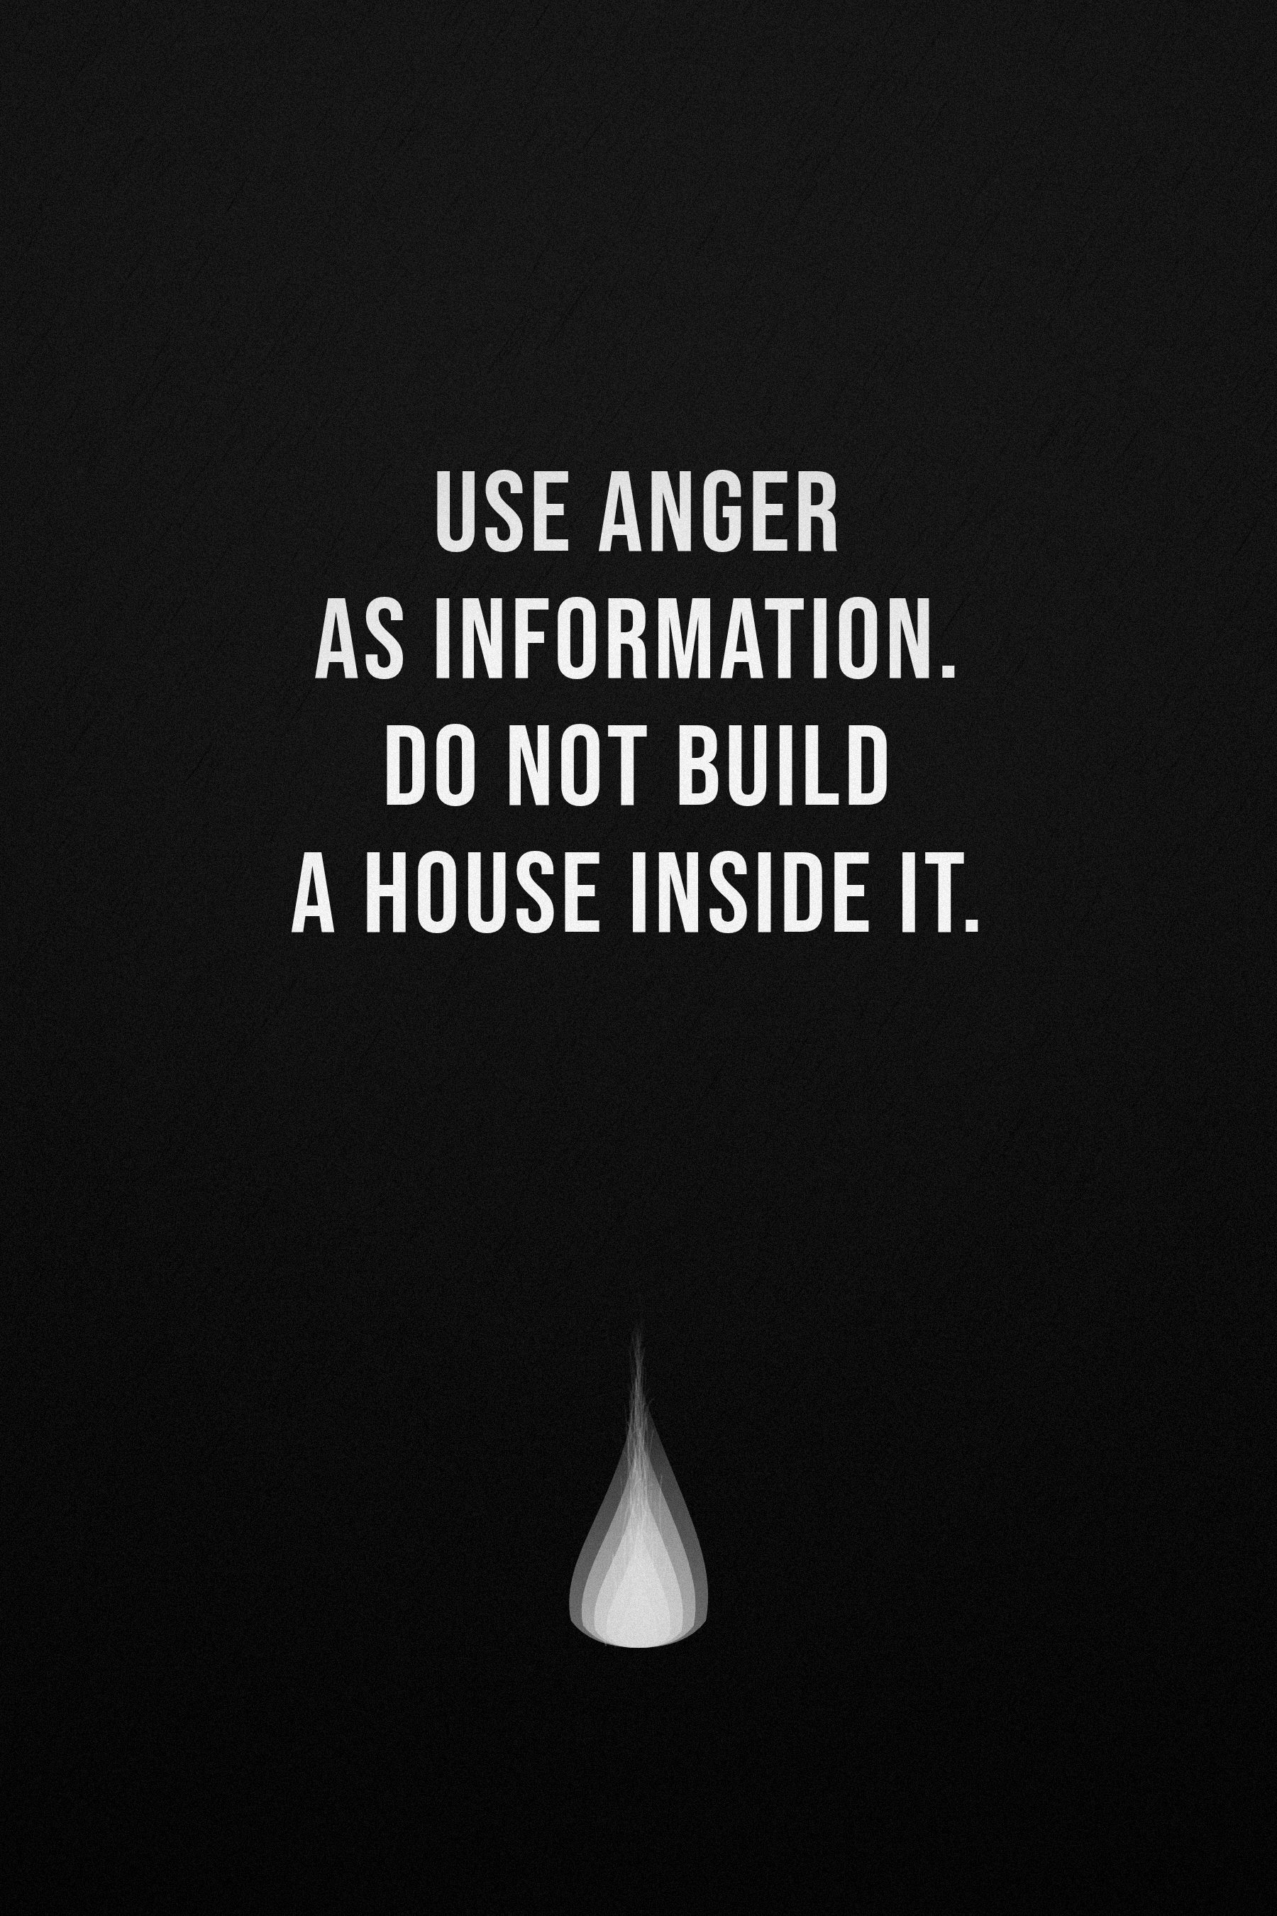

CHAPTER FORTY-FOUR

THE LIFE YOU KEEP POSTPONING
❖

The Life That Exists Only in Your Imagination
There is a version of your life that exists only in your imagination.
In that life, you finally become disciplined. You finally become confident. You finally make the money, build the body, start the business, write the book. You finally travel. You finally tell them how you feel. You finally become the person you keep promising yourself you will become.
Everything is waiting. The perfect morning. The perfect opportunity. The perfect version of you.
There is only one problem. That life does not exist.
Not yet. Maybe never.
Because the imagined life is effortless, and reality is not. Reality has bills, fatigue, bad days, rejection, illness, boring work, conflicting responsibilities, people who misunderstand you, plans that collapse, opportunities that arrive at inconvenient times—and mornings when you simply do not feel like becoming anything.
The life you imagine is clean. The life you are given is messy. And somewhere between those two is the only life you actually get.

What You Keep Waiting For
Maybe you have been waiting for confidence. But confidence usually grows after evidence. You act. You survive. You learn. You discover that you can handle more than you thought. Then confidence arrives, a little late, like a witness who saw the whole thing.
Maybe you have been waiting for motivation. But motivation comes and goes.
Maybe you have been waiting for money. But there will always be another financial threshold.
Maybe you have been waiting for permission. But the person whose permission you want may never give it.
Maybe you have been waiting until you know exactly what you want. But knowing often comes from trying.
Maybe you have been waiting until you stop being afraid. You may be waiting forever.
The life you want may require you to begin before the feeling arrives.

The Fantasy of a Different You
There is a strange comfort in imagining your future self.
Future you does not procrastinate. Future you wakes up early, eats well, works consistently, knows what to say, has money, is respected, and has everything under control. Future you is almost fictional.
And because that person does not exist yet, you can keep assigning responsibility to them. They will handle it. They will start. They will apologize. They will become disciplined. They will figure it out.
But future you is not coming to rescue present you. Future you is being constructed by present you.
That is the uncomfortable part.

Your Future Self Is Watching
Imagine meeting yourself ten years from now. Not the fantasy version. The actual person.
They have lived ten more years. They have experienced things you cannot predict. They have lost people and met people. They have failed at some things and succeeded at others. They have changed their mind. Perhaps they have become a parent. Perhaps they have buried someone they loved. Perhaps they built something. Perhaps they abandoned something. Perhaps they discovered a completely different ambition.
And they ask you one question:
What did you do with the time I gave you?
Not “Why weren’t you perfect?” Not “Why didn’t you become famous?” Not “Why didn’t everything work?”
Just: what did you do with it?
What would you want to be able to tell them?

Do Not Make a Deal With an Imaginary Future
You cannot promise your future self everything. You cannot guarantee the health, the money, the people, the opportunity, the energy, or the circumstances. You cannot even guarantee that you will still want the same things.
So stop making your entire present pay for an imaginary future.
Plan for tomorrow, but live today. Build for five years, but notice this morning. Save money, but enjoy something money cannot buy. Work hard, but remember why you wanted the freedom in the first place. Train, but inhabit the body you are training. Study, but look up occasionally. Build—but do not become absent from your own construction.

The Price of Delay
Every decision has a cost. We have talked about the cost of action. Now consider the cost of waiting.
If you delay learning a skill for five years, you do not simply lose five years of progress. You lose the version of yourself who might have existed after five years of practice.
If you delay repairing a relationship, the relationship changes while you wait. If you delay caring for your health, your future body inherits the consequences. If you delay creating, you lose the work that could have existed. If you delay speaking, the unsaid words become part of the relationship.
Delay is not neutral. Sometimes waiting is wise. Sometimes waiting is simply expensive.

The Compounding of Ordinary Days
People love dramatic transformation: the before, the after, the montage. But most lives are not transformed in dramatic moments. They are accumulated.
One workout. One page. One conversation. One amount saved. One hour of study. One decision to sleep. One decision to stop. One decision to begin again. Then another. And another.
The result eventually becomes visible. By then, the transformation looks sudden to everyone who wasn’t there.
They see the tree. They do not see the years of roots.

You Do Not Need to Change Everything
This is where people often make another mistake. They read something powerful and become overwhelmed. Tomorrow, they decide, they will wake at five, meditate, run, read, study, work, build a business, learn a language, eat perfectly, train, journal, sleep early, and never touch their phone. New life. New identity. New person.
Three days later: nothing.
Not because they are incapable. Because they attempted to build a new life in one violent movement.
You do not need a new personality tomorrow. You need one changed behavior. Then another.
The goal is not intensity. It is integration.

The Smallest Honest Step
Ask: what is the smallest action that would make this real?
Not “How do I become a writer?” Write one page.
Not “How do I become fit?” Train today.
Not “How do I fix my entire career?” Research one opportunity.
Not “How do I repair this relationship?” Send one honest message.
Not “How do I find my purpose?” Try something that matters enough to teach you more about yourself.
The first step does not need to solve the entire problem. It only needs to prove that the problem has entered reality.

Stop Making Yourself a Project
You have spent much of this book thinking about becoming. Be careful.
You are not a renovation project that must be completed before you are allowed to live inside yourself.
There is a point where self-improvement becomes self-obsession. Every emotion becomes something to optimize. Every flaw becomes a project. Every weakness becomes content. Every mistake becomes a lesson. Every day becomes a performance review.
Stop.
Sometimes you are simply a human being having a difficult day. Sometimes you need food. Sometimes you need sleep. Sometimes you need someone to sit beside you. Sometimes nothing needs to be optimized.
You can improve without turning yourself into a problem that must be solved.

Enough Is Not the End
Ambition can make people strangely incapable of celebration. They reach the goal and immediately ask, “What’s next?” If you never stop long enough to acknowledge what you have done, your mind learns a dangerous lesson: nothing is ever enough.
So hold two truths at once.
You can say, “This is enough for today,” and still want tomorrow. You can say, “I am proud of myself,” and still have work to do. You can say, “I accept who I am,” and still change. You can say, “I have enough,” and still build.
Growth does not require dissatisfaction with your existence. Sometimes growth comes from caring enough about your life to improve it.

Useful Before Impressive
Maybe you are waiting to become successful before you allow yourself to help others. Don’t.
You can contribute now. You can encourage someone now. You can teach what you know now. You can listen now. You can be kind now. You can create now.
You can become useful before you become impressive. Usefulness may matter more. Impressive is about perception. Useful is about effect.

The Question to Keep
Eventually this book will end. You will put it down. Maybe it will sit on a shelf. Maybe you will underline passages. Maybe you will forget most of it.
That is all right. I do not need you to remember every chapter. I want you to remember one question. When you are making a decision, ask:
Is this taking me toward the life I actually want, or simply away from discomfort?
Sometimes the answer will be toward. Sometimes it will be away. And sometimes it will be I don’t know.
That is allowed. You are not trying to become all-knowing. You are trying to become honest.

The Moment After Reading
Imagine closing this book. You sit there for a few seconds.
Nothing changes. The room is the same. The phone is still there. Your responsibilities remain. Your problems have not disappeared. The world has not suddenly become fair. You are still you.
But perhaps one thing is different. You cannot unknow certain questions. You have seen the cage. You have noticed the door.
Now you have to decide whether to walk through it.

The Door
Remember the image from the beginning. The room. The chair. The phone. The mountain outside. The door.
It was never locked.
Maybe the door was never even the point. Maybe the point was that you had spent years staring at it: analyzing it, researching the best way to open it, watching other people walk through theirs, wondering whether you were ready, waiting for the right weather, waiting for confidence, waiting for someone to tell you, Go.
And now you understand. The door does not care how ready you feel. It is simply there.
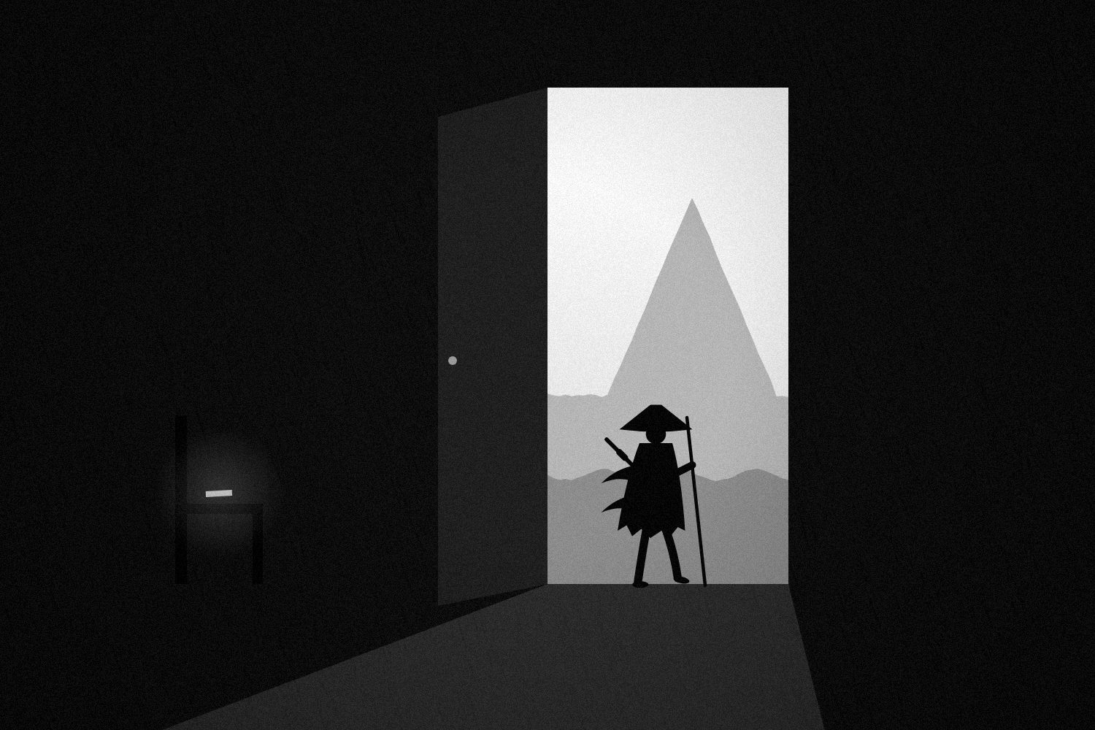
Figure 16. The door was never locked. The mountain was always outside.

Walk
Not because the mountain is guaranteed to reward you. Not because the journey will be easy. Not because you will become famous. Not because you will never fall.
Walk because standing still has become a decision too. Walk because there is something you want to discover. Walk because you care. Walk because you want to see what happens if you actually try. Walk because the person you might become is worth meeting.
And if you discover halfway there that the mountain was wrong—turn. That is allowed. You are not obligated to finish a journey simply because you started it.
Changing direction is not always quitting. Sometimes it is waking up.

A Thousand Ordinary Choices
Maybe the life you keep postponing is not waiting somewhere far away. Maybe it is hidden inside ordinary choices. The call. The page. The workout. The apology. The application. The boundary. The rest. The beginning. The decision.
You keep expecting your life to change through one enormous moment. Maybe it changes through a thousand ordinary ones—so quietly that you do not notice it happening, until one day you look around and realize: I don’t recognize this life.
And for once, that is a good thing.

The Last Choice
You can close this book and return to exactly what you were doing. Nothing will stop you. You can return to the same habits, the same excuses, the same distractions, the same conversations, the same “later.”
Nobody will arrest you. Nobody will announce that you failed.
That is the terrifying freedom of adulthood. The world will let you waste your life. And it will let you live it too.
So choose. Not forever. Today.

Tomorrow Morning
When you wake up tomorrow, do not try to become a completely different person. Before you touch your phone, ask yourself one question:
What is one thing I already know I need to do?
Then do it.
Not because a book told you. Not because you are afraid. Not because you need to prove something. Do it because you decided.
That is where the fire becomes yours.
Then live the day. Have the difficult conversation. Do the boring work. Laugh with someone. Eat. Train. Study. Rest. Fail. Try again. Maybe you will accomplish something. Maybe you will accomplish nothing. Maybe the day will be beautiful. Maybe it will be terrible. You do not control all of that.
But you were there. You participated. And tomorrow you get another chance.
Until you don’t.

The Life You Could Have Lived
There will always be another life you could have lived. The artist. The athlete. The entrepreneur. The traveler. The scholar. The parent. The person who stayed. The person who left. The person who took the risk. The person who didn’t.
You cannot live them all. So do not spend your life grieving every possible version.
Choose one. Live it deeply. And when it changes, choose again.

The Final Question
If you removed every external measure of success—money, followers, titles, trophies, grades, status, beauty, fame, recognition—what would still make you want to wake up tomorrow?
Whatever remains, pay attention. That may be where your life is asking you to look.

The Door Was Never Locked
You do not need another quote. You do not need another video. You do not need another five-step system. You do not need to wait until Monday. You do not need to become fearless, or perfect, or someone else.
You need to take what you now know and do something with it.
The door is open. The mountain is outside. Your life is already moving.
Go.

EPILOGUE
THE STAR
❖
There is a line people repeat because it sounds beautiful: to become a star, you must burn.
It is a powerful metaphor, but it can be misunderstood. We often confuse devotion with destruction. We imagine that a person who wants something badly enough should exhaust themselves, sacrifice everything, and turn suffering into proof of worth.
That was never the point of this book.
The fire was never supposed to consume you. It was supposed to illuminate what mattered.
You have spent these pages asking what you are willing to change, what you are willing to lose, what you are willing to endure, and what you are willing to become. But there is another question worth keeping: What are you willing to care about deeply enough to keep returning to?
Because becoming is rarely one heroic decision. It is repetition: returning after embarrassment, returning after failure, returning after the excitement disappears, returning when nobody applauds, returning when the work becomes ordinary.
Maybe you will become extraordinary. Maybe you will not. You do not know, and neither does anyone else.
You can work hard and fail. You can prepare and lose. You can choose courage and still be afraid. You can build something beautiful and watch it disappear. You can spend years pursuing one dream and discover that you want another.
That is not a flaw in life. It is life.
The point was never to control the ending. It was to participate in the story while you are still inside it.
· · ·
One day, years from now, you may look back at the person reading these words. You may not remember this book. You may not remember the chapters. You may not remember the sentences that felt important.
But perhaps you will remember something you did afterward: the application you finally sent, the conversation you finally had, the thing you finally created, the habit you finally abandoned, the person you finally forgave, the boundary you finally set, the dream you finally gave an honest attempt.
Or perhaps something much smaller—a morning when you put the phone down, a walk you took, a page you wrote, a person you called, an ordinary Tuesday when, for once, you were completely present for your own life.
Those moments count. Especially those moments.
You were never required to become a legend. You were never required to conquer every mountain. You were never required to prove that your existence was important enough to be remembered. The world is already full of people trying to be remembered.
Perhaps the harder task is learning to live a life that would still matter to you if nobody remembered your name. A life with people you loved. Work you respected. Mistakes you learned from. Days you actually inhabited. Values you did not abandon when they became inconvenient. A life that, when it eventually becomes a memory, feels unmistakably like yours.
And perhaps this is what becoming really means. Not becoming perfect. Not becoming invincible. Not becoming someone who never doubts. Not becoming someone who never falls.
It means becoming more honest about what matters, more willing to act, more capable of changing your mind, more comfortable being a beginner, more willing to leave what no longer fits, more willing to stay when staying is meaningful, and more willing to rest without calling yourself weak.
You do not have to spend your life fixing yourself. You have to live it.
· · ·
The world will keep offering you definitions of success: more, faster, bigger, richer, stronger, more visible, more impressive. You will be tempted to believe that your life is a scoreboard.
It isn’t.
At some point, the numbers stop answering the important questions. You can have the title and hate the life. You can have the applause and still not recognize yourself. You can lose everything that looked impressive and discover that what remains is what mattered all along: people, purpose, attention, character, love, and the ability to look at your own life without needing to lie about it.
So burn. But not yourself.
Burn through the excuses that have kept you small. Burn through the identities you have outgrown. Burn through the fear that has been making your decisions for you. Burn through the need to be understood by everyone. Burn through the fantasy that one perfect future version of you will eventually arrive and fix everything.
Burn with the steady heat of commitment. Burn with curiosity. Burn with love.
Let the fire make you clearer. Not crueler. Stronger. Not harder. More alive.

Figure 17. Let the fire make you clearer. Not crueler.
At some point, the question changes. You stop asking, “How can I prove that I am extraordinary?” You begin asking, “What is worth giving my life to?”
That is a quieter question. A more difficult one. And perhaps a more important one.
Because your life is not an audition. You do not have to convince the universe that you deserved to be here. You are here. The question is what you will do with that fact.
There is no final version of you. There is no perfect ending. There is no mountain that will make every other mountain disappear. There is only this moment, then the next, then the next.
And somewhere inside all those ordinary moments is the life you kept searching for. Not waiting at the summit. Not hidden in the future. Not inside some better version of yourself.
Here. Now. Already happening.
· · ·
So close this book. Not because you have finished becoming. You never will. Close it because there is nothing left for these pages to do for you.
The rest belongs to the world outside them: to the people you love, to the work in front of you, to the choices you keep postponing, to the mornings you have not lived yet, to the mistakes you have not made, to the places you have not seen, to the people you have not yet met, including the future versions of yourself.
Go meet them. Not by imagining them. By living.
You were never promised a perfect life. You were given a finite one. That is different. And perhaps that is enough. More than enough.
Because a finite life can still contain an enormous number of meaningful moments: a conversation, a hand held, a page written, a problem solved, a mountain climbed, a failure survived, a child taught, a friend forgiven, a stranger helped, a dream attempted, a quiet morning noticed.
None of it has to last forever to matter.
And someday, when all the striving is finished, when the trophies have gathered dust, when the photographs have faded, when the names that once seemed important have been forgotten, what remains may be much simpler than you imagined.
You were here. You loved. You tried. You changed. You failed. You began again. You gave something. You received something. You paid attention. You lived.
And perhaps, in the end, that is what it means to burn to become. Not to destroy yourself in pursuit of some impossible ideal, but to become awake enough to spend your one life deliberately.
The fire is yours now. Protect it. Feed it. Let it warm other people. Let it illuminate the road. And when it grows quiet, return to it.
Again. And again. And again.
Because the goal was never to burn forever. The goal was to become someone who knows what the fire is for.

BURN TO BECOME.
Not because you must destroy yourself to become worthy.
But because you have decided that your life is worth being awake for.

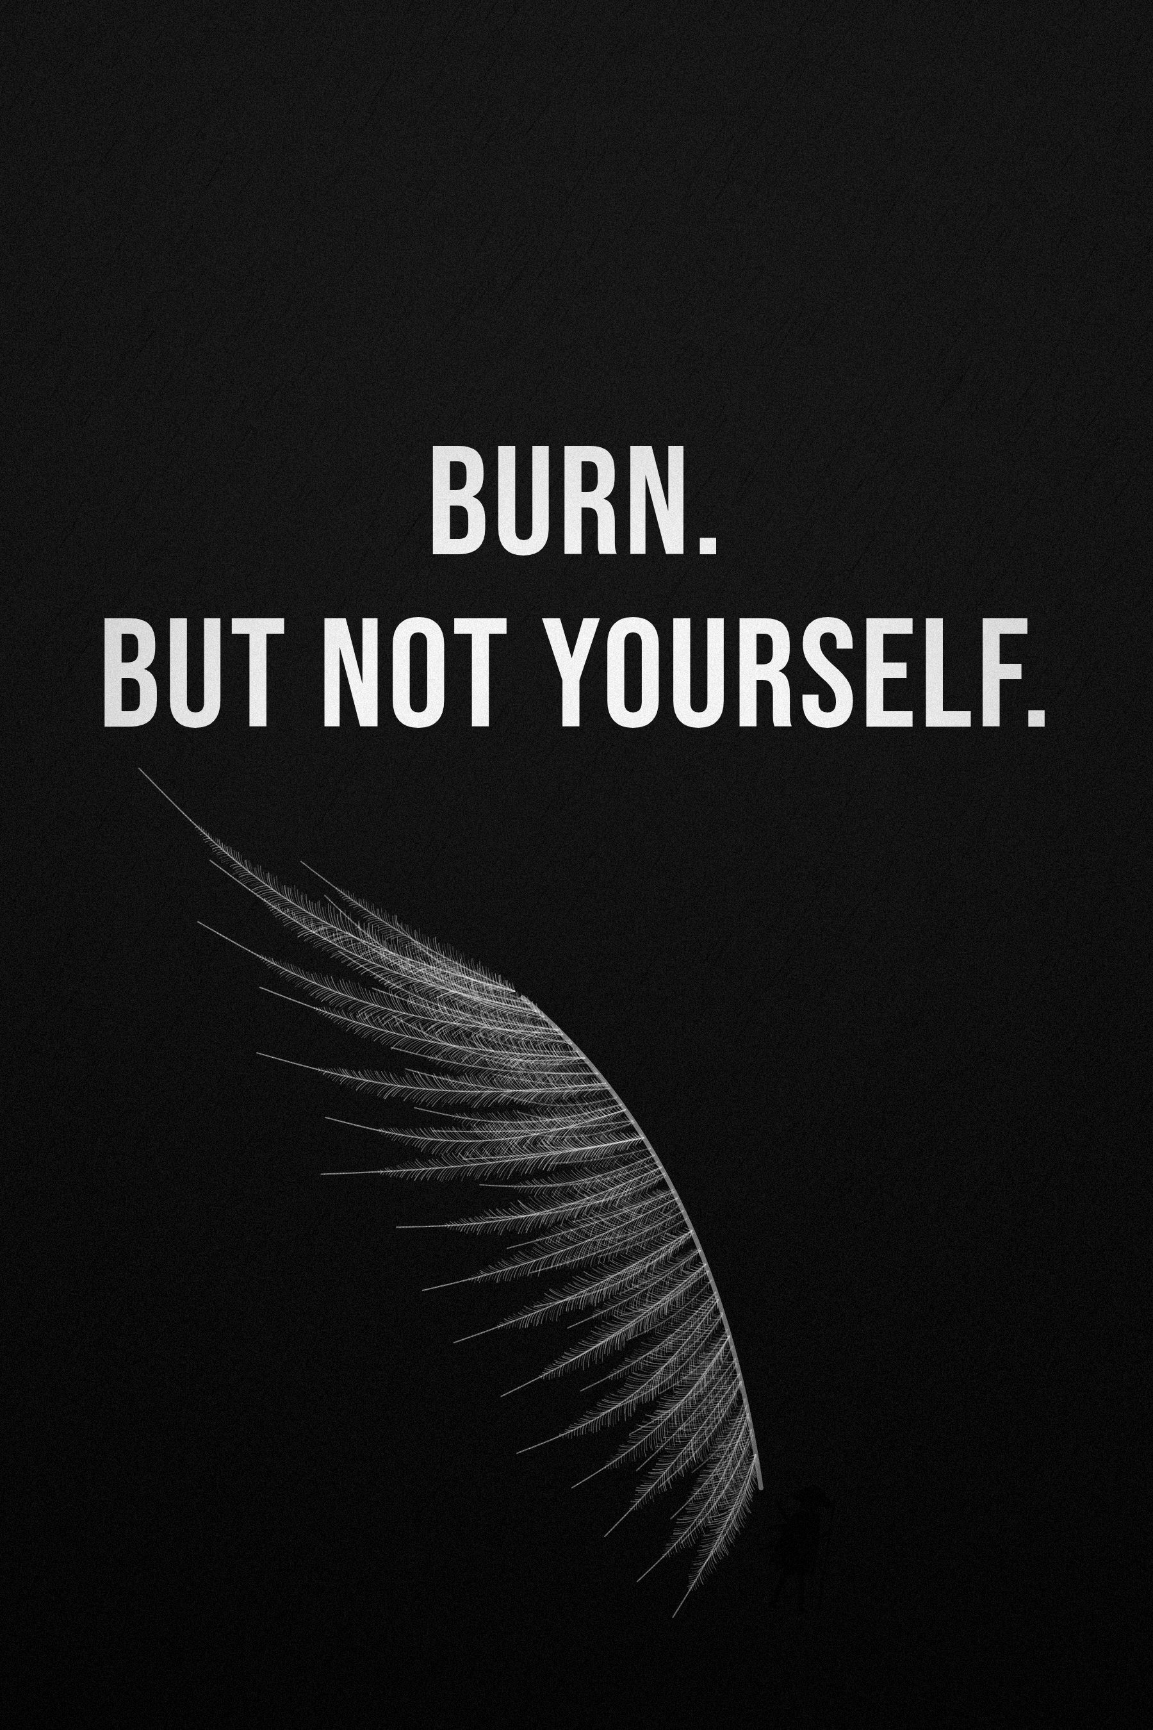

THE FIELD MANUAL
Thirty Days to Burn to Become
❖
A book can change how you see. Only behavior changes how you live.
This manual turns the ideas of the book into thirty short, concrete practices. Each takes between five and thirty minutes. None requires you to overhaul your life. Most ask you to notice something, write something down, or take one small action and then look honestly at what happened.
The thirty days are grouped into five weeks, one for each part of the book, plus a closing stretch. You do not have to do them on consecutive days. You do have to do them in writing. Thinking about an exercise and doing it are not the same thing, which is, in a sense, the argument of the entire book.

Three rules before you begin
1. Accuracy over severity. When a question makes you uncomfortable, the goal is not the harshest answer. It is the most accurate one.
2. Smaller than you think. If a day’s action feels heroic, shrink it until it feels almost too easy. You are building evidence, not a performance.
3. Missing is not failing. If you miss a day, do not start over. Return. Returning is the skill.
A note of care: some of these practices touch on painful things—failure, loss, mortality, old wounds. If a question opens something that feels bigger than a notebook can hold, that is not weakness. It is a signal to talk to someone you trust or a qualified professional.

Week One — See the Life You Are Living
DAY 1 The Receipts
Open your calendar, your screen-time report, and your bank statement for the last seven days. Without judging, write down the five things that received the most of your time, attention, and money.
Then write the five things you say matter most. Put the two lists side by side.
DAY 2 The Five-Year Projection
If nothing about your current habits changed for five years, describe the life they would build. Be specific: your body, your work, your relationships, your finances, your attention. Then circle the one sentence that bothers you most.
DAY 3 The Door
Name one door you have been studying instead of opening—an application, a conversation, a project, a question. Write what you fear is on the other side, and what might be. Then take one action that puts your hand on the handle: open the document, draft the email, book the time.
DAY 4 Recovery or Avoidance
Every time you take a break today, ask afterward: do I feel more able to return, or less? Keep a tally. At the end of the day, write down what the avoidance breaks were protecting you from.
DAY 5 Name the Fear
Choose the thing you have been postponing longest. Finish this sentence three different ways: “If I really try, I am afraid it will become true that…” Then finish this one once: “If I never try, it will become true that…”
DAY 6 Wish and Obstacle
Write one wish for the next three months. Write the best outcome in one sentence. Write the main inner obstacle. Then write a plan: “If [obstacle], then I will [action].”
DAY 7 Review
Reread the week’s pages. Answer one question: “What does my behavior seem to believe that my words do not?”
WORKSHEET
The Say / Do / Gap Inventory
Area | What I say | What I actually do | What the gap might mean
Health
Work
Relationships
Attention
Money
Promises to myself

Week Two — Confront the Patterns
DAY 8 The Friction Test
For one block of at least forty-five minutes, remove the easiest escape: phone in another room, one tab open, notifications off. Work on something that matters. Write down each urge to leave, what you wanted to escape to, and how long the urge lasted.
DAY 9 Your When–Then
Choose one behavior you want to build. Write: “When it is [time] and I am in [place], I will [first physical action].” Then write your minimum—the version you will still do on your worst ordinary day. Do the minimum today.
DAY 10 Redesign One Environment
Pick one place where you repeatedly make a choice you regret—your desk, your bed, your kitchen, your phone’s home screen. Make the better choice easier and the worse choice harder. Move one object. Delete one app from the home screen. Prepare one thing tonight for tomorrow morning.
DAY 11 One Small Promise
Make yourself one promise so small you cannot reasonably fail. Keep it. Write it in your evidence file (see below). Repeat this every day for the rest of the month.
DAY 12 Rewrite a Label
Write down one sentence you often say about yourself that sounds like a verdict: “I’m just not…”, “I always…”, “I’ve never been…”. Rewrite it as a practice: “I have practiced ___. I am now practicing ___.”
DAY 13 Translate Your Envy
Think of someone whose life you envy. Write what exactly you envy. Then ask underneath it: is it really their money, or security? Their body, or confidence? Their audience, or being seen? Write the need beneath the symbol, and one way to pursue that need directly.
DAY 14 Remove the Witness
Choose one current goal. Imagine that nobody will ever know you achieved it. No post, no announcement, no one impressed. Write honestly: do you still want it? If yes, why? If no, what were you really after?
WORKSHEET
The Evidence File
Date | Promise kept or hard thing done | What it proves about who I am becoming

Week Three — Study Lives, Including Your Own
DAY 15 The Moving Summit
List three achievements from your past that you once badly wanted. For each, write how long the satisfaction lasted, and what goal replaced it. Ask Alexander’s question: what would “enough” look like for your current goal?
DAY 16 The Hidden Repetitions
Choose one skill you admire in someone else. Research, honestly, the unseen part: how many years, what instruction, what advantages, what setbacks. Then choose one skill of your own and schedule twenty minutes of deliberate practice aimed at a specific weakness.
DAY 17 A Better System, Not More Intensity
Recall a failure you responded to by “trying harder” that did not work. Write down what system, method, coach, or structure might have helped instead. Apply that thinking to one current problem.
DAY 18 Your Failure Portfolio
Write down three attempts that did not work. For each: what did you try, what happened, what did you learn, what would you change? Notice that you survived all three.
DAY 19 The Scoreboard Audit
List the numbers you check most often—followers, weight, grades, income, likes, rankings. For each, ask: is this information, or a verdict on my worth? Choose one to check less often this week.
DAY 20 What Is Life Asking?
Instead of asking what you want from life today, ask what today is asking of you. Write down the person, the responsibility, or the task in front of you that most needs your attention. Give it thirty undistracted minutes.
DAY 21 Review
Reread your Failure Portfolio and your Evidence File together. Write one paragraph describing the person the evidence suggests you are becoming.
WORKSHEET
The Failure Portfolio
What I tried | What happened | What I learned | What I will change

Week Four — Design the Life Beyond the Cage
DAY 22 Seven Days Without a Borrowed Deadline
Begin a one-week comparison log. Each time someone else’s life changes how you feel about your own, write what you saw and what you suddenly believed you were behind in. At the end of the week, answer: “If I had never seen another person’s progress, what would I still want?”
DAY 23 The Ten-Year Mirror
Imagine meeting yourself in ten years and discovering that almost nothing important changed. Write how you feel—peaceful, relieved, trapped? Then decide, in one sentence, whether the answer points toward leaving, staying more present, or simply appreciating what you have.
DAY 24 Design the Ordinary Tuesday
Fill in the worksheet below twice: once for your current Tuesday, and once for the Tuesday you want to be living in two years. Circle the three smallest differences that you could begin now.
DAY 25 One Experiment
Choose one thing worth trying next—a course, a conversation, a small version of a project, a month of living differently. Define it as an experiment: what will you do, for how long, and what information are you hoping to gain?
DAY 26 The Calendar as a Drawing
Open next week’s calendar. Put one block of time on it for each of the three things you say matter most. If nothing on the calendar belongs to what matters, that absence is today’s finding.
WORKSHEET
The Ordinary Tuesday
Time | My current Tuesday | The Tuesday I want
Waking
Morning
Work
Movement
People
Evening
When I’m tired
When the plan breaks

Week Five — Know What the Fire Is For
DAY 27 What Are You Willing to Lose?
Write one thing you are pursuing. Then write the honest price: what it costs in time, money, relationships, comfort, and other possibilities. Ask: if I were starting today, knowing what I know now, would I choose this again?
DAY 28 Control, Influence, Accept
Pick your biggest current worry. Divide a page into three columns: what I can control, what I can influence, what I cannot control. Take one action from the first column today. Write one sentence of acceptance for the third.
DAY 29 A Letter to the Old You
Write to the person you were five years ago. Thank them for what they carried. Tell them what they misunderstood. Tell them what you are keeping and what you are leaving behind.
DAY 30 The Last Ordinary Day
Imagine this is your last ordinary day. Write down who you would call, what you would stop caring about, and what you would finally do. Then choose one item from the list and do it today—not recklessly, but deliberately.

After the thirty days
Do not start over. Continue.
Keep the evidence file. Keep one small promise a day. Once a month, redo Day 1 and Day 24. Once a year, redo Day 2 and Day 30.
And every morning, before the phone and before the noise, ask the question from the last chapter:
What is one thing I already know I need to do?
Then do it.

QUESTIONS FOR REFLECTION AND DISCUSSION
❖
These questions can be used alone with a notebook, with a friend, or in a reading group. There are no correct answers. The useful ones are the honest ones.

Part I — The Life You Are Sleepwalking Through
1. Which of your current routines began as a choice and now feels like a fact?
2. What have you been “preparing” for longer than a year? What would contact with reality look like?
3. The book distinguishes recovery from avoidance. Where in your week does one disguise itself as the other?
4. Which of the four voices—fear, ego, approval, values—most often gets the final word in your decisions?
5. What would you lose if you stopped being “someone who could” and became “someone who did,” even imperfectly?

Part II — The War Inside You
1. Describe a time when changing your environment worked better than trying harder.
2. What small promise to yourself do you break most often? What would a smaller version you can keep be?
3. Is there a label you use about yourself that sounds like an observation but works like a prediction?
4. Who is in your invisible audience? What would change if they were no longer watching?
5. Which mountain in your life might not be yours? How would you find out?
6. What is one beginning you keep collecting instead of continuing?

Part III — The People Who Refused to Remain Small
1. Alexander could not recognize enough. What would “enough” look like in one area of your life?
2. Musashi’s legend is cleaner than his history. What legend do you tell about yourself that the evidence does not fully support?
3. Jordan’s Pistons years suggest that sometimes the answer to failure is a better system, not more intensity. Where might that apply to you?
4. Ronaldo became better by changing the teenager he was. What part of your younger self are you protecting in the name of authenticity?
5. Frankl insisted that meaning is not a formula for survival. Why does that caution matter?

Part IV — The Cage and the Open Door
1. When does looking at other people’s lives inform you, and when does it hand you a deadline you never agreed to?
2. What in your life are you defending simply because it is already assembled?
3. If the door opened tomorrow, what would you build on the other side—and what would your ordinary Tuesday look like there?

Part V — What the Fire Is For
1. What are you giving your life to that you have never consciously chosen?
2. What is one sunk cost you might be protecting at the expense of the future?
3. After a goal you achieved, what happened on the day after the photograph?
4. If you knew you had five years left, what would you stop postponing?
5. The Epilogue says: “Burn. But not yourself.” What does that mean in your life right now?

A NOTE ON THE ILLUSTRATIONS
❖
Every illustration and typographic plate in this edition was created for it, and they are designed to be read as one continuous story.
A single figure walks through this book: a nameless wanderer in a straw hat and a torn cloak, carrying a staff. You meet the wanderer on the opening page, climbing a slope beneath a wing too large to be real. You see the room with the unopened door in Chapter One, the reflection in the water at the start of Part II, the boulder on the hill, the first footprints in the snow, the river where an army refused to go farther, the cage that was never locked, and the fire that gives Part V its name. In the final chapter the same door opens, and the wanderer steps through it toward the mountain. The Epilogue ends beneath a burning star.
The wanderer has no face on purpose. It is not a hero to admire. It is a place for you to stand.
Three recurring symbols carry the book’s argument: the door (the choice you keep studying instead of making), the mountain (the goal, which keeps moving), and the fire (attention and care, which can warm or destroy). The style—black and white, high contrast, ink and grain—was chosen to keep attention on those symbols rather than on decoration.
The diagrams are numbered as figures and summarize ideas discussed in the text. They are simplifications meant to help you think, not substitutes for the research cited in the Notes.
While the book was being written, a private mood board of images collected online, many drawn from manga such as Takehiko Inoue’s Vagabond and Kentaro Miura’s Berserk, helped shape its atmosphere. Those images belong to their creators and are not reproduced here; the motifs they share are old ones, redrawn from scratch in this book’s own style.

NOTES
❖
The notes are organized by chapter and keyed to phrases in the text. Where a claim rests on a single study, the study is named; where the research is broader, a representative review is given. Full details of the books and articles cited appear in the Selected Bibliography.

Epigraph
It is not that we have a short time to live. Seneca, On the Shortness of Life (De Brevitate Vitae), 1.3. Translations vary; the wording here is a common modern rendering.

Chapter 2 — The Comfortable Cage
a mood-management one. Fuschia M. Sirois and Timothy A. Pychyl, “Procrastination and the Priority of Short-Term Mood Regulation,” Social and Personality Psychology Compass 7, no. 2 (2013): 115–127. See also Piers Steel, “The Nature of Procrastination,” Psychological Bulletin 133, no. 1 (2007): 65–94.

Chapter 4 — What Are You Actually Afraid Of?
self-handicapping. Steven Berglas and Edward E. Jones, “Drug Choice as a Self-Handicapping Strategy in Response to Noncontingent Success,” Journal of Personality and Social Psychology 36, no. 4 (1978): 405–417.

Chapter 6 — The Death of Potential
Gabriele Oettingen. Gabriele Oettingen and Doris Mayer, “The Motivating Function of Thinking About the Future: Expectations Versus Fantasies,” Journal of Personality and Social Psychology 83, no. 5 (2002): 1198–1212; Heather Barry Kappes and Gabriele Oettingen, “Positive Fantasies About Idealized Futures Sap Energy,” Journal of Experimental Social Psychology 47, no. 4 (2011): 719–729. The wish–outcome–obstacle–plan structure in the exercise is adapted from Oettingen, Rethinking Positive Thinking (2014).

Chapter 7 — It Is You vs. You
rewards lose their pull on us. George Ainslie, “Specious Reward: A Behavioral Theory of Impulsiveness and Impulse Control,” Psychological Bulletin 82, no. 4 (1975): 463–496.
experience fewer temptations. Wilhelm Hofmann, Roy F. Baumeister, Georg Förster, and Kathleen D. Vohs, “Everyday Temptations: An Experience Sampling Study of Desire, Conflict, and Self-Control,” Journal of Personality and Social Psychology 102, no. 6 (2012): 1318–1335. On arranging situations rather than resisting them, see Angela L. Duckworth, Tamar Szabó Gendler, and James J. Gross, “Situational Strategies for Self-Control,” Perspectives on Psychological Science 11, no. 1 (2016): 35–55.

Chapter 8 — The Addiction to Easy
sit alone in a room. Timothy D. Wilson et al., “Just Think: The Challenges of the Disengaged Mind,” Science 345, no. 6192 (2014): 75–77. In the shock study, 12 of 18 men and 6 of 24 women administered at least one shock.

Chapter 9 — Why Motivation Keeps Betraying You
implementation intentions. Peter M. Gollwitzer, “Implementation Intentions: Strong Effects of Simple Plans,” American Psychologist 54, no. 7 (1999): 493–503; Peter M. Gollwitzer and Paschal Sheeran, “Implementation Intentions and Goal Achievement: A Meta-Analysis of Effects and Processes,” Advances in Experimental Social Psychology 38 (2006): 69–119.

Chapter 12 — The War Is Spiritual
after an interruption. Gloria Mark, Daniela Gudith, and Ulrich Klocke, “The Cost of Interrupted Work: More Speed and Stress,” Proceedings of the SIGCHI Conference on Human Factors in Computing Systems (2008): 107–110.

Chapter 15 — The Day Motivation Dies
a median of around two months. Phillippa Lally, Cornelia H. M. van Jaarsveld, Henry W. W. Potts, and Jane Wardle, “How Are Habits Formed: Modelling Habit Formation in the Real World,” European Journal of Social Psychology 40, no. 6 (2010): 998–1009. Estimated times to reach automaticity ranged from 18 to 254 days, with a median of 66.

Chapter 16 — The First 1,000 Failures
practice that builds skill tends to be deliberate. K. Anders Ericsson, Ralf T. Krampe, and Clemens Tesch-Römer, “The Role of Deliberate Practice in the Acquisition of Expert Performance,” Psychological Review 100, no. 3 (1993): 363–406.
explains only part of the difference. Brooke N. Macnamara, David Z. Hambrick, and Frederick L. Oswald, “Deliberate Practice and Performance in Music, Games, Sports, Education, and Professions: A Meta-Analysis,” Psychological Science 25, no. 8 (2014): 1608–1618.

Chapter 17 — The Person You Keep Trying to Prove
contingent self-worth. Jennifer Crocker and Connie T. Wolfe, “Contingencies of Self-Worth,” Psychological Review 108, no. 3 (2001): 593–623; Jennifer Crocker, Samuel R. Sommers, and Riia K. Luhtanen, “Hopes Dashed and Dreams Fulfilled: Contingencies of Self-Worth and Graduate School Admissions,” Personality and Social Psychology Bulletin 28, no. 9 (2002): 1275–1286.

Chapter 23 — Alexander
The River; The Men Who Said No. The principal ancient narrative is Arrian, Anabasis of Alexander (The Campaigns of Alexander), Book 5: the Hydaspes at 5.8–19, the halt at the Hyphasis and the speech attributed to Coenus at 5.25–29. See also Plutarch, Life of Alexander, 60–62, and Quintus Curtius Rufus, History of Alexander, Book 9. The ancient accounts were written centuries after the events and differ in detail; speeches in them are literary reconstructions.
pothos. Arrian uses the word repeatedly for Alexander’s longing to go further, for example at Anabasis 5.2 and 7.1. On its interpretation, see A. B. Bosworth, Conquest and Empire (1988).
Aristotle. Plutarch, Life of Alexander, 7–8.
Tyre. Arrian, Anabasis 2.24, reports about 8,000 Tyrians killed and some 30,000 sold into slavery. Ancient casualty figures should be treated with caution.
Cleitus. Arrian, Anabasis 4.8–9; Plutarch, Life of Alexander, 50–52.
mutiny. For a modern assessment of the Hyphasis episode and its sources, see Bosworth, Conquest and Empire, and Paul Cartledge, Alexander the Great: The Hunt for a New Past (2004).

Chapter 24 — Musashi
fought his first duel at thirteen. Musashi makes these claims in the opening of The Book of Five Rings (Gorin no Sho). No autograph manuscript survives; modern editions rely on copies transmitted after his death. On what can and cannot be verified, see Kenji Tokitsu, Miyamoto Musashi: His Life and Writings (2004).
Ganryūjima. The best-known account of the duel with Sasaki Kojirō, the Nitenki, was compiled in the eighteenth century, more than a century after the event.
ink paintings. Works attributed to Musashi, including Shrike on a Withered Branch (Koboku Meigeki-zu), are held in Japanese collections; the Izumi City Kubosō Memorial Museum of Art holds that painting. Attributions of some other works are debated.
“From one thing, know ten thousand things”. The Book of Five Rings, Ground Book. Translations vary; see the editions by Thomas Cleary (1993) and William Scott Wilson (2002).
“A thousand days of training to forge”. The Book of Five Rings, Water Book.
a favorite weapon. The Book of Five Rings, Ground Book.
the Hosokawa lords in Kumamoto. Musashi went to Kumamoto in 1640 at the invitation of Hosokawa Tadatoshi. He began The Book of Five Rings in 1643 and died in 1645.
Eiji Yoshikawa. Yoshikawa’s novel Musashi was serialized in 1935–39. Takehiko Inoue’s manga Vagabond (1998– ) is adapted from it.

Chapter 25 — Michael Jordan
career facts. Career totals are from the NBA’s historical records and Jordan’s Naismith Memorial Basketball Hall of Fame profile. On the high-school cut, see Roland Lazenby, Michael Jordan: The Life (2014), which also discusses how the story grew in retelling.
the triangle offense. Phil Jackson and Hugh Delehanty, Eleven Rings: The Soul of Success (2013); Sam Smith, The Jordan Rules (1992).
Hall of Fame induction speech. Jordan’s speech at his induction on September 11, 2009, in Springfield, Massachusetts, referred among others to Leroy Smith, the classmate who made the Laney varsity team the year Jordan did not.

Chapter 26 — Cristiano Ronaldo
left his family and his island. Ronaldo has described his move to Lisbon at twelve and his homesickness in several interviews and in his book Moments (2007). Career details are from UEFA and club records.
£12 million. Manchester United reported a fee of £12.24 million in August 2003; the figure is often given as about €17.5 million.
EURO 2004; EURO 2016. Portugal lost the EURO 2004 final to Greece 1–0 in Lisbon on July 4, 2004. Portugal beat France 1–0 after extra time in the EURO 2016 final on July 10, 2016; Ronaldo was substituted through injury in the first half.

Chapter 27 — Kobe Bryant
Four Shots. Contemporaneous coverage appeared in the Deseret News (Salt Lake City) and the Los Angeles Times on May 13, 1997. Bryant discusses the game and its aftermath in The Mamba Mentality: How I Play (2018).
career totals. NBA historical records. The 81-point game was against the Toronto Raptors on January 22, 2006. The final game against Utah was on April 13, 2016.
helicopter crash. Bryant, his daughter Gianna, and seven others died on January 26, 2020, near Calabasas, California. See the National Transportation Safety Board’s final report (2021).

Chapter 28 — Viktor Frankl
four camps; family. Viktor Frankl Institut, Vienna, biographical materials; Viktor E. Frankl, Man’s Search for Meaning (1946; English edition 1959, revised 1962); Frankl, Recollections: An Autobiography (1997).
The Holocaust. United States Holocaust Memorial Museum, Holocaust Encyclopedia, “Introduction to the Holocaust.”
sewn into the lining of his coat. Frankl, Man’s Search for Meaning, part one; Frankl, Recollections.
three broad ways. Frankl, Man’s Search for Meaning, part two, “Logotherapy in a Nutshell”; Frankl, The Doctor and the Soul (1946; English edition 1955).
the best of us did not return. Frankl, Man’s Search for Meaning, part one.

Chapter 29 — The Cage in Your Pocket
Leon Festinger. Leon Festinger, “A Theory of Social Comparison Processes,” Human Relations 7, no. 2 (1954): 117–140.
fifty-one studies. Sameer Ansari et al., “Social Media Use and Well-Being: A Systematic Review and Meta-Analysis,” Cyberpsychology, Behavior, and Social Networking (2024), doi:10.1089/cyber.2024.0001.
eighty-three studies. Rubinia Celeste Bonfanti et al., “The Association Between Social Comparison in Social Media, Body Image Concerns and Eating Disorder Symptoms: A Systematic Review and Meta-Analysis,” Body Image 52 (2025).

Chapter 30 — The Cage You Decorated
status quo bias. William Samuelson and Richard Zeckhauser, “Status Quo Bias in Decision Making,” Journal of Risk and Uncertainty 1 (1988): 7–59; Stephen M. Fleming, Charlotte L. Thomas, and Raymond J. Dolan, “Overcoming Status Quo Bias in the Human Brain,” Proceedings of the National Academy of Sciences 107, no. 13 (2010): 6005–6010.
changing cues, context, and friction. Wendy Wood and Dennis Rünger, “Psychology of Habit,” Annual Review of Psychology 67 (2016): 289–314.
lottery winners. Philip Brickman, Dan Coates, and Ronnie Janoff-Bulman, “Lottery Winners and Accident Victims: Is Happiness Relative?” Journal of Personality and Social Psychology 36, no. 8 (1978): 917–927. On the limits of the “hedonic treadmill,” see Ed Diener, Richard E. Lucas, and Christie Napa Scollon, “Beyond the Hedonic Treadmill: Revising the Adaptation Theory of Well-Being,” American Psychologist 61, no. 4 (2006): 305–314. For an earlier review, see Shane Frederick and George Loewenstein, “Hedonic Adaptation,” in Well-Being: The Foundations of Hedonic Psychology, ed. Kahneman, Diener, and Schwarz (1999).

Chapter 31 — What Will You Do With Your Freedom?
self-determination theory. Richard M. Ryan and Edward L. Deci, “Self-Determination Theory and the Facilitation of Intrinsic Motivation, Social Development, and Well-Being,” American Psychologist 55, no. 1 (2000): 68–78.

Chapter 32 — The Life You Build After the Escape
major life transitions. Bas Verplanken and Deborah Roy, “Empowering Interventions to Promote Sustainable Lifestyles: Testing the Habit Discontinuity Hypothesis in a Field Experiment,” Journal of Environmental Psychology 45 (2016): 127–134.

Chapter 34 — What Are You Willing to Lose?
season ticket. Hal R. Arkes and Catherine Blumer, “The Psychology of Sunk Cost,” Organizational Behavior and Human Decision Processes 35, no. 1 (1985): 124–140.

Chapter 36 — Who Are You When the Plan Doesn’t Work?
Epictetus. Epictetus, Enchiridion (Handbook), 1.
fifty-five studies. Alexander D. Stover, Jonathan Shulkin, Andrew Lac, and Theresa Rapp, “A Meta-Analysis of Cognitive Reappraisal and Personal Resilience,” Clinical Psychology Review 110 (2024): 102428.
umbrella review. Biruk Beletew Abate et al., “Resilience After Adversity: An Umbrella Review of Adversity Protective Factors and Resilience-Promoting Interventions,” Frontiers in Psychiatry 15 (2024), doi:10.3389/fpsyt.2024.1391312.
self-compassion. Juliana G. Breines and Serena Chen, “Self-Compassion Increases Self-Improvement Motivation,” Personality and Social Psychology Bulletin 38, no. 9 (2012): 1133–1143. See also Kristin Neff, “Self-Compassion: An Alternative Conceptualization of a Healthy Attitude Toward Oneself,” Self and Identity 2 (2003): 85–101.

Chapter 37 — What Happens After You Get What You Wanted?
arrival fallacy. Tal Ben-Shahar, Happier (2007).

Chapter 38 — The Summit Does Not Exist
Camus. Albert Camus, The Myth of Sisyphus (1942), trans. Justin O’Brien (1955).

Chapter 39 — The Old You Is Dying
rarely erased. Mark E. Bouton, “Context and Behavioral Processes in Extinction,” Learning & Memory 11, no. 5 (2004): 485–494; Wood and Rünger, “Psychology of Habit” (2016).

Chapter 40 — The Clock Does Not Care
socioemotional selectivity theory. Laura L. Carstensen, Derek M. Isaacowitz, and Susan T. Charles, “Taking Time Seriously: A Theory of Socioemotional Selectivity,” American Psychologist 54, no. 3 (1999): 165–181.
Studies of regret. Thomas Gilovich and Victoria Husted Medvec, “The Experience of Regret: What, When, and Why,” Psychological Review 102, no. 2 (1995): 379–395.

Chapter 42 — The Last Day
Let us postpone nothing. Seneca, Moral Letters to Lucilius, 101.7–8.

SELECTED BIBLIOGRAPHY
❖

History and Biography
Arrian. The Campaigns of Alexander. Translated by Aubrey de Sélincourt. Penguin Classics, 1971.
Bosworth, A. B. Conquest and Empire: The Reign of Alexander the Great. Cambridge University Press, 1988.
Bryant, Kobe. The Mamba Mentality: How I Play. MCD/Farrar, Straus and Giroux, 2018.
Cartledge, Paul. Alexander the Great: The Hunt for a New Past. Overlook Press, 2004.
Frankl, Viktor E. Man’s Search for Meaning. Beacon Press, 2006 edition.
Frankl, Viktor E. The Doctor and the Soul. Knopf, 1955.
Frankl, Viktor E. Recollections: An Autobiography. Plenum, 1997.
Jackson, Phil, and Hugh Delehanty. Eleven Rings: The Soul of Success. Penguin Press, 2013.
Lazenby, Roland. Michael Jordan: The Life. Little, Brown, 2014.
Miyamoto Musashi. The Book of Five Rings. Translated by Thomas Cleary. Shambhala, 1993.
Miyamoto Musashi. The Book of Five Rings. Translated by William Scott Wilson. Kodansha, 2002.
Plutarch. The Age of Alexander. Translated by Ian Scott-Kilvert and Timothy E. Duff. Penguin Classics, 2011.
Ronaldo, Cristiano. Moments. Macmillan, 2007.
Smith, Sam. The Jordan Rules. Simon & Schuster, 1992.
Tokitsu, Kenji. Miyamoto Musashi: His Life and Writings. Shambhala, 2004.
United States Holocaust Memorial Museum. Holocaust Encyclopedia. encyclopedia.ushmm.org.

Philosophy
Burkeman, Oliver. Four Thousand Weeks: Time Management for Mortals. Farrar, Straus and Giroux, 2021.
Camus, Albert. The Myth of Sisyphus. Translated by Justin O’Brien. Hamish Hamilton, 1955.
Epictetus. The Enchiridion. Various translations.
Marcus Aurelius. Meditations. Translated by Gregory Hays. Modern Library, 2002.
Seneca. Letters from a Stoic. Translated by Robin Campbell. Penguin Classics, 1969.
Seneca. On the Shortness of Life. Various translations.

Psychology and Behavior
Ben-Shahar, Tal. Happier. McGraw-Hill, 2007.
Clear, James. Atomic Habits. Avery, 2018.
Dweck, Carol S. Mindset: The New Psychology of Success. Random House, 2006.
Neff, Kristin. Self-Compassion. William Morrow, 2011.
Oettingen, Gabriele. Rethinking Positive Thinking: Inside the New Science of Motivation. Current, 2014.
Wood, Wendy. Good Habits, Bad Habits. Farrar, Straus and Giroux, 2019.
Journal articles cited are listed in full in the Notes.

ACKNOWLEDGEMENTS
❖
[To be written by the author.]
Suggested structure: the people who read early drafts; the people whose lives shaped the questions in this book; anyone who helped with research, editing, or design; and the person who most often reminded you to open the door.

ABOUT THE AUTHOR
❖
Bazooka is [a short, specific description: where you live, what you do, and why you wrote this book].
[One or two sentences about your own door—the thing you finally stopped postponing.]
[Optional: website or social handle.]

