Table of Contents

1. Purpose 2

1.1. Intended Audience 2

1.2. Intended Use 2

1.3. Scope 2

1.4. Definitions and Acronyms 2

2. Overall System Description 3

2.1. Use Case Diagrams 3

2.2. System Architecture 4

2.3. Functional Requirements 5

2.3.1. Function xxxx 5

2.3.2. Function yyyy 6

2.3.3. Function zzzz 6

3.1. Non-Functional Requirements 7

3.1.1. Non-Functional Requirement xxxx 7

4. Software Architecture 8

4.1. Static Software Architecture 8

# Purpose

## Intended Audience

This SRS document describes the System Requirements and Software Design for an IoT Coffee maker and the target audience are System and Software Engineers working on the development of this project.

## Intended Use

The SRS defines the overall System Architecture and Requirements as well as the Software Architecture and Design. This document is also contains the definition of the System Requirements which shall be used as the input for System Test cases and Software Unit Test cases.

## Scope

## Definitions and Acronyms

|  |  |
| --- | --- |
| **Acronym** | **Description** |
| IR | Infra Red |
| LED | Light Emitting Diode |
| NFC | Near Field Communication |
| SW | Software |
| HW | Hardware |

# Overall System Description

## Use Case Diagrams

Add Use Case diagrams here ..

## System Architecture



DC Motor

Servo Motor

Heater

Water Temperature Sensor

SPI_ADC_CH01

LCD

I2C

**Raspberry Pi Development Board**

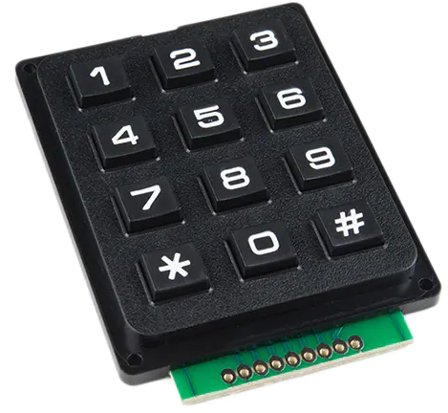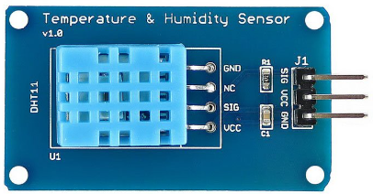

Water Temperature Sensor

## Functional Requirements

### Function xxxx

Add short description here …

|  |  |
| --- | --- |
| **REQ_ID** | **Requirement** |
| REQ-xx |  |
| REQ-xx |  |
| REQ-xx |  |

### Function yyyy

Add short description here …

|  |  |
| --- | --- |
| **REQ_ID** | **Requirement** |
| REQ-xx |  |

### Function zzzz

1. Add short description here …

|  |  |
| --- | --- |
| **REQ_ID** | **Requirement** |
| REQ-xx |  |

## Non-Functional Requirements

### Non-Functional Requirement xxxx

Add short description here …

|  |  |
| --- | --- |
| **REQ_ID** | **Requirement** |
| REQ-xx |  |
| REQ-xx |  |

# Software Architecture

## Static Software Architecture

The Software Architecture defines the various Software Components that are developed to realize the implementation of the system requirements.

**PowerMgt**

**HMI**

**Application Layer**

**Hardware Abstraction Layer (HAL)**

**ADC**

**USonic**

**NFC**

**Servo**

**RainSens**

**BlackCoffee**

**HotWater**