Developer Manual

Real estate smart chat bot

**Installation: -**

Assuming you’ve already installed Node.js and git, create a directory to hold your application, and make that you’re working directory.

$ mkdir myapp

$ cd myapp

Now install real-estate-chatbot in the myapp directory and install all it’s dependencies.

$ git clone reponame

$ npm install

**Features: -**

* Start the dialogue and give options to the user when they visit the website.
* Live properties
* Get customer query
* Fully functional form to gather data from user

**Quick Start: -**

There are two different ways to start application.

1. **Auto start: -**

To start backend server and frontend application automatically, run the following command

$ run-script run-dev

1. **Manual Start: -**

To start server:

$ npm start

To start frontend:

$ cd client

$ npm start

Both will start the Nodejs server on port 5000 and react application on port 3000.

View the website at:

<http://localhost:3000>

**Application Overview: -**

**Directory Structure: -** Below you’ll find a brief explanation of each file annotated in the structure image.

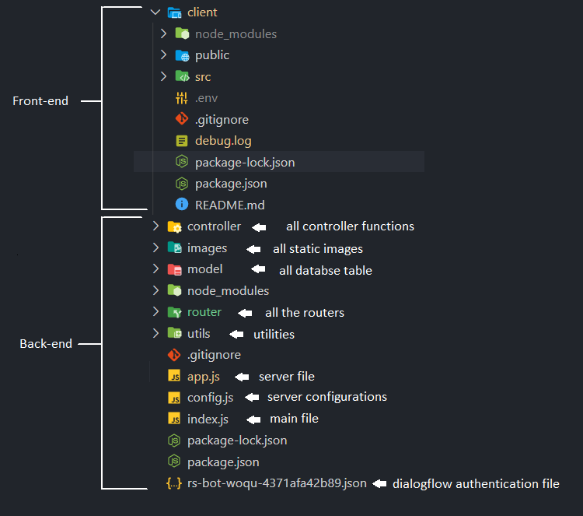

e.g.- Backend

**Backend:**

1. **– index.js: -** The entry point of the application.
2. **– app.js: -** This is the server file. it create express server and connect to mongodb database, apply middleware, configure website routes etc.
3. **– config.js: -** This file contains all server configurations. You can change server port from this file. By default, server port is 5000.

Note that mongodb url is not set initially, you need to add your mongodb url here or you can keep it in environment variables.

1. **– utils: -** As the name suggest this folder contain utility scripts of the application. At this version this file is contain only parser.js file which is used to parse dialogflow responses.
2. **– router: -** This file contains all website routes. If you add any route of this website you have to make your router file and add its reference to app.js file to use the route. There is already a test route, named tesRoute.js. To use this route you need to uncomment this route from app.js file which is already declared or you need to add this route manually.
3. **– model: -** This file contains all database tables
4. **– images: -** This file contain static images of the website. You can get images by get request in /images/{images name}.

**Frontend:**

1. **– assets: -** This folder contains static assets. Basically it contains images, logos used in frontend to display.
2. **– components: -** This file contains different components.

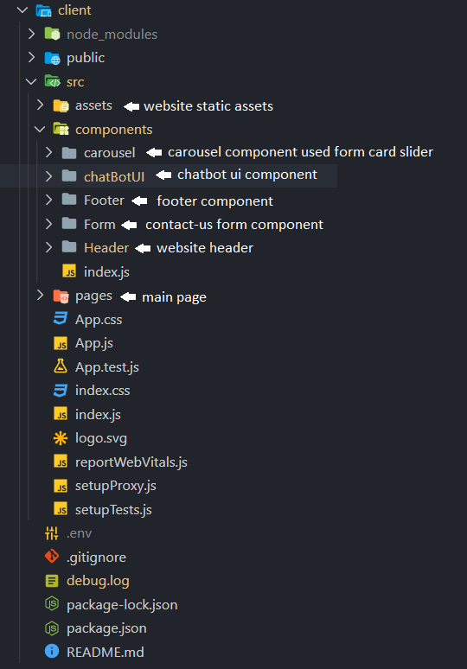

e.g.- Front-end

**(3) – pages: -** This folder contains all the pages of website. As now our website is single page, so this folder only contains home page. If you want to add new pages then you can create pages here.

**Tests: -**

To run the test suite, first install the dependencies, then run npm test:

$ npm install

$ npm test

**People: -**

The original author of the real-estate-bot is {}.

The current lead maintainer is {}.

{list of all contributor}