Social Awareness Prototype Document

**Contents**

Analysis of development tools 2

Selection of most feasible solution 2

Screenshot of Running Prototype 3

Manual Start: - 3

Screenshot of Backend code 4

**Table of Figures**

Analysis of development tools 2

Selection of most feasible solution 2

Screenshot of Running Prototype 3

Manual Start: - 3

Screenshot of Backend code4

# Analysis of development tools

In order to develop the frontend html, css and bootstrap has been the most common options but there exist some better options today. AngularJS is one such framework which is supported by Google and also has a huge developer community. It uses MVVM architecture that ensures a good quality of code and easy testing. Vue JS is relatively recent but has earned recognition for its being lightweight. Flutter, built on cross-platform and open-source UI toolkit released by Google is also a wonderful consideration for frontend. The speed of development and simplicity is attributed by its feature name hot reload.

A plethora of tools exists for backend development. Some languages and frameworks used are PHP, Python, Ruby on Rails, Laravel. For a web server technology like Apache, Nginx are available option. Along with this choice of database is also a dilemma. The best available options however are MySQL, PostgreSQL and MongoDB.

Despite the availability of alternatives in the market for each of the development tools selected to building the Social Awareness Website. There are some specific reasons because of which the above discussed tools are given preference. The reasons are described in the next section.

# Selection of most feasible solution

The tools used for developing the Social Awareness Prototype are:

**React**: It is used for frontend development. The design was first done in HTML and then it was converted to React based on the requirements. React in comparison to other frameworks used for frontend is easier to code and maintain because of its modular structure. As a result, a lot of development and maintenance cost will be saved.

**Express and NodeJs**: They are used for the backend of the application. NodeJS serves APIs as requested by frontend which is built in React, save data to database. NodeJS is scalable and easier to maintain. Express helps to maintain routes, middleware etc. easily.

**Nginx:** As a webserver Nginx is used compared to other options like Apache. The reason being its capability to serve static files fast, load balancing support and compared to Apache its can handle 4 times more concurrent connections.

**MongoDB:** It is the database used to collect customer information during their conversation with the chatbot. Mongo Atlas a DB in cloud has been used for the same to reduce dependency in on-premise resources.

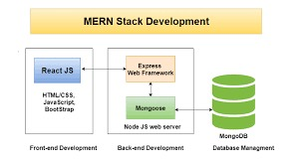

*Figure 1: Flow diagram of the application*

The working of the application and the integration of different tools and technologies to bring about the complete prototype is shown in figure 1.

# Screenshot of Running Prototype

On can start the application in this way:

## Manual Start: -

To start frontend:

$ npm start

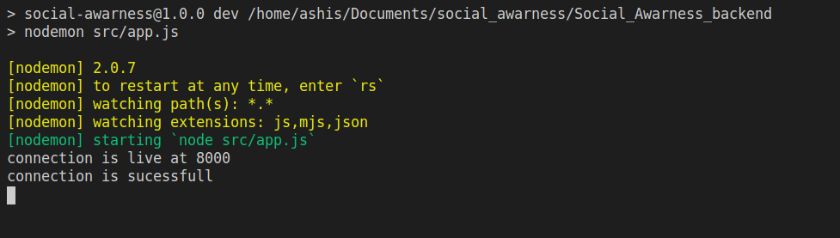

To start backend:

$ cd Social_Awarness_backend/

$ npm run dev

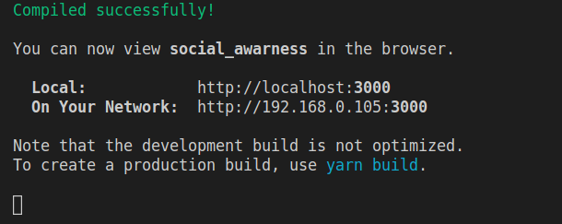

this will start the Node Js server on port 8000 and react application on port 3000.

View the website at:

<http://localhost:3000>

# Screenshot of Backend code

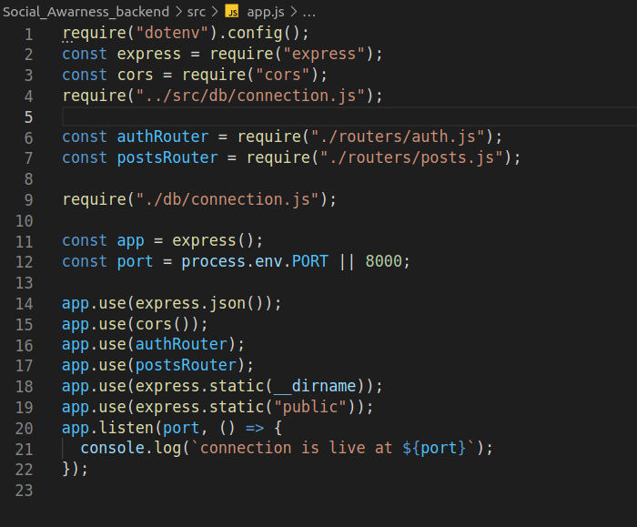

*Figure 3: app.js(server entry point,contain server routes, middleware etc)*