USER MANUAL

Real estate smart chat bot

**OVERVIEW**

This section describes how to start using our website. It provides a quick orientation to the home page, how to send us your queries, how to user our chatbot and navigate the website.

The link to access website is http://real-estate-smart-bot.herokuapp.com/

The snippet of the home page is given below.

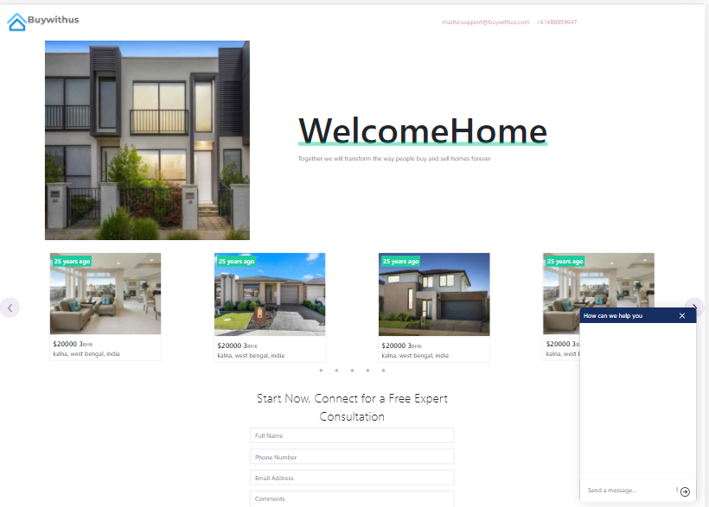

It has a banner with some text and a banner image.

There is also listing of properties with some details.

The menu has an email id and a contact number to which the user can directly call or email by clicking on them

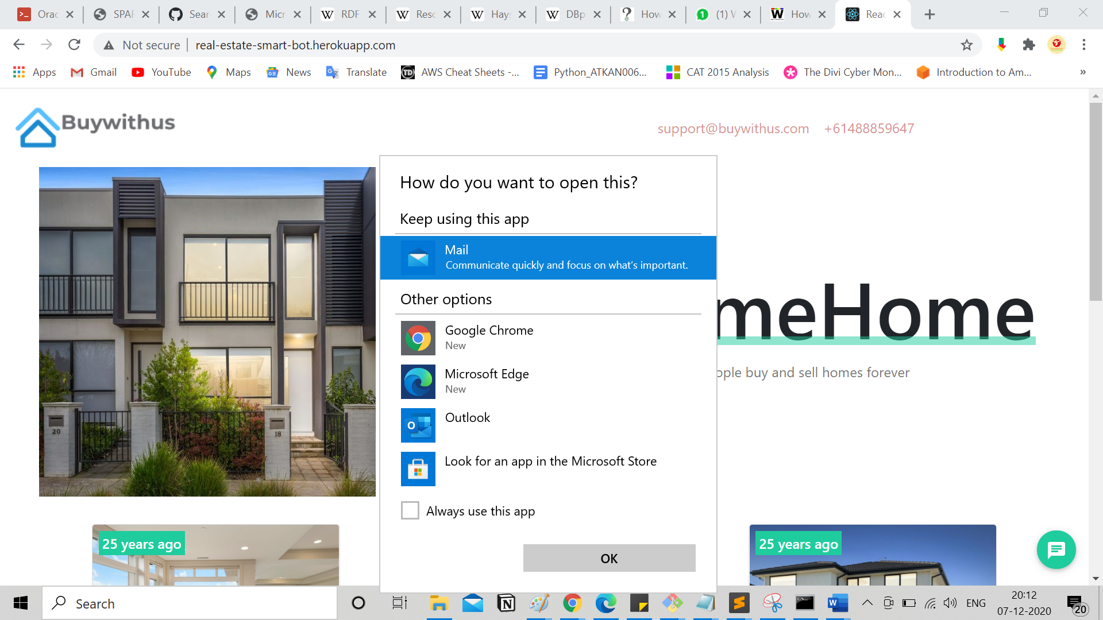

Click on email id to send an email.

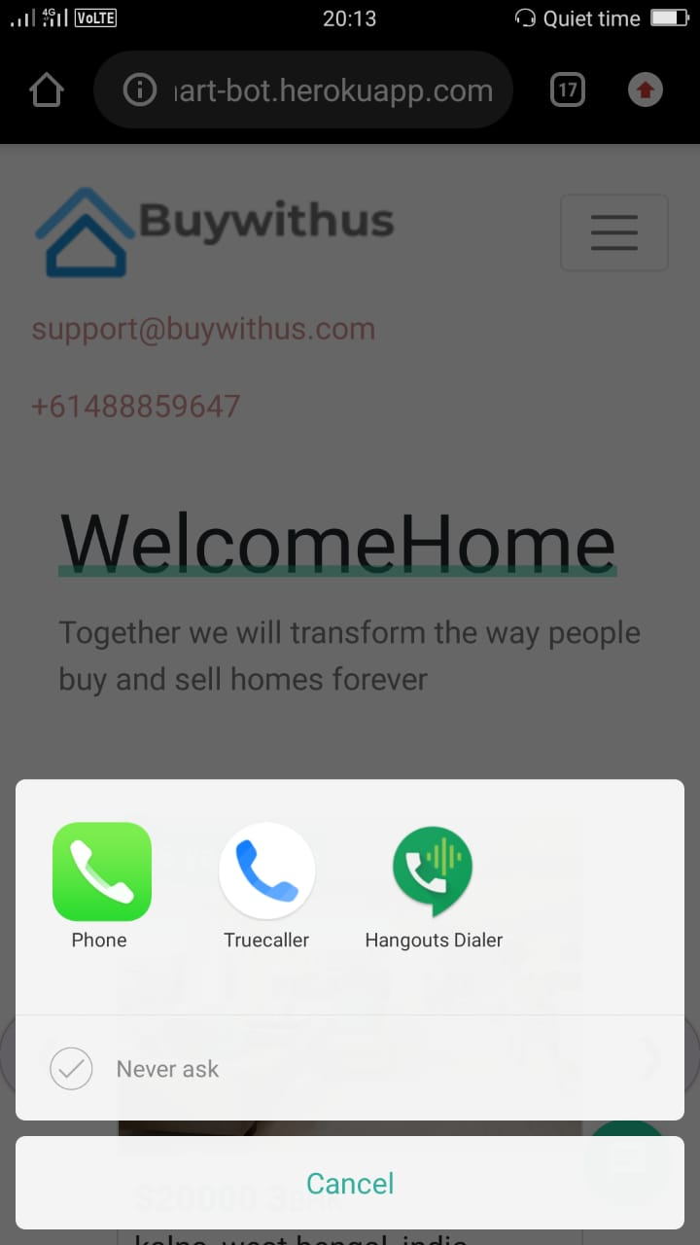

Click on number to make a call

A small chatbot exists for all sort of communication and queries.

For some quick and generic queries there exists a contact us form as well.

**START CHAT**

To start chat, at first click massage icon which is on bottom right corner in the website and a chat box will appear.

At first time there is already ‘/start’ massage present. Now click send icon to start. You can also manually type ‘/start’, ‘hi’ like that to start chat.

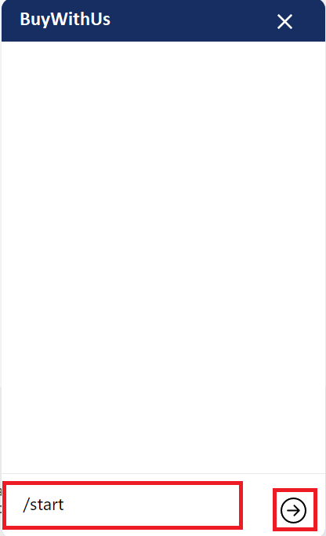

Now some options will appear in the chat box, please select any options to continue. In the example we select ‘Find home’ option. And then you are asked a few details like name, country, state, contact number, etc.

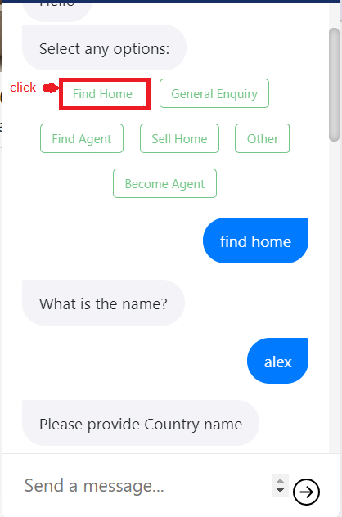

After these queries you are asked to confirm to save the given details and two buttons will appear ‘yes’ and ‘no’. please click ‘yes’ button and it’s done.

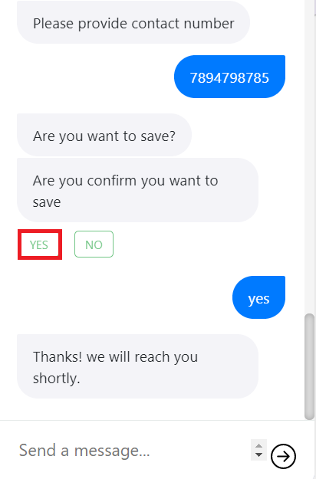

**CONTACT US**

If you are facing any issue or you want a expert consultation or have any query, you can leave a massage with your name, email, contact number.

Here is an example to fill the form.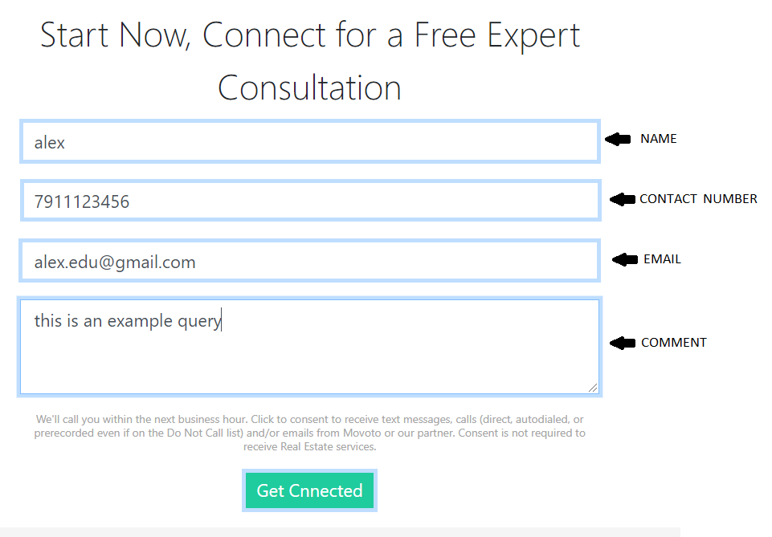

Please fill the form and click ‘Get Connected’ button and you will get a success notification when your details are successfully submitted.

