JOB-TRACKER
A Full-Stack Job Board & Applicant Tracking System
Advanced Java — Final Project Submission
Project Report
Team Members | Role
Harun Mohamud Ahmed | Team Lead · Categories · Security & Integration
Sabirin Abdukadir Salad | Companies module
Jabir Abdi Hassan Sahal | Users module
Yasin Farah Igale | Jobs & Saved Jobs modules

1. Project Overview
Job-Tracker is a full-stack job board and applicant tracking system (ATS) built with Spring Boot 3 (Java 21), PostgreSQL, and a React 19 + Vite + Tailwind CSS frontend. It supports three roles — Applicant, Employer, and Admin — and covers the complete hiring lifecycle: employers create company profiles and post jobs, applicants browse, search, save, and apply to jobs, and admins moderate the whole platform, including a company-approval workflow that gates which companies may publicly list jobs.
The system is containerized with Docker Compose (a PostgreSQL container plus the Spring Boot backend), authenticated with stateless JWT tokens, and persists data through Spring Data JPA/Hibernate over six relational tables.

Technology Stack
- Backend: Spring Boot 3, Java 21, Spring Security, Spring Data JPA/Hibernate, Maven
- Database: PostgreSQL 16, Dockerized
- Frontend: React 19, Vite, Axios, Tailwind CSS, React Router
- Auth: Stateless JWT (JJWT), BCrypt password hashing, role-based access control
- Tooling: Docker Compose for local orchestration of backend + database

2. System Architecture
The backend follows a standard layered architecture: Controller → Service → Repository → Hibernate → PostgreSQL. Each REST resource (Users, Companies, Jobs, Applications, Categories, SavedJobs) has its own Controller, Service interface + implementation, JPA Repository, and Entity, keeping request handling, business rules, and persistence cleanly separated.
Security is handled by a stateless JwtAuthenticationFilter that validates the Authorization header on every request, loads the user through a CustomUserDetailsService, and populates the Spring Security context — no server-side session state is kept. Endpoint-level authorization is enforced with @PreAuthorize annotations (e.g. hasRole('ADMIN')) on top of a global SecurityConfig that defines which routes are public (job/company browsing) versus authenticated.
On the frontend, a central Axios instance attaches the JWT to every request and a React Context (AuthContext) exposes the current user and role across the app. PrivateRoute components gate pages by role, so /admin/** routes are inaccessible to non-admin users client-side, with the backend independently enforcing the same rule.

Database Design
The schema has six tables: users, companies, categories, job_vacancies, applications, and saved_jobs. A user can own multiple companies (employer) or submit multiple applications/saved jobs (applicant); a company posts many jobs; a category groups many jobs; and a job receives many applications and can be saved by many users. The ERD below reflects the actual PostgreSQL schema running in the project's Docker container.
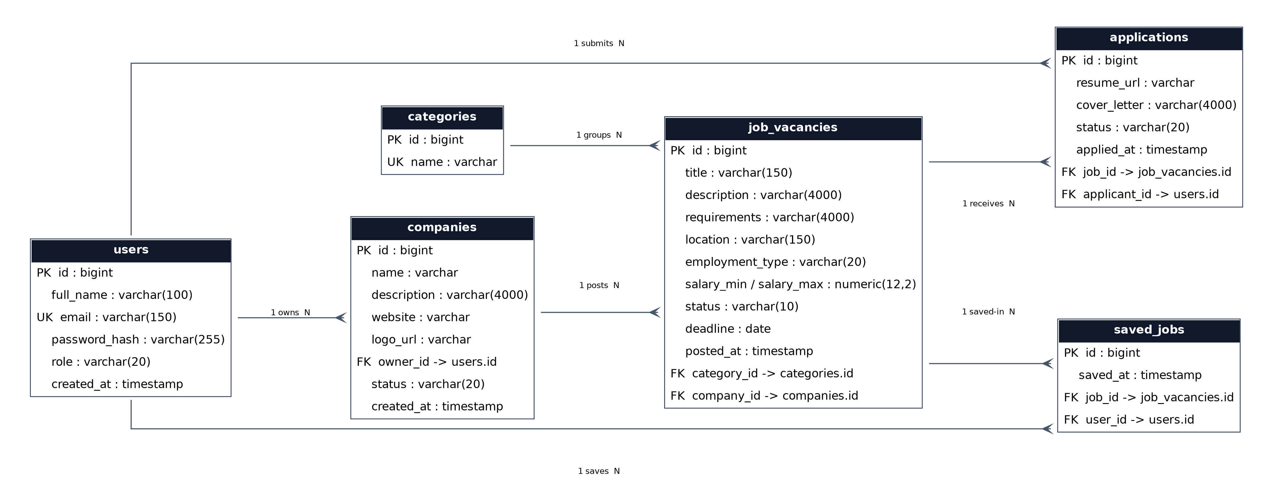
Figure 1 — Entity-Relationship Diagram (generated from the live schema)

3. Key Features
- JWT-based authentication and registration with three roles: Applicant, Employer, Admin
- Employer company profiles with an admin approval workflow (PENDING → APPROVED/REJECTED); unapproved companies cannot post publicly visible jobs
- Job posting, editing, closing, and deletion, scoped to the owning employer (or admin)
- Public job search with category, location, and keyword filters
- Job applications with resume URL and cover letter, plus an ATS-style status pipeline (Pending → Reviewed → Shortlisted → Accepted/Rejected)
- Saved jobs (bookmarking) for applicants
- Full admin dashboard: manage users (role changes, deletion), manage companies (approve/reject), manage jobs (close/delete), manage applications (status updates), all backed by live database queries

4. Challenges & Solutions

Challenge: PostgreSQL "function lower(bytea) does not exist"
The job search endpoint crashed with a 500 error whenever a search filter was left blank. Root cause: when a query parameter was null, Hibernate could not infer its SQL type inside a CONCAT() expression, so the JDBC driver sent it as untyped binary data, which Postgres interpreted as bytea — and lower() has no bytea overload. Fix: explicitly cast every optional parameter with CAST(:param AS string) in the JPQL query, forcing a consistent varchar binding whether or not the parameter is null.

Challenge: LazyInitializationException across Companies, Jobs, Applications, and Saved Jobs
List endpoints for these resources intermittently returned generic 500 errors. Root cause: with spring.jpa.open-in-view disabled, several service methods read lazily-fetched relationships (e.g. company.getOwner(), job.getCompany()) after the repository call had already returned and closed the Hibernate session. Fix: added @Transactional(readOnly = true) to every read method that touches a lazy association, keeping the persistence context open long enough to serialize the response.

Challenge: missing backend for user management
The admin dashboard called GET /api/users, but no UserController, UserService, or implementation existed anywhere in the codebase. The team built this module from scratch, including admin-only endpoints to list, view, change the role of, and delete users.

Challenge: enforcing the company-approval requirement
The project required that new company profiles be reviewed by an admin before going live. The team added a CompanyStatus enum (PENDING/APPROVED/REJECTED), gated public company/job visibility and job-posting rights on that status, and exposed approve/reject endpoints restricted to the ADMIN role.

Challenge: a registration-time privilege-escalation risk
The original registration endpoint accepted any role, including ADMIN, directly from client input — meaning any unauthenticated caller could grant themselves admin rights. This was closed by rejecting ADMIN at registration; new admins can now only be created by an existing admin through the user-management endpoint.

Challenge: local environment setup (Docker/PostgreSQL/ports)
During development the team hit port conflicts between a local Apache/XAMPP instance and the Dockerized Postgres container, along with authentication failures on first boot. These were resolved by standardizing on a single startup path (docker compose up --build) and updating only the frontend API base URL when port mappings changed, without touching backend code.

5. Acknowledgement of GenAI Tool Use
This project used Claude (Anthropic) as a development assistant throughout the build and debugging process. Specifically, it was used to: (1) diagnose and fix backend runtime errors, including a PostgreSQL "function lower(bytea) does not exist" error caused by untyped null query parameters, and Hibernate LazyInitializationException failures caused by missing @Transactional boundaries around lazily-fetched JPA relationships; (2) design and implement the company-approval workflow (the CompanyStatus enum and its supporting endpoints); (3) build the previously-missing user-management backend (UserController/UserService) that the admin dashboard depended on; (4) review Spring Security configuration for a self-registration privilege-escalation vulnerability, which was then patched; and (5) generate this report, the ERD diagram, and the accompanying presentation deck. All generated code was reviewed, tested against the team's actual PostgreSQL schema and Docker Compose environment, and adjusted by the team before being included in the final submission. No AI tool was used to fabricate results, data, or claims in this report; all described bugs and fixes were reproduced from the team's own Docker container logs.

6. Conclusion & Future Work
Job-Tracker demonstrates a complete, secured, role-based full-stack application built on Spring Boot and React, with a working company-approval moderation workflow and an admin control panel backed entirely by live data. Future improvements could include: server-side pagination for large data sets, email notifications on application status changes, file upload support for resumes rather than URLs, automated test coverage (JUnit/Mockito for the backend, Vitest/RTL for the frontend), and CI/CD via GitHub Actions.

