# Unit 6 Project – FranklinCritters

This assignment will give you practice with defining classes.  You are to write a set of classes that define the behavior of certain animals.  You will be given a program that runs a simulation of a world with many animals wandering around in it.  Different kinds of animals will behave in different ways and you are defining those differences.

For this assignment, you will be given a lot of supporting code that runs the simulation.  While it is running, the simulation will look something like this:

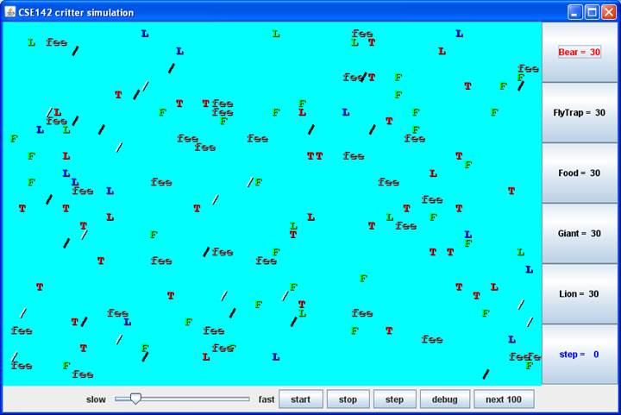

Every object in this world is a “critter”, where Critter is the super class with default behavior defined. You will be writing **five** classes, each representing a different type of Critter: Bear, Tiger, WhiteTiger, Giant and Quaker. **All of the classes you right should be sub classes of Critter.**

On each round of the simulation, each critter is asked for 3 pieces of information:

1. How should it act?
2. What color is it?
3. What string represents that critter?

These 3 pieces of information are provided by 3 methods present in each Critter class. You will be responsible for overriding these methods and programming their appropriate behavior:

public Action getMove(CritterInfo info) {

    ...

}

public Color getColor() {

    ...

}

public String toString() {

    ...

}

For example, here is a Food class who would always appear as a green “F” that would try to infect whatever critter is in front of it:

import java.awt.*;

public class Food extends Critter {

    public Action getMove(CritterInfo info) {

        return Action.INFECT;

    }

    public Color getColor() {

        return Color.GREEN;

    }

    public String toString() {

        return "F";

}

}

Notice that it begins with an import declaration to be able to access the Color class.  **All of your Critter classes will have the basic format shown above.**

# Your Five Classes’ Behavior

### Bear

|  |  |
| --- | --- |
| Constructor | public Bear(boolean polar) |
| getColor | Color.WHITE for a polar bear (when polar is true), Color.BLACK otherwise (when polar is false) |
| toString | Should alternate on each different move between a slash character (/) and a backslash character (\) starting with a slash. |
| getMove | always infect if an enemy is in front otherwise hop if possible otherwise turn left. |

### Tiger

|  |  |
| --- | --- |
| Constructor | public Tiger() |
| getColor | Randomly picks one of three colors (Color.RED, Color.GREEN, Color.BLUE) and uses that color for three moves, then randomly picks one of those colors again for the next three moves, then randomly picks another one of those colors for the next three moves, and so on. |
| toString | "TGR" |
| getMove | always infect if an enemy is in front otherwise if a wall is in front or to the right, then turn left otherwise if a fellow Tiger is in front, then turn right otherwise hop. |

### WhiteTiger

|  |  |
| --- | --- |
| Constructor | public WhiteTiger() |
| getColor | Always Color.WHITE. |
| toString | “tgr” if it hasn’t infected another Critter yet,  “TGR” if it has infected. |
| getMove | Same as a Tiger. Note: you’ll have to override this method to figure out if it has infected another Critter. |

### Giant

|  |  |
| --- | --- |
| Constructor | public Giant() |
| getColor | Color.GRAY |
| toString | "fee" for 6 moves, then "fie" for 6 moves, then "foe" for 6 moves, then "fum" for 6 moves, then repeat. |
| getMove | always infect if an enemy is in front otherwise hop if possible otherwise turn right. |

### Quaker

|  |  |
| --- | --- |
| Constructor | public Quaker() |
| getColor | You decide |
| toString | You decide |
| getMove | You decide |

# The Methods

## getColor()

As the simplest method, we suggest you start writing the getColor() method first. For getColor you should return whatever color you want the simulator to use when drawing your critter. Colors are represented like “Color.WHITE”.

For the random colors, each possible choice must be equally likely.  You may use either a Random object or the Math.random() method.

If your color changes based on moves, you will want some way to count how many moves a critter has made. This state should only be updated in the getMove method, and simply referenced in others (like getColor or toString).

## toString()

For the toString method, you should return whatever text you want the simulator to use when displaying your critter (normally a single character). Remember, that if your String changes based on moves you might need to keep track of the critter’s number of moves. For this assignment, do not worry about integer overflow (we won’t run the simulation that long).

## getMove()

The getMove method can return only 4 different things:

|  |  |
| --- | --- |
| **Constant** | **Description** |
| Action.HOP | Move forward one square in its current direction |
| Action.LEFT | Turn left (rotate 90 degrees counter-clockwise) |
| Action.RIGHT | Turn right (rotate 90 degrees clockwise) |
| Action.INFECT | Infect the critter in front of you |

This is why your return type is “Action”. You will need to use information about the area around your Critter to determine which Action to return. For example, Bear, Tiger,WhiteTiger and Quaker should all return Action.INFECT if an enemy is in front of them.

You can tell what is around your critter based on the CritterInfo object parameter:

|  |  |  |
| --- | --- | --- |
| **CritterInfo Method** | **Description** | **Possible Return Values** |
| public Neighbor getFront() | returns neighbor in front of you | Neighbor.WALL, Neighbor.EMPTY, Neighbor.SAME, Neighbor.OTHER |
| public Neighbor getBack() | returns neighbor in back of you | Neighbor.WALL, Neighbor.EMPTY, Neighbor.SAME, Neighbor.OTHER |
| public Neighbor getLeft() | returns neighbor to your left | Neighbor.WALL, Neighbor.EMPTY, Neighbor.SAME, Neighbor.OTHER |
| public Neighbor getRight() | returns neighbor to your right | Neighbor.WALL, Neighbor.EMPTY, Neighbor.SAME, Neighbor.OTHER |
| public Direction getDirection() | returns direction you are facing | Direction.NORTH, Direction.SOUTH, Direction.EAST, Direction.WEST |
| public boolean frontThreat() | whether there is an enemy facing you in front of you | TRUE or FALSE |
| public boolean backThreat() | whether there is an enemy facing you in back of you | TRUE or FALSE |
| public boolean leftThreat() | whether there is an enemy facing you to your left | TRUE or FALSE |
| public boolean rightThreat() | whether there is an enemy facing you to your right | TRUE or FALSE |

# FAQ

* You are not writing the main method; your code will not be in control.  Instead, you are defining a series of objects that become part of a larger system.  For example, **you might find that you want to have one of your critters make several moves all at once.  You won’t be able to do that.**  The only way a critter can move is to wait for the simulator to ask it for a move. The simulator is in control, not your critters.
* Critters move around in a world of finite size that is enclosed on all four sides by walls.
* You should include a constructor for each class you write as most classes need to keep track of number of moves or other variables.
* For classes that always use the same Strings/Colors, you should declare them as class constants.
* The simulator has several supporting classes that are included (CritterModel, CritterFrame, etc).  You can in general ignore these classes.  When you compile CritterMain, these other classes will be compiled. The only classes you will have to modify and recompile are CritterMain (if you change what critters to include in the simulation) and your own individual Critter classes.
* Do not implement any Critter behavior in the CritterMain class. The only classes that are graded are your 5 Critter classes, so if the behavior is not in that class, it is not graded.

## Testing

You will notice that CritterMain has lines of code like the following:

// frame.add(30, Tiger.class);

You should uncomment these lines of code as you complete the various classes you have been asked to write.  Then critters of that type will be included in the simulation.

The simulator provides great visual feedback about where critters are, so you can watch them move around the world.  But it doesn’t give great feedback about what direction critters are facing.  The simulator has a “debug” button that makes this easier to see.  When you request debug mode, your critters will be displayed as arrow characters that indicate the direction they are facing.

The simulator also indicates the “step” number as the simulation proceeds (initially displaying a 0).  Below are some suggestions for how you can test your critters:

**Bear**: Try running the simulator with just 30 bears in the world.  You should see about half of them being white and about half being black.  Initially they should all be displayed with slash characters.  When you click “step,” they should all switch to backslash characters.  When you click “step” again they should go back to slash characters.  And so on.  When you click “start,” you should observe the bears heading towards walls and then hugging the walls in a counterclockwise direction.  They will sometimes bump into each other and go off in other directions, but their tendency should be to follow along the walls.

**Tiger**: Try running the simulator with just 30 Tigers in the world.  You should see about one third of them being red and one third being green and one third being blue.  Use the “step” button to make sure that the colors alternate properly.  They should keep these initial colors for three moves.  That means that they should stay this color while the simulator is indicating that it is step 0, step 1, and step 2.  They should switch colors when the simulator indicates that you are up to step 3 and should stay with these new colors for steps 4 and 5.  Then you should see a new color scheme for steps 6, 7, and 8.  And so on.  When you click “start” you should see them bouncing off of walls.  When they bump into a wall, they should turn around and head back in the direction they came.  They will sometimes bump into each other as well.  They shouldn’t end up clustering together anywhere.

**WhiteTiger:** This should behave just like a Tiger except that they will be White. They will also be lower-case until they infect another Critter, then they “grow up.”

**Giant**: Try running the simulator with just 30 giants in the world.  They should all be displayed as “fee.”  This should be true for steps 0, 1, 2, 3, 4, and 5.  When you get to step 6, they should all switch to displaying “fie” and should stay that way for steps 6, 7, 8, 9, 10, and 11.  Then they should be “foe” for steps 12, 13, 14, 15, 16, and 17.  And they should be “fum” for steps 18, 19, 20, 21, 22, and 23.  Then they should go back to “fee” for 6 more steps, and so on.  When you click “start,” you should observe the same kind of wall-hugging behavior that bears have, but this time in a clockwise direction.